EXPERIMENT 1

Create a table with constraints
- NOT NULL Constraint
Ensures that a column must always contain a value. NULL values are not allowed.
- UNIQUE Constraint
Makes sure that all the values in a column are different. No duplicate entries are allowed.
- PRIMARY KEY Constraint
Uniquely identifies each record in a table. It automatically includes both NOT NULL and UNIQUE.
- FOREIGN KEY Constraint
Links a column in one table to the primary key of another table to maintain relational consistency.
- CHECK Constraint
Ensures that values in a column follow a specific rule (example: age must be greater than 0).
- DEFAULT Constraint
Assigns a predefined value to a column when no value is provided during insertion.
- CREATE INDEX
Creates an index on one or more columns to speed up data searching and retrieval.
QUERY:

CREATE TABLE Department (
dept_id INT PRIMARY KEY,
dept_name VARCHAR(50) UNIQUE NOT NULL
);
DESC Department;
OUTPUT:

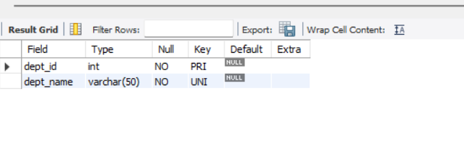

QUERY:

CREATE TABLE Employee (
emp_id INT PRIMARY KEY,
emp_name VARCHAR(50) NOT NULL,
email VARCHAR(100) UNIQUE,
salary DECIMAL(10,2) CHECK (salary > 0),
dept_id INT,
joining_date DATE DEFAULT (CURRENT_DATE),
CONSTRAINT fk_dept FOREIGN KEY (dept_id)
REFERENCES Department(dept_id)
);
DESC Employee;

OUTPUT:

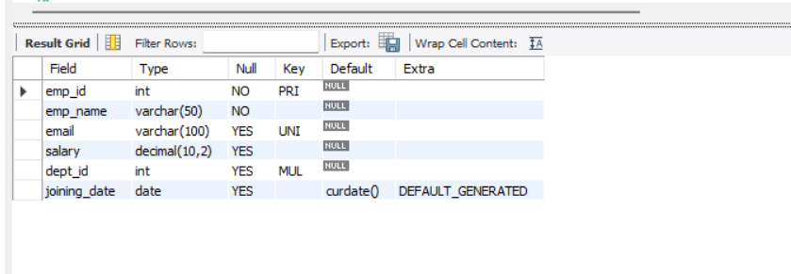

QUERY:

CREATE INDEX idx_employee_email
ON Employee(email);
SHOW INDEX FROM Employee;

OUTPUT:

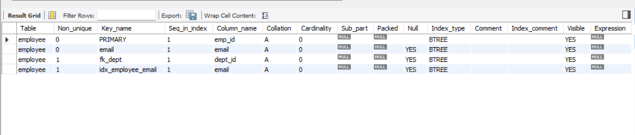

EXPERIMENT 2

Implementation of SQL Commands
1. Insert values with a single entry
Used to add one row at a time into a table using the INSERT INTO statement.
2. Insert values with multiple entries
Used to insert multiple rows in a single query, making data insertion faster and efficient.
3. ALTER Table Structure
Modifies the table's design by adding, deleting, or changing columns without recreating the table.
4. VIEW Table structure
Displays the table’s schema, including column names, data types, and constraints, using DESCRIBE or SHOW COLUMNS.
5. UPDATE table
Used to modify existing records in a table. It updates fields where the condition matches.
6. DELETE Rows in table
Used to remove specific rows from a table using the DELETE FROM statement and a WHERE clause.
7. DROP table
Completely removes the table and all its data from the database permanently.

QUERIES:
1. Insert Single Row

INSERT INTO Department (dept_id, dept_name)
VALUES (1, 'HR');
OUTPUT:
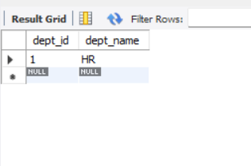

2. Insert Multiple Rows
INSERT INTO Department (dept_id, dept_name)
VALUES
(2, 'Finance'),
(3, 'IT');

OUTPUT:
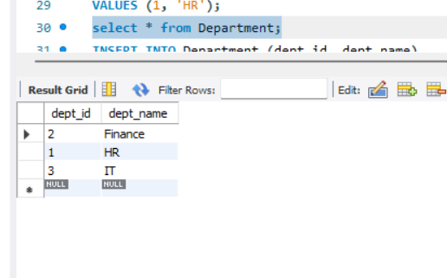
INSERT INTO Employee (emp_id, emp_name, email, salary, dept_id)
VALUES
(102, 'Kavi', 'kavi@gmail.com', 35000, 1),
(103, 'Arun', 'arun@gmail.com', 28000, 2),
(104, 'Meena', 'meena@gmail.com', 40000, 3);

OUTPUT:

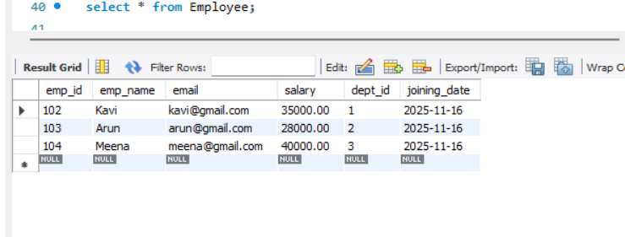

3. ALTER Table Structure Add a new column
ALTER TABLE Employee
ADD phone VARCHAR(15);

OUTPUT:

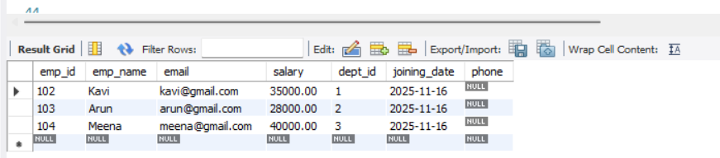
Modify existing column
ALTER TABLE Employee
MODIFY salary DECIMAL(12,2);

OUTPUT:
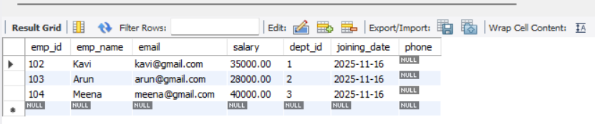

Drop a column
ALTER TABLE Employee
DROP COLUMN phone;
OUTPUT:
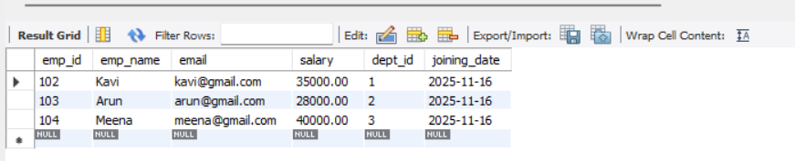

4. VIEW Table Structure Using DESCRIBE
DESCRIBE Employee;
OUTPUT:
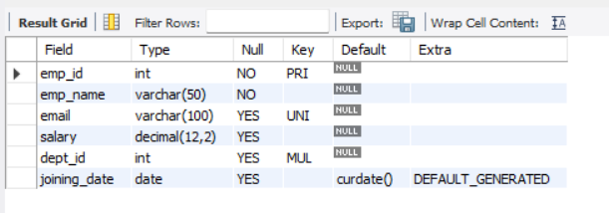

5. UPDATE Table
UPDATE Employee
SET salary = 45000
WHERE emp_id = 103;
OUTPUT:
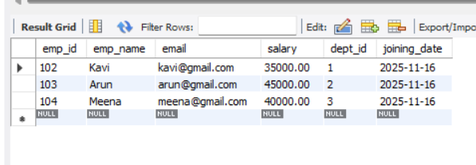
6. DELETE Rows
DELETE FROM Employee
WHERE emp_id = 104;

OUTPUT:
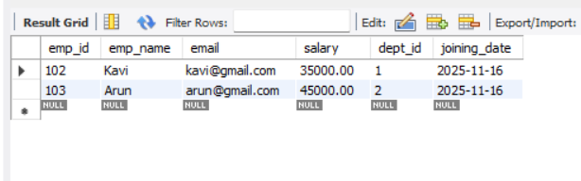

7. DROP Table
DROP TABLE Employee;
OUTPUT:

EXPERIMENT 3

Aggregate Function
1. MIN()
Returns the smallest value from a column (e.g., lowest salary).
2. MAX()
Returns the largest value from a column (e.g., highest salary).
3. COUNT()
Returns the number of rows that satisfy a condition (e.g., total employees).
4. SUM()
Calculates the total sum of all values in a numeric column (e.g., sum of salaries).
5. AVG()
Returns the average value of a numeric column (e.g., average salary).

QUERIES:
1. MIN() – Minimum Salary
SELECT MIN(salary) AS Minimum_Salary
FROM Employee;
OUTPUT:
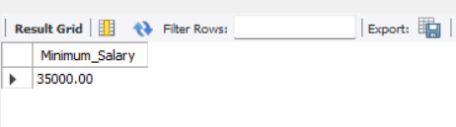
2. MAX() – Maximum Salary
SELECT MAX(salary) AS Maximum_Salary
FROM Employee;
OUTPUT:
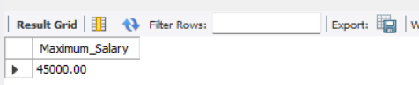
3. COUNT() – Count Total Employees
SELECT COUNT(*) AS Total_Employees
FROM Employee;
OUTPUT:
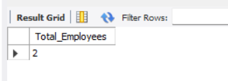
4. SUM() – Total Salary
SELECT SUM(salary) AS Total_Salary
FROM Employee;

OUTPUT:

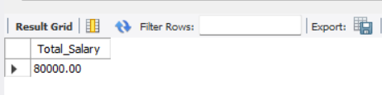
5.AVG() – Average Salary
SELECT AVG(salary) AS Average_Salary
FROM Employee;

OUTPUT:
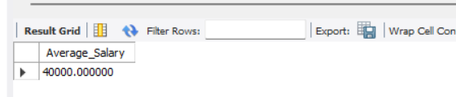

EXPERIMENT 4
1. GROUP BY
Used to arrange rows into groups based on one or more columns.
It is commonly used with aggregate functions (SUM, AVG, COUNT, MIN, MAX) to perform calculations for each group separately.
2. ORDER BY
Used to sort the result of a query based on one or more columns.
Sorting can be:
- ASC → Ascending order (default)
- DESC → Descending order

QUERIES:
GROUP BY:
SELECT dept_id, COUNT(*) AS total_employees
FROM Employee
GROUP BY dept_id;

OUTPUT:
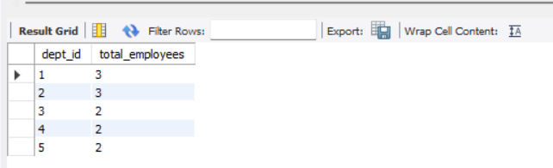

ORDER BY:
SELECT emp_id, emp_name, salary
FROM Employee
ORDER BY salary DESC;

OUTPUT:

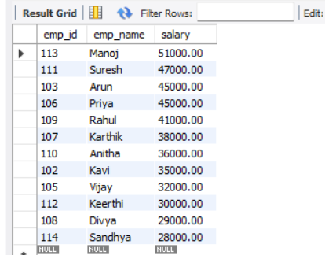

EXPERIMENT 5
SQL OPERATORS

1. LIKE Operator (Wildcard characters)
Used to filter records using pattern matching.
Wildcards used:
- % → matches any number of characters
- _ → matches exactly one character

2. BETWEEN Operator
Used to check whether a value lies within a specified inclusive range.
Works with numbers, dates, or text (alphabetical ranges).

3. OR Operator
Used to return records when any one of the conditions is TRUE.
Often used when multiple filters are possible.

QUERIES:

1.LIKE Operator:

SELECT * FROM Employee
WHERE emp_name LIKE 'A%';

OUTPUT:

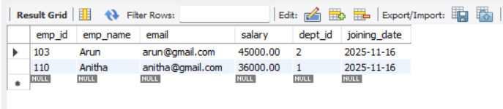

SELECT * FROM Employee
WHERE emp_name LIKE '_a%';
OUTPUT:

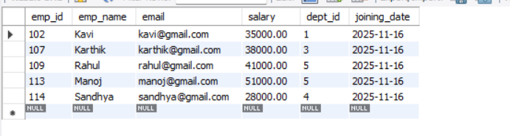

2.BETWEEN Operator:

SELECT * FROM Employee
WHERE salary BETWEEN 30000 AND 60000;

OUTPUT:

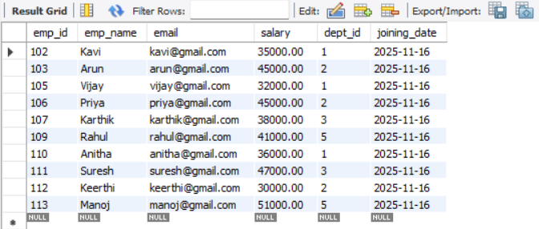

3.OR Operator:

SELECT * FROM Employee
WHERE dept_id = 1 OR dept_id= 2;
OUTPUT:

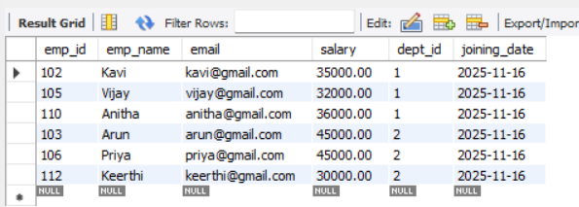

EXPERIMENT -6

SQL JOINS

1. INNER JOIN
Returns only the rows where the data matches in both tables.
2. LEFT JOIN
Returns all rows from the left table and only the matching rows from the right table.
3. RIGHT JOIN
Returns all rows from the right table and only the matching rows from the left table.
4. OUTER JOIN (FULL OUTER JOIN)
Returns all rows from both tables, whether they match or not.
5. LEFT JOIN excluding INNER JOIN
Returns only the rows from the left table that have NO matching row in the right table.
6. RIGHT JOIN excluding INNER JOIN
Returns only the rows from the right table that have NO matching row in the left table.
7. OUTER JOIN excluding INNER JOIN
Returns unmatched rows from both tables
(left-only + right-only), but not the matching rows.

QUERIES:

1.INNER JOIN
SELECT Employee.emp_id, emp_name, salary, dept_name
FROM Employee
INNER JOIN Department
ON Employee.dept_id = Department.dept_id;

OUTPUT:
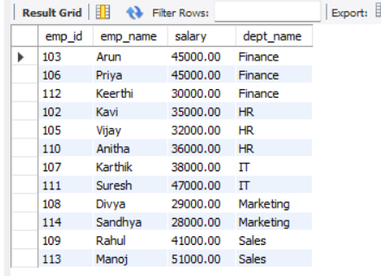

2.LEFT JOIN:
SELECT Employee.emp_id, emp_name, salary, dept_name
FROM Employee
LEFT JOIN Department
ON Employee.dept_id = Department.dept_id;

OUTPUT:
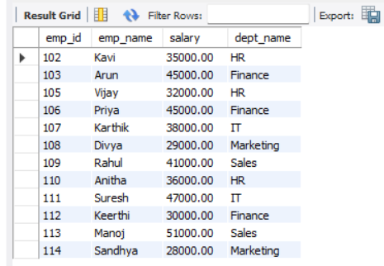

3.RIGHT JOIN

SELECT Employee.emp_id, emp_name, salary, dept_name
FROM Employee
RIGHT JOIN Department
ON Employee.dept_id = Department.dept_id;

OUTPUT:

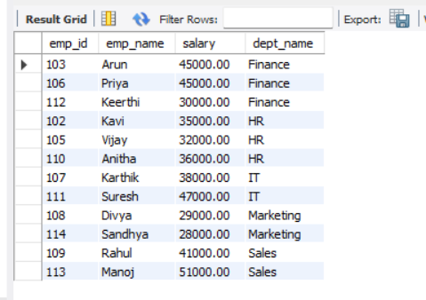

4. OUTER JOIN (FULL OUTER JOIN)
SELECT Employee.emp_id, emp_name, salary, dept_name
FROM Employee
LEFT JOIN Department
ON Employee.dept_id = Department.dept_id

UNION

SELECT Employee.emp_id, emp_name, salary, dept_name
FROM Employee
RIGHT JOIN Department
ON Employee.dept_id = Department.dept_id;

OUTPUT:

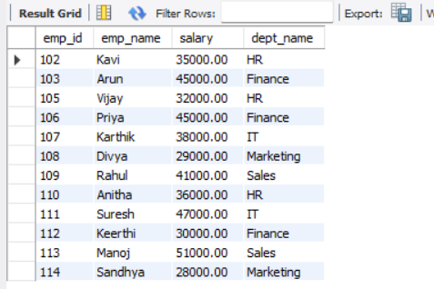

5. LEFT JOIN excluding INNER JOIN
SET FOREIGN_KEY_CHECKS = 0;

INSERT INTO Employee (emp_id, emp_name, email, salary, dept_id)
VALUES (200, 'UnknownEmp', 'unknown@mail.com', 25000, 9);

SET FOREIGN_KEY_CHECKS = 1;
INSERT INTO Department (dept_id, dept_name)
VALUES (10, 'UnassignedDept');

SELECT Employee.emp_id, emp_name, salary, Employee.dept_id
FROM Employee
LEFT JOIN Department
ON Employee.dept_id = Department.dept_id
WHERE Department.dept_id IS NULL;

OUTPUT:


6. RIGHT JOIN excluding INNER JOIN
SET FOREIGN_KEY_CHECKS = 0;

INSERT INTO Employee (emp_id, emp_name, email, salary, dept_id)
VALUES (200, 'UnknownEmp', 'unknown@mail.com', 25000, 9);

SET FOREIGN_KEY_CHECKS = 1;
INSERT INTO Department (dept_id, dept_name)
VALUES (10, 'UnassignedDept');

SELECT Department.dept_id, dept_name
FROM Employee
RIGHT JOIN Department
ON Employee.dept_id = Department.dept_id
WHERE Employee.dept_id IS NULL;

OUTPUT:
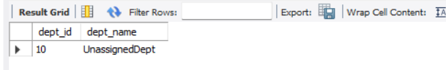

7.OUTER JOIN excluding INNER JOIN
SET FOREIGN_KEY_CHECKS = 0;
INSERT INTO Employee (emp_id, emp_name, email, salary, dept_id)
VALUES (200, 'UnknownEmp', 'unknown@mail.com', 25000, 9);
SET FOREIGN_KEY_CHECKS = 1;

INSERT INTO Department (dept_id, dept_name)
VALUES (10, 'UnassignedDept');

SELECT Employee.emp_id, emp_name, salary, Employee.dept_id
FROM Employee
LEFT JOIN Department
ON Employee.dept_id = Department.dept_id
WHERE Department.dept_id IS NULL

UNION

SELECT NULL AS emp_id, NULL AS emp_name, NULL AS salary, Department.dept_id
FROM Employee
RIGHT JOIN Department
ON Employee.dept_id = Department.dept_id
WHERE Employee.dept_id IS NULL;

OUTPUT:

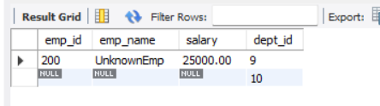

EXPERIMENT 7
Normal Forms
1. 1NF (First Normal Form)
Ensures that every column contains atomic (indivisible) values and that there are no repeating groups or multi-valued attributes.

2. 2NF (Second Normal Form)
A table is in 2NF when it is already in 1NF and all non-key columns are fully dependent on the entire primary key (no partial dependency).

3. 3NF (Third Normal Form)
A table is in 3NF when it is already in 2NF and no non-key attribute depends on another non-key attribute (no transitive dependency).

QUERIES:
a).1NF
CREATE TABLE student_1nf (
student_id INT,
student_name VARCHAR(50),
subject VARCHAR(50)
);

INSERT INTO student_1nf VALUES (1, 'Alice', 'Math');
INSERT INTO student_1nf VALUES (1, 'Alice', 'Science');
INSERT INTO student_1nf VALUES (2, 'Bob', 'English');
INSERT INTO student_1nf VALUES (2, 'Bob', 'History');

SELECT * FROM student_1nf;

OUTPUT:
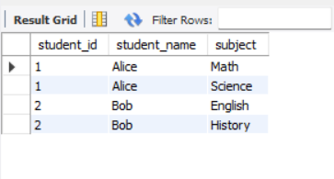
b). 2NF
CREATE TABLE Students2 (
student_id INT PRIMARY KEY,
student_name VARCHAR(50)
);

CREATE TABLE Courses2 (
course_id INT PRIMARY KEY,
course_name VARCHAR(50),
instructor_name VARCHAR(50)
);

CREATE TABLE Enrollments2 (
student_id INT,
course_id INT,
PRIMARY KEY (student_id, course_id),
FOREIGN KEY (student_id) REFERENCES Students2(student_id),
FOREIGN KEY (course_id) REFERENCES Courses2(course_id)
);

INSERT INTO Students2 VALUES (1, 'Alice');
INSERT INTO Students2 VALUES (2, 'Bob');
INSERT INTO Students2 VALUES (3, 'Charlie');

INSERT INTO Courses2 VALUES (101, 'Database Systems', 'Dr. Smith');
INSERT INTO Courses2 VALUES (102, 'Operating Systems', 'Prof. Brown');
INSERT INTO Courses2 VALUES (103, 'Networks', 'Dr. Green');

INSERT INTO Enrollments2 VALUES (1, 101);
INSERT INTO Enrollments2 VALUES (1, 102);
INSERT INTO Enrollments2 VALUES (2, 103);
INSERT INTO Enrollments2 VALUES (3, 101);

SELECT
s.student_id,
s.student_name,
c.course_id,
c.course_name,
c.instructor_name
FROM Enrollments2 e
JOIN Students2 s ON e.student_id = s.student_id
JOIN Courses2 c ON e.course_id = c.course_id
ORDER BY s.student_id, c.course_id;

OUTPUT:

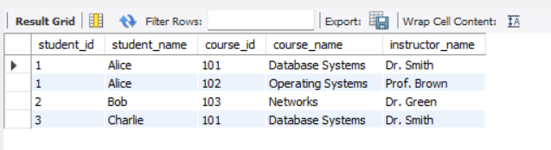

C). 3NF

CREATE TABLE Students3 (
student_id INT PRIMARY KEY,
student_name VARCHAR2(50)
);

CREATE TABLE Instructors3 (
instructor_id INT PRIMARY KEY,
instructor_name VARCHAR2(50)
);

CREATE TABLE Courses3 (
course_id INT PRIMARY KEY,
course_name VARCHAR2(50),
instructor_id INT,
FOREIGN KEY (instructor_id) REFERENCES Instructors3(instructor_id)
);

CREATE TABLE Enrollments3 (
student_id INT,
course_id INT,
PRIMARY KEY (student_id, course_id),
FOREIGN KEY (student_id) REFERENCES Students3(student_id),
FOREIGN KEY (course_id) REFERENCES Courses3(course_id)
);

INSERT INTO Students3 VALUES (1, 'Alice');
INSERT INTO Students3 VALUES (2, 'Bob');
INSERT INTO Students3 VALUES (3, 'Charlie');

INSERT INTO Instructors3 VALUES (201, 'Dr. Smith');
INSERT INTO Instructors3 VALUES (202, 'Prof. Brown');
INSERT INTO Instructors3 VALUES (203, 'Dr. Green');

INSERT INTO Courses3 VALUES (101, 'Database Systems', 201);
INSERT INTO Courses3 VALUES (102, 'Operating Systems', 202);
INSERT INTO Courses3 VALUES (103, 'Networks', 203);

INSERT INTO Enrollments3 VALUES (1, 101);
INSERT INTO Enrollments3 VALUES (1, 102);
INSERT INTO Enrollments3 VALUES (2, 103);
INSERT INTO Enrollments3 VALUES (3, 101);

COMMIT;

SELECT
s.student_id,
s.student_name,
c.course_id,
c.course_name,
i.instructor_name
FROM Enrollments3 e
JOIN Students3 s ON e.student_id = s.student_id
JOIN Courses3 c ON e.course_id = c.course_id
JOIN Instructors3 i ON c.instructor_id = i.instructor_id
ORDER BY s.student_id, c.course_id;

OUTPUT:

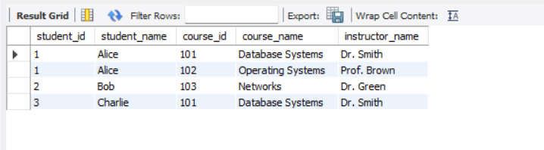

EXPERIMENT 8
Nested Queries (Subqueries)
A query written inside another SQL query, used for filtering, comparing, or calculating based on intermediate results.

QUERIES:

1. Find employees who earn more than the average salary
SELECT emp_id, emp_name, salary
FROM Employee
WHERE salary > (
SELECT AVG(salary)
FROM Employee
);
OUTPUT:
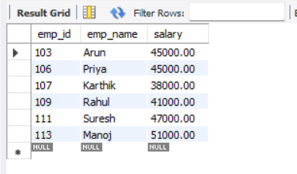

2.Display employees working in the ‘IT’ department
SELECT emp_id, emp_name, dept_id
FROM Employee
WHERE dept_id = (
SELECT dept_id
FROM Department
WHERE dept_name = 'IT'
);
OUTPUT:
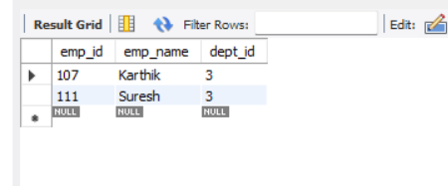

3. Find employees who have the highest salary
SELECT emp_id, emp_name, salary
FROM Employee
WHERE salary = (
SELECT MAX(salary)
FROM Employee
);

OUTPUT:

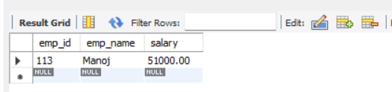

EXPERIMENT 9
Comparison operators are used in SQL to filter rows based on specific conditions.
Operators:
- = : Equal to
- > : Greater than
- < : Less than
- >= : Greater than or equal
- <= : Less than or equal
- <> : Not equal to

QUERIES:

1. Using = (Equal to)
SELECT * FROM employee
WHERE dept_id = 2;
OUTPUT:

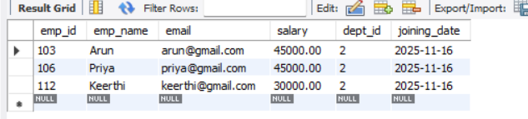
2. Using > (Greater than)
SELECT * FROM employee
WHERE salary > 30000;
OUTPUT:

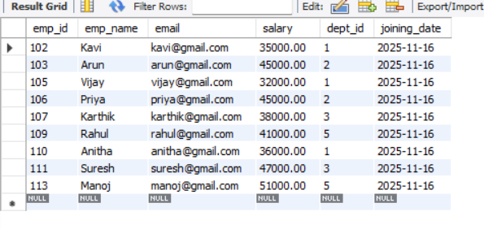
3.Using < (Less than)
SELECT * FROM employee
WHERE salary < 30000;
OUTPUT:

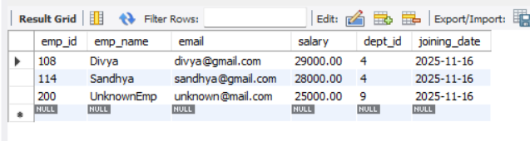
4. Using >= (Greater than or Equal to)
SELECT * FROM employee
WHERE salary >= 40000;
OUTPUT:
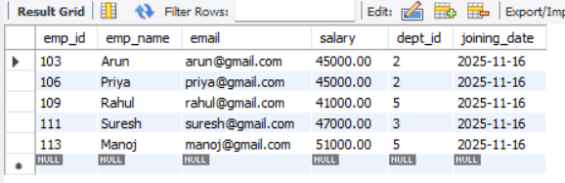

5.Using <= (Less than or Equal to)
SELECT * FROM employee
WHERE salary <= 40000;
OUTPUT:

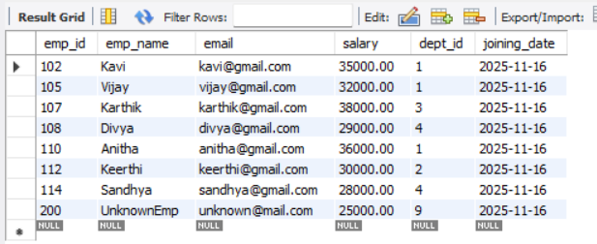
6. Using <> (Not Equal to)
SELECT * FROM employee
WHERE dept_id <> 1;

OUTPUT:

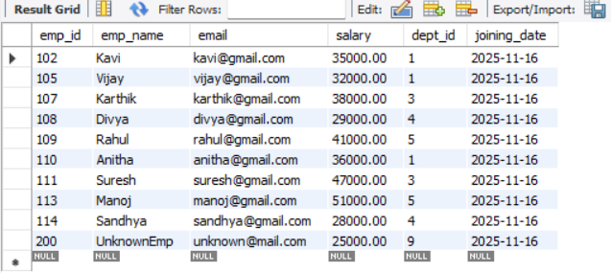

EXPERIMENT 10

Working on Local Host XAMPP Server
- Server Variables in XAMPP:
Provide environment and request details via PHP’s $_SERVER array.
OUTPUT:

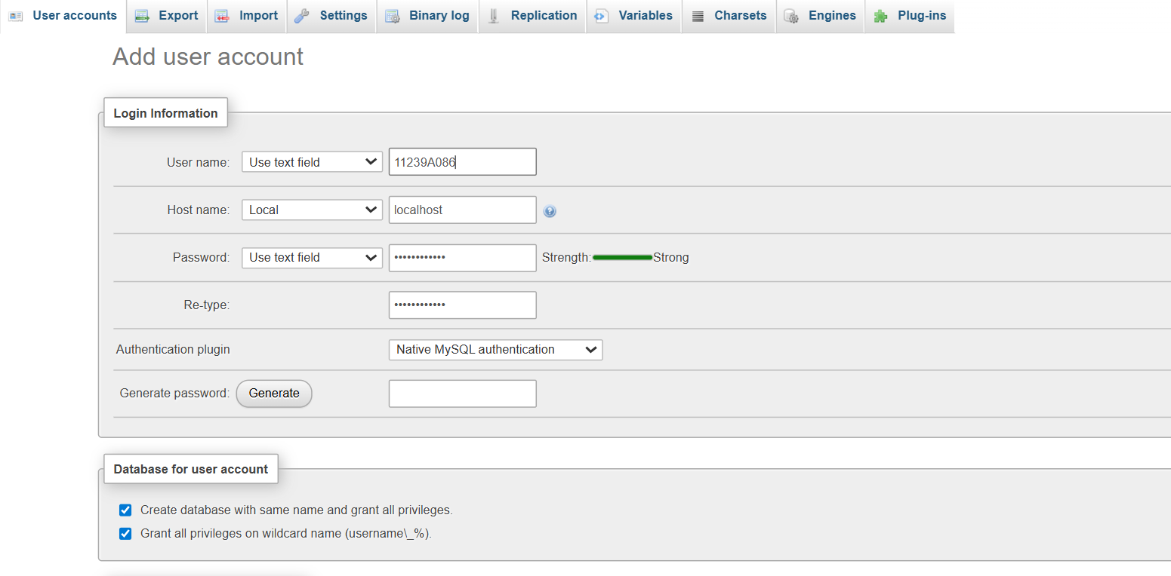

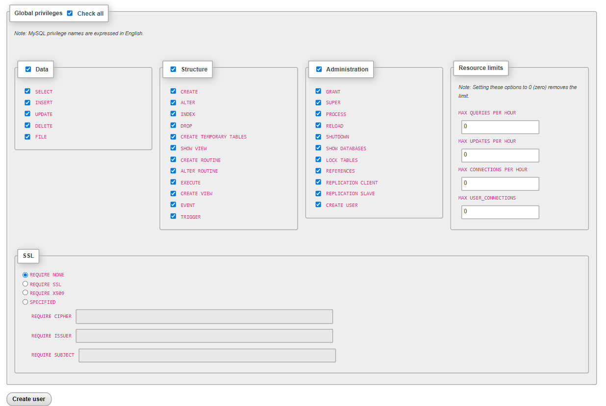
- Hierarchical User Access in XAMPP:
Assign different privileges to MySQL users to control database access levels.

OUTPUT:

