Unit 1:
Word Analysis Tokens, types, lemmas, tokenization, Zipf's law and code-mixed text. Q1. Vocabulary Statistics for a News Startup [Basic | 4 marks]
Scenario: A news startup wants to measure how diverse the vocabulary of its headlines is. An analyst takes this two-sentence sample: "The cat sat on the mat. The dog sat on the log."
(a) Count the number of word tokens (ignore punctuation).
(b) Count the number of word types when the text is lowercased, and again when case is preserved.
(c) Compute the type-token ratio (TTR) for the lowercased text.
(d) Explain in one line why TTR is a poor way to compare a 100-word headline set with a 1-million-word archive.
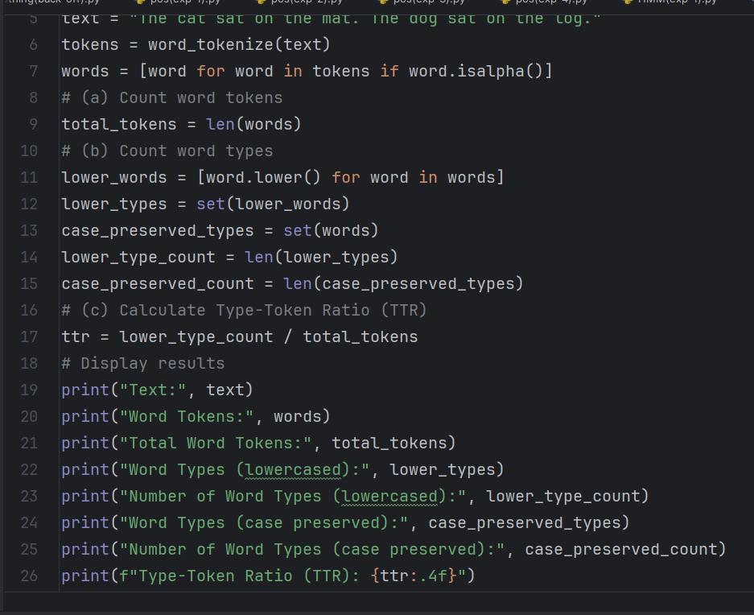

Output :
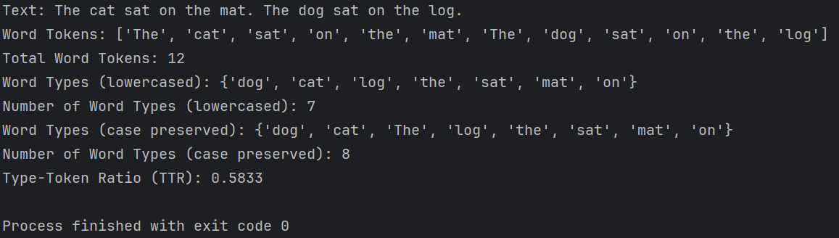

(d) Type-Token-Ratio (TTR) decreases as text length increases, so it is not directly comparable across texts of very different lengths.

Q2. Tokenizing a Social-Media Post [Intermediate | 5 marks] Scenario: A sentiment-analysis team receives this post: "OMG!! Can't wait for #NLP2026 @IITM :) Tickets cost $4.5k, e-mail me at ravi@example.com". Their first tokenizer simply splits on whitespace.
(a) List at least four tokens produced by whitespace splitting that are clearly wrong or unhelpful. (b) Propose a better token list, handling hashtags, mentions, emoticons, currency amounts, e-mail addresses and punctuation.
(c) Should "Can't" be kept whole or split? Justify with the Penn Treebank convention.
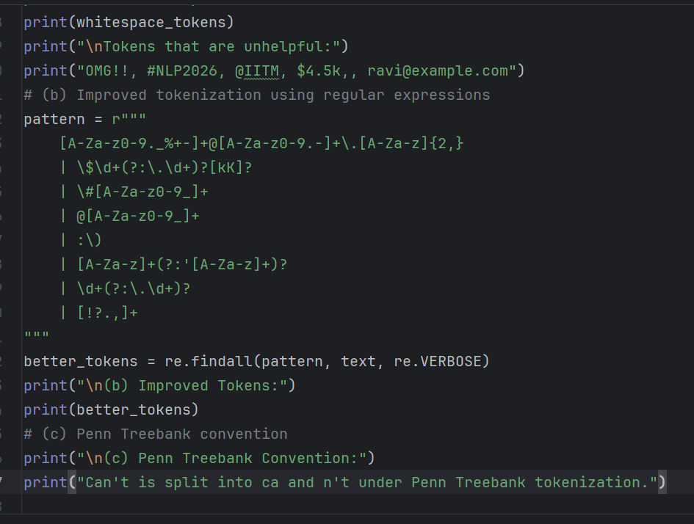
Output :
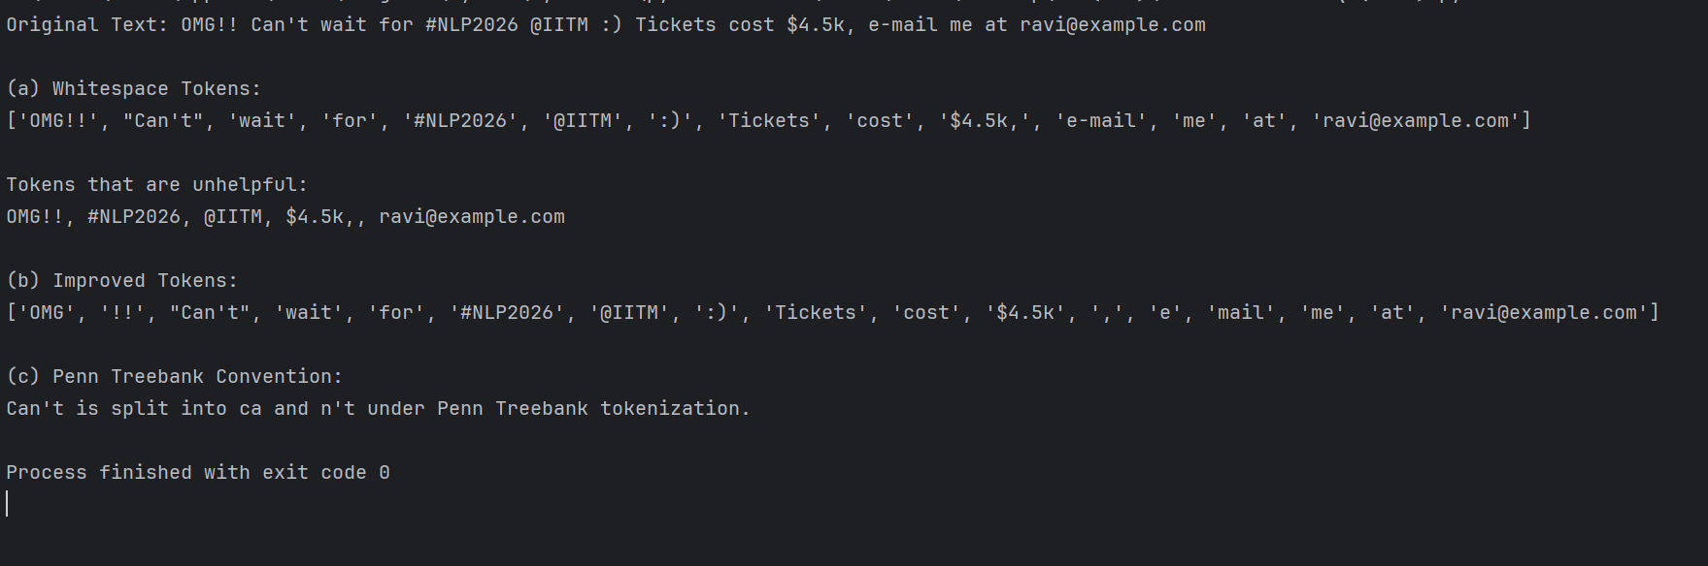

Q3. Query Normalisation in a Search Engine [Intermediate | 5 marks] Scenario: A library search engine indexes the words running, ran, runs, runner and runners. Users complain that a query for "run" misses relevant books.
(a) Which of these words share the lemma "run"?
(b) What would the Porter stemmer output for each word?
(c) Which technique (stemming or lemmatization) gives higher recall, and which gives higher precision? What extra input does a lemmatizer need?

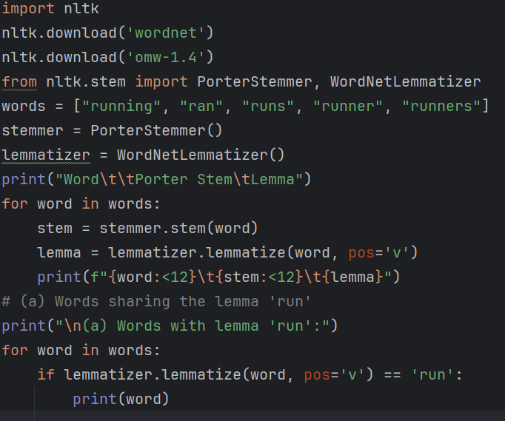

Output :
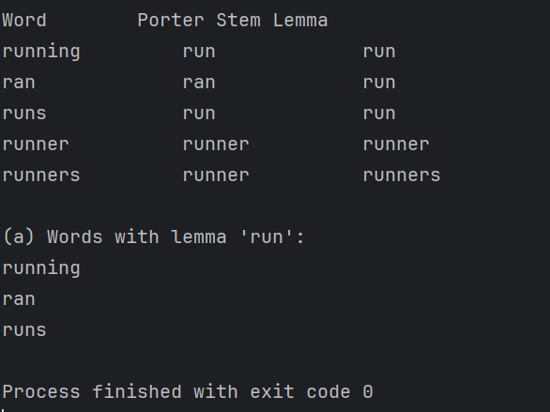

( c )
Stemming generally gives higher recall. Lemmatization generally gives higher precision. A lemmatizer needs the correct part of speech (POS).

Q4. Zipf's Law in a Customer-Review Corpus [Intermediate | 4 marks] Scenario: A 2-million-token review corpus has "the" as its most frequent word with 120,000 occurrences. The vocabulary has 50,000 types. Assume Zipf's law f = k / r.
(a) Estimate the frequency of the words ranked 2nd, 10th and 100th.
(b) Estimate the frequency of the word ranked 50,000th.
(c) What does this long tail mean for a model trained on this corpus
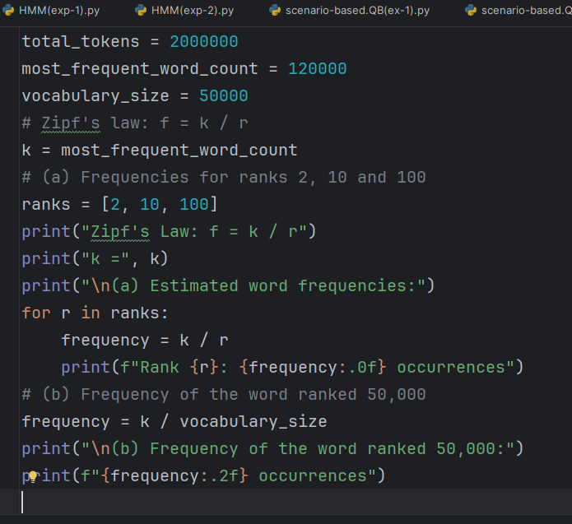

Output :
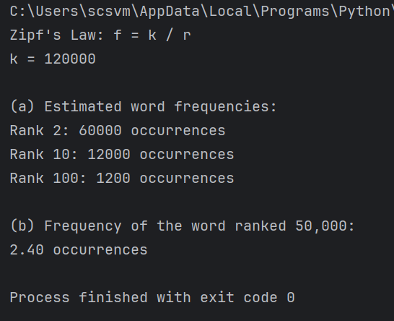
Q5. Code-Mixed Customer Chat [Advanced | 6 marks] Scenario: A customer-support bot in India receives: "Kal ka meeting cancel ho gaya, please reschedule it by Friday." The text is romanised Hindi mixed with English.
(a) Label each token as Hindi (HI) or English (EN).
(b) Give two reasons why standard English word analysis fails on this input.
(c) Outline a preprocessing pipeline that could handle it.
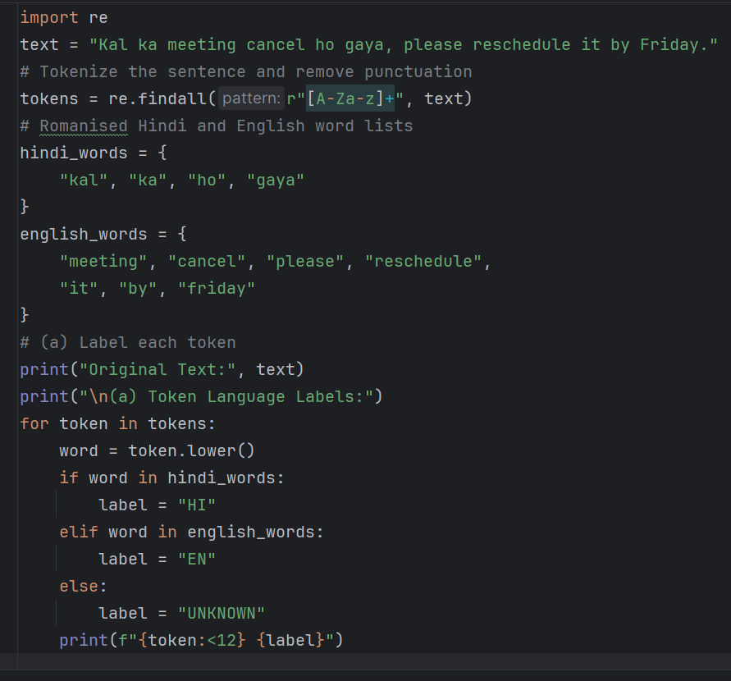

Output :
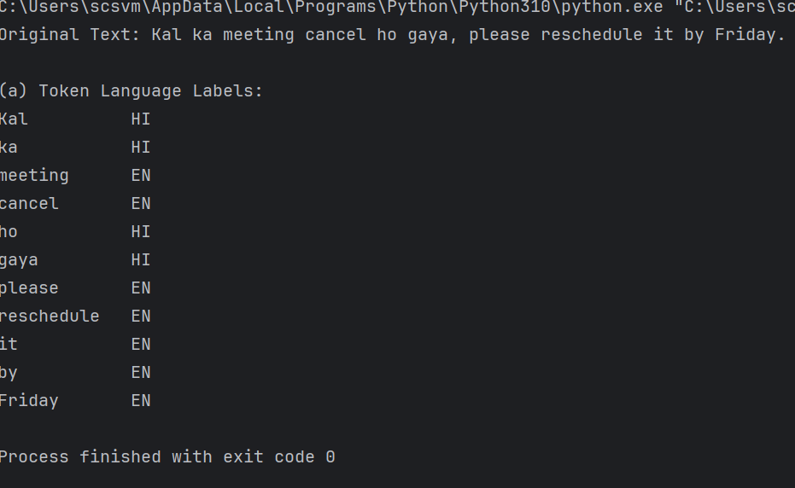

(b) Why standard English analysis fails:
1. Romanised Hindi words are not recognised correctly.
2. Hindi grammar and word meanings differ from English.

(c) Preprocessing Pipeline:
1. Clean text and remove unnecessary symbols.
2. Tokenize the mixed-language sentence.
3. Detect the language of each token.
4. Normalize romanised Hindi spellings.
5. Apply Hindi and English linguistic analysis.
6. Use a code-mixed model for the final task.

UNIT-02
Q6. Plural Generator for an E-Commerce Catalogue [Basic | 4 marks] Scenario: An e-commerce site auto-generates product headings such as "12 ___". The generator receives a lemma and the feature +PL. Input Your output box + PL ? city + PL ? child + PL ? boy + PL ? bus + PL ? knife + PL ?
(a) Generate the plural surface form for each input.
(b) Which forms come from a general rule and which need a lexicon of exceptions?

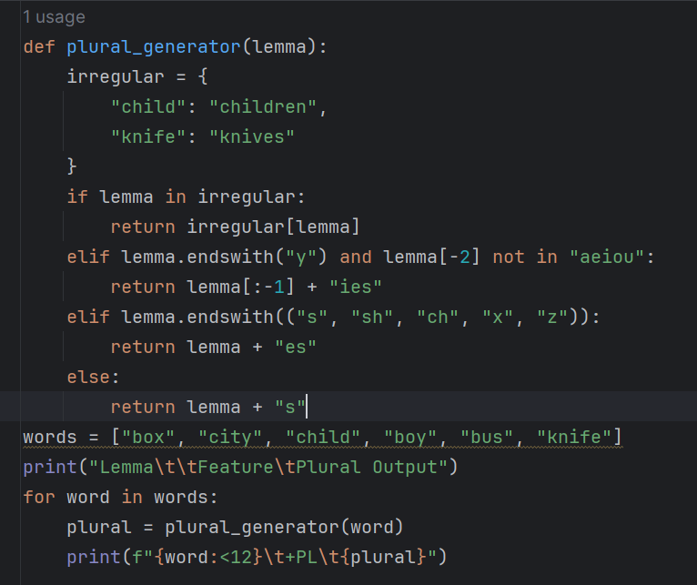
Output :
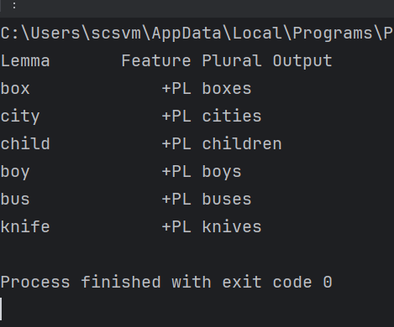

Q7. Verb Forms for a Grammar-Correction Tool [Intermediate | 5 marks] Scenario:
A grammar tool must generate the correct verb form from a lemma and a morphological tag. Lemma + tag Meaning of tag write + VBD past tense write + VBN past participle stop + VBG present participle study + VBZ 3rd person singular present die + VBG present participle play + VBD past tense
(a) Generate the surface form for each row.
(b) Name the orthographic rule involved in stop → ?, study → ?, and die → ?.
(c) How would you combine an irregular-forms table with rules?

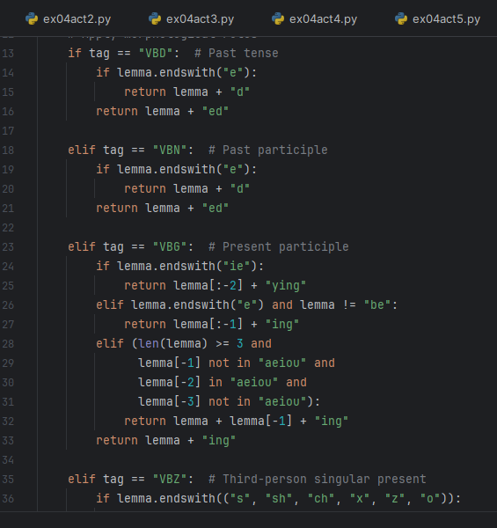

Output:
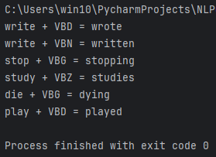

(b) Output:
- write + VBD = wrote
- write + VBN = written
- stop + VBG = stopping
- study + VBZ = studies
- die + VBG = dying
- play + VBD = played
(c) Orthographic Rules:
- stop → stopping: Final consonant doubling rule. The final consonant 'p' is doubled before adding '-ing'.
- study → studies: Consonant + 'y' changes to 'ies' before adding the third-person singular suffix.
- die → dying: The final 'ie' changes to 'y' before adding '-ing'.
(d) Combining an Irregular-Forms Table with Rules:
First, check an irregular-forms dictionary for the given lemma and morphological tag. If the form exists, return it. Otherwise, apply the appropriate morphological rules to generate the surface form.
For example, write + VBD returns 'wrote' from the irregular-forms table, while play + VBD returns 'played' using the regular past-tense rule.
This hybrid approach handles irregular verbs through dictionary lookup and regular verbs through rule-based generation.

Q8. Finite-State Transducer for English Plurals [Advanced | 6 marks] Scenario:
A team is building a two-level (lexical / surface) morphological generator. The lexical form is fox+N+PL. An intermediate tape writes morpheme boundaries, for example fox^s#.
(a) Write the intermediate form for cat+N+PL and fox+N+PL.
(b) State the e-insertion rule in transducer notation.
(c) Apply the rule to get the surface forms of fox, cat, church, wish and boy (all plural).
(d) Why can the same transducer be run in reverse for analysis?

(a) Intermediate forms:
- cat+N+PL → cat^s#
- fox+N+PL → fox^s#
(b) E-insertion rule in transducer notation:
Insert 'e' between sibilant sounds and the plural suffix 's'.
Rule: ∅ → e / {s, z, ʃ, ʒ, tʃ, dʒ} _ s
Here, ∅ represents an empty symbol, and the rule inserts 'e' before the plural suffix 's' after a sibilant sound.
(c)
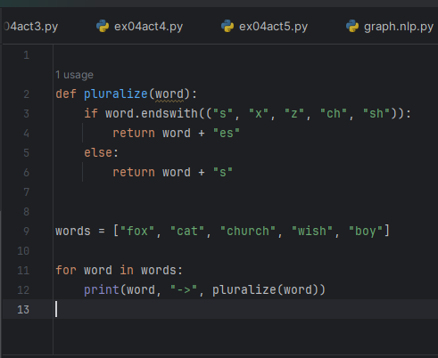
Output :
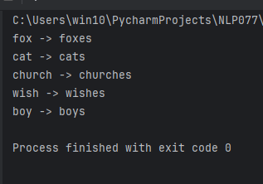
(d) Reverse transducer for analysis:
The same transducer can be run in reverse because a finite-state transducer maps lexical forms to surface forms and can also map surface forms back to lexical forms. In reverse mode, it takes a surface form as input and identifies the corresponding lexical form and morphological tags. For example, 'foxes' can be analyzed as fox+N+PL.

Q9. Tamil Noun Forms for an e-Governance Chatbot [Intermediate | 5 marks]
Scenario: A Tamil e-governance chatbot must generate noun forms. Consider the noun மமமம (maram, "tree") with the plural form மமமமமமம (maraṅgaḷ) and the accusative form மமமமமம (marattai).
(a) Which part of the stem changes before the plural suffix and before the case suffix?
(b) Predict the surface form for "tree + PL + ACC" and give its meaning.
(c) Explain why a rule-based generator for Tamil needs paradigm classes and sandhi rules.

(a) Stem changes:
Before the plural suffix, the noun stem changes from maram to maraṅg- to form maraṅgaḷ. Before the accusative case suffix, the final m changes to tt, forming marattai.
(b) Surface form and meaning:
Tree + PL + ACC → மரங்களை (maraṅgaḷai) Meaning: Trees (as the objects of an action).
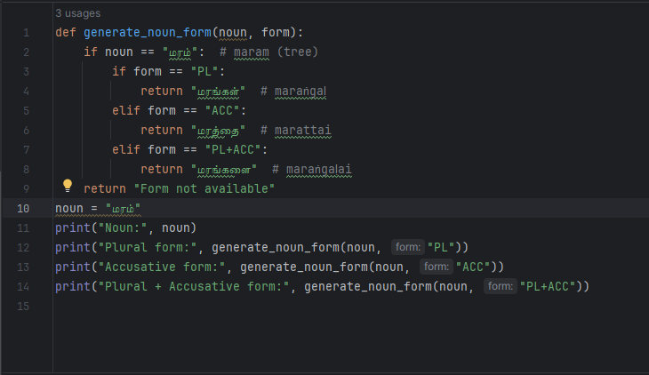
Output:
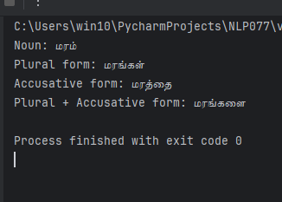
(c) Need for paradigm classes and sandhi rules:
A rule-based generator for Tamil needs paradigm classes because different nouns undergo different stem changes when plural and case suffixes are added. Sandhi rules are required to handle sound changes and combinations at morpheme boundaries. These rules help generate grammatically correct Tamil noun forms.

Q10. Derivational Word Generator for Brand Names [Intermediate | 5 marks]
Scenario: A marketing tool generates new words by attaching affixes: un-, re-, -able, -ness, ment, -ize. The team notices that it sometimes produces nonsense such as "employness".
(a) Generate valid words for: un + lock + able; happy + ness; employ + ment; modern + ize; re + write + ing.
(b) Why are "employness" and "unhappyable" rejected? State the constraint.
(c) The word "unlockable" is ambiguous. Explain how.
(d) Suggest a simple filter for the tool.

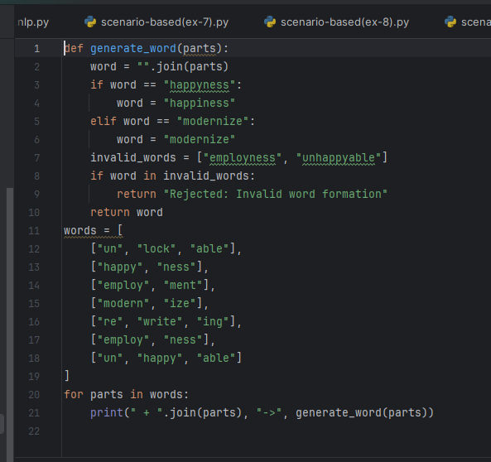
Output :
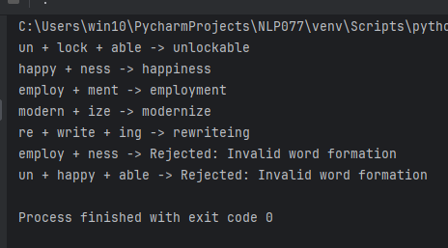

(b) Why are “employness” and “unhappyable” rejected?
They violate morphological selectional restrictions. Affixes can attach only to certain grammatical categories or stems. For example, -ness commonly attaches to adjectives, so happy + ness becomes happiness, while employ + ness is not a standard English derivation.

(c) Why is “unlockable” ambiguous?
“Unlockable” has two possible interpretations:
- Able to be unlocked — something that can be unlocked.
- Not lockable — something that cannot be locked.
The ambiguity arises because the prefix un- can express negation or reversal, depending on how the word is analyzed.

(d) Suggest a simple filter
A simple filter can check the base word's grammatical category, verify whether an affix is permitted for that category, apply spelling rules, and compare the generated word against a dictionary or list of valid words. This helps reject invalid combinations before displaying them.

Unit 3: Morphology
NLP Scenario-Based Question Bank Morphemes, inflection vs derivation, stemmer errors, agglutinative languages and ambiguity.
Q11. Morpheme Segmentation for a Spell-Checker [Basic | 5 marks] Scenario: A spell-checker splits words into morphemes to decide which words are valid. Segment the following words and label each morpheme as prefix, root or suffix (and inflectional or derivational). Word unhappiness teachers disestablishment internationalization
(a) Segment each word into morphemes.
(b) State the number of morphemes in each word.
(c) Mark each suffix as inflectional or derivational.
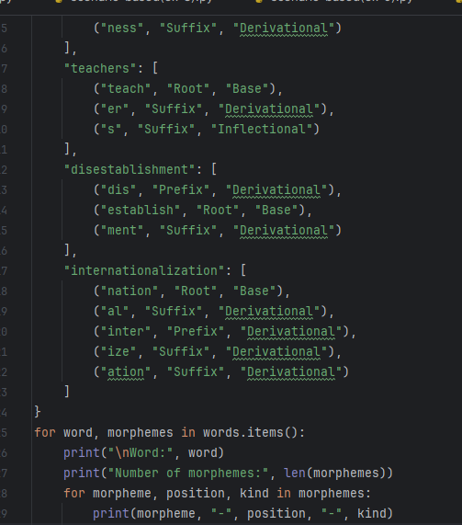

Output :
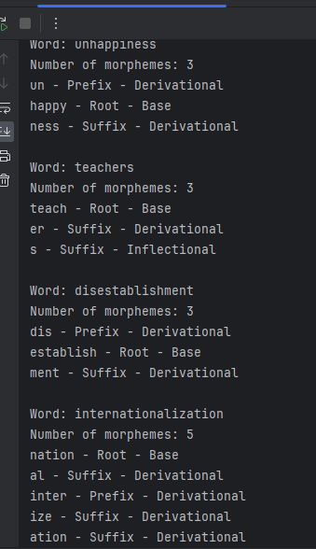
(a)
- Unhappiness: un- + happy + -ness
- Teachers: teach + -er + -s
- Disestablishment: dis- + establish + -ment
- Internationalization: inter- + nation + -al + -ize + -ation
(b) Number of Morphemes
- Unhappiness – 3
- Teachers – 3
- Disestablishment – 3
- Internationalization – 5
(c) Suffix Classification
- Unhappiness: -ness – Derivational
- Teachers: -er – Derivational; -s – Inflectional
- Disestablishment: -ment – Derivational
- Internationalization: -al, -ize, -ation – Derivational

Q12. Inflection versus Derivation [Intermediate | 5 marks]
Scenario: A search engine wants to conflate inflectional variants but keep derivational variants separate. The team gets the following word pairs. Base Derived form walk walked teach teacher dog dogs nation national big bigger quick quickly
(a) Classify each pair as inflection or derivation.
(b) For the derivational pairs, state how the part of speech changes.
(c) Which pairs should the search engine conflate? Justify.
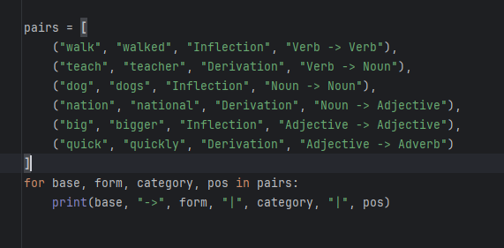

Output :
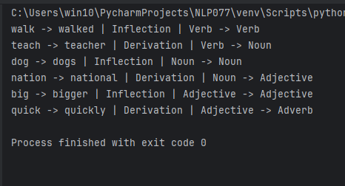
(a) Classification
- walk → walked: Inflection
- teach → teacher: Derivation
- dog → dogs: Inflection
- nation → national: Derivation
- big → bigger: Inflection
- quick → quickly: Derivation
(b) Part-of-speech changes
- teach → teacher: Verb → Noun
- nation → national: Noun → Adjective
- quick → quickly: Adjective → Adverb
(c) Search engine conflation
The search engine should conflate walk/walked, dog/dogs, and big/bigger because they are inflectional variants of the same lexeme. Derivational pairs should remain separate because they may have different meanings or parts of speech.

Q13. Stemmer Errors in Legal Search [Intermediate | 5 marks] Scenario: A legal-document search engine uses the Porter stemmer. Testers report that queries for "university" also retrieve documents about "universe" (a commonly cited overstemming example), while "alumnus" and "alumni" are never matched. (a) Define over-stemming and under-stemming, and classify the two problems above. (b) Explain how each error affects precision and recall. (c) Suggest two remedies.
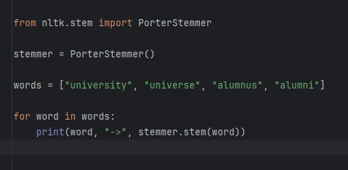
Output :
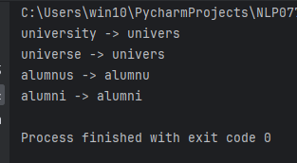

(a) Definitions and classification
- Over-stemming: Unrelated words are reduced to the same stem. University and universe illustrate the reported over-stemming problem.
- Under-stemming: Related words are not reduced to the same stem. Alumnus and alumni illustrate the reported under-stemming problem.
(b) Effects on precision and recall
- Over-stemming reduces precision because irrelevant documents may be retrieved.
- Under-stemming reduces recall because relevant documents may be missed.
(c) Two remedies
- Use a lemmatizer that considers vocabulary and word forms.
- Add domain-specific rules or a dictionary for legal terms and irregular word forms.
Q14. Agglutinative Turkish and Vocabulary Explosion [Advanced | 6 marks] Scenario: A team building a Turkish search engine finds that a word-level vocabulary keeps growing without bound. One example word is evlerimizden, meaning "from our houses". (a) Segment evlerimizden into morphemes and gloss each one. (b) Why does an agglutinative language cause a much larger word-level vocabulary than English? (c) Propose a subword or morphology-aware alternative.
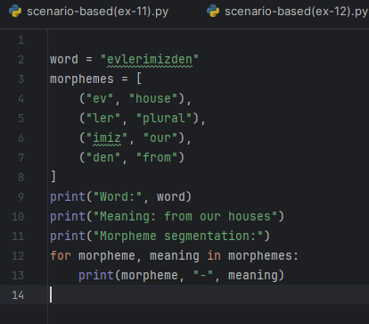
Output :
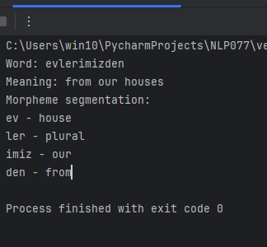
(a) Morpheme segmentation
ev + ler + imiz + den
- ev: house (root)
- ler: plural suffix
- imiz: our (possessive suffix)
- den: from (case suffix)
(b) Vocabulary explosion
Turkish is agglutinative, so many suffixes can be attached to a root to express grammatical meanings. This creates numerous word forms, increasing the word-level vocabulary compared with English.
(c) Alternative
Use subword tokenization, such as BPE or WordPiece, or a morphology-aware analyzer to split words into roots and affixes. This reduces vocabulary size and helps recognize related word forms.

Q15. Ambiguous Analyses from a Morphological Analyzer [Intermediate | 5 marks] Scenario: A morphological analyzer returns all possible analyses for each surface form. A developer inspects the words flies, saw and leaves. (a) Give at least two analyses (lemma + POS + features) for each word. (b) In "Time flies like an arrow", which analysis of "flies" is correct? (c) Which downstream component resolves the ambiguity?
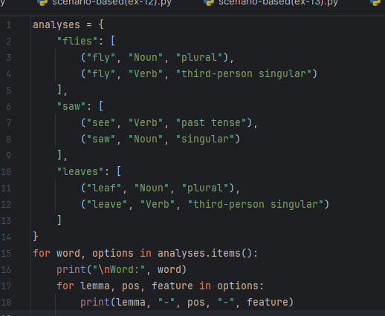
Output :
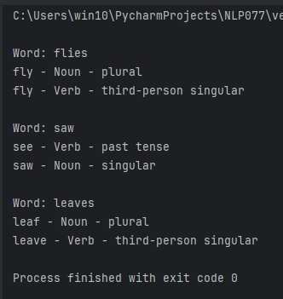
(a) Possible analyses
- Flies
  - fly + Noun + Plural
  - fly + Verb + Present, third-person singular
- Saw
  - see + Verb + Past tense
  - saw + Noun + Singular
- Leaves
  - leaf + Noun + Plural
  - leave + Verb + Present, third-person singular
(b) Correct analysis in “Time flies like an arrow”
“Flies” is a verb meaning moves quickly, with “time” as its subject.
(c) Component that resolves ambiguity
A part-of-speech tagger or contextual disambiguation component uses sentence context to select the correct analysis.

Unit 4: N-Grams
Q16. Building a Bigram Model [Basic | 6 marks] Scenario: A student trains a bigram language model with maximum-likelihood estimation on the four-sentence corpus shown above. (a) Give the unigram counts of <s>, I, love and NLP. (b) Give all bigram counts that begin with I and with love. (c) Compute P(I | <s>), P(love | I), P(NLP | love) and P(</s> | NLP). (d) Compute P(<s> I love NLP </s>).
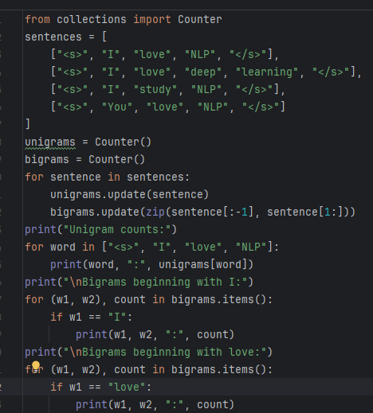

Output :
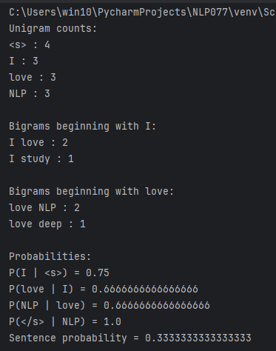
(a) Unigram counts
- <s> = 4
- I = 3
- love = 3
- NLP = 3
(b) Bigram counts
- Beginning with I: (I, love) = 2; (I, study) = 1
- Beginning with love: (love, NLP) = 2; (love, deep) = 1
(c) Bigram probabilities
- P(I | <s>) = 3/4 = 0.75
- P(love | I) = 2/3 = 0.667
- P(NLP | love) = 2/3 = 0.667
- P(</s> | NLP) = 3/3 = 1
(d) Sentence probability
P(<s> I love NLP </s>) = 0.75 × 0.667 × 0.667 × 1 = 0.3333

Q17. Comparing Two Candidate Sentences [Intermediate | 5 marks] Scenario: A speech-recognition system must choose between two hypotheses using the bigram model from the corpus above: (A) "I love NLP" and (B) "I love deep learning". (a) Compute P(A) and P(B), including <s> and </s>. (b) Which sentence does the model prefer? Why is comparing sentences of different lengths problematic? (c) Compute the perplexity of sentence A (N = 4 tokens including </s>).

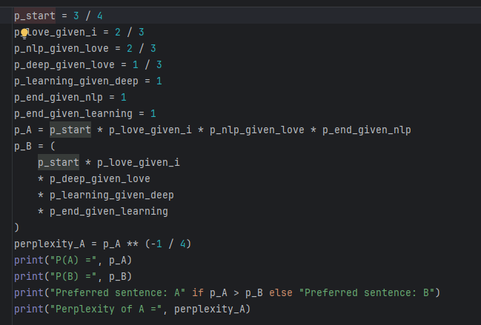

Output :
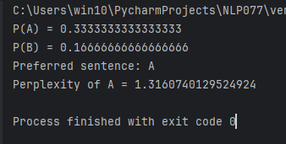
(a) Sentence probabilities
- A: I love NLP = 3/4 × 2/3 × 2/3 × 1 = 1/3
- B: I love deep learning = 3/4 × 2/3 × 1/3 × 1 × 1 = 1/6
(b) Preferred sentence
The model prefers sentence A because its probability is higher. Comparing different-length sentences using raw probabilities is problematic because longer sentences generally receive smaller probabilities.
(c) Perplexity of A
PP(A) = P(A)^(-1/N)
= (1/3)^(-1/4)
= 1.316 (approximately)

Q18. The Zero-Probability Problem [Intermediate | 4 marks] Scenario: The same bigram model is tested on the perfectly grammatical sentence "You study NLP". A separate keyboard app also uses the model to predict the word after "I love". (a) Compute P(<s> You study NLP </s>) and explain the result. (b) What does the model predict after the history "love"? Give the probabilities. (c) Name the general technique needed to fix the first problem.
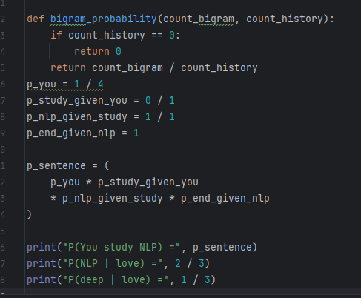
Output :
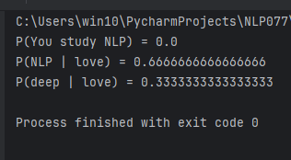

(a) Sentence probability
P(<s> You study NLP </s>) = 1/4 × 0 × 1 × 1 = 0
The probability is zero because the bigram (You, study) does not occur in the training corpus.
(b) Prediction after love
- P(NLP | love) = 2/3
- P(deep | love) = 1/3
The model predicts NLP as the most likely next word.
(c) Solution
Use smoothing, such as Laplace (add-one) smoothing, to assign nonzero probabilities to unseen bigrams.
Q19. Model Size and Data Sparsity on a Phone [Intermediate | 5 marks] Scenario: A phone keyboard has a vocabulary of 20,000 words and is trained on 10 million tokens. The team debates using bigrams or trigrams. (a) How many possible bigrams and trigrams exist? (b) What is the maximum fraction of possible trigrams that can appear in the training data? (c) Discuss the trade-off between bigram and trigram models for this device.
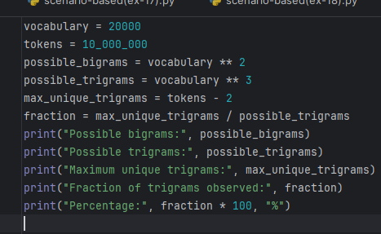
Output :
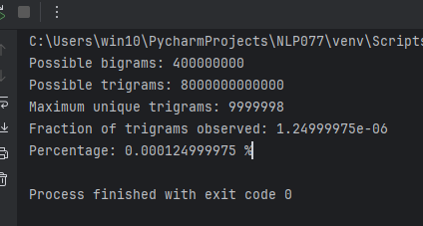
(a) Possible n-grams
- Bigrams = 20,000² = 400,000,000
- Trigrams = 20,000³ = 8,000,000,000,000
(b) Maximum fraction of trigrams
Maximum distinct trigram occurrences = 10,000,000 − 2 = 9,999,998.
Fraction ≈ 9,999,998 / 8,000,000,000,000
≈ 0.00000125, or approximately 0.000125%.
(c) Trade-off
Bigrams require less memory and have less data sparsity but capture only one previous word. Trigrams use two previous words and capture more context, but require more memory and suffer from greater data sparsity.

Q20. Underflow and Language Identification [Advanced | 5 marks] Scenario: An engineer scores a 100-word sentence with a bigram model where each conditional probability is about 10⁻ ⁴. The program prints 0.0. Separately, the team wants to detect whether a short message written in Roman script is English, Hindi or Tamil. (a) Why does the program output 0.0? (b) Show how to compute the score in log space and give the approximate value. (c) Which n-gram unit (word or character) suits the language-identification task, and why?
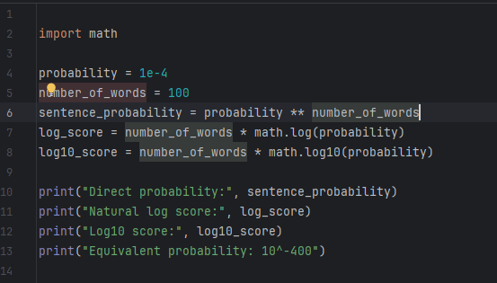
Output :
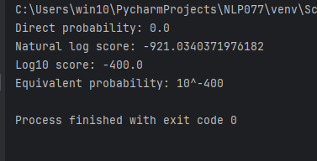

(a) Why does the program output 0.0?
Multiplying many small probabilities causes numerical underflow. The probability (10⁻⁴)¹⁰⁰ = 10⁻⁴⁰⁰ is too small to be represented by standard floating-point numbers.
(b) Log-space computation
Log P = 100 × log(10⁻⁴)
Natural log score = −921.03 (approximately).
Base-10 log score = −400.
Log-space computation adds log probabilities instead of multiplying tiny probabilities.
(c) Suitable n-gram unit
Character n-grams are suitable because English, Hindi and Tamil written in Roman script often have different character sequences and spelling patterns. Character n-grams can identify these patterns even in short messages or unfamiliar words.

Unit 5: N-Gram Smoothing
Q21. Laplace Smoothing of an Unseen Bigram [Basic | 5 marks] Scenario: The bigram model gives "You study NLP" probability zero. The team applies addone (Laplace) smoothing: P(w | v) = (C(v w) + 1) / (C(v) + V). (a) Compute the smoothed P(You | <s>), P(study | You), P(NLP | study) and P(</s> | NLP). (b) Compute the smoothed probability of <s> You study NLP </s>.
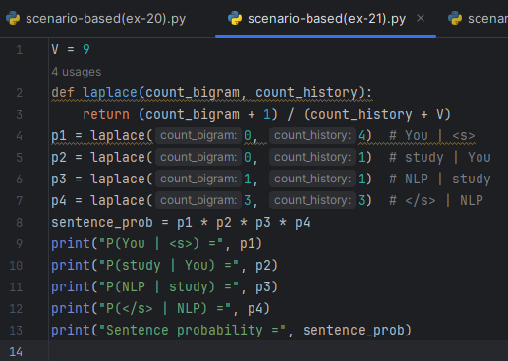
Output :
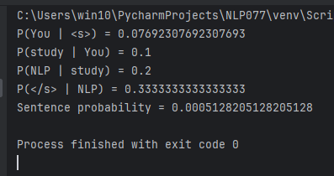
(a) Smoothed probabilities
- P(You | <s>) = 1/13 = 0.0769
- P(study | You) = 1/10 = 0.1
- P(NLP | study) = 2/10 = 0.2
- P(</s> | NLP) = 4/12 = 0.3333
(b) Sentence probability
P(<s> You study NLP </s>) = (1/13) × (1/10) × (2/10) × (4/12)
= 1/1950 ≈ 0.000513

Q22. How Much Mass Does Laplace Steal? [Intermediate | 5 marks] Scenario: A reviewer says add-one smoothing changes the probabilities of seen events too much. Examine the history "I". (a) Compare P(love | I) before and after add-one smoothing. (b) How much total probability is assigned to unseen words after "I"? (c) Recompute P(love | I) and P(study | You) with add-k, k = 0.1, and comment.
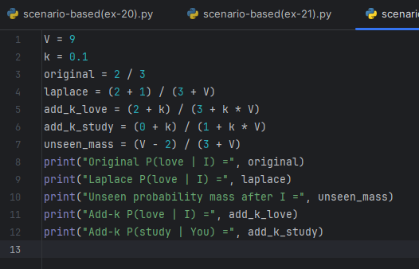

Output :
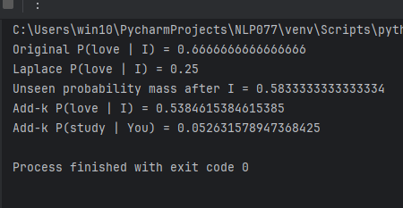
(a) P(love | I)
- Before smoothing = 2/3 = 0.6667
- After Laplace smoothing = 3/12 = 0.25
(b) Probability mass assigned to unseen words
There are 7 unseen continuations after I.
Total unseen mass = 7/12 = 0.5833.
(c) Add-k smoothing, k = 0.1
- P(love | I) = 2.1/3.9 = 0.5385
- P(study | You) = 0.1/1.9 = 0.0526
Add-k smoothing with a small k changes seen probabilities less than add-one smoothing.

Q23. Good-Turing Discounting [Advanced | 6 marks] Scenario: A researcher applies Good-Turing smoothing to the bigram counts of the corpus. There are 11 distinct bigram types and 17 bigram tokens in total. Let N_c be the number of bigram types that occur exactly c times. (a) Compute N₁ , N₂ and N₃ . (b) Estimate the total probability mass reserved for unseen bigrams. (c) Compute the adjusted counts c*(1) and c*(2) using c* = (c+1) N(c+1) / N(c). (d) Why can c*(3) not be computed here, and how is it fixed?
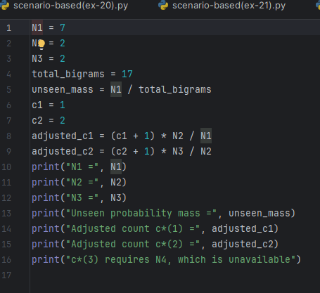
Output :
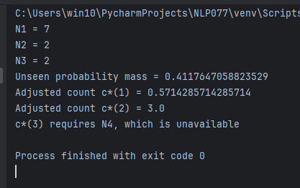

(a) Frequency of frequencies
- N₁ = 7
- N₂ = 2
- N₃ = 2
(b) Probability mass for unseen bigrams
P(unseen) = N₁/N = 7/17 = 0.4118.
(c) Adjusted counts
Using c* = (c + 1)N(c + 1)/N(c):
- c*(1) = 2 × 2/7 = 0.5714
- c*(2) = 3 × 2/2 = 3
(d) Why c(3) cannot be computed*
c*(3) requires N₄, the number of bigram types occurring four times. N₄ is zero in this corpus, so the formula cannot be applied directly. In practice, frequency smoothing or a fitted Good-Turing estimate is used.

Q24. Interpolation and Backoff [Intermediate | 5 marks] Scenario: A team wants a smoothed model that combines bigram and unigram evidence. The unigram probability is P(w) = C(w)/17. They compare linear interpolation (λ = 0.7 for bigram, 0.3 for unigram) with stupid backoff (factor 0.4). (a) Compute the interpolated P(love | I) and P(study | You). (b) Compute the stupid-backoff score S(study | You) and S(love | I). (c) How should λ be chosen? Why is stupid backoff not a true probability?
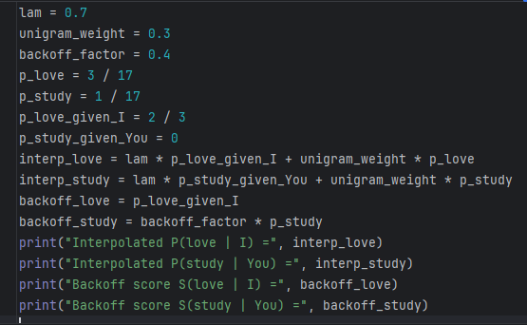
Output :
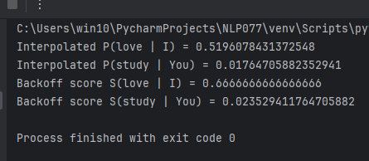
(a) Linear interpolation
Formula: P(w | h) = 0.7P(w | h)bigram + 0.3P(w)unigram
- P(love | I) = 0.7(2/3) + 0.3(3/17) = 0.5196
- P(study | You) = 0.7(0) + 0.3(1/17) = 0.0176
(b) Stupid backoff
- S(study | You) = 0.4 × (1/17) = 0.0235
- S(love | I) = 2/3 = 0.6667
(c) Choosing λ
Choose λ using validation data to achieve the best language-model performance. Stupid backoff is not a true probability model because its scores are not normalized to sum to 1.

Q25. Why "Francisco" Should Not Follow "reading" [Advanced | 5 marks] Scenario: A predictive-text system completes "I can't see without my reading ___". With interpolated unigram backoff it suggests "Francisco", because "Francisco" is a frequent word in the training data (almost always after "San"). A colleague recommends Kneser-Ney smoothing. (a) Why does the plain unigram probability give the wrong answer? (b) Define the continuation probability used by Kneser-Ney. (c) Which word will Kneser-Ney prefer, "glasses" or "Francisco", and why? (d) How would you handle words never seen in training?
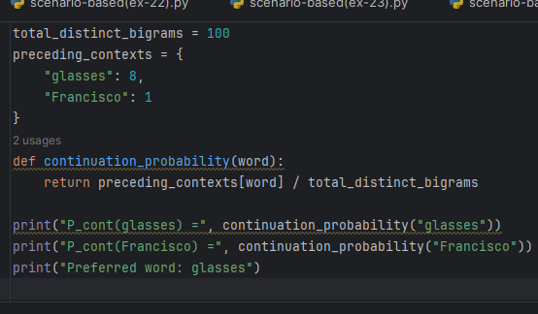
Output :
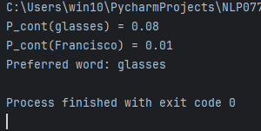
(a) Why does the unigram probability give the wrong answer?
Francisco may be frequent overall because it often follows San. Plain unigram probability ignores the diversity of contexts in which a word occurs.
(b) Kneser-Ney continuation probability
P_cont(w) = Number of distinct words preceding w / Total number of distinct bigrams.
(c) Preferred word
Kneser-Ney prefers glasses because it can occur after many different words, whereas Francisco mostly follows San.
(d) Handling unseen words
Use an <UNK> token for unknown words and apply smoothing. Character or subword models can also help handle words absent from training.

Unit 6: POS Tagging: Hidden Markov Model
Q26. Training an HMM Tagger from a Tagged Corpus [Basic | 5 marks] Scenario: A linguist hands a startup a tiny tagged corpus (tags: D = determiner, N = noun, V = verb). Words are lowercased. # Tagged sentence 1 the/D dog/N barks/V 2 a/D cat/N sleeps/V 3 dogs/N bark/V 4 the/D cat/N chases/V the/D dog/N (a) Compute the transition probabilities P(D | <s>), P(N | D), P(V | N) and P(</s> | V). (b) Compute the emission probabilities P(the | D), P(cat | N) and P(barks | V). (c) State the two assumptions that make the HMM tractable.
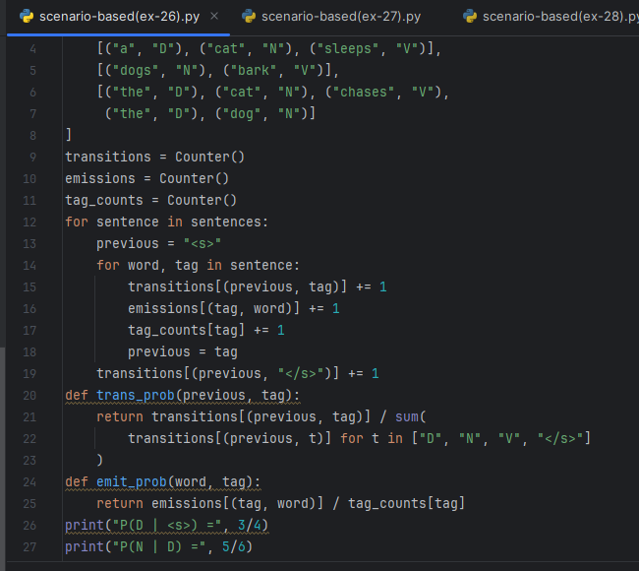

Output :
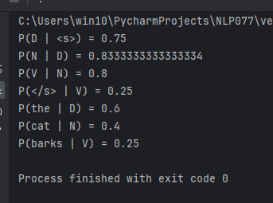
(a) Transition probabilities
- P(D | <s>) = 3/4 = 0.75
- P(N | D) = 5/6 = 0.8333
- P(V | N) = 4/5 = 0.8
- P(</s> | V) = 1/4 = 0.25
(b) Emission probabilities
- P(the | D) = 3/5 = 0.6
- P(cat | N) = 2/5 = 0.4
- P(barks | V) = 1/4 = 0.25
(c) HMM assumptions
- Markov assumption: the current tag depends only on the previous tag.
- Emission assumption: the current word depends only on its current tag.
Q27. Joint Probability of Competing Tag Sequences [Intermediate | 5 marks] Scenario: A production HMM has the parameters below (omitted words have probability 0 for that tag). It must tag "the dog barks". Consider the candidate sequences D N V and D N N. Transitions D N from <s> V 0.6 0.3 from D 0.1 0.05 0.90 from N 0.05 0.2 0.2 from V 0.6 0.6 0.3 0.1 (a) Emissions: P(the | D) = 0.7; P(dog | N) = 0.3, P(dog | V) = 0.01; P(barks | N) = 0.1, P(barks | V) = 0.2. Compute P(words, D N V). (b) Compute P(words, D N N). (c) Which tag sequence is preferred, and by what factor?
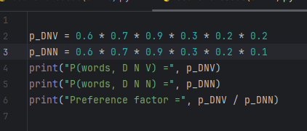
Output :
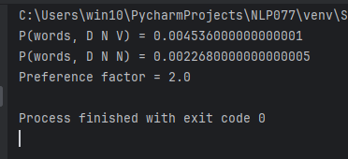
(a) Probability of D N V
P(words, D N V) = 0.6 × 0.7 × 0.9 × 0.3 × 0.2 × 0.2
= 0.004536
(b) Probability of D N N
P(words, D N N) = 0.6 × 0.7 × 0.9 × 0.3 × 0.2 × 0.1
= 0.002268
(c) Preferred sequence
D N V is preferred because its joint probability is 2 times that of D N N.
Q28. Running the Viterbi Algorithm [Advanced | 8 marks] Scenario: Using the same HMM and emissions as the previous question, run Viterbi on "the dog barks". The tag set is {D, N, V}; there is no end-of-sentence transition to include. (a) Compute δ₁ (D), δ₁ (N), δ₁ (V) for "the". (b) Compute δ₂ for "dog" for all three tags and record the back-pointers. (c) Compute δ₃ for "barks" for all three tags. (d) Backtrack to find the best tag sequence and its probability.
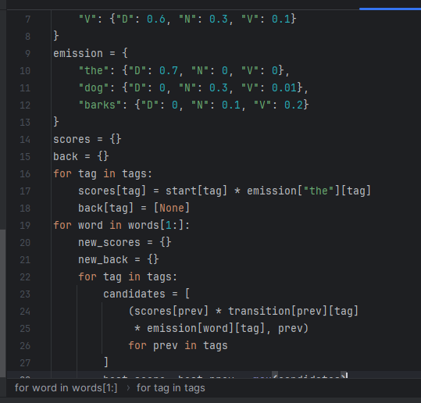
Output :
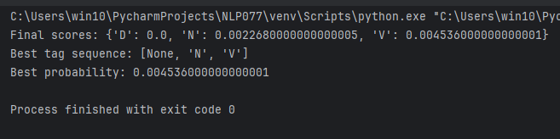
(a) Initial probabilities
- δ₁(D) = 0.6 × 0.7 = 0.42
- δ₁(N) = 0
- δ₁(V) = 0
(b) Second word: dog
- δ₂(N) = 0.42 × 0.9 × 0.3 = 0.1134
- δ₂(V) = 0.42 × 0.05 × 0.01 = 0.00021
- δ₂(D) = 0
Back-pointers: N ← D, V ← D.
(c) Third word: barks
- δ₃(V) = max(0.1134 × 0.2 × 0.2, 0.00021 × 0.1 × 0.2) = 0.004536
- δ₃(N) = max(0.1134 × 0.2 × 0.1, 0.00021 × 0.3 × 0.1) = 0.002268
- δ₃(D) = 0
(d) Best sequence
The best sequence is D N V, with probability 0.004536.
Q29. Why Viterbi Instead of Brute Force? [Intermediate | 4 marks] Scenario: A developer proposes to tag sentences by scoring every possible tag sequence. The Penn Treebank tag set has 45 tags and a typical sentence has 20 words. Page 12 NLP Scenario-Based Question Bank (a) How many tag sequences must be scored by brute force? (b) How many operations does Viterbi need (order of magnitude, O(N·T²))? (c) Which property of the HMM lets dynamic programming work?
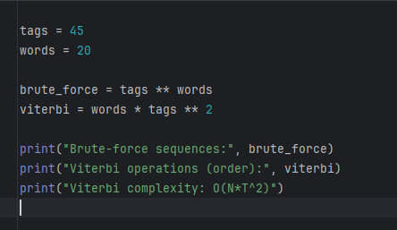
Output :
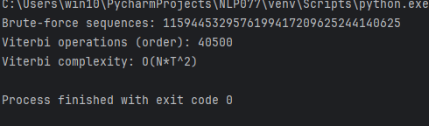
(a) Brute-force sequences
45²⁰ ≈ 1.15 × 10³³ possible tag sequences.
(b) Viterbi operations
N × T² = 20 × 45² = 40,500 operations (order of magnitude).
(c) HMM property
The Markov assumption allows the best path to be computed using dynamic programming, reusing the best scores for previous states.

Q30. Unknown Words and Model Limitations [Advanced | 6 marks] Scenario: A deployed HMM tagger (trained on the tiny corpus above) receives "the cats chase the dog" and gives no tag sequence at all. It also mis-tags "Time flies like an arrow".
(a) Why does the word "cats" break the tagger?
(b) Suggest two ways to handle unknown words.
(c) Name two limitations of an HMM tagger and suggest one alternative model.
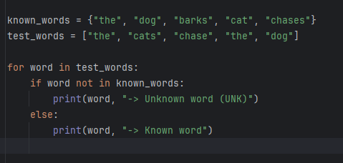
Output :
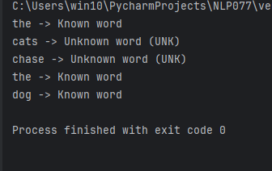
(a) Why does cats break the tagger?
The word cats was not observed during training, so its emission probability may be zero for every tag.
(b) Two methods for unknown words
- Use an <UNK> token and smoothing.
- Use suffixes, capitalization, prefixes, and word-shape features to estimate likely tags.
(c) Limitations and alternative:HMMs use limited previous-tag context and assume words depend only on their current tags. They also struggle with unseen words and sparse data.
An alternative is a Conditional Random Field (CRF) or a BiLSTM-based tagger, which can use richer contextual information.
Name : Dandhu Likitha
yr/Sec: 3rd/s2
reg.no : 11249a075
Sub: Natural Language Processing
Date : 9.10.26

