Mini Project
Air Quality Index Monitoring
India — 30th April 2025

Submitted By
Name : K Harish
Reg No: 11249A125
CSE Department | Section S5
R-Programming Lab
SCSVMV UNIVERSITY

1. Aim
The aim of this study is to monitor and analyse the Air Quality Index (AQI) across various cities in India using real-time pollution data collected from monitoring stations. By examining AQI values and predominant pollutants, this analysis seeks to identify pollution levels, classify air quality categories, and derive insights that can support environmental decision-making and public health awareness.

2. Scenario
India's rapid urbanization and industrial growth have resulted in significant air pollution across urban and semi-urban areas. Monitoring air quality is crucial to protect public health and enforce environmental regulations. The Central Pollution Control Board (CPCB) deploys monitoring stations across Indian states to measure pollutants such as PM2.5, PM10, O3, NO2, CO, and others.
In this scenario, data has been collected from 19 cities across 11 Indian states on 30th April 2025. Each record includes the state and city of measurement, the number of active monitoring stations, the predominant pollutant parameter detected, the calculated AQI value, and the resulting AQI category (Good, Satisfactory, or Moderate).
The AQI categories used in this dataset are defined as follows:
Good (0–50): Air quality is satisfactory and poses little or no risk.
Satisfactory (51–100): Acceptable air quality; some pollutants may be a concern for a small number of sensitive individuals.
Moderate (101–200): Members of sensitive groups may experience health effects; general public is unlikely to be affected.

3. Sample Dataset
The following table presents AQI monitoring data collected from 19 Indian cities on 30th April 2025. The dataset includes the number of monitoring stations, predominant pollutant parameter, AQI index value, and air quality category for each location.
Date | State | City | No. of Stations | Predominant Parameter | AQI Value | AQI Category
30-04-2025 | Assam | Nalbari | 1 | PM10 | 39 | Good
30-04-2025 | Karnataka | Hubballi | 1 | PM10 | 46 | Good
30-04-2025 | Gujarat | Ahmedabad | 8 | PM2.5,PM10 | 110 | Moderate
30-04-2025 | Uttarakhand | Dehradun | 1 | PM10 | 114 | Moderate
30-04-2025 | Tamil Nadu | Vellore | 1 | PM10 | 51 | Satisfactory
30-04-2025 | Maharashtra | Ulhasnagar | 1 | PM10 | 84 | Satisfactory
30-04-2025 | Tamil Nadu | Chengalpattu | 1 | PM10 | 66 | Satisfactory
30-04-2025 | Andhra Pradesh | Tirupati | 1 | PM2.5 | 47 | Good
30-04-2025 | Tamil Nadu | Dindigul | 1 | PM10 | 99 | Satisfactory
30-04-2025 | Andhra Pradesh | Kadapa | 1 | O3 | 67 | Satisfactory
30-04-2025 | Maharashtra | Thane | 2 | PM10 | 58 | Satisfactory
30-04-2025 | Uttarakhand | Rishikesh | 1 | PM2.5 | 98 | Satisfactory
30-04-2025 | Chhattisgarh | Raipur | 3 | PM10,NO2 | 42 | Good
30-04-2025 | Tamil Nadu | Ranipet | 1 | PM10 | 39 | Good
30-04-2025 | Bihar | Samastipur | 1 | PM10 | 37 | Good
30-04-2025 | Madhya Pradesh | Jabalpur | 3 | PM10,O3 | 75 | Satisfactory
30-04-2025 | Bihar | Kishanganj | 1 | PM10 | 35 | Good
30-04-2025 | Bihar | Saharsa | 1 | CO | 41 | Good
30-04-2025 | Karnataka | Yadgir | 1 | PM2.5 | 107 | Moderate

# ============================================================
# Air Quality Index (AQI) Monitoring - R Program
# Date: 30-04-2025 | Source: CPCB India
# ============================================================
# ------ STEP 1: Dataset ------
cities <- c(
"Nalbari", "Hubballi", "Ahmedabad", "Dehradun", "Vellore",
"Ulhasnagar", "Chengalpattu", "Tirupati", "Dindigul", "Kadapa",
"Thane", "Rishikesh", "Raipur", "Ranipet", "Samastipur",
"Jabalpur", "Kishanganj", "Saharsa", "Yadgir"
) # City names
aqi_values <- c(
39, 46, 110, 114, 51,
84, 66, 47, 99, 67,
58, 98, 42, 39, 37,
75, 35, 41, 107
) # AQI index values
categories <- c(
"Good", "Good", "Moderate", "Moderate", "Satisfactory",
"Satisfactory", "Satisfactory", "Good", "Satisfactory", "Satisfactory",
"Satisfactory", "Satisfactory", "Good", "Good", "Good",
"Satisfactory", "Good", "Good", "Moderate"
) # AQI category per city
states <- c(
"Assam", "Karnataka", "Gujarat", "Uttarakhand", "Tamil Nadu",
"Maharashtra", "Tamil Nadu", "Andhra Pradesh", "Tamil Nadu", "Andhra Pradesh",
"Maharashtra", "Uttarakhand", "Chhattisgarh", "Tamil Nadu", "Bihar",
"Madhya Pradesh", "Bihar", "Bihar", "Karnataka"
) # State names
# ------ Color mapping for categories ------
bar_colors <- ifelse(categories == "Good", "#2E7D32",
ifelse(categories == "Moderate", "#E65100", "#F9A825"))
# Green=Good, Amber=Satisfactory, Orange=Moderate
# ============================================================
# GRAPH 1 - Bar Plot: AQI Values by City
# ============================================================
par(mar = c(8, 5, 4, 2)) # Set margins for rotated labels
barplot(
aqi_values, # Heights of bars
names.arg = cities, # City names on X-axis
col = bar_colors, # Bar colors by category
border = "white", # White border between bars
las = 2, # Rotate X-axis labels vertically
cex.names = 0.75, # Reduce city name font size
ylim = c(0, 130), # Y-axis range
main = "AQI Values by City (30-Apr-2025)", # Chart title
xlab = "", # No X label (labels rotated)
ylab = "AQI Value (Indices)", # Y-axis label
cex.main = 1.2 # Title font size
)
abline(h = 50, col = "green", lty = 2, lwd = 1.5) # Good boundary line
abline(h = 100, col = "orange", lty = 2, lwd = 1.5) # Satisfactory boundary line

text( # Add value labels on top of bars
x = seq(0.7, by = 1.2, length.out = length(aqi_values)),
y = aqi_values + 3, # Slightly above each bar
labels = aqi_values, # Display AQI value
cex = 0.75, # Font size
col = "black" # Label color
)
legend( # Add legend
"topright",
legend = c("Good", "Satisfactory", "Moderate"),
fill = c("#2E7D32", "#F9A825", "#E65100"),
title = "AQI Category",
cex = 0.85,
bty = "n" # No legend box border
)
# ============================================================
# GRAPH 2 - Pie Chart: AQI Category Distribution
# ============================================================
good_count <- sum(categories == "Good") # Count Good cities
satisfactory_count <- sum(categories == "Satisfactory") # Count Satisfactory cities
moderate_count <- sum(categories == "Moderate") # Count Moderate cities
pie_values <- c(good_count, satisfactory_count, moderate_count) # Slice sizes
pie_labels <- c( # Slice labels with count
paste0("Good\n", good_count, " cities"),
paste0("Satisfactory\n", satisfactory_count, " cities"),
paste0("Moderate\n", moderate_count, " cities")
)
pie_colors <- c("#2E7D32", "#F9A825", "#E65100") # Slice colors
pie(
pie_values, # Slice sizes
labels = pie_labels, # Labels on slices
col = pie_colors, # Slice colors
main = "AQI Category Distribution\n19 Cities | 30-Apr-2025", # Title
cex = 0.9 # Label font size
)
legend( # Add legend
"bottomright",
legend = c("Good", "Satisfactory", "Moderate"),
fill = pie_colors,
title = "AQI Category",
cex = 0.85,
bty = "n"
)
# ============================================================
# GRAPH 3 - Bar Plot: State-wise Average AQI
# ============================================================
state_avg <- tapply(aqi_values, states, mean) # Calculate average AQI per state
state_avg <- round(state_avg, 1) # Round to 1 decimal
state_avg <- sort(state_avg) # Sort ascending
par(mar = c(9, 5, 4, 2)) # Margins for rotated labels
barplot(
state_avg, # Average AQI values
names.arg = names(state_avg), # State names on X-axis
col = "#2E75B6", # Blue bars
border = "white",
las = 2, # Rotate labels
cex.names = 0.8,
ylim = c(0, 130),
main = "State-wise Average AQI Value\n30-Apr-2025",
xlab = "",
ylab = "Average AQI (Indices)",
cex.main = 1.2
)
text( # Value labels on bars
x = seq(0.7, by = 1.2, length.out = length(state_avg)),
y = state_avg + 3,
labels = state_avg,
cex = 0.8,
col = "black"
)
# ============================================================
# GRAPH 4 - Horizontal Bar Plot: City AQI Ranking
# ============================================================
sorted_order <- order(aqi_values) # Sort cities by AQI ascending
sorted_aqi <- aqi_values[sorted_order] # Sorted AQI values
sorted_cities <- cities[sorted_order] # Sorted city names
sorted_colors <- bar_colors[sorted_order] # Sorted colors
par(mar = c(4, 8, 4, 3)) # Wide left margin for city names
barplot(
sorted_aqi, # AQI values (sorted)
names.arg = sorted_cities, # City names on Y-axis
col = sorted_colors, # Colors by category
border = "white",
horiz = TRUE, # Horizontal bars
las = 1, # Horizontal labels
cex.names = 0.75,
xlim = c(0, 135),
main = "City-wise AQI Ranking (Low to High)\n30-Apr-2025",
xlab = "AQI Value (Indices)",
ylab = "",
cex.main = 1.2
)
text( # Value labels at end of bars
x = sorted_aqi + 2,
y = seq(0.7, by = 1.2, length.out = length(sorted_aqi)),
labels = sorted_aqi,
cex = 0.75,
col = "black"
)
legend( # Legend
"bottomright",
legend = c("Good", "Satisfactory", "Moderate"),
fill = c("#2E7D32", "#F9A825", "#E65100"),
title = "AQI Category",
cex = 0.85,
bty = "n"
)
Overall Observation
The data was collected from 19 cities in India on 30th April 2025.

Air Quality Summary
Out of 19 cities:
- 8 cities had Good air quality
- 8 cities had Satisfactory air quality
- 3 cities had Moderate air quality
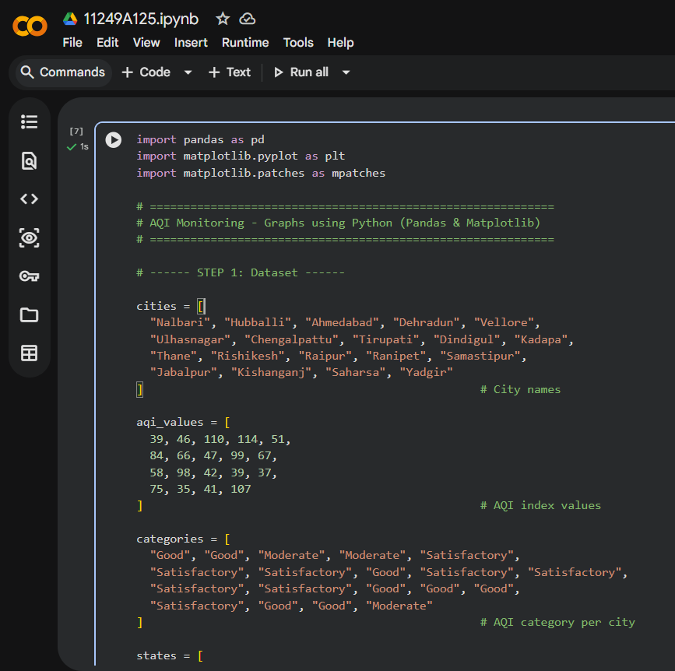
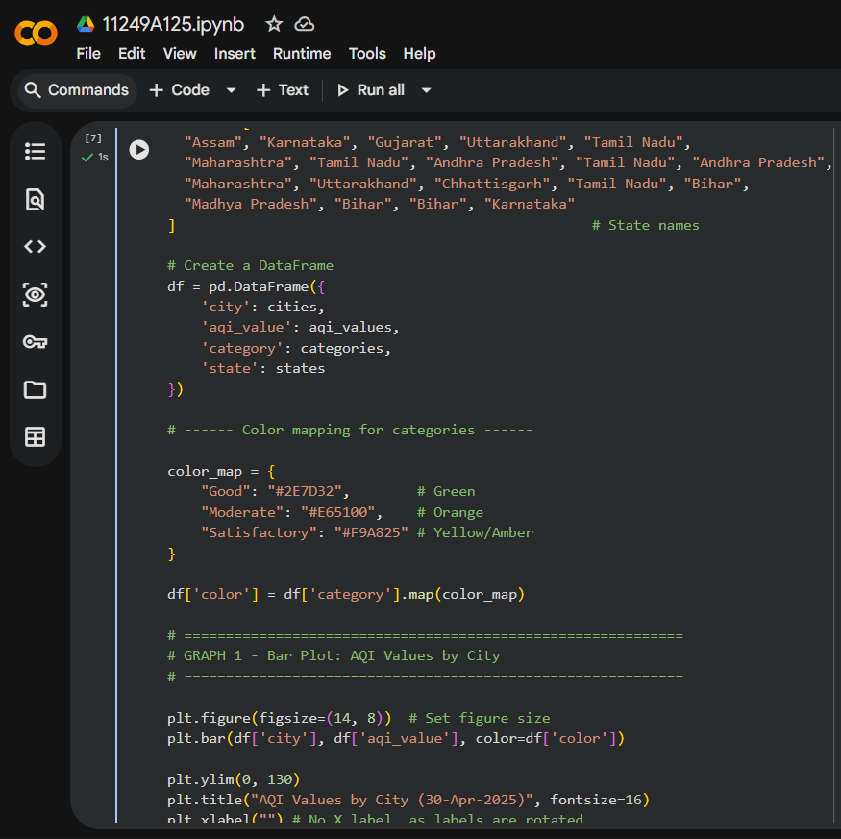
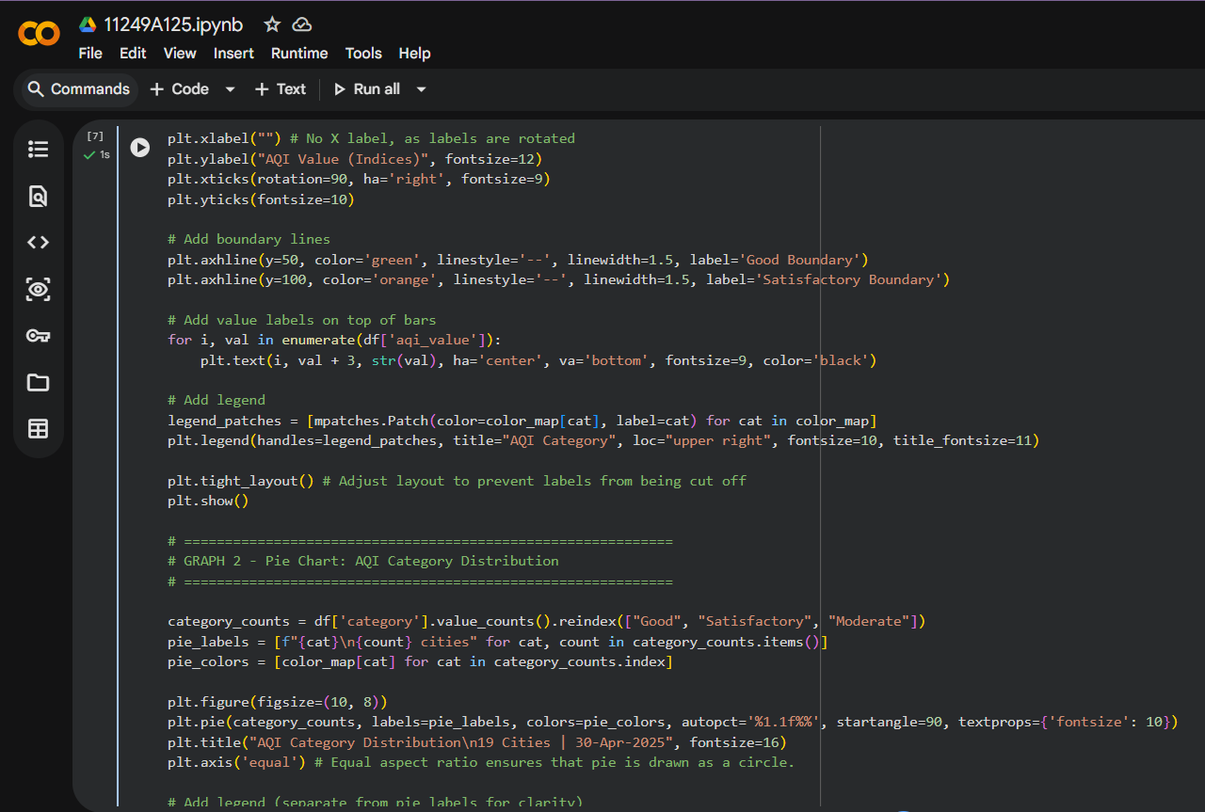
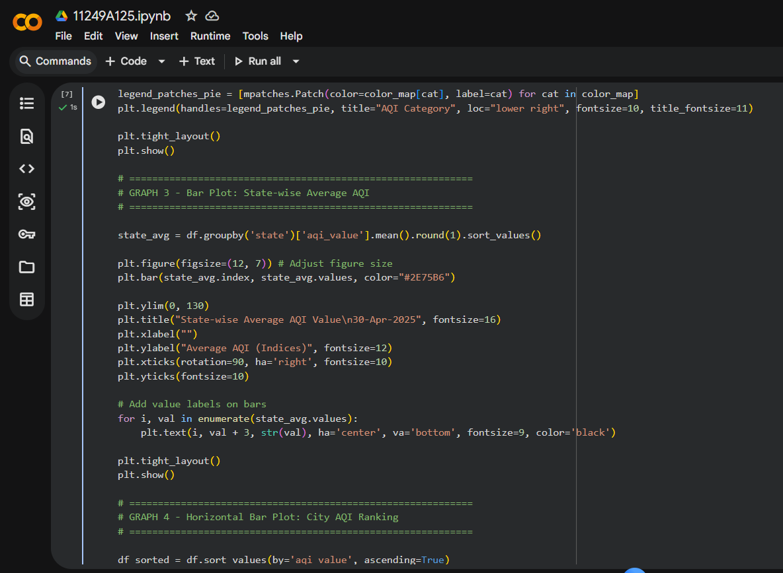
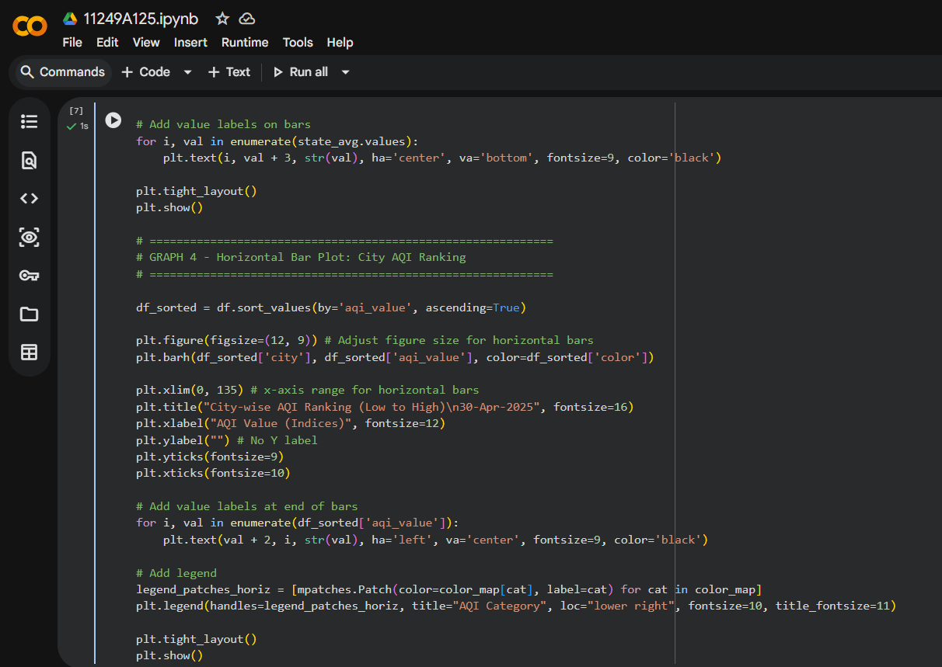
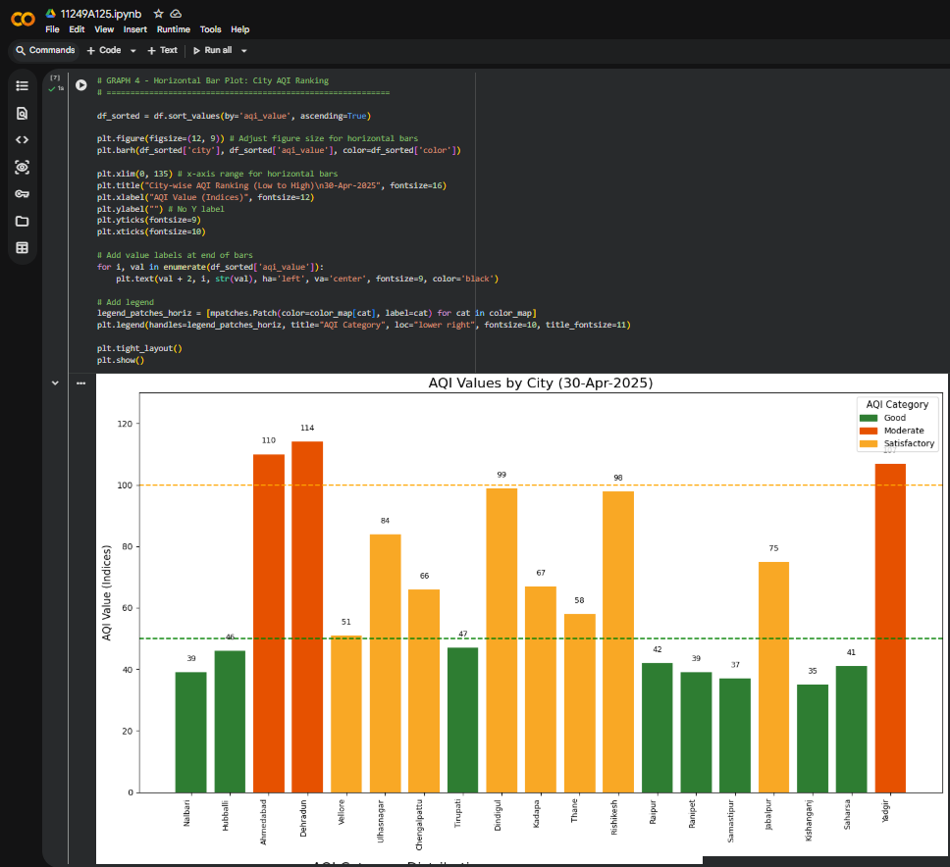
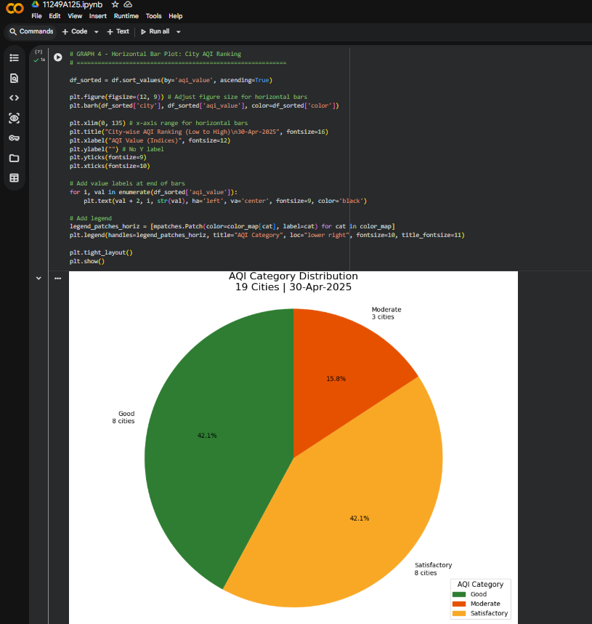
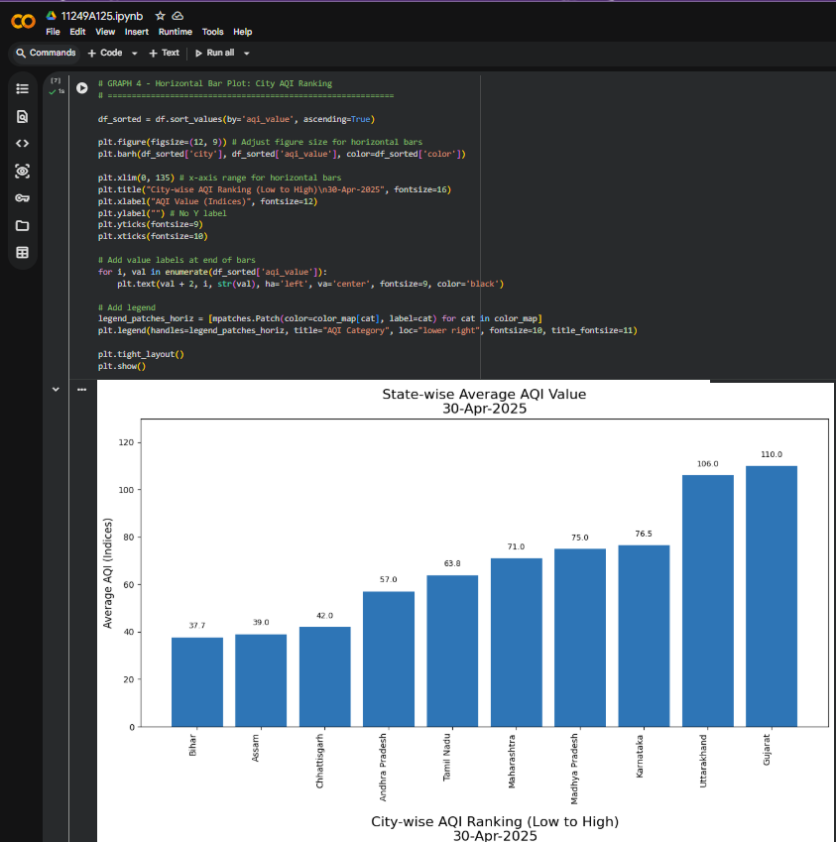
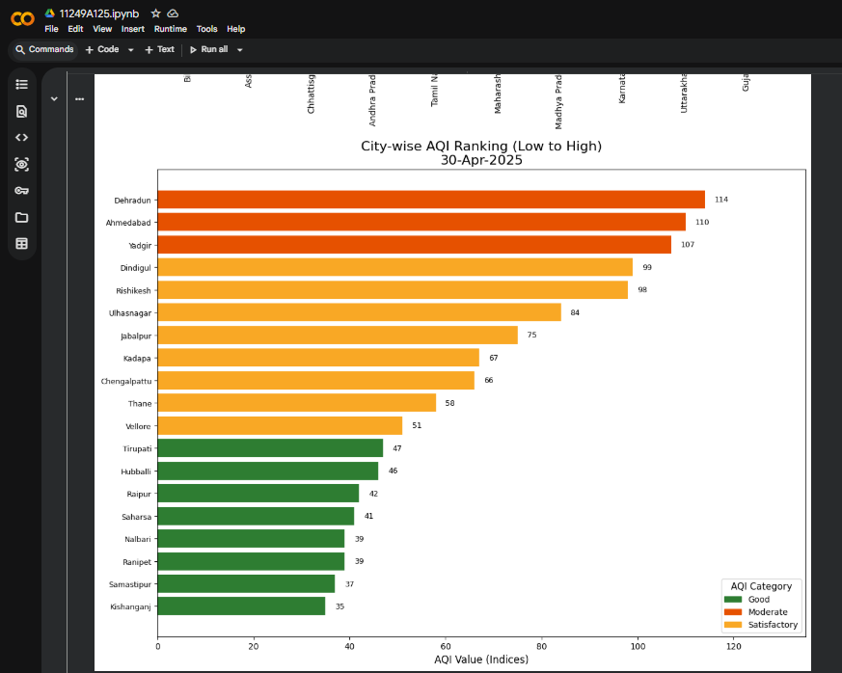

Source: Central Pollution Control Board (CPCB), India — 30 April 2025

