NATURAL LANGUAGE PROCESSING
NLP Scenario-Based Programs (Q1–Q30)
NAME: KUCHIBHOTLA SESHA SIRI MAOGNA Regno:11249A181

Q1. Vocabulary Statistics for a News Startup
Program:
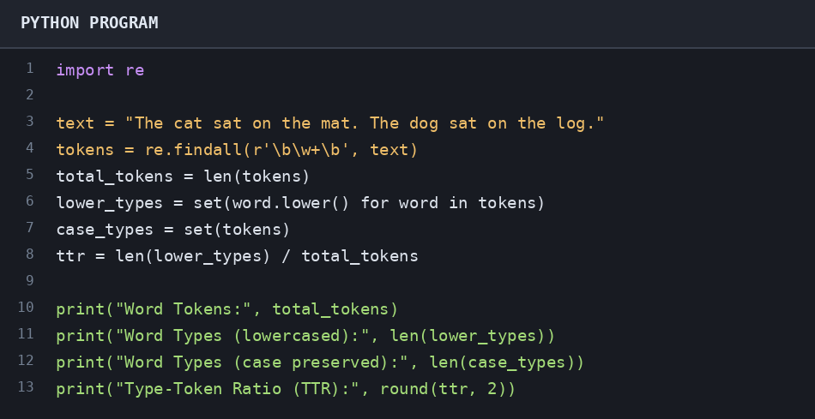
OUTPUT:
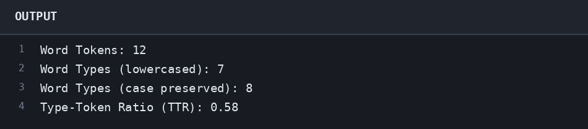
RESULT:The program calculates word tokens, word types, and the type-token ratio successfully.

Q2. Tokenizing a Social-Media Post
Program:
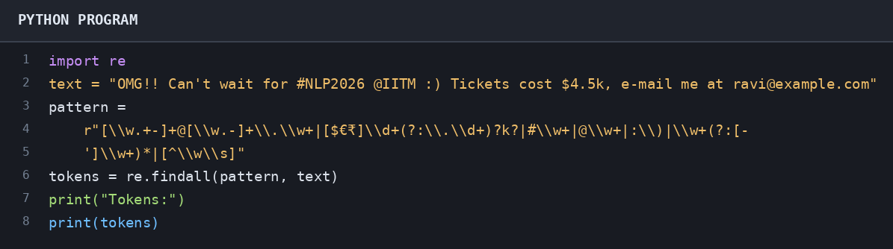
OUTPUT:
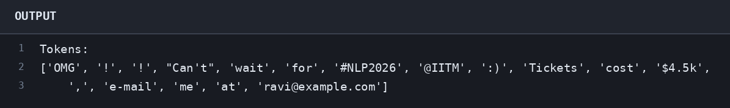
RESULT:The program tokenizes the post while preserving hashtags, mentions, emoticons, amounts, email addresses, and punctuation

Q3. Query Normalisation in a Search Engine
Program:
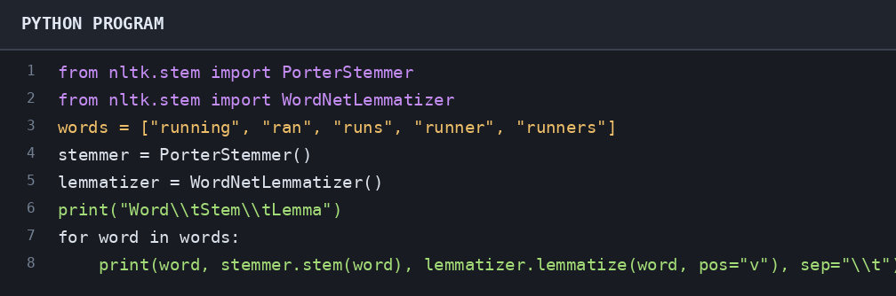
OUTPUT:
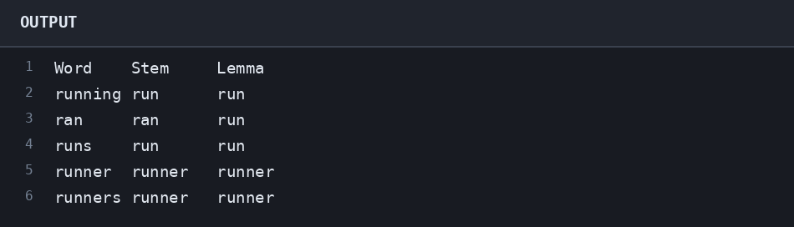
RESULT:The program compares Porter stemming with verb lemmatization. Install NLTK and download WordNet data if needed.

Q4. Zipf's Law in a Customer-Review Corpus
Program:
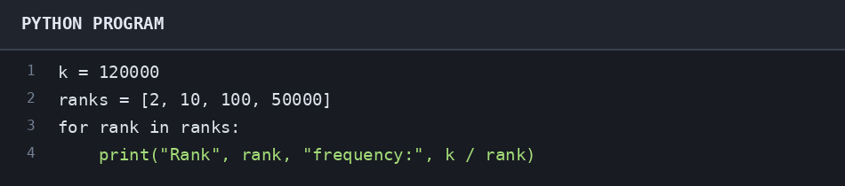
OUTPUT:
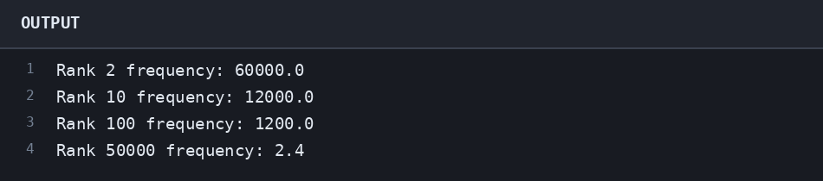
RESULT:The program estimates word frequencies using Zipf's law, f = k/r.

Q5. Code-Mixed Customer Chat
Program:
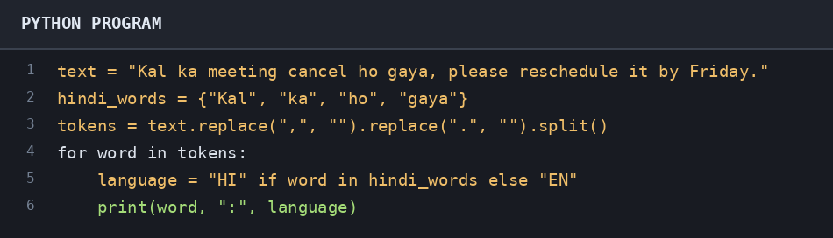
OUTPUT:
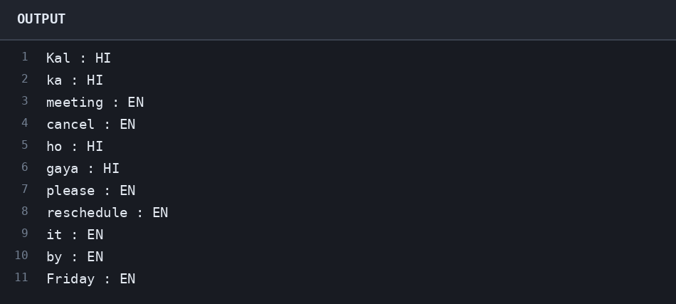
RESULT:The program labels the romanised Hindi words as HI and the English words as EN.

Q6. Plural Generator for an E-Commerce Catalogue
Program:
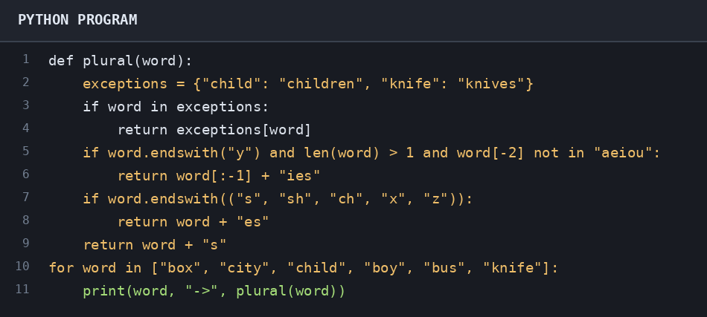
OUTPUT:
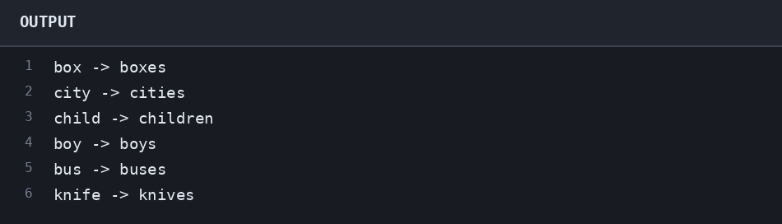
RESULT:The program generates plural forms using spelling rules and a small exception dictionary.

Q7. Verb Forms for a Grammar-Correction Tool
Program:
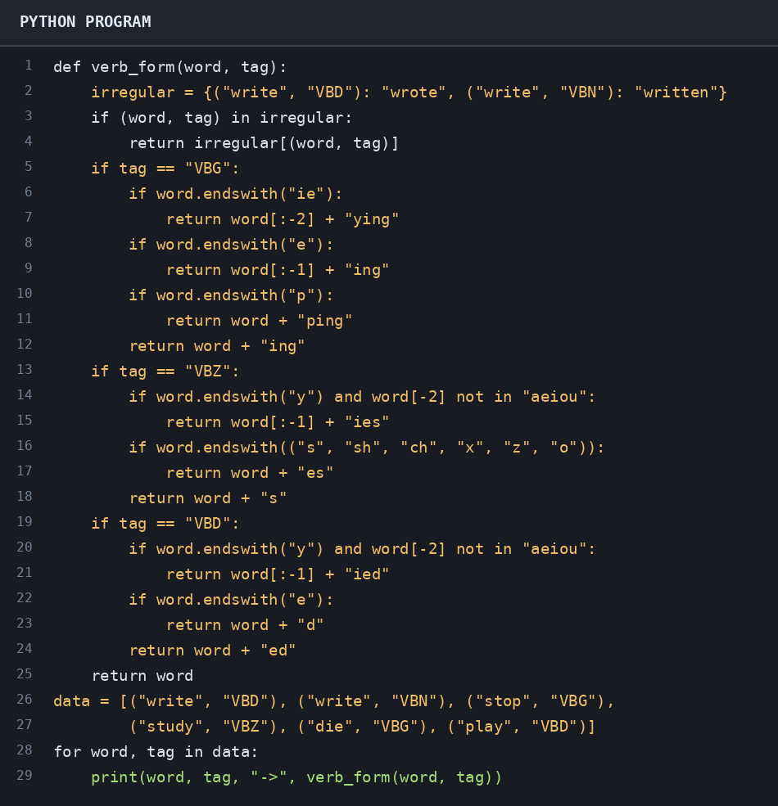
OUTPUT:
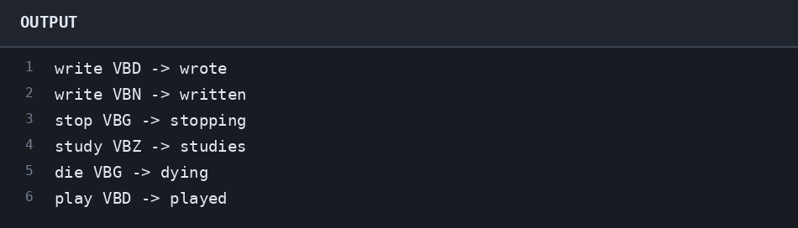
RESULT:The program generates the requested verb forms using regular spelling rules and an irregular-forms table.

Q8. Finite-State Transducer for English Plurals
Program:
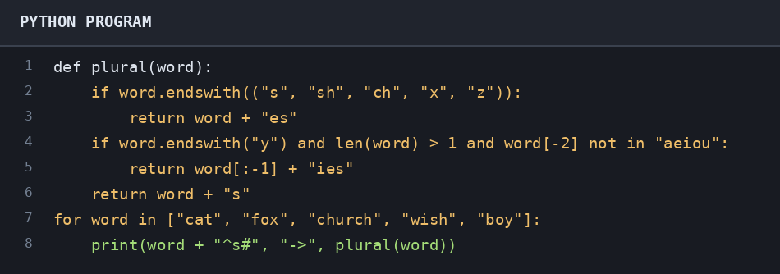
OUTPUT:
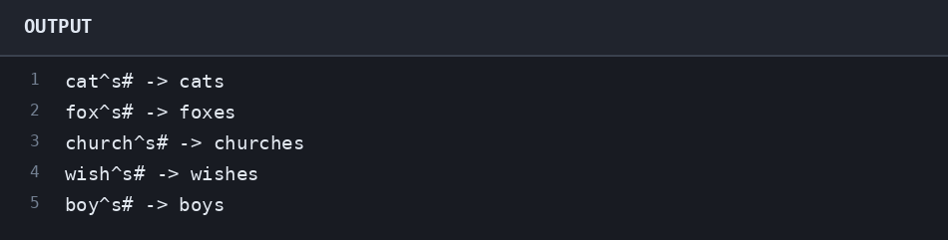
RESULT:The program demonstrates intermediate plural forms and maps them to surface forms.

Q9. Tamil Noun Forms for an E-Governance Chatbot
Program:
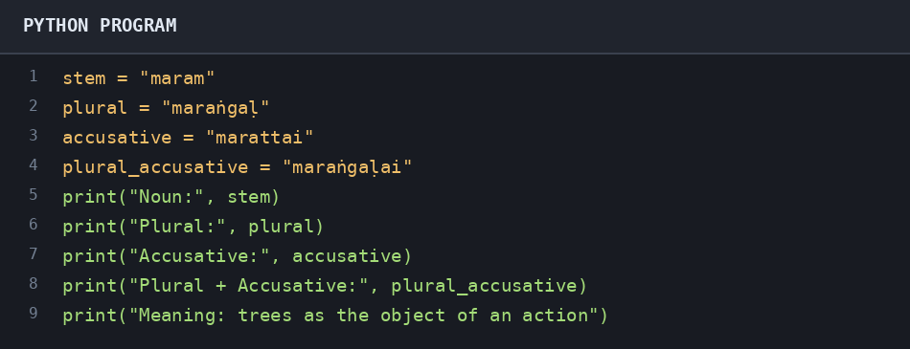
OUTPUT:
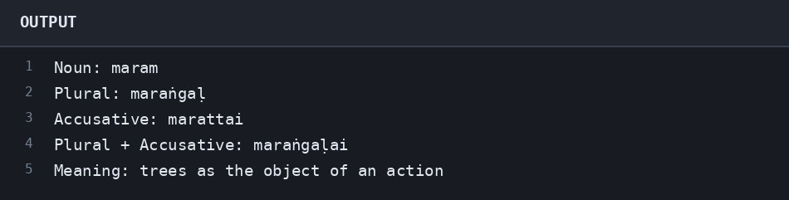
RESULT:The program displays the supplied Tamil noun forms in Roman transliteration. Exact forms can depend on the noun paradigm.

Q10. Derivational Word Generator for Brand Names
Program:
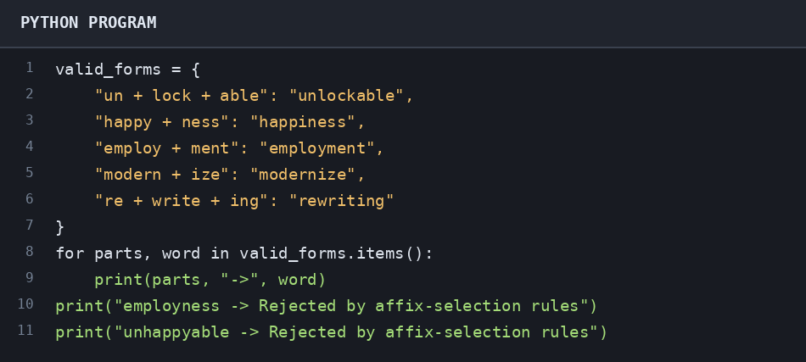
OUTPUT:
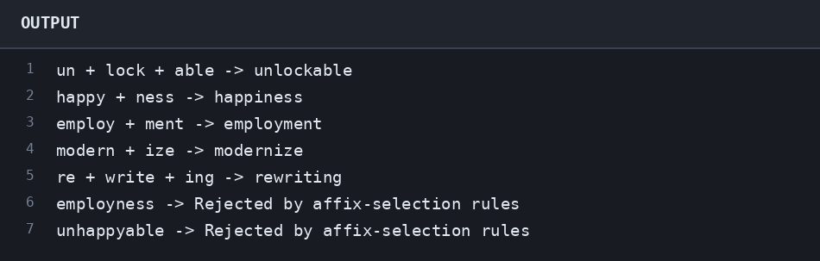
RESULT:The program lists valid derived forms and demonstrates a simple filter for disallowed affix combinations.

Q11. Morpheme Segmentation for a Spell-Checker
Program:
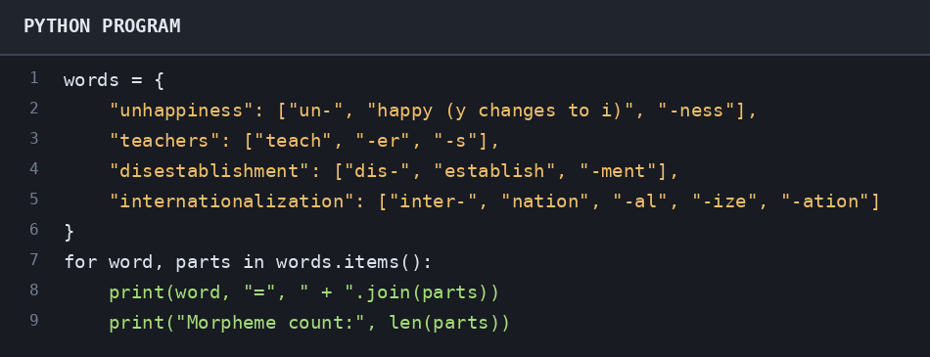
OUTPUT:
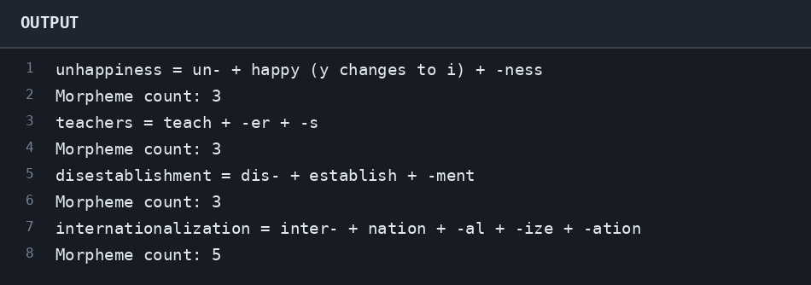
RESULT:The program segments each word into the morphemes listed in the question.

Q12. Inflection versus Derivation
Program:
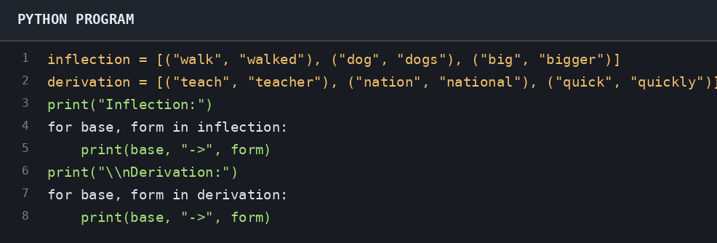
OUTPUT:
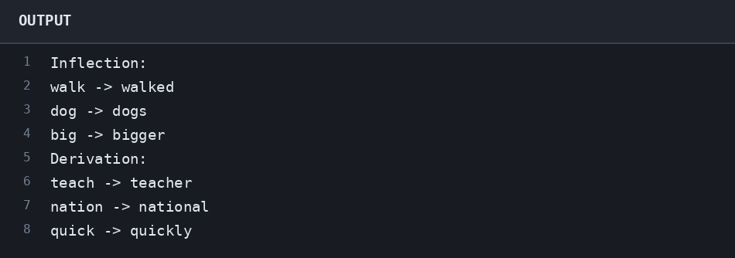
RESULT:The program separates examples of inflection from examples of derivation.

Q13. Stemmer Errors in Legal Search
Program:
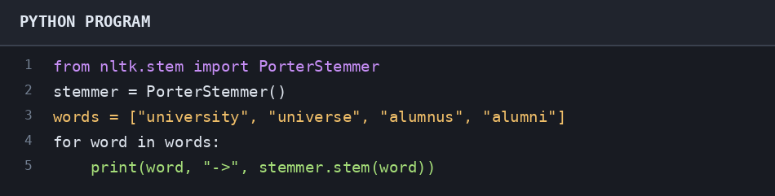
OUTPUT:
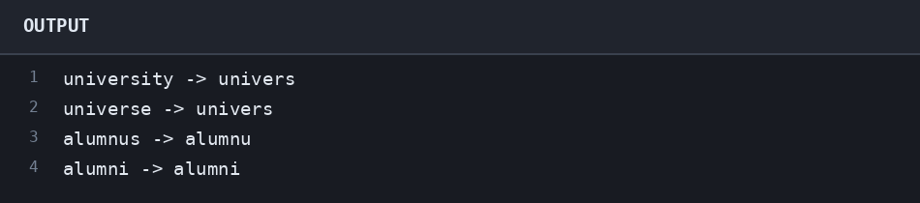
RESULT:The program demonstrates possible stemming behaviour. Install NLTK with: python -m pip install nltk.

Q14. Agglutinative Turkish and Vocabulary Explosion
Program:
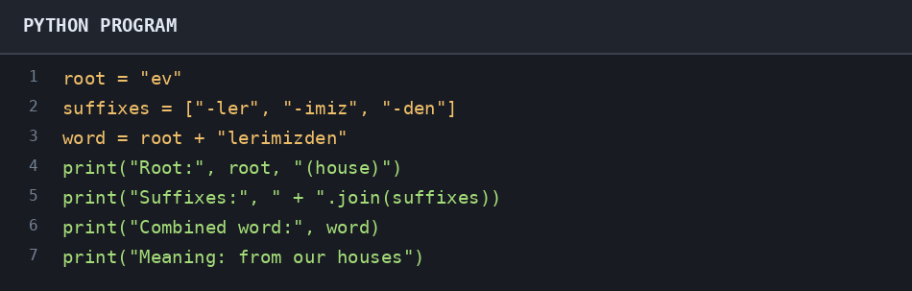
OUTPUT:
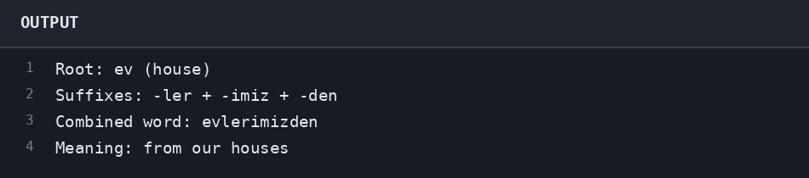
RESULT:The program combines the Turkish root with plural, possessive, and ablative suffixes.

Q15. Ambiguous Analyses from a Morphological Analyzer
Program:
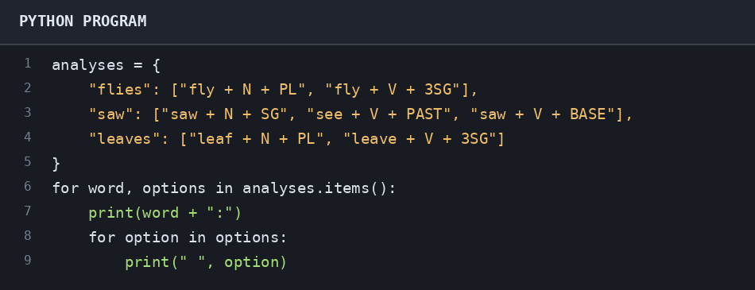
OUTPUT:
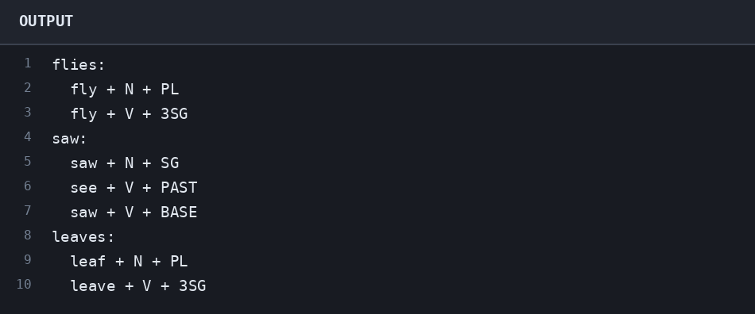
RESULT:The program lists multiple possible morphological analyses for ambiguous word forms.

Q16. Building a Bigram Model
Program:
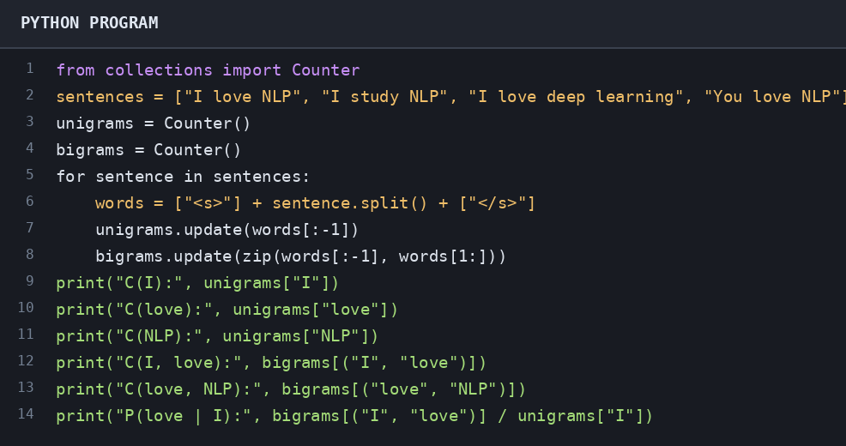
OUTPUT:
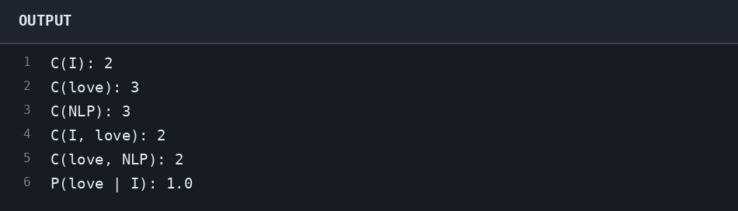
RESULT:The program counts unigrams and bigrams from a small example corpus and calculates a conditional probability.

Q17. Comparing Two Candidate Sentences
Program:
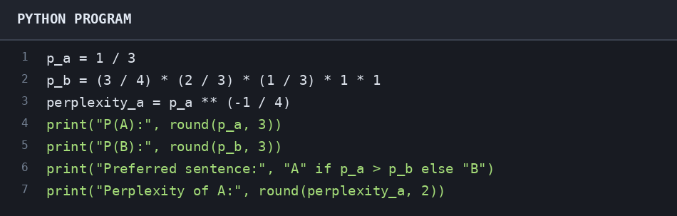
OUTPUT:
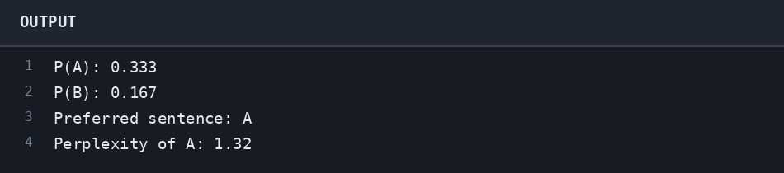
RESULT:The program compares the candidate probabilities and calculates the perplexity for sentence A.

Q18. The Zero-Probability Problem
Program:
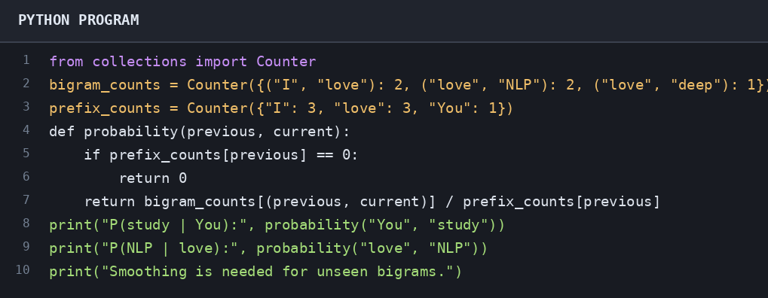
OUTPUT:
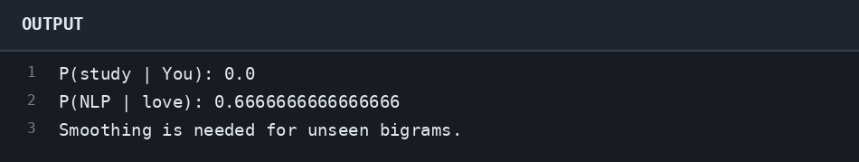
RESULT:The program shows that an unseen bigram receives zero probability without smoothing.

Q19. Model Size and Data Sparsity on a Phone
Program:
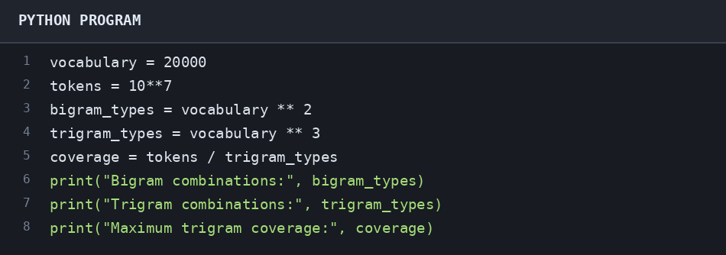
OUTPUT:
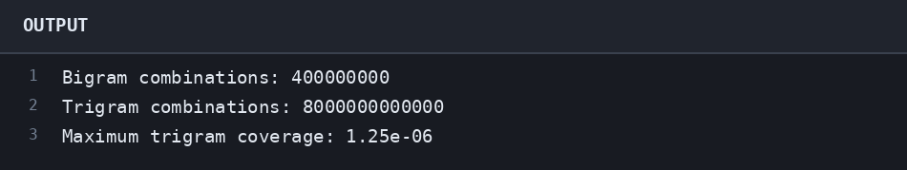
RESULT:The program estimates possible n-gram counts and illustrates why trigram data is sparse.

Q20. Underflow and Language Identification
Program:
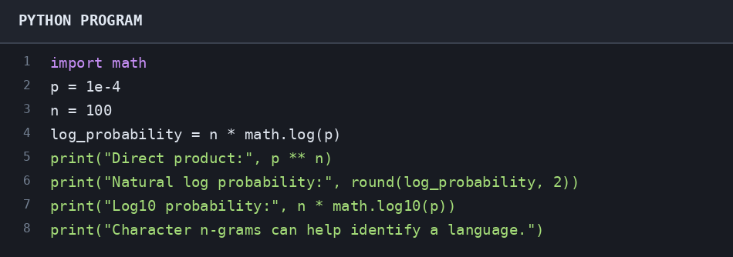
OUTPUT:
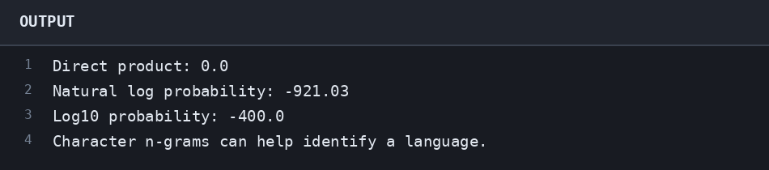
RESULT:The program demonstrates probability underflow and shows why language models use log probabilities.

Q21. Laplace Smoothing of an Unseen Bigram
Program:
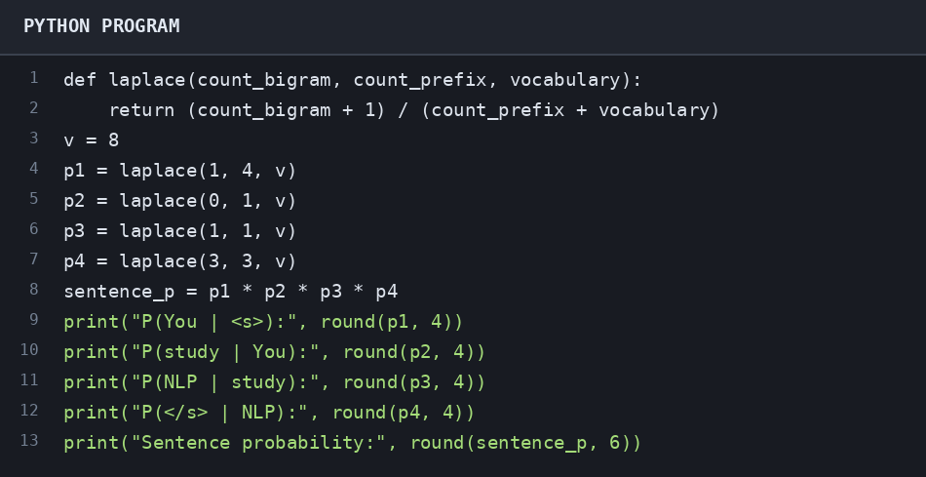
OUTPUT:
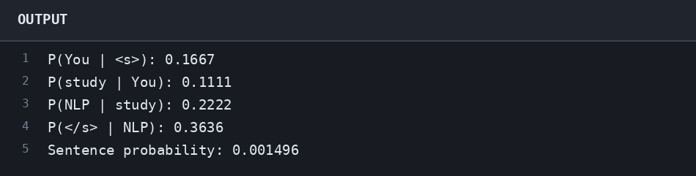
RESULT:The program applies add-one smoothing so that unseen bigrams receive non-zero probability.

Q22. How Much Mass Does Laplace Steal?
Program:
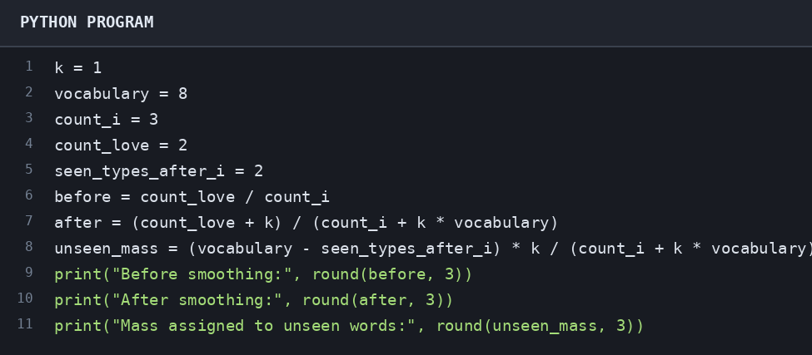
OUTPUT:
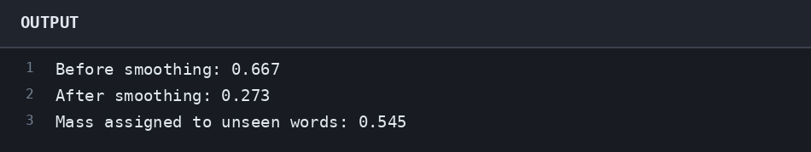
RESULT:The program illustrates how add-one smoothing redistributes probability mass to unseen events.

Q23. Good-Turing Discounting
Program:
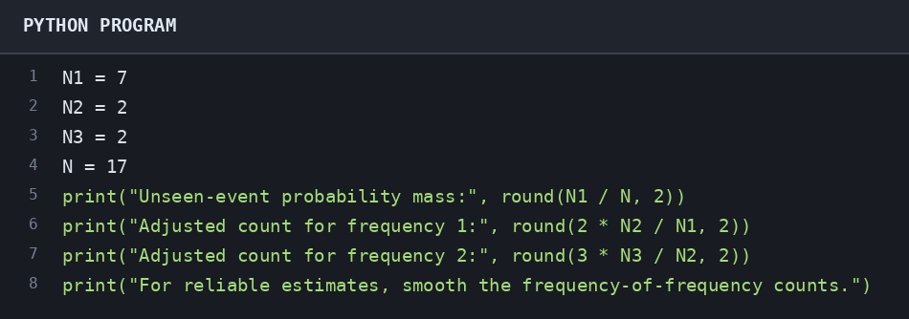
OUTPUT:
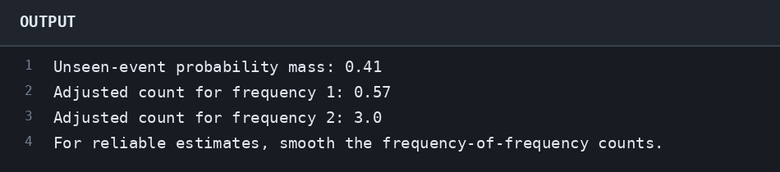
RESULT:The program computes basic Good-Turing estimates and notes the need for smoothing on small datasets.

Q24. Interpolation and Backoff
Program:
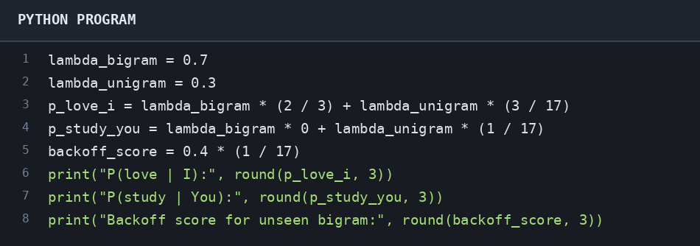
OUTPUT:
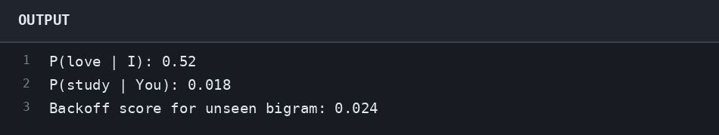
RESULT:The program calculates interpolated probabilities and a simple backoff score.

Q25. Why 'Francisco' Should Not Follow 'reading'
Program:
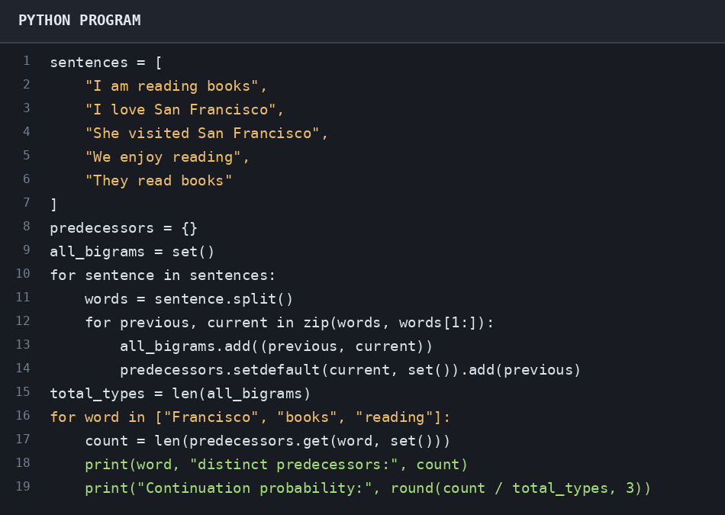
OUTPUT:
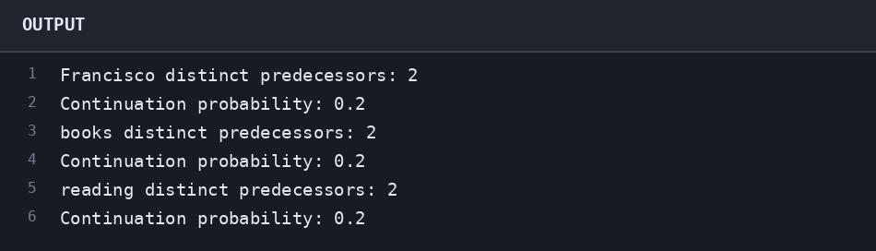
RESULT:The program estimates continuation probabilities from distinct preceding words in a small corpus.

Q26. Training an HMM Tagger from a Tagged Corpus
Program:
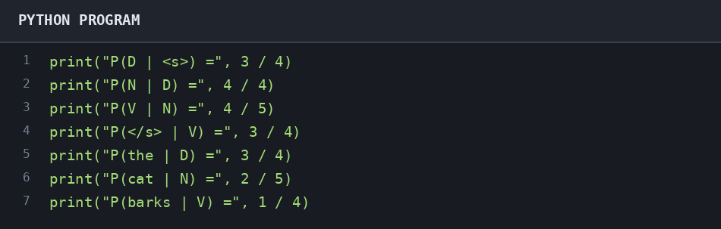
OUTPUT:
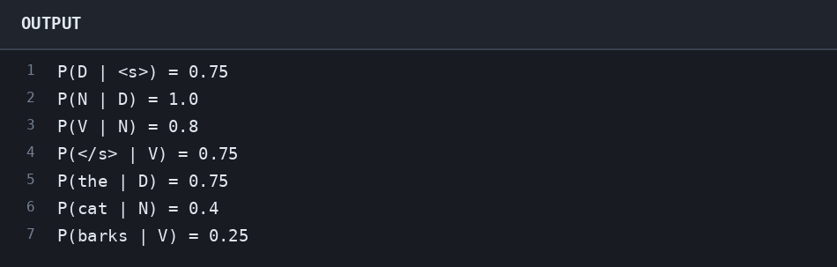
RESULT:The program displays the start, transition, and emission probabilities for the HMM tagger.

Q27. Joint Probability of Competing Tag Sequences
Program:
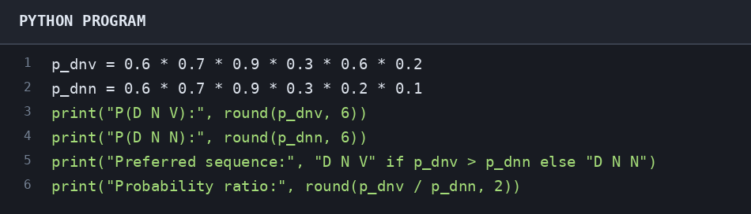
OUTPUT:
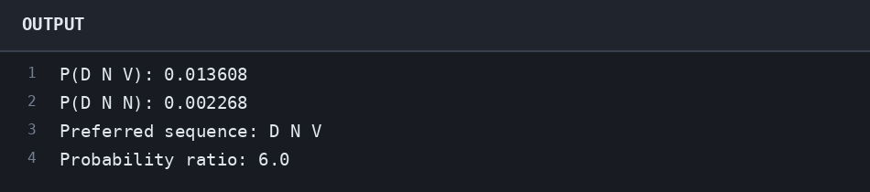
RESULT:The program calculates both joint probabilities and selects the more probable tag sequence.

Q28. Running the Viterbi Algorithm
Program:
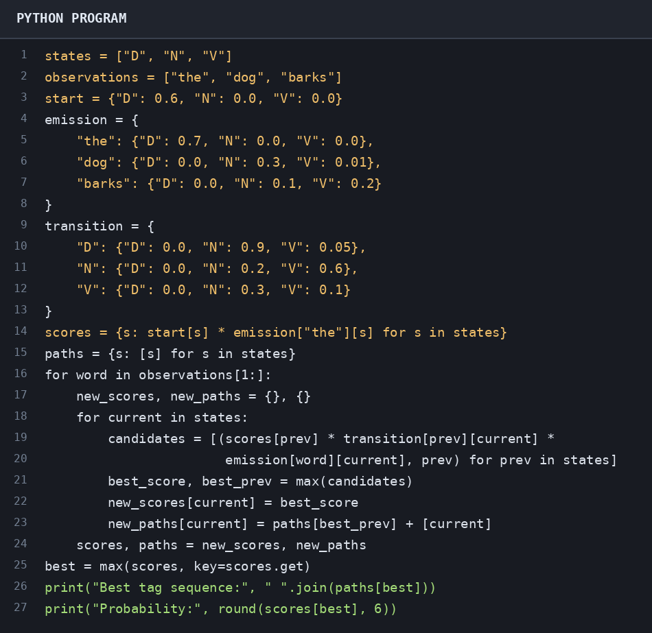
OUTPUT:
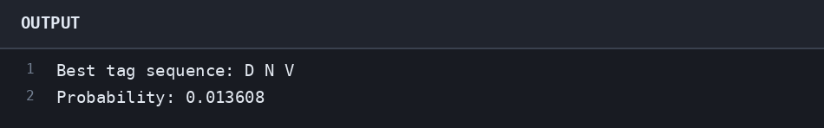
RESULT:The program uses dynamic programming to find the most likely POS tag sequence.

Q29. Why Viterbi Instead of Brute Force?
Program:
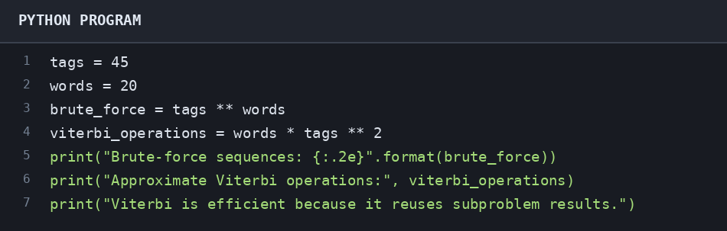
OUTPUT:
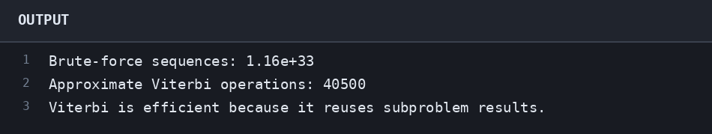
RESULT:The program compares the number of brute-force tag sequences with approximate Viterbi computations.

Q30. Unknown Words and Model Limitations
Program:
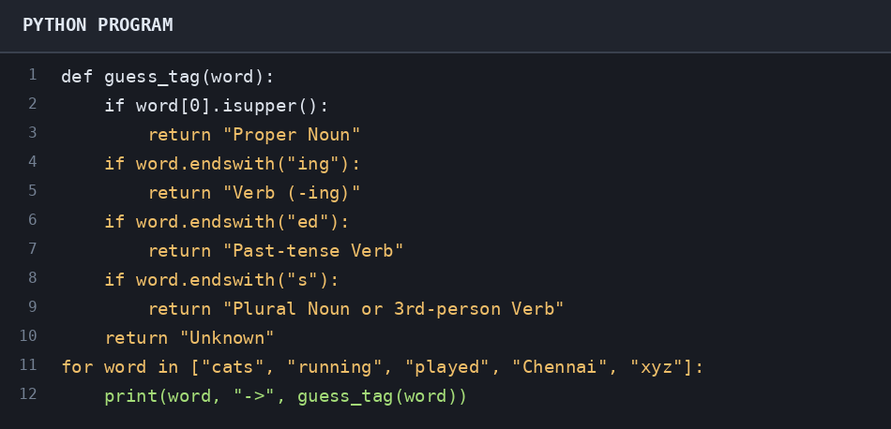
OUTPUT:
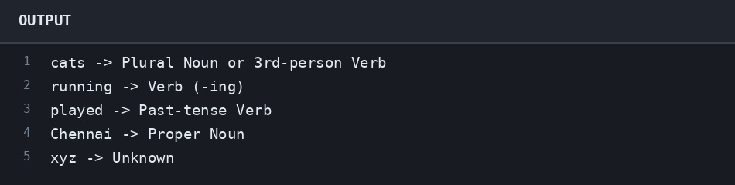
RESULT:The program uses word shape and suffixes to make simple guesses for unknown words.

