DATE
24/07/2026

Natural Language Processing laboratory observation

EXPERIMENT 1:
Grammar-Based Language Model

PROGRAM:
subjects = ["Virat", "Anushka"]
verbs = ["plays", "does"]
objects = ["Cricket", "Acting"]
for s in subjects:
for v in verbs:
for o in objects:
print(s,v,o)

OUTPUT:
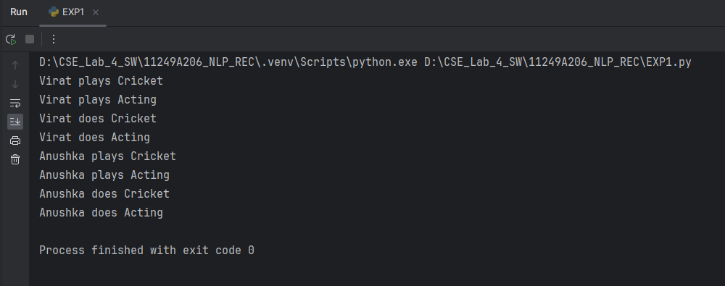

RESULT:

Grammar -Based Language model has executed successfully using Python.

EXPERIMENT 2:
Bigram Statistical Language Model

PROGRAM:

text="I Am a Motorhead,I love Bikes"
w=text.split()
for i in range(len(w)-1):
print((w[i],w[i+1]))

OUTPUT:

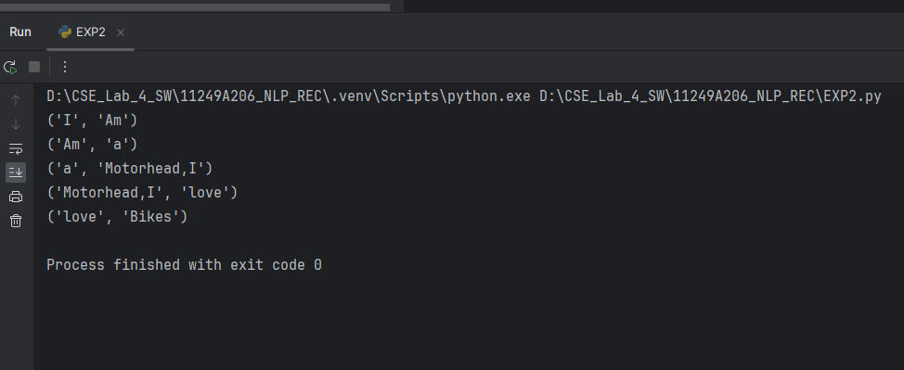

RESULT :

Bigram Statistical Language Model has been executed successfully using Python .

EXPERIMENT 3:
Regular Expression

PROGRAM :
import re
email="11249A206@kanchiuniv.ac.in"
print("Valid" if re.match(r"^[\w.+-]+@[\w.-]+\.[A-Za-z]{2,}$",email)
else 'Invalid')

OUTPUT :

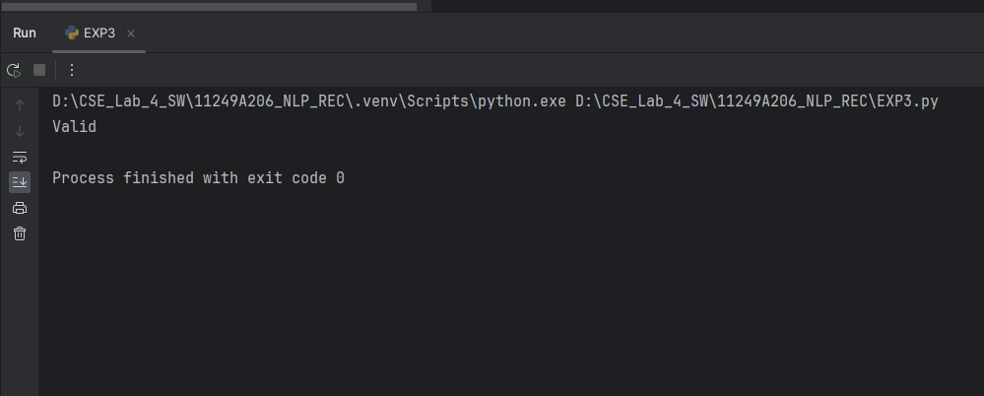

RESULT :
Regular expression model has successfully executed by using Python.

EXPERIMENT 4 :
Finite State Automata

PROGRAM :
s="ab"
state=0
for c in s:
if state==0 and c=="a": state=1
elif state==1 and c=="b": state=2
else: state=-1
print("Accepted" if state==2 else "Rejected")

OUTPUT :
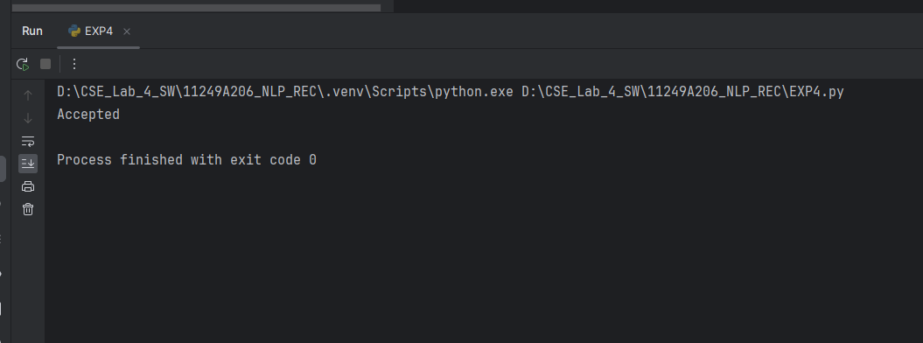

RESULT :
Finite state automaton model has been executed successfully by using python.

SUBMITTED BY :
MANIKYALA PRAMODH
11249A206
CSE-3RD YEAR
S2-SECTION

__________________________________________________________

