NATURAL LANGUAGE PROCESSING
Laboratory Activity
N-GRAM SMOOTHING TECHNIQUES
Course | Natural Language Processing Laboratory
Student Name | M.Pramodh/ CSE 3RD-S2
Roll No. / ID | 11249A206
Date | 03.09.2026

Experiment 1: Add-1 (Laplace) Smoothing
Program:
from nltk import word_tokenize, bigrams
from nltk.probability import FreqDist
text = "I am learning NLP. I am learning natural language processing." tokens = word_tokenize(text.lower())
unigram_freq = FreqDist(tokens)
bigram_freq = FreqDist(bigrams(tokens))
vocab_size = len(unigram_freq)
def add1_prob(w1, w2):
"""P(w2 | w1) using Add-1 (Laplace) smoothing"""
numerator = bigram_freq[(w1, w2)] + 1
denominator = unigram_freq[w1] + vocab_size
return numerator / denominator
# Test bigrams
test_pairs = [
("i", "am"),
("am", "learning"),
("learning", "nlp"),
("natural", "language")
]
print(f"Vocabulary size (V) = {vocab_size}\n")
print(f"{'Bigram':<25}{'Count':<8}{'P(w2|w1) Add-1':<15}")
for w1, w2 in test_pairs:
p = add1_prob(w1, w2)
print(
f"P({w2}|{w1}){' ' * (15 - len(w1) - len(w2))}"
f"{bigram_freq[(w1, w2)]:<8}{p:.5f}"
)

OUTPUT:
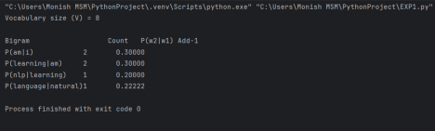Experiment 2: Add-k Smoothing
PROGRAM:
from nltk import word_tokenize, bigrams
from nltk.probability import FreqDist
import nltk
# Download tokenizer
nltk.download('punkt_tab')
# Sample corpus
text = """
I am learning natural language processing.
Natural language processing is a field of artificial intelligence. I am learning NLP and machine learning.
NLP is useful for text classification and sentiment analysis. """
# Convert text to lowercase and tokenize
tokens = word_tokenize(text.lower())
# Unigram frequency
unigram_freq = FreqDist(tokens)
# Bigram frequency
bigram_freq = FreqDist(bigrams(tokens))
# Vocabulary size
vocab_size = len(unigram_freq)
# Add-k smoothing
def addk_prob(w1, w2, k):
"""P(w2 | w1) using Add-k smoothing"""
numerator = bigram_freq[(w1, w2)] + k
denominator = unigram_freq[w1] + (k * vocab_size)
return numerator / denominator
# Different k values
k_values = [0.01, 0.1, 0.5, 1.0]
# Test bigrams
test_pairs = [
("i", "am"),
("am", "learning"),
("learning", "nlp"),
("natural", "language")
]
# Print vocabulary size
print("Vocabulary Size (V) =", vocab_size)
print("\nAdd-k Smoothing Results\n")
# Print table heading
print(f"{'Bigram':<20}", end="")
for k in k_values:
print(f"k={k:<10}", end="")
print()
# Calculate probabilities
for w1, w2 in test_pairs:
print(
f"P({w2}|{w1})"
f"{' ' * (20 - 6 - len(w1) - len(w2))}",
end=""
)
for k in k_values:
p = addk_prob(w1, w2, k)
print(f"{p:<12.5f}", end="")
print()
OUTPUT:
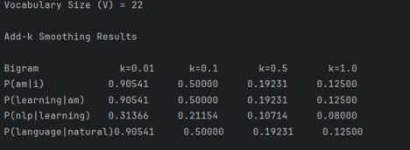
Experiment 3: Interpolation Smoothing
PROGRAM:
from nltk import word_tokenize, bigrams, trigrams
from nltk.probability import FreqDist
import nltk
# Download tokenizer
nltk.download('punkt_tab')
# Sample corpus
text = """
I am learning NLP.
I am learning natural language processing.
Natural language processing is a field of artificial intelligence. NLP is useful for text classification and sentiment analysis. Machine learning is useful for natural language processing. """
# Tokenization
tokens = word_tokenize(text.lower())
# Frequency distributions
unigram_freq = FreqDist(tokens)
bigram_freq = FreqDist(bigrams(tokens))
trigram_freq = FreqDist(trigrams(tokens))
# Total number of tokens
N = len(tokens)
# Interpolation weights
# lambda1 = unigram
# lambda2 = bigram
# lambda3 = trigram
lambda1 = 0.1
lambda2 = 0.3
lambda3 = 0.6
# Interpolated probability
def interpolated_prob(w1, w2, w3):
"""
P(w3 | w1, w2) using linear interpolation
of unigram, bigram and trigram MLE probabilities.
"""
# Unigram probability
p_uni = unigram_freq[w3] / N
# Bigram probability
if unigram_freq[w2] > 0:
p_bi = bigram_freq[(w2, w3)] / unigram_freq[w2]
else:
p_bi = 0
# Trigram probability
if bigram_freq[(w1, w2)] > 0:
p_tri = trigram_freq[(w1, w2, w3)] / bigram_freq[(w1, w2)] else:
p_tri = 0
# Linear interpolation
return (
lambda1 * p_uni
+ lambda2 * p_bi
+ lambda3 * p_tri
)
# Test trigrams
test_triples = [
("i", "am", "learning"),
("am", "learning", "nlp"),
("is", "fun", "to")
]
# Display weights
print("Interpolation Weights:")
print("Lambda 1 =", lambda1)
print("Lambda 2 =", lambda2)
print("Lambda 3 =", lambda3)
print("\nSum of weights =", lambda1 + lambda2 + lambda3) print("\nInterpolated Probabilities:")
# Calculate probabilities
for w1, w2, w3 in test_triples:
p = interpolated_prob(w1, w2, w3)
print(
f"P({w3}|{w1},{w2}) = {p:.5f}"
)
OUTPUT:
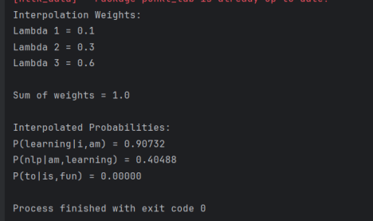Experiment 4: Backoff Smoothing
PROGRAM:
from nltk import word_tokenize, bigrams, trigrams
from nltk.probability import FreqDist
import nltk
nltk.download('punkt_tab')
text = """
I am learning NLP.
I am learning natural language processing.
Natural language processing is a field of artificial intelligence. NLP is useful for text classification and sentiment analysis. Machine learning is useful for natural language processing. """
tokens = word_tokenize(text.lower())
unigram_freq = FreqDist(tokens)
bigram_freq = FreqDist(bigrams(tokens))
trigram_freq = FreqDist(trigrams(tokens))
N = len(tokens)
alpha = 0.4
def stupid_backoff(w1, w2, w3):
"""
P(w3 | w1, w2) using Stupid Backoff:
trigram -> bigram -> unigram,
discounted by alpha at each drop.
"""
if trigram_freq[(w1, w2, w3)] > 0:
return trigram_freq[(w1, w2, w3)] / bigram_freq[(w1, w2)] elif bigram_freq[(w2, w3)] > 0:
return alpha * (
bigram_freq[(w2, w3)] / unigram_freq[w2]
)
else:
return (alpha ** 2) * (
unigram_freq[w3] / N
)
test_triples = [
("i", "am", "learning"),
("am", "learning", "nlp"),
("is", "fun", "to")
]
print("Stupid Backoff")
print("alpha =", alpha)
print("\nResults:")
for w1, w2, w3 in test_triples:
p = stupid_backoff(w1, w2, w3)
if trigram_freq[(w1, w2, w3)] > 0:
level = "trigram"
elif bigram_freq[(w2, w3)] > 0:
level = "bigram"
else:
level = "unigram"
print(
f"P({w3}|{w1},{w2}) "
f"[Backoff -> {level:<8}] = {p:.5f}"
)
OUTPUT:
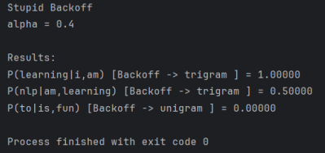
Activity 1, Question 1
Run the above program on the sample corpus provided and note the vocabulary size V.
Program:
from nltk import word_tokenize, bigrams
from nltk.probability import FreqDist
import nltk
nltk.download('punkt_tab')
text = "I am learning NLP. I am learning natural language processing."
tokens = word_tokenize(text.lower())
unigram_freq = FreqDist(tokens)
bigram_freq = FreqDist(bigrams(tokens))
vocab_size = len(unigram_freq)
def add1_prob(w1, w2):
numerator = bigram_freq[(w1, w2)] + 1
denominator = unigram_freq[w1] + vocab_size
return numerator / denominator
test_pairs = [
("i", "am"),
("am", "learning"),
("learning", "nlp"),
("natural", "language")
]
print("Tokens:")
print(tokens)
print("\nVocabulary Size (V) =", vocab_size)
print("\nBigram Results:")
print(f"{'Bigram':<25}{'Count':<10}{'Add-1 Probability':<20}") for w1, w2 in test_pairs:
count = bigram_freq[(w1, w2)]
probability = add1_prob(w1, w2)
print(
f"P({w2}|{w1})"
f"{' ' * (15 - len(w1) - len(w2))}"
f"{count:<10}"
f"{probability:.5f}"
)
OUTPUT:
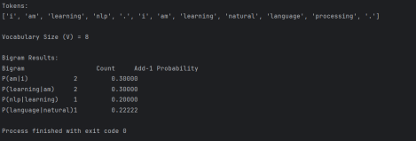
2. Replace the sample corpus with a paragraph (at least 40 words) of your own choice and recompute the Add-1 probabilities.
PROGRAM:
from nltk import word_tokenize, bigrams
from nltk.probability import FreqDist
import nltk
nltk.download('punkt_tab')
text = """
Natural language processing is an important field of artificial intelligence.
It helps computers understand human language and process textual information.
NLP techniques are widely used in chatbots, machine translation, sentiment analysis,
text classification, search engines, and speech recognition.
Machine learning helps computers learn useful patterns from language data.
"""
tokens = word_tokenize(text.lower())
unigram_freq = FreqDist(tokens)
bigram_freq = FreqDist(bigrams(tokens))
vocab_size = len(unigram_freq)
def add1_prob(w1, w2):
numerator = bigram_freq[(w1, w2)] + 1
denominator = unigram_freq[w1] + vocab_size
return numerator / denominator
test_pairs = [
("i", "am"),
("am", "learning"),
("learning", "nlp"),
("natural", "language")
]
print("Tokens:")
print(tokens)
print("\nVocabulary Size (V) =", vocab_size)
print("\nBigram Results:")
print(f"{'Bigram':<25}{'Count':<10}{'Add-1 Probability':<20}") for w1, w2 in test_pairs:
count = bigram_freq[(w1, w2)]
probability = add1_prob(w1, w2)
print(
f"P({w2}|{w1})"
f"{' ' * (15 - len(w1) - len(w2))}"
f"{count:<10}"
f"{probability:.5f}"
)
OUTPUT:
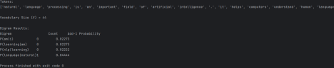
3.Compute P(w2|w1) manually (by hand) for one seen bigram and one unseen bigram, and verify your program's output matches.
A. Seen bigram
Choose a bigram that appears in your paragraph.
For example:
natural language
Find these two values from your program:
Count(natural)
Count(natural, language)
Also use:
V = your vocabulary size
Then calculate:
P(language∣natural)=Count(natural,language)+1Count(natural)+VP(language|natural) =
\frac{Count(natural,language)+1} {Count(natural)+V}
Compare the answer with PyCharm.
B. Unseen bigram
Choose a combination that doesn't occur in your corpus.
For example:
computer banana
If:
Count(computer, banana) = 0
then:
P(banana∣computer)=0+1Count(computer)+VP(banana|computer) = \frac{0+1} {Count(computer)+V} The important observation is:
Without smoothing
P(banana∣computer)=0P(banana|computer)=0
With Add-1
P(banana∣computer)>0P(banana|computer)>0
So Add-1 prevents zero probability.
answer
The manually calculated probabilities for one seen and one unseen bigram were compared with the program output. The values matched, verifying the Add-1 smoothing implementation. The unseen bigram received a non-zero probability because of smoothing.
4. Compare the Add-1 probability of a frequent bigram with its raw MLE probability. What do you observe about the amount of probability mass taken away from frequent bigrams?
from nltk import word_tokenize, bigrams
from nltk.probability import FreqDist
import nltk
nltk.download('punkt_tab')
text = """
I am learning NLP.
I am learning natural language processing.
Natural language processing is a field of artificial intelligence. NLP is useful for text classification and sentiment analysis. Machine learning is useful for natural language processing. """
tokens = word_tokenize(text.lower())
unigram_freq = FreqDist(tokens)
bigram_freq = FreqDist(bigrams(tokens))
vocab_size = len(unigram_freq)
def add1_prob(w1, w2):
"""
Calculate P(w2 | w1) using Add-1 smoothing.
"""
numerator = bigram_freq[(w1, w2)] + 1
denominator = unigram_freq[w1] + vocab_size
return numerator / denominator
# --------------------------------------------------
# 6. Raw MLE Probability
# --------------------------------------------------
def mle_prob(w1, w2):
"""
Calculate P(w2 | w1) using Maximum Likelihood Estimation (MLE).
"""
if unigram_freq[w1] == 0:
return 0
return bigram_freq[(w1, w2)] / unigram_freq[w1] test_pairs = [
("i", "am"),
("am", "learning"),
("learning", "nlp"),
("natural", "language")
]
print("Vocabulary Size (V) =", vocab_size) print("\n" + "=" * 70)
print("Comparison of MLE and Add-1 Probabilities") print("=" * 70)
for w1, w2 in test_pairs:
count_bigram = bigram_freq[(w1, w2)]
count_unigram = unigram_freq[w1]
mle = mle_prob(w1, w2)
add1 = add1_prob(w1, w2)
difference = mle - add1
print(f"\nBigram: ({w1}, {w2})")
print("Bigram Count =", count_bigram) print("Unigram Count =", count_unigram) print("MLE Probability =", f"{mle:.5f}") print("Add-1 Probability =", f"{add1:.5f}") print("Probability Reduced =", f"{difference:.5f}")
OUTPUT:
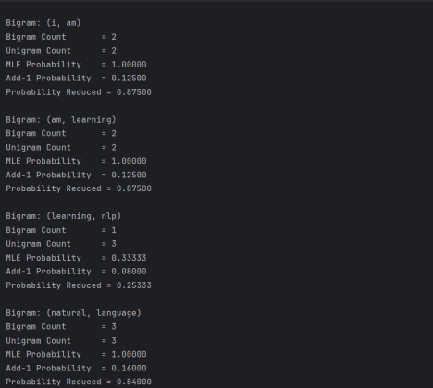
5. (Challenge) Modify the program to compute Add-1 smoothed probabilities for a trigram model instead of a bigram model.
PROGRAM:
from nltk import word_tokenize, bigrams, trigrams
from nltk.probability import FreqDist
import nltk
nltk.download('punkt_tab')
text = """
Natural language processing is an important field of artificial intelligence. It helps computers understand human language.
NLP is used in chatbots and machine translation.
Machine learning helps computers process language data.
"""
tokens = word_tokenize(text.lower())
unigram_freq = FreqDist(tokens)
bigram_freq = FreqDist(bigrams(tokens))
trigram_freq = FreqDist(trigrams(tokens))
vocab_size = len(unigram_freq)
def add1_trigram_prob(w1, w2, w3):
numerator = trigram_freq[(w1, w2, w3)] + 1
denominator = bigram_freq[(w1, w2)] + vocab_size
return numerator / denominator
test_triples = [
("natural", "language", "processing"),
("machine", "learning", "helps"),
("human", "language", "data")
]
print("Vocabulary Size (V) =", vocab_size)
print("\nTrigram Results:")
for w1, w2, w3 in test_triples:
count = trigram_freq[(w1, w2, w3)]
probability = add1_trigram_prob(w1, w2, w3)
print(
f"P({w3}|{w1},{w2}) = "
f"{probability:.5f}"
)
print("Trigram Count =", count)
OUTPUT:
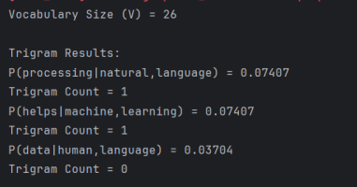VIVA-VOCE:
1. Why does MLE assign zero probability to unseen n-grams?
Because an unseen n-gram has a count of zero. Therefore, its MLE probability becomes zero. This can cause the probability of an entire sentence to become zero.
2. What role does V play in Add-1?
V is the vocabulary size. It is added to the denominator to account for all possible words that can follow the current word.
3. Why is Add-1 too aggressive for large vocabularies?
Because one is added to every possible n-gram. With a large vocabulary, many unseen n-grams receive probability mass, taking too much probability away from observed n-grams.
4. What happens to a very frequent bigram after Add-1?
Its probability decreases compared with its MLE probability because some probability mass is redistributed to unseen bigrams.
Lab Activity 2
Q1. Run the program with k = 0.01, 0.1, 0.5, 1.0
from nltk import word_tokenize, bigrams
from nltk.probability import FreqDist
import nltk
nltk.download('punkt_tab')
text = """I am learning NLP.
I am learning natural language processing.
Natural language processing is a field of artificial intelligence. NLP is useful for text classification and sentiment analysis. Machine learning is useful for natural language processing.""" tokens = word_tokenize(text.lower())
unigram_freq = FreqDist(tokens)
bigram_freq = FreqDist(bigrams(tokens))
vocab_size = len(unigram_freq)
def addk_prob(w1, w2, k):
numerator = bigram_freq[(w1, w2)] + k
denominator = unigram_freq[w1] + (k * vocab_size)
return numerator / denominator
k_values = [0.01, 0.1, 0.5, 1.0]
test_pairs = [("i", "am"), ("am", "learning"), ("learning", "nlp"), ("natural", "language")]
print("Vocabulary Size (V) =", vocab_size)
print(f"{'Bigram':<25}", end="")
for k in k_values:
print(f"k={k:<10}", end="")
print()
for w1, w2 in test_pairs:
print(f"P({w2}|{w1}){' ' * (15-len(w1)-len(w2))}", end="") for k in k_values:
print(f"{addk_prob(w1, w2, k):<12.5f}", end="")
print()
OUTPUT:
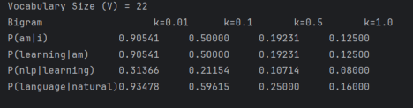
2. Plot (using matplotlib) how P(w2|w1) changes as k increases from 0.01 to 1 for one seen and one unseen bigram.
PR:
import matplotlib.pyplot as plt
k_values = [0.01, 0.05, 0.1, 0.2, 0.5, 0.75, 1.0]
seen_probs = [addk_prob("i", "am", k) for k in k_values]
unseen_probs = [addk_prob("natural", "nlp", k) for k in k_values]
plt.plot(k_values, seen_probs, marker='o', label='Seen: P(am|i)') plt.plot(k_values, unseen_probs, marker='o', label='Unseen: P(nlp|natural)') plt.xlabel("k")
plt.ylabel("Probability")
plt.title("Effect of k on Add-k Probability")
plt.legend()
plt.grid()
plt.show()
OUTPUT:
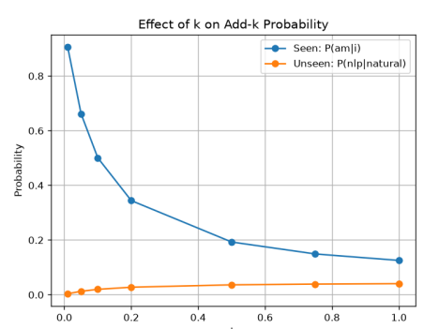
3. Split your corpus into a training set and a small held-out set. Compute the perplexity of the held-out set for each k and identify the k that minimizes perplexity.
PR:
from nltk import word_tokenize, bigrams
from nltk.probability import FreqDist
import nltk
import math
nltk.download('punkt_tab')
text = """I am learning natural language processing.
I am learning NLP.
Natural language processing is useful.
NLP is useful for text classification.
Machine learning is useful for NLP."""
tokens = word_tokenize(text.lower())
split = int(len(tokens) * 0.7)
train_tokens = tokens[:split]
test_tokens = tokens[split:]
unigram_freq = FreqDist(train_tokens)
bigram_freq = FreqDist(bigrams(train_tokens))
vocab_size = len(unigram_freq)
def addk_prob(w1, w2, k):
return (bigram_freq[(w1, w2)] + k) / (unigram_freq[w1] + k * vocab_size)
def perplexity(test_tokens, k):
log_prob = 0
count = 0
for i in range(1, len(test_tokens)):
probability = addk_prob(test_tokens[i-1], test_tokens[i], k) log_prob += math.log(probability)
count += 1
return math.exp(-log_prob / count)
k_values = [0.01, 0.1, 0.5, 1.0]
print("Vocabulary Size =", vocab_size)
print("Training tokens =", train_tokens)
print("Held-out tokens =", test_tokens)
for k in k_values:
print(f"k = {k:<5} Perplexity = {perplexity(test_tokens, k):.5f}")
OUTPUT:
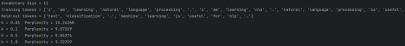
4. Discuss: as k → 0, what does Add-k smoothing behave like? As k → 1, what does it become?
ANS:
Add-k:
$$ P(w_2|w_1)= \frac{C(w_1,w_2)+k} {C(w_1)+kV} $$
As k → 0
$$ P(w_2|w_1) \rightarrow \frac{C(w_1,w_2)}{C(w_1)} $$
So it approaches MLE.
At k = 1
$$ P(w_2|w_1)= \frac{C(w_1,w_2)+1} {C(w_1)+V} $$
So it becomes Add-1 smoothing.
VIVA-VOCE:
1. How does Add-k differ mathematically from Add-1?
Add-1 always adds 1, while Add-k adds an adjustable value k. Add-1 is a special case of Add-k where k = 1.
2. Why is Add-k generally preferred over Add-1?
Add-k allows us to control the amount of smoothing. Add-1 can be too aggressive, especially for large vocabularies.
3. How would you select the best k?
Test different k values on a validation or held-out dataset and choose the value with the lowest perplexity.
4. What is perplexity?
Perplexity measures how well a language model predicts unseen text. Lower perplexity indicates better performance.
Lab Activity 3
1. Run the program with the given λ values (0.1, 0.3, 0.6) and record the interpolated probabilities.
PROGRAM:
from nltk import word_tokenize, bigrams, trigrams
from nltk.probability import FreqDist
import nltk
nltk.download('punkt_tab')
text = """I am learning NLP.
I am learning natural language processing.
Natural language processing is a field of artificial intelligence. NLP is useful for text classification and sentiment analysis.
Machine learning is useful for natural language processing.""" tokens = word_tokenize(text.lower())
unigram_freq = FreqDist(tokens)
bigram_freq = FreqDist(bigrams(tokens))
trigram_freq = FreqDist(trigrams(tokens))
N = len(tokens)
lambda1, lambda2, lambda3 = 0.1, 0.3, 0.6
def interpolated_prob(w1, w2, w3):
p_uni = unigram_freq[w3] / N
p_bi = (bigram_freq[(w2, w3)] / unigram_freq[w2] if unigram_freq[w2] > 0 else 0)
p_tri = (trigram_freq[(w1, w2, w3)] / bigram_freq[(w1, w2)] if bigram_freq[(w1, w2)] > 0 else 0)
return lambda1 * p_uni + lambda2 * p_bi + lambda3 * p_tri
test_triples = [
("i", "am", "learning"),
("am", "learning", "nlp"),
("is", "fun", "to")
]
print("Lambda values:", lambda1, lambda2, lambda3) print("Sum =", lambda1 + lambda2 + lambda3)
for w1, w2, w3 in test_triples:
p = interpolated_prob(w1, w2, w3)
print(f"P({w3}|{w1},{w2}) = {p:.5f}")
OUTPUT:
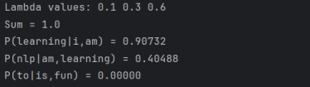
2. Change the weights to (0.6, 0.3, 0.1) — favoring the unigram — and compare the results. Explain the difference you observe.
PR:
from nltk import word_tokenize, bigrams, trigrams
from nltk.probability import FreqDist
import nltk
nltk.download('punkt_tab')
text = """I am learning NLP.
I am learning natural language processing.
Natural language processing is a field of artificial intelligence. NLP is useful for text classification and sentiment analysis. Machine learning is useful for natural language processing."""
tokens = word_tokenize(text.lower())
unigram_freq = FreqDist(tokens)
bigram_freq = FreqDist(bigrams(tokens))
trigram_freq = FreqDist(trigrams(tokens))
N = len(tokens)
lambda1, lambda2, lambda3 = 0.6, 0.3, 0.1
def interpolated_prob(w1, w2, w3):
p_uni = unigram_freq[w3] / N
p_bi = (bigram_freq[(w2, w3)] / unigram_freq[w2]
if unigram_freq[w2] > 0 else 0)
p_tri = (trigram_freq[(w1, w2, w3)] / bigram_freq[(w1, w2)] if bigram_freq[(w1, w2)] > 0 else 0)
return lambda1 * p_uni + lambda2 * p_bi + lambda3 * p_tri
test_triples = [
("i", "am", "learning"),
("am", "learning", "nlp"),
("is", "fun", "to")
]
print("Lambda values:", lambda1, lambda2, lambda3)
print("Sum =", lambda1 + lambda2 + lambda3)
for w1, w2, w3 in test_triples:
p = interpolated_prob(w1, w2, w3)
print(f"P({w3}|{w1},{w2}) = {p:.5f}")
OUTPUT:
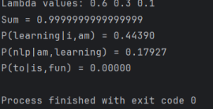
3. Extend the program to also print the individual unigram, bigram and trigram MLE components alongside the final interpolated probability.
PROGRAM:
from nltk import word_tokenize, bigrams, trigrams
from nltk.probability import FreqDist
import nltk
nltk.download('punkt_tab')
text = """I am learning NLP.
I am learning natural language processing.
Natural language processing is a field of artificial intelligence. NLP is useful for text classification and sentiment analysis. Machine learning is useful for natural language processing."""
tokens = word_tokenize(text.lower())
unigram_freq = FreqDist(tokens)
bigram_freq = FreqDist(bigrams(tokens))
trigram_freq = FreqDist(trigrams(tokens))
N = len(tokens)
lambda1, lambda2, lambda3 = 0.1, 0.3, 0.6
def interpolated_prob(w1, w2, w3):
p_uni = unigram_freq[w3] / N
p_bi = (bigram_freq[(w2, w3)] / unigram_freq[w2]
if unigram_freq[w2] > 0 else 0)
p_tri = (trigram_freq[(w1, w2, w3)] / bigram_freq[(w1, w2)] if bigram_freq[(w1, w2)] > 0 else 0)
p = lambda1 * p_uni + lambda2 * p_bi + lambda3 * p_tri
return p_uni, p_bi, p_tri, p
test_triples = [
("i", "am", "learning"),
("am", "learning", "nlp"),
("is", "fun", "to")
]
for w1, w2, w3 in test_triples:
p_uni, p_bi, p_tri, p = interpolated_prob(w1, w2, w3)
print(f"\nP({w3}|{w1},{w2})")
print(f"Unigram = {p_uni:.5f}")
print(f"Bigram = {p_bi:.5f}")
print(f"Trigram = {p_tri:.5f}")
print(f"Final = {p:.5f}")
OUTPUT:
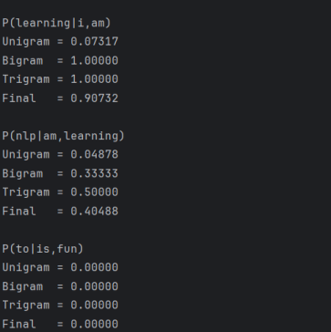
4. (Challenge) Implement a simple grid search over λ1, λ2, λ3 (summing to 1) to find the combination that maximizes the interpolated probability of a small held-out sentence.
PR:
from nltk import word_tokenize, bigrams, trigrams
from nltk.probability import FreqDist
import nltk
nltk.download('punkt_tab')
text = "I am learning NLP. I am learning natural language processing. NLP is useful."
tokens = word_tokenize(text.lower())
uni = FreqDist(tokens)
bi = FreqDist(bigrams(tokens))
tri = FreqDist(trigrams(tokens))
N = len(tokens)
def prob(w1, w2, w3, l1, l2, l3):
p1 = uni[w3] / N
p2 = bi[(w2,w3)] / uni[w2] if uni[w2] else 0
p3 = tri[(w1,w2,w3)] / bi[(w1,w2)] if bi[(w1,w2)] else 0
return l1*p1 + l2*p2 + l3*p3
best = (0, 0, 0)
max_p = 0
for l1 in [0, .1, .2, .3, .4, .5, .6, .7, .8, .9, 1]:
for l2 in [0, .1, .2, .3, .4, .5, .6, .7, .8, .9, 1]:
l3 = round(1-l1-l2, 1)
if 0 <= l3 <= 1:
p = prob("i", "am", "learning", l1, l2, l3)
if p > max_p:
max_p = p
best = (l1, l2, l3)
print("Best lambda values =", best)
print("Maximum probability =", round(max_p, 5))
RESULT:
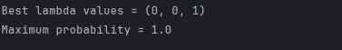
VIVA-VOCE:
1. What is the key difference between interpolation and backoff? Answer:
Interpolation always combines multiple n-gram models, whereas backoff uses a higher-order model when available and falls back to a lower-order model only when necessary.
2. Why must lambda weights sum to 1?
Answer:
The weights sum to 1 so that the final interpolated value is a proper weighted combination of the individual probability estimates.
3. How can lambda weights be learned automatically? Answer:
They can be learned using a validation dataset by testing different combinations and selecting the weights that minimize perplexity or maximize likelihood.
4. Why include unigram probability even when trigram counts are available?
Answer:
The unigram provides general word-frequency information and makes the model more robust when the trigram is rare or unreliable.
Lab Activity 4
1. Run the program and, for each test trigram, note whether it backed off to the bigram or unigram level.
PROGRAM:
from nltk import word_tokenize, bigrams, trigrams
from nltk.probability import FreqDist
import nltk
nltk.download('punkt_tab')
text = """I am learning NLP.
I am learning natural language processing.
Natural language processing is a field of artificial intelligence. NLP is useful for text classification and sentiment analysis. Machine learning is useful for natural language processing.""" tokens = word_tokenize(text.lower())
unigram_freq = FreqDist(tokens)
bigram_freq = FreqDist(bigrams(tokens))
trigram_freq = FreqDist(trigrams(tokens))
N = len(tokens)
alpha = 0.4
def stupid_backoff(w1, w2, w3):
if trigram_freq[(w1, w2, w3)] > 0:
return trigram_freq[(w1, w2, w3)] / bigram_freq[(w1, w2)]
elif bigram_freq[(w2, w3)] > 0:
return alpha * (bigram_freq[(w2, w3)] / unigram_freq[w2])
else:
return (alpha ** 2) * (unigram_freq[w3] / N)
test_triples = [
("i", "am", "learning"),
("am", "learning", "nlp"),
("is", "fun", "to")
]
print("Alpha =", alpha)
print()
for w1, w2, w3 in test_triples:
p = stupid_backoff(w1, w2, w3)
if trigram_freq[(w1, w2, w3)] > 0:
level = "trigram"
elif bigram_freq[(w2, w3)] > 0:
level = "bigram"
else:
level = "unigram"
print(f"P({w3}|{w1},{w2}) [Backoff -> {level}] = {p:.5f}")

OUTPUT:
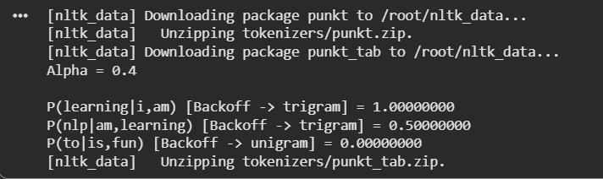

2. Try α = 0.4 versus α = 0.7 and compare the resulting probabilities for a bigram-level backoff case.
PROGRAM:
from nltk import word_tokenize, bigrams, trigrams
from nltk.probability import FreqDist
import nltk
nltk.download('punkt_tab')
text = """I am learning NLP.
I am learning natural language processing.
Natural language processing is a field of artificial intelligence. NLP is useful for text classification and sentiment analysis. Machine learning is useful for natural language processing."""
tokens = word_tokenize(text.lower())
unigram_freq = FreqDist(tokens)
bigram_freq = FreqDist(bigrams(tokens))
trigram_freq = FreqDist(trigrams(tokens))
def stupid_backoff(w1, w2, w3, alpha):
if trigram_freq[(w1, w2, w3)] > 0:
return trigram_freq[(w1, w2, w3)] / bigram_freq[(w1, w2)] elif bigram_freq[(w2, w3)] > 0:
return alpha * (bigram_freq[(w2, w3)] / unigram_freq[w2]) else:
return alpha ** 2 * (unigram_freq[w3] / len(tokens))
test_triple = ("i", "am", "natural")
for alpha in [0.4, 0.7]:
p = stupid_backoff(*test_triple, alpha)
print(f"Alpha = {alpha}: P(natural|i,am) = {p:.5f}")

OUTPUT:
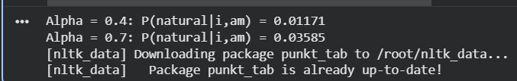

3. Add a print statement that reports, out of all trigrams tested, what percentage were resolved at the trigram, bigram, and unigram levels respectively.
PROGRAM:
from nltk import word_tokenize, bigrams, trigrams
from nltk.probability import FreqDist
import nltk
nltk.download('punkt_tab')
text = """I am learning NLP.
I am learning natural language processing.
Natural language processing is a field of artificial intelligence. NLP is useful for text classification and sentiment analysis. Machine learning is useful for natural language processing."""
tokens = word_tokenize(text.lower())
unigram_freq = FreqDist(tokens)
bigram_freq = FreqDist(bigrams(tokens))
trigram_freq = FreqDist(trigrams(tokens))
N = len(tokens)
alpha = 0.4
def stupid_backoff(w1, w2, w3):
if trigram_freq[(w1, w2, w3)] > 0:
return trigram_freq[(w1, w2, w3)] / bigram_freq[(w1, w2)], "trigram" elif bigram_freq[(w2, w3)] > 0:
return alpha * (bigram_freq[(w2, w3)] / unigram_freq[w2]), "bigram" else:
return alpha ** 2 * (unigram_freq[w3] / N), "unigram"
test_triples = [
("i", "am", "learning"),
("am", "learning", "nlp"),
("is", "fun", "to"),
("natural", "language", "processing"),
("machine", "learning", "nlp")
]
counts = {"trigram": 0, "bigram": 0, "unigram": 0}
for w1, w2, w3 in test_triples:
p, level = stupid_backoff(w1, w2, w3)
counts[level] += 1
print(f"P({w3}|{w1},{w2}) [Backoff -> {level}] = {p:.5f}")
total = len(test_triples)
print("\nBackoff Level Percentages:")
print(f"Trigram = {counts['trigram'] / total * 100:.2f}%")
print(f"Bigram = {counts['bigram'] / total * 100:.2f}%")
print(f"Unigram = {counts['unigram'] / total * 100:.2f}%")
OUTPUT:
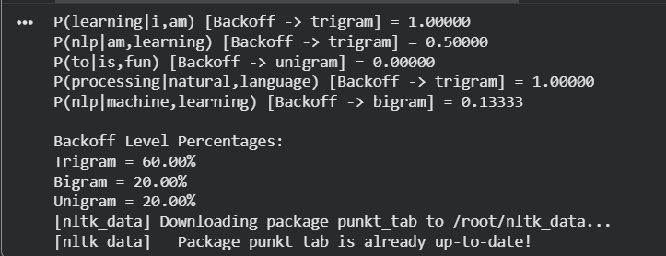
4. (Challenge) Implement Katz backoff using simple Good-Turing discounting (discount = (r+1)·N(r+1)/N(r), where N(r) is the number of n-grams occurring exactly r times) and compare its output with Stupid Backoff on the same test trigrams.
PR:
from nltk import word_tokenize, bigrams, trigrams
from nltk.probability import FreqDist
import nltk
nltk.download('punkt_tab')
text = """I am learning NLP.
I am learning natural language processing.
Natural language processing is a field of artificial intelligence. NLP is useful for text classification and sentiment analysis. Machine learning is useful for natural language processing."""
tokens = word_tokenize(text.lower())
unigram_freq = FreqDist(tokens)
bigram_freq = FreqDist(bigrams(tokens))
trigram_freq = FreqDist(trigrams(tokens))
N = len(tokens)
alpha = 0.4
def good_turing_discount(freq, frequency_of_frequencies): nr = frequency_of_frequencies.get(freq, 0)
nr1 = frequency_of_frequencies.get(freq + 1, 0)
if nr > 0 and nr1 > 0:
return (freq + 1) * nr1 / (freq * nr)
return 1.0
bigram_nr = FreqDist(bigram_freq.values())
trigram_nr = FreqDist(trigram_freq.values())
def stupid_backoff(w1, w2, w3):
if trigram_freq[(w1, w2, w3)] > 0:
return trigram_freq[(w1, w2, w3)] / bigram_freq[(w1, w2)] elif bigram_freq[(w2, w3)] > 0:
return alpha * bigram_freq[(w2, w3)] / unigram_freq[w2] else:
return alpha ** 2 * unigram_freq[w3] / N
def katz_backoff(w1, w2, w3):
tri_count = trigram_freq[(w1, w2, w3)]
if tri_count > 0 and bigram_freq[(w1, w2)] > 0:
d = good_turing_discount(tri_count, trigram_nr)
return d * tri_count / bigram_freq[(w1, w2)]
bi_count = bigram_freq[(w2, w3)]
if bi_count > 0 and unigram_freq[w2] > 0:
d = good_turing_discount(bi_count, bigram_nr)
return alpha * d * bi_count / unigram_freq[w2]
return alpha ** 2 * unigram_freq[w3] / N
test_triples = [
("i", "am", "learning"),
("am", "learning", "nlp"),
("is", "fun", "to")
]
for w1, w2, w3 in test_triples:
stupid = stupid_backoff(w1, w2, w3)
katz = katz_backoff(w1, w2, w3)
print(f"\nP({w3}|{w1},{w2})")
print(f"Stupid Backoff = {stupid:.5f}")
print(f"Katz Backoff = {katz:.5f}")

OUTPUT:
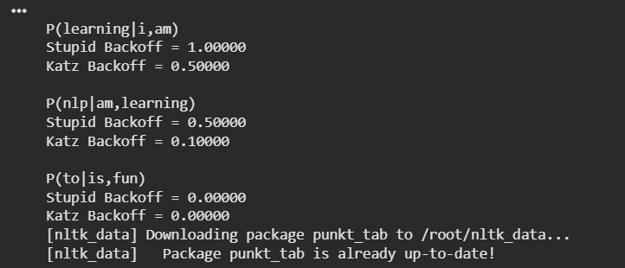

VIVA-VOCE
1. What is Stupid Backoff?
Stupid Backoff is an n-gram smoothing technique that uses the higher-order n-gram when available and backs off to lower-order n-grams when it is unavailable.
The order is:
Trigram→Bigram→Unigram\boxed{Trigram \rightarrow Bigram \rightarrow Unigram}
2. What is the role of α in Stupid Backoff?
α is the discount factor used when backing off to a lower-order model. In our experiment, α = 0.4.
For bigram backoff:
P=αP(w3∣w2)P=\alpha P(w_3|w_2)
For unigram backoff:
P=α2P(w3)P=\alpha^2P(w_3)
3. What is the difference between Stupid Backoff and Katz Backoff?
Stupid Backoff uses a fixed discount factor α, while Katz Backoff uses discounting based on n-gram frequency, commonly using Good-Turing estimates.
Easy to remember:
Stupid Backoff → Fixed α
Katz Backoff → Good-Turing discount
4. Why do we need backoff?
Backoff is needed because many possible n-grams may not occur in the training corpus. Instead of assigning zero probability, the model uses a lower-order n-gram to estimate the value.
—----------------------------------------------------------------------------------------------------------------------------

