Natural Language Processing
LAB TASKS & EXPERIMENTS
EXPERIMENTS:8-10
SUBMITTED BY :
NAME | M.PRAMODH
REGISTER_NO & SECTION | 11249A206 -S2
DATE | 23/10/2026
COURSE | CSE-AI&ML

Experiment 8: Building a POS Tagger
Aim : To implement a Part-of-Speech (POS) tagger using Python and NLTK to assign grammatical categories to words in a sentence.
Program :
import nltk
# Download resources (run once; internet may be required)
nltk.download('punkt')
nltk.download('punkt_tab')
nltk.download('averaged_perceptron_tagger_eng')
sentence = "The intelligent student reads a book."
tokens = nltk.word_tokenize(sentence)
tagged_words = nltk.pos_tag(tokens)
print("Word\tPOS Tag")
print("-" * 25)
for word, tag in tagged_words:
print(f"{word}\t{tag}")

OUTPUT :
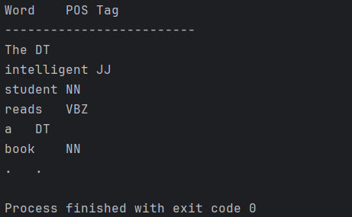
Result :
Grammatical category The POS tagger was implemented using Python and NLTK to tokenize a sentence and assign grammatical tags to its tokens .

Experiment 9: Chunking
Aim :
To understand shallow parsing and identify meaningful phrase groups from POS-tagged text.
PROGRAM :
import nltk
from nltk import RegexpParser
nltk.download('punkt')
nltk.download('averaged_perceptron_tagger_eng')
sentence = input("Enter a sentence: ")
words = nltk.word_tokenize(sentence)
tags = nltk.pos_tag(words)
grammar = """
NP: {<DT>?<JJ>*<NN.*>+}
VP: {<VB.*><NP>?}
"""
parser = RegexpParser(grammar)
result = parser.parse(tags)
print("POS Tags:", tags)
print("Phrase Groups:")
print(result)

OUTPUT :
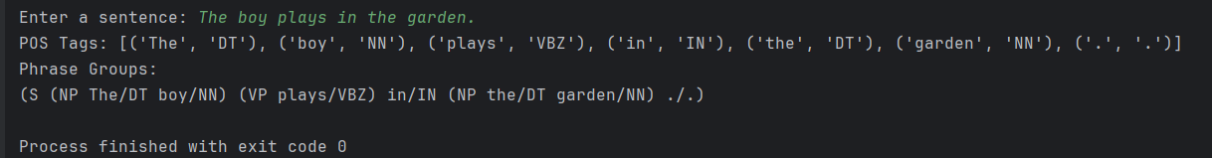
RESULT :
Chunking is Done Using Python.

Experiment 10:
Building a Chunker
AIM :
To implement a rule-based chunker using NLTK RegexpParser to identify noun phrases, verb groups, and prepositional phrases.
PROGRAM :
import nltk
nltk.download('punkt')
nltk.download('punkt_tab')
nltk.download('averaged_perceptron_tagger_eng')
sentence = input("Enter a sentence: ")
tokens = nltk.word_tokenize(sentence)
tagged = nltk.pos_tag(tokens)
grammar = r"""
NP: {<DT>?<JJ.*>*<NN.*>+}
VP: {<MD>?<VB.*>+}
PP: {<IN><NP>}
"""
chunker = nltk.RegexpParser(grammar)
tree = chunker.parse(tagged)
print("POS Tags:", tagged)
print("Chunk Tree:")
print(tree)

OUTPUT :
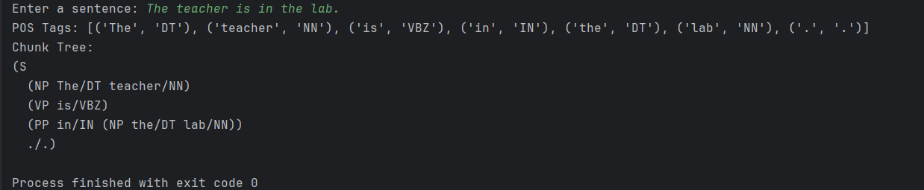
RESULT :
A rule-based chunker was implemented using Python and NLTK. It uses POS tags and regular-expression grammar rules to group tokens into phrase-level chunks

ACTIVITIES :
EXPERIMENT-8:
Activity 1 : POS tag a simple sentence
PROGRAM :
import nltk
nltk.download('punkt')
nltk.download('punkt_tab')
nltk.download('averaged_perceptron_tagger_eng')
sentence = input("Enter a sentence: ")
words = nltk.word_tokenize(sentence)
tags = nltk.pos_tag(words)
print("POS Tags:")
print(tags)
for word, tag in tags:
if tag.startswith('NN'):
print(word, "- Noun")
elif tag.startswith('VB'):
print(word, "- Verb")
elif tag.startswith('RB'):
print(word, "- Adverb")

OUTPUT :
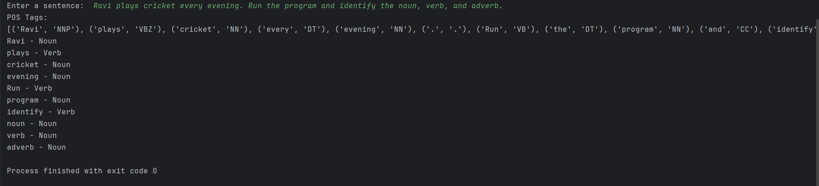
Activity 2: Compare sentences
PROGRAM :
import nltk
nltk.download('punkt')
nltk.download('punkt_tab')
nltk.download('averaged_perceptron_tagger_eng')
sentences = [
"The children are playing outside.",
"She writes beautiful poems.",
"They visited the library yesterday."
]
for sentence in sentences:
print("\nSentence:", sentence)
words = nltk.word_tokenize(sentence)
tags = nltk.pos_tag(words)
print("Tags:", tags)

for word, tag in tags:
if tag.startswith('NN'):
print(word, "- Noun")
elif tag.startswith('VB'):
print(word, "- Verb")
elif tag.startswith('JJ'):
print(word, "- Adjective")
elif tag.startswith('RB'):
print(word, "- Adverb")
elif tag.startswith('PRP'):
print(word, "- Pronoun")
elif tag.startswith('DT'):
print(word, "- Determiner")

OUTPUT :
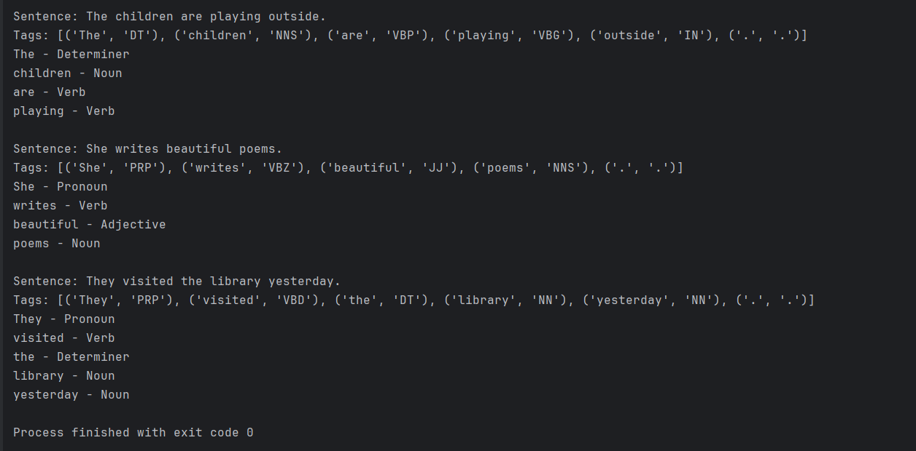

Activity 3: Context-dependent tagging
PROGRAM :
import nltk
nltk.download('punkt')
nltk.download('punkt_tab')
nltk.download('averaged_perceptron_tagger_eng')
sentences = [
"I read a book.",
"Please book a ticket.",
"Children play football.",
"We watched a play."
]
for sentence in sentences:
words = nltk.word_tokenize(sentence)
tags = nltk.pos_tag(words)
print("\nSentence:", sentence)
print(tags)

OUTPUT :
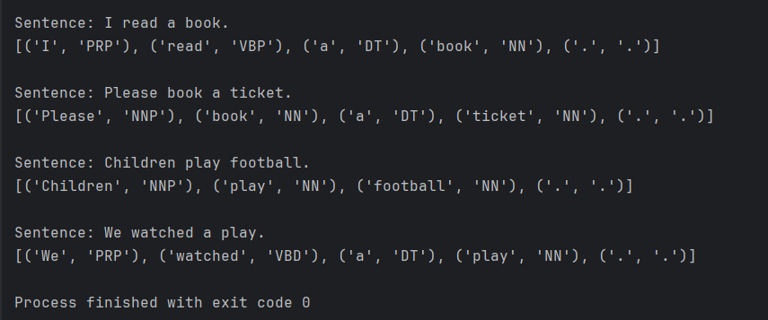
Viva-Voce Questions
• What is POS tagging?
- POS (Part-of-Speech) tagging is the process of assigning grammatical labels, such as noun, verb, adjective, and adverb, to each word in a sentence.
• What is tokenization?
- Tokenization is the process of splitting a sentence into smaller units called tokens, such as words and punctuation marks.
Example: Ravi plays cricket. → ['Ravi', 'plays', 'cricket', '.']
• What is the difference between a noun and a verb tag?
- Noun tag: Identifies a person, place, thing, or idea. Example: student/NN
- Verb tag: Identifies an action or state. Example: plays/VBZ
• What do NN, VBZ, JJ, RB, and DT represent?
- NN: Singular noun — book
- VBZ: Verb in the third-person singular present tense — plays
- JJ: Adjective — beautiful
- RB: Adverb — quickly
- DT: Determiner — the, a
• Why can the same word receive different POS tags in different contexts?
A)The grammatical role of a word depends on how it is used in a sentence.
Example:
- I read a book. — book is a noun (NN).
- Please book a ticket. — book is a verb (VB).

EXPERIMENT-9 :
Activity 1: Identify noun phrases
import nltk
nltk.download('punkt')
nltk.download('punkt_tab')
nltk.download('averaged_perceptron_tagger_eng')
sentences = [
"The tall boy runs fast.",
"A beautiful flower blooms.",
"The computer science student studies NLP."
]
grammar = r"NP: {<DT>?<JJ.*>*<NN.*>+}"
parser = nltk.RegexpParser(grammar)
for sentence in sentences:
words = nltk.word_tokenize(sentence)
tags = nltk.pos_tag(words)
result = parser.parse(tags)
print("\nSentence:", sentence)
print(result)

OUTPUT :
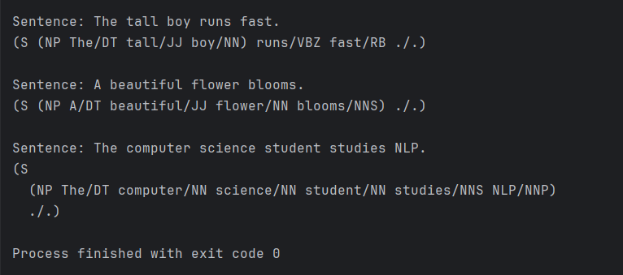
Activity 2: Manual chunking
Given Sentence:
The teacher explains the lesson in the classroom.

Manual Chunking
- Noun Phrase (NP): The teacher
- Noun Phrase (NP): the lesson
- Prepositional Phrase (PP): in the classroom
  - Noun Phrase (NP) inside PP: the classroom
Chunked Sentence :
[NP The teacher] explains [NP the lesson] [PP in [NP the classroom]].
Activity 3: Annotate a sentence
PROGRAM :
import nltk
nltk.download('punkt')
nltk.download('punkt_tab')
nltk.download('averaged_perceptron_tagger_eng')
sentence = input("Enter a sentence: ")
words = nltk.word_tokenize(sentence)
tags = nltk.pos_tag(words)
grammar = r"NP: {<DT>?<JJ.*>*<NN.*>+}"
parser = nltk.RegexpParser(grammar)
print("POS Tags:", tags)
print("Noun Phrases:")
print(parser.parse(tags))

OUTPUT :
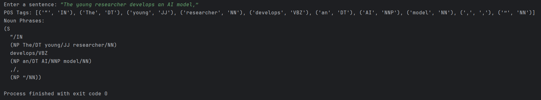
Activity 4: Compare two chunk structures

Chunk Structures :
Sentence 1: “a student”
a — Determiner (DT)
student — Noun (NN)
Sentence 2: “the very intelligent student”
the — Determiner (DT)
very — Adverb (RB)
intelligent — Adjective (JJ)
student — Noun (NN)
Comparison :

Feature | a student | the very intelligent student
Determiner | a | the
Adjective | None | intelligent
Adverb | None | very
Noun | student | student
Noun phrase | a student | the very intelligent student
Viva-Voce Questions :
• What is chunking in NLP?
- Chunking is the process of grouping words into meaningful phrases, such as noun phrases (NP), verb phrases (VP), and prepositional phrases (PP).
• Why is chunking called shallow parsing?
- Chunking is called shallow parsing because it identifies basic phrase groups without analyzing the complete grammatical structure of a sentence.
• What is the difference between an NP and a PP?
- NP (Noun Phrase): A group of words centered around a noun. Example: the intelligent student.
PP (Prepositional Phrase): A group of words beginning with a preposition. Example: in the classroom.

• How does POS tagging support chunking?
- POS tagging assigns grammatical labels to words, such as noun, verb, adjective, and determiner. Chunking uses these tags to identify meaningful phrase groups.
• How does chunking differ from full syntactic parsing?
- Chunking identifies basic phrases without showing their complete grammatical relationships, whereas full syntactic parsing analyzes the entire sentence structure and relationships between its components .

Experiment 10:
Activity 1: Changing the input
import nltk
nltk.download('punkt')
nltk.download('punkt_tab')
nltk.download('averaged_perceptron_tagger_eng')
sentence = input("Enter a sentence: ")
words = nltk.word_tokenize(sentence)
tags = nltk.pos_tag(words)
grammar = r"""
NP: {<DT>?<JJ.*>*<NN.*>+}
VP: {<MD>?<VB.*>+}
PP: {<IN><NP>}
"""
parser = nltk.RegexpParser(grammar)
result = parser.parse(tags)
print("POS Tags:", tags)
print("Chunk Tree:")
print(result)

OUTPUT :
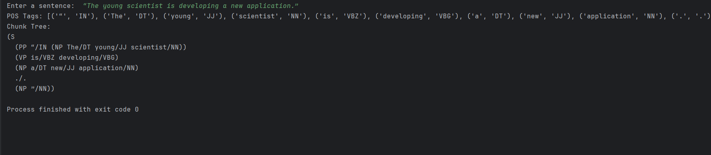
Activity 2: Extend the noun phrase rule
import nltk
nltk.download('punkt')
nltk.download('punkt_tab')
nltk.download('averaged_perceptron_tagger_eng')
sentence = input("Enter a sentence: ")
words = nltk.word_tokenize(sentence)
tags = nltk.pos_tag(words)
grammar = r"""
NP: {<DT|PRP\$>?<JJ.*>*<NN.*>+}
VP: {<VB.*>+}
"""
parser = nltk.RegexpParser(grammar)
result = parser.parse(tags)
print("POS Tags:", tags)
print("Chunk Tree:")
print(result)

OUTPUT :
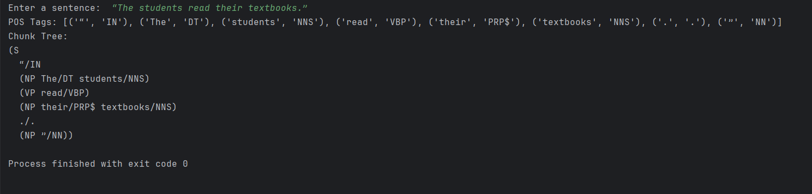

Activity 3: Compare grammar rules
PROGRAM :
import nltk
nltk.download('punkt')
nltk.download('punkt_tab')
nltk.download('averaged_perceptron_tagger_eng')
sentence = input("Enter a sentence: ")
words = nltk.word_tokenize(sentence)
tags = nltk.pos_tag(words)
np_grammar = r"NP: {<DT>?<JJ.*>*<NN.*>+}"
full_grammar = r"""
NP: {<DT>?<JJ.*>*<NN.*>+}
VP: {<VB.*>+}
PP: {<IN><NP>}
"""
print("NP Only:")
print(nltk.RegexpParser(np_grammar).parse(tags))
print("\nNP + VP + PP:")
print(nltk.RegexpParser(full_grammar).parse(tags))

OUTPUT :
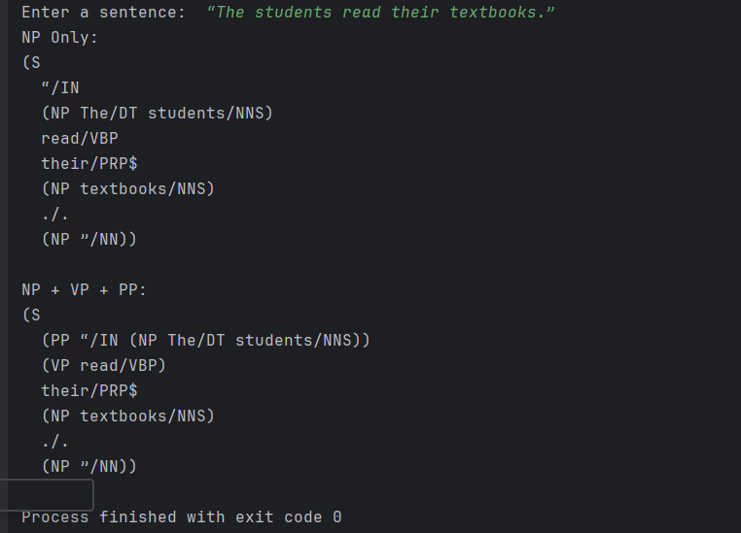
Activity 4: Campus sentence mini-project
PROGRAM :
import nltk
nltk.download('punkt')
nltk.download('punkt_tab')
nltk.download('averaged_perceptron_tagger_eng')
sentences = [
"The student reads a book in the library.",
"The professor teaches computer science.",
"Students play games on the playground.",
"The librarian works in the library.",
"The teacher explains the lesson in the classroom."
]
grammar = r"""
NP: {<DT>?<JJ.*>*<NN.*>+}
VP: {<VB.*>+}
PP: {<IN><NP>}
"""
parser = nltk.RegexpParser(grammar)
for sentence in sentences:
words = nltk.word_tokenize(sentence)
tags = nltk.pos_tag(words)
result = parser.parse(tags)
print("\nSentence:", sentence)
print(result)

OUTPUT :
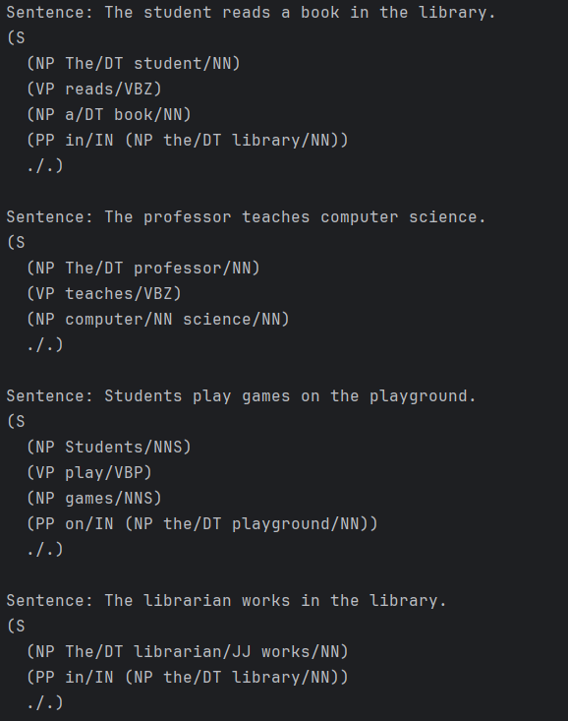
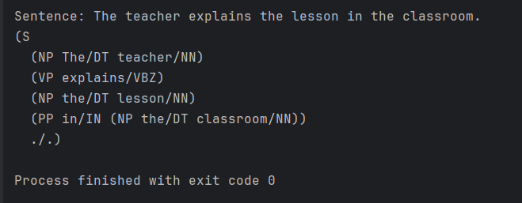
Activity 5: Error analysis
Input Sentence :
The intelligent student is studying NLP.
Existing Grammar :
grammar = r"""
NP: {<DT>?<JJ.*>*<NN.*>+}
VP: {<VB.*>+}
PP: {<IN><NP>}
"""
Incorrect Output :
(S
(NP The/DT intelligent/JJ student/NN)
(VP is/VBZ)
(VP studying/VBG)
(NP NLP/NNP)
./.)
Error identified: The verb phrase “is studying” is split into two separate chunks instead of being grouped together.
Improved Grammar :
grammar = r"""
NP: {<DT>?<JJ.*>*<NN.*>+}
VP: {<VB.*><VB.*>*}
PP: {<IN><NP>}
"""
Expected Improved Output :
(S
(NP The/DT intelligent/JJ student/NN)
(VP is/VBZ studying/VBG)
(NP NLP/NNP)
./.)

Explanation
The original rule groups consecutive verbs separately because the auxiliary verb is and the main verb studying have different POS tags. The improved rule allows multiple consecutive verb tags, so they can form one VP.
Limitation: Regular-expression chunking uses local POS-tag patterns and cannot reliably identify every grammatical phrase. More complex rules may be needed for sentences with adverbs, objects, or other auxiliary constructions.
Result: The VP grammar is improved to recognize the phrase “is studying” as one verb phrase.
Viva-Voce Questions
• What is NLTK RegexpParser?
- RegexpParser is an NLTK tool that uses regular-expression grammar rules to identify phrase groups, such as noun phrases and verb phrases.
• How is a chunk grammar specified?
- A chunk grammar is specified using POS-tag patterns inside curly braces.
EXAMPLE : grammar = r"NP: {<DT>?<JJ>*<NN>}"
• What do ?, *, and + mean in regular expressions?
- ? — Matches zero or one occurrence (optional).
* — Matches zero or more occurrences.
+ — Matches one or more occurrences
• Why must POS tagging usually be performed before chunking?
- POS tagging provides grammatical labels for words. The chunker uses these labels to identify phrase structures according to grammar rules.
• What are the limitations of a rule-based chunker?
A) It depends on manually written grammar rules.
It may miss complex phrases.
It may incorrectly group words.
It cannot easily handle every sentence structure.

• How could a statistical or machine-learning chunker differ from this implementation?
A ) A rule-based chunker uses manually defined patterns, whereas a statistical or machine-learning chunker learns patterns from annotated training data. It can recognize more complex structures but requires suitable training data and computational resources.

