Natural language Processing
Lab Activity & Experiments
POS TAGGING
Submitted BY :
Field | Details
Course | Natural Language Processing Laboratory
Student Name | M.Pramodh
REG.NO & SEC | 11249A206 / S2-Section
DATE | 09/10/2026

Experiment-1:
Word Classes and Introduction to Part-of-Speech Tagging
Program :
import nltk
from nltk import word_tokenize, pos_tag
# Download required resources
nltk.download('punkt')
nltk.download('punkt_tab')
nltk.download('averaged_perceptron_tagger_eng')
sentence = input("Enter a sentence: ")
tokens = word_tokenize(sentence)
tagged = pos_tag(tokens)
print("\nWord\tPOS Tag")
print("-" * 30)
for word, tag in tagged:
print(word, "\t", tag)

Output :
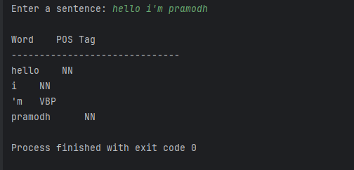

Experiment-2:
Rule-Based Part-of-Speech Tagging
Program :
import nltk
from nltk import word_tokenize
from nltk.tag import RegexpTagger
nltk.download('punkt')
nltk.download('punkt_tab')
# Define rules
patterns = [
(r'.*ing$', 'VBG'),
(r'.*ed$', 'VBD'),
(r'.*ly$', 'RB'),
(r'(The|the|A|a|An|an)$', 'DT'),
(r'(in|on|at|of|for|with)$', 'IN'),
(r'.*s$', 'NNS'),
(r'.*', 'NN')
]

tagger = RegexpTagger(patterns)

sentence = input("Enter a sentence: ")
tokens = word_tokenize(sentence)

tagged = tagger.tag(tokens)

print("\nWord\tPOS Tag")
print("-" * 30)

for word, tag in tagged:
print(word, "\t", tag)

Output:
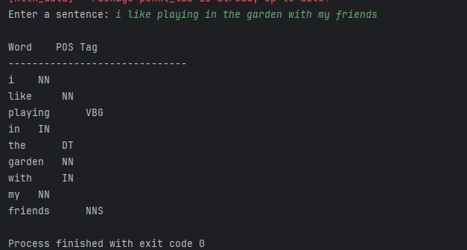
Experiment-3:
Stochastic (Probabilistic) Part-of-Speech Tagging
Program :
import nltk
from nltk.corpus import brown
from nltk import UnigramTagger, BigramTagger, word_tokenize

# Download required resources
nltk.download('brown')
nltk.download('punkt')
nltk.download('punkt_tab')

# Load the Brown corpus
tagged_sentences = brown.tagged_sents(categories='news')

# Split data into training and testing sets
size = int(len(tagged_sentences) * 0.9)
train_data = tagged_sentences[:size]
test_data = tagged_sentences[size:]

# Train the Unigram Tagger
unigram_tagger = UnigramTagger(train_data)

# Train the Bigram Tagger
bigram_tagger = BigramTagger(train_data, backoff=unigram_tagger)

# Calculate accuracy
accuracy = bigram_tagger.accuracy(test_data)
print("Tagger Accuracy:", round(accuracy * 100, 2), "%")

# Get input from the user
sentence = input("\nEnter a sentence: ")
tokens = word_tokenize(sentence)

# Perform POS tagging
result = bigram_tagger.tag(tokens)

print("\nWord\tPOS Tag")
print("-" * 30)

for word, tag in result:
print(word, "\t", tag)

Output:
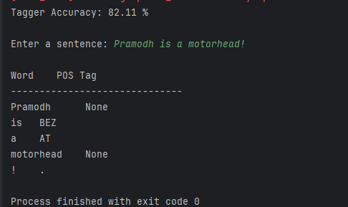
Experiment-4:
Transformation-Based Tagging (Brill Tagger)
Program:
import nltk
from nltk.corpus import brown
from nltk import UnigramTagger, word_tokenize
from nltk.tag import brill, brill_trainer

# Download required resources
nltk.download('brown')
nltk.download('punkt')
nltk.download('punkt_tab')

# Load the Brown corpus
tagged_sentences = brown.tagged_sents(categories='news')

# Split into training and testing data
size = int(len(tagged_sentences) * 0.9)
train_data = tagged_sentences[:size]
test_data = tagged_sentences[size:]

# Create baseline tagger
baseline_tagger = UnigramTagger(train_data)
print("Baseline Accuracy:",
round(baseline_tagger.accuracy(test_data) * 100, 2), "%")

# Define transformation rule templates
templates = brill.brill24()

# Train the Brill tagger
trainer = brill_trainer.BrillTaggerTrainer(
baseline_tagger, templates, trace=0
)
brill_tagger = trainer.train(train_data, max_rules=20)

# Evaluate accuracy
print("Brill Tagger Accuracy:",
round(brill_tagger.accuracy(test_data) * 100, 2), "%")

# Get input from the user
sentence = input("\nEnter a sentence: ")
tokens = word_tokenize(sentence)

# Perform POS tagging
tagged_output = brill_tagger.tag(tokens)

print("\nWord\tPOS Tag")
print("-" * 30)

for word, tag in tagged_output:
print(word, "\t", tag)

Output:
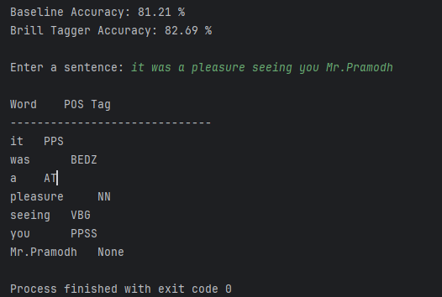
Experiment-5a:
Issues in PoS Tagging & Tagging using Hidden Markov Model (HMM)
Program :
import nltk
import numpy as np
from nltk.corpus import brown
from nltk.tag import hmm

# Download Brown corpus
nltk.download('brown')

# Load tagged sentences
tagged_sentences = brown.tagged_sents(categories='news')

# Split data into training and testing sets
size = int(len(tagged_sentences) * 0.9)
train_data = tagged_sentences[:size]
test_data = tagged_sentences[size:]

# Train HMM tagger
trainer = hmm.HiddenMarkovModelTrainer()
hmm_tagger = trainer.train_supervised(train_data)

# Calculate accuracy
accuracy = hmm_tagger.accuracy(test_data)
print("HMM Tagger Accuracy:", round(accuracy * 100, 2), "%")

# Get sentence input from user
sentence = input("\nEnter a sentence: ")
tokens = sentence.split()

# Perform POS tagging
tagged_output = hmm_tagger.tag(tokens)

# Display output
print("\nWord\tPOS Tag")
print("-" * 30)

for word, tag in tagged_output:
print(word, "\t", tag)

Output:
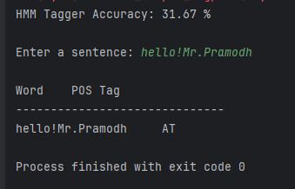
Experiment-5b :
Program:
# Hidden Markov Model using Viterbi Algorithm
states = ['DT', 'NN', 'VB']

start_p = {
'DT': 0.6,
'NN': 0.3,
'VB': 0.1
}

trans_p = {
'DT': {'DT': 0.05, 'NN': 0.85, 'VB': 0.10},
'NN': {'DT': 0.10, 'NN': 0.30, 'VB': 0.60},
'VB': {'DT': 0.40, 'NN': 0.50, 'VB': 0.10}
}

emit_p = {
'DT': {'the': 0.7, 'a': 0.3},
'NN': {'dog': 0.4, 'cat': 0.4, 'bites': 0.05, 'runs': 0.15},
'VB': {'bites': 0.6, 'runs': 0.4}
}

def viterbi(obs, states, start_p, trans_p, emit_p):
V = [{}]
path = {}

# Initialization
for st in states:
V[0][st] = start_p[st] * emit_p[st].get(obs[0], 1e-6)
path[st] = [st]

# Recursion
for t in range(1, len(obs)):
V.append({})
new_path = {}

for cur in states:
best_prob, best_prev = max(
(
V[t - 1][prev]
* trans_p[prev][cur]
* emit_p[cur].get(obs[t], 1e-6),
prev
)
for prev in states
)

V[t][cur] = best_prob
new_path[cur] = path[best_prev] + [cur]

path = new_path

# Termination
n = len(obs) - 1
best_final_prob, best_final_st = max(
(V[n][st], st) for st in states
)

return best_final_prob, path[best_final_st]

# Get input from the user
sentence = input("Enter words (example: the dog bites): ")
words = sentence.lower().split()

prob, tag_sequence = viterbi(
words, states, start_p, trans_p, emit_p
)

print("Sentence:", words)
print("Best Tag Sequence:", tag_sequence)
print("Probability:", format(prob, ".6f"))

Output:
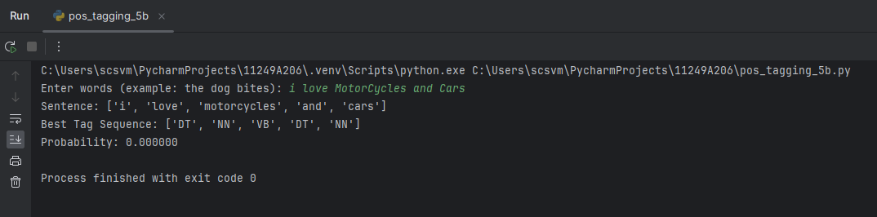

LAB ACTIVITIES :
Lab Activity 1: Exploring Word Classes and Basic PoS Tagging
Program :
import nltk
from nltk import word_tokenize, pos_tag

nltk.download('punkt')
nltk.download('punkt_tab')
nltk.download('averaged_perceptron_tagger')
nltk.download('averaged_perceptron_tagger_eng')

sentence = "The little girl quickly finished her homework before dinner."

tokens = word_tokenize(sentence)
tagged = pos_tag(tokens)

for word, tag in tagged:
print(word, "->", tag)

Output:
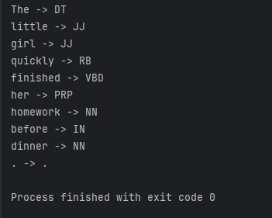

Lab Activity 2: Building a Rule-Based PoS Tagger
Program :
import nltk
from nltk import word_tokenize
from nltk.tag import RegexpTagger

nltk.download('punkt')
nltk.download('punkt_tab')

patterns = [
(r'.*ing$', 'VBG'),
(r'.*ed$', 'VBD'),
(r'.*ly$', 'RB'),
(r'.*ous$', 'JJ'),
(r'.*ment$', 'NN'),
(r'.*ness$', 'NN'),
(r'.*', 'NN')
]

tagger = RegexpTagger(patterns)

paragraph = "The scientists carefully examined the newly discovered species. They quickly noted its unusual behaviour and recorded their findings in a detailed report."

tokens = word_tokenize(paragraph)
tagged = tagger.tag(tokens)

for word, tag in tagged:
print(word, "->", tag)

Output :
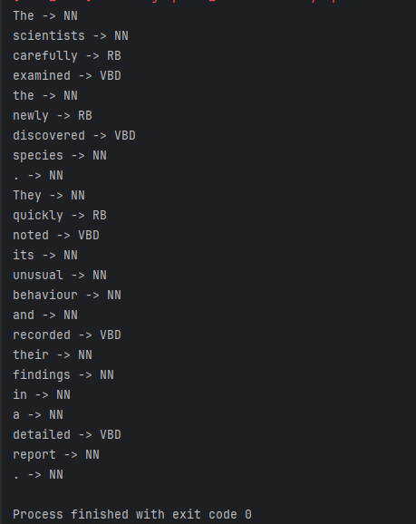

Lab Activity 3: Stochastic PoS Tagging and Accuracy Evaluation
Program :
import nltk
from nltk.corpus import brown
from nltk import UnigramTagger, BigramTagger

nltk.download('brown')

categories = ['news', 'romance']
training_sizes = [0.9, 0.5]

for category in categories:
print("\nCategory:", category)

tagged_sentences = brown.tagged_sents(categories=category)

for train_percent in training_sizes:
size = int(len(tagged_sentences) * train_percent)

train_data = tagged_sentences[:size]
test_data = tagged_sentences[size:]

unigram_tagger = UnigramTagger(train_data)
bigram_tagger = BigramTagger(
train_data, backoff=unigram_tagger
)

print("\nTraining percentage:", train_percent * 100, "%")
print("Unigram accuracy:", unigram_tagger.accuracy(test_data))
print("Bigram accuracy :", bigram_tagger.accuracy(test_data))

Output :
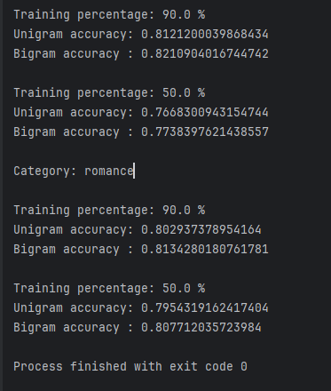
Lab Activity 4: Transformation-Based (Brill) Tagging
Program :
import nltk
from nltk.corpus import brown
from nltk import UnigramTagger
from nltk.tag import brill, brill_trainer

nltk.download('brown')

# Load Brown corpus
tagged_sentences = brown.tagged_sents(categories='news')

# Split into training and testing data
size = int(len(tagged_sentences) * 0.9)
train_data = tagged_sentences[:size]
test_data = tagged_sentences[size:]

# Create baseline tagger
baseline_tagger = UnigramTagger(train_data)

# Create Brill transformation templates
templates = brill.brill24()

# Train and evaluate Brill taggers
print("Baseline accuracy:", baseline_tagger.accuracy(test_data))

for max_rules in [10, 30]:
trainer = brill_trainer.BrillTaggerTrainer(
baseline_tagger,
templates,
trace=1
)

brill_tagger = trainer.train(
train_data,
max_rules=max_rules
)

baseline_accuracy = baseline_tagger.accuracy(test_data)
brill_accuracy = brill_tagger.accuracy(test_data)

improvement = (brill_accuracy - baseline_accuracy) * 100

print("\nMaximum rules:", max_rules)
print("Brill accuracy:", brill_accuracy)
print("Improvement (percentage points):", improvement)

print("\nLearned rules:")
for rule in brill_tagger.rules()[:5]:
print(rule)

# Test sentence
sentence = "They will fish for hours near the river bank"

print("\nTest sentence:")
print(baseline_tagger.tag(sentence.split()))

print("\nBrill tagged sentence (max_rules = 30):")
print(brill_tagger.tag(sentence.split()))

Output :
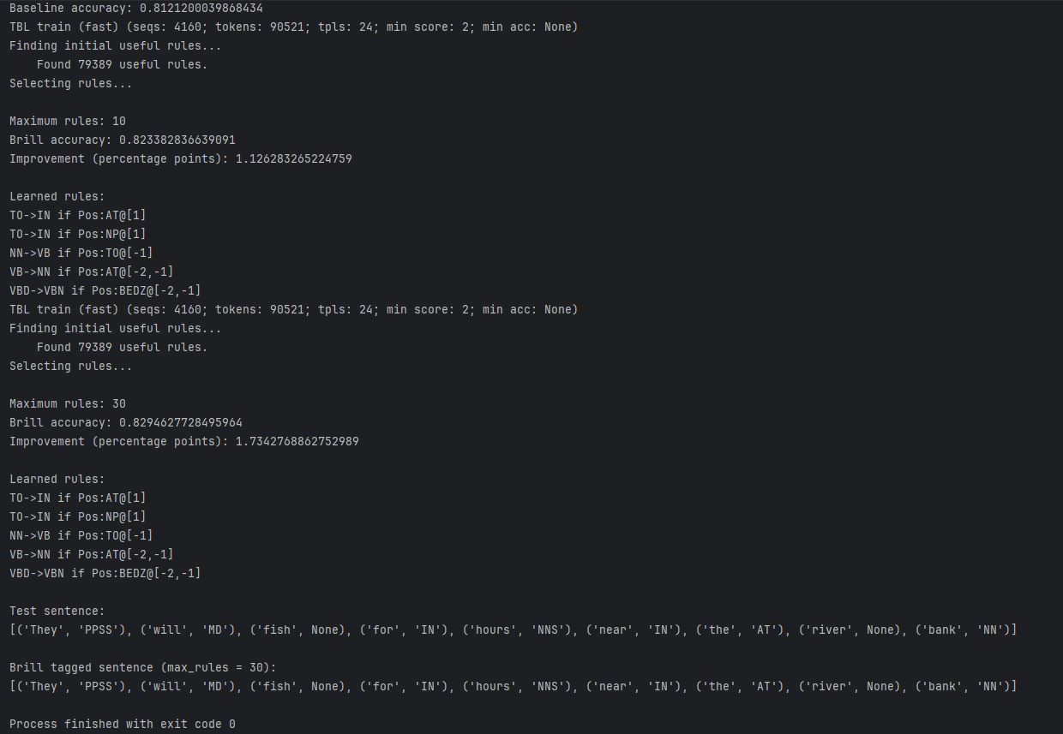
Lab Activity 5: Investigating Issues in PoS Tagging + HMM/Viterbi Tagging
5a :
Program :
import nltk
from nltk.corpus import brown
from nltk import UnigramTagger, word_tokenize

nltk.download('brown')
nltk.download('punkt')
nltk.download('punkt_tab')

data = brown.tagged_sents(categories='news')
tagger = UnigramTagger(data[:int(len(data)*0.9)])

sentences = [
"I saw her duck under the table and duck the flying ball.",
"Zorblax entered the room.",
"OMG this movie is lit "
]

for sentence in sentences:
print("\n", sentence)
print(tagger.tag(word_tokenize(sentence)))

Output :
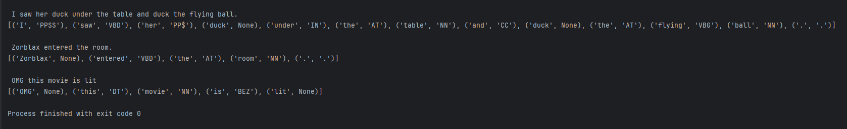
5b :
Program :
start = {'DT': 0.6, 'NN': 0.3, 'VB': 0.1}
emit = {'a': 'DT', 'cat': 'NN', 'runs': 'VB'}

words = ['a', 'cat', 'runs']

for word in words:
print(word, "->", emit[word])

Output :
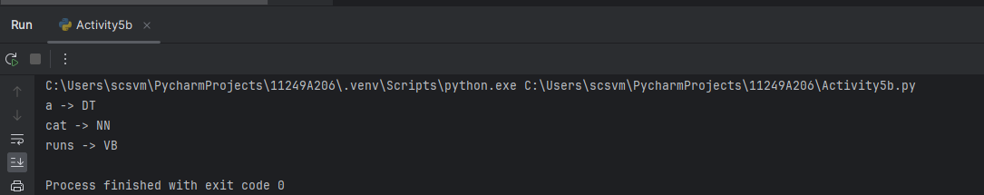
Viva-Voce

1. What is a word class? Give examples of open and closed word classes. A word class is a group of words with similar grammatical functions.
- Open: Nouns, verbs, adjectives, adverbs.
- Closed: Pronouns, prepositions, conjunctions, articles.
2. Define Part-of-Speech tagging. PoS tagging is assigning grammatical labels, such as noun, verb, and adjective, to words in a sentence.
3. Why is PoS tagging considered a disambiguation problem? Because a word can have different grammatical roles depending on the context. Example: book can be a noun or a verb.
4. What tag set does NLTK's default tagger use? NLTK's pos_tag() uses the Penn Treebank tag set by default.
5. List any five Penn Treebank PoS tags with examples.
- NN – Noun: book
- VB – Verb: run
- JJ – Adjective: good
- RB – Adverb: quickly
- PRP – Pronoun: he
Exp-2

1. What is Rule-Based PoS tagging? It assigns tags to words using predefined linguistic rules.
2. Name a well-known rule-based tagger and describe its two-stage architecture. The Brill tagger uses two stages: an initial tagger assigns tags, then transformation rules correct errors.
3. What are the advantages and limitations of rule-based tagging? Advantages: Easy to understand and uses linguistic rules. Limitations: Requires manual rules and may not handle all contexts.
4. How does a regular-expression tagger decide the tag of an unseen word? It matches the word against predefined patterns and assigns the corresponding tag.
5. Why is a default tag (e.g., NN) required at the end of the rule list? It assigns a tag when no other rule matches, preventing words from remaining untagged.
Exp-3

1. What is a stochastic tagger and how does it differ from a rule-based tagger? A stochastic tagger uses probabilities to assign tags. A rule-based tagger uses predefined linguistic rules.
2. Define emission probability and transition probability.
- Emission probability: Probability of a word given its tag.
- Transition probability: Probability of a tag given the previous tag.
3. What is the concept of backoff in NLTK taggers? Backoff uses another tagger when the current tagger cannot assign a tag.
4. Why is a large annotated corpus required for stochastic tagging? It helps estimate accurate probabilities from many examples of words and tags.
5. What is Maximum Likelihood Estimation (MLE) in PoS tagging? MLE estimates probabilities from observed frequencies in the training corpus.
Exp-4

Who introduced Transformation-Based Learning and in which year? Eric Brill introduced it in 1993.
2. What are the two parts of a transformation rule in Brill tagging? The condition and the action.
3. How does Brill tagging combine rule-based and stochastic methods? It uses an initial tagger and learns rules from training data to correct tagging errors.
4. What is a template in the Brill tagger? A template defines the patterns used to create transformation rules.
5. What is the main advantage of transformation-based tagging over purely rule-based tagging? It automatically learns correction rules from data, reducing manual rule writing.
Exp-5
1. What are hidden states and observations in an HMM applied to PoS tagging? Hidden states: PoS tags (noun, verb, etc.). Observations: Words in a sentence.
2. State the two independence assumptions made by an HMM tagger.
- Each tag depends only on the previous tag.
- Each word depends only on its current tag.
3. Why is the Viterbi algorithm preferred over exhaustively enumerating all tag sequences? It efficiently finds the most probable tag sequence without checking every possible sequence.
4. What is the time complexity of the Viterbi algorithm? O(TN2)O(TN^2)O(TN2), where TTT is the number of words and NNN is the number of tags.
5. List any four major issues encountered in Part-of-Speech tagging.
- Lexical ambiguity
- Unknown words
- Data sparsity
- Contextual ambiguity
6. How does smoothing help in handling data sparsity in HMM-based tagging? Smoothing assigns non-zero probabilities to unseen events, improving tagging accuracy.

Lab Activity Post Lab Questions:
1. Manual guess vs tagger: My manual guess differed for ambiguous words because their tags depend on the sentence context.
2. Same word, two word classes:
- I book a ticket. — Book: Verb (VB)
- I read a book. — Book: Noun (NN)
3. Most frequent open-class category: Noun (NN), depending on the test sentences.
Activity-2
1. Wrong words: “are” was tagged as NN instead of a verb because the rules lacked a specific rule for auxiliary verbs.
2. More rules: No. Conflicting rules can reduce accuracy. For example, a word ending in “s” may match both a plural noun rule and a verb rule.
3. Suffix-based limitation: “book” cannot be correctly tagged using suffixes alone because it can be a noun or a verb depending on context.

Activity-3
1. Accuracy decreased when the training data was reduced from 90% to 50% because the tagger learned from fewer examples and had less information to predict tags correctly.
2. A backoff tagger helps the Bigram tagger handle words or tag sequences it has not seen during training. It uses a simpler tagger, such as a unigram or default tagger, when the Bigram tagger cannot provide a tag.
3. No, the tagger did not perform equally well on a different category. A tagger trained on news text may perform worse on another category because vocabulary and tagging patterns differ. This shows domain dependence: tagging accuracy depends on how similar the test text is to the training data.

Activity-4
1. Accuracy may plateau when increasing max_rules from 10 to 30 because the most useful rules are learned first. Additional rules may provide little improvement or correct only a few errors.
2. Example learned rule: Change a noun tag to a verb tag when the previous word is “to.” This corrects mistakes such as tagging play as a noun in “to play.”
3. A Brill-tagger rule is learned automatically from training data to correct tagging errors, whereas a rule in Activity 2 is written manually by the programmer based on patterns or grammar.
Activity-5
1. Three issues in PoS tagging and mitigation:
- Ambiguity: Use the surrounding context to choose the correct tag.
- Unknown words: Use smoothing or a suffix-based fallback tagger.
- Data sparsity: Use more training data and smoothing techniques.
2. No, not always. A greedy method chooses the best tag for each word independently of future choices, while Viterbi finds the most probable complete tag sequence. Therefore, Viterbi may produce a better overall sequence.
3. If a test word has zero entries in emit_p, its emission probability becomes zero, making the entire sequence probability zero for that path. This can be addressed using Laplace (add-one) smoothing or another smoothing technique.
4. HMM + Viterbi tagging uses probabilities and context to select the most likely sequence of tags. It handles ambiguous words better than simple rule-based tagging by considering both transition and emission probabilities. Smoothing helps deal with unseen words or rare word-tag combinations. Therefore, it can be more flexible when processing different sentences, although its performance depends on the training data.

