EXPNO:01 DATE:05-02-26
INTRODUCTION TO PYTHON LIBRARIS FOR DATA SCIENCE
AIM: To learn basic python libraries for data science (numPy,Pandas,Matplotlib,Scikit learn)
PROGRAM:

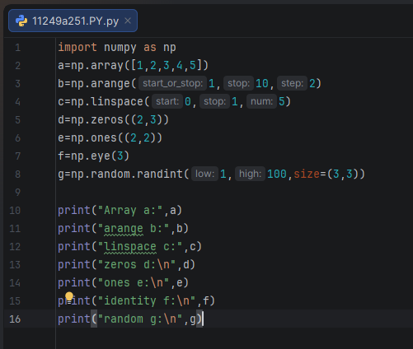
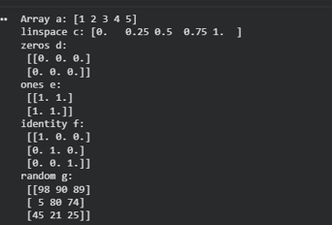

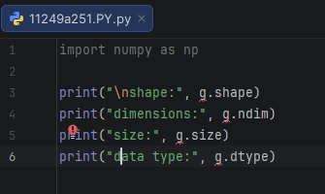

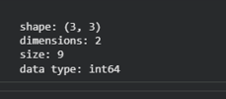
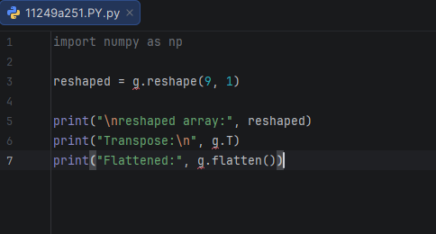

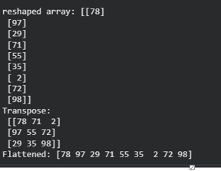

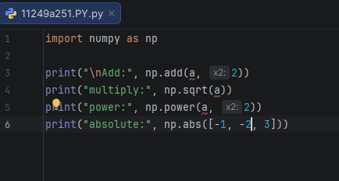

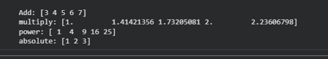
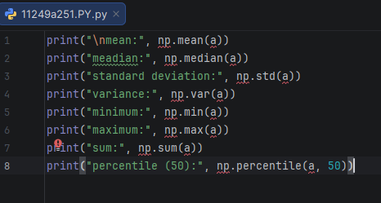

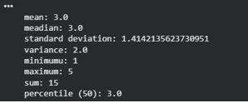
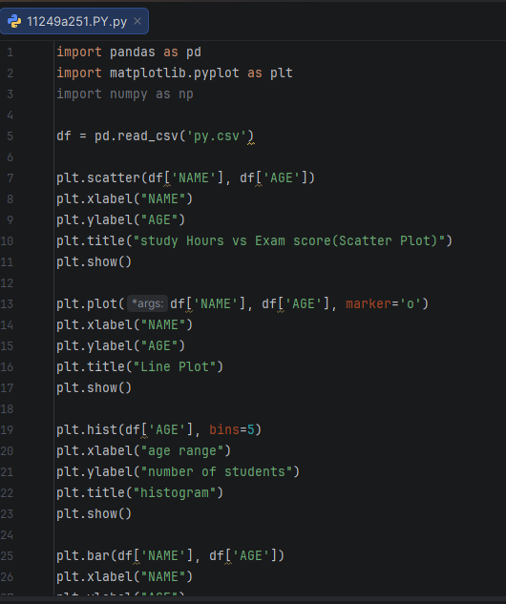

OUTPUT:

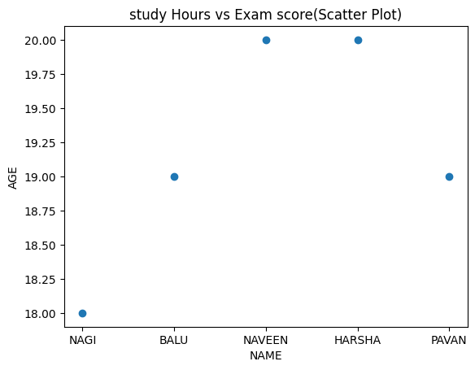

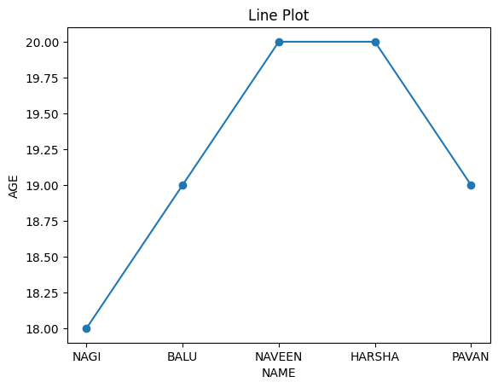

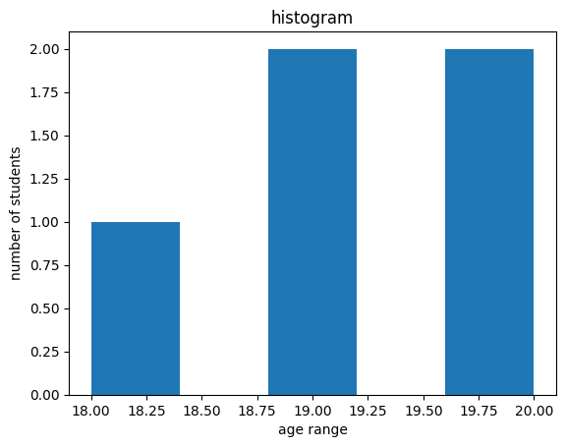

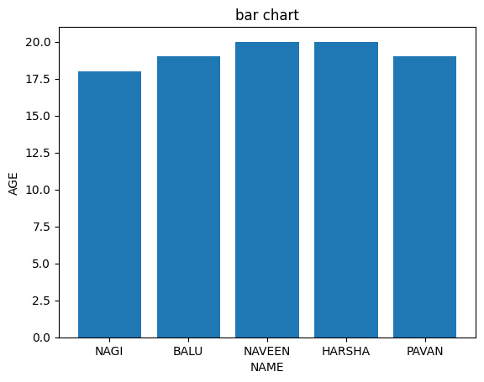
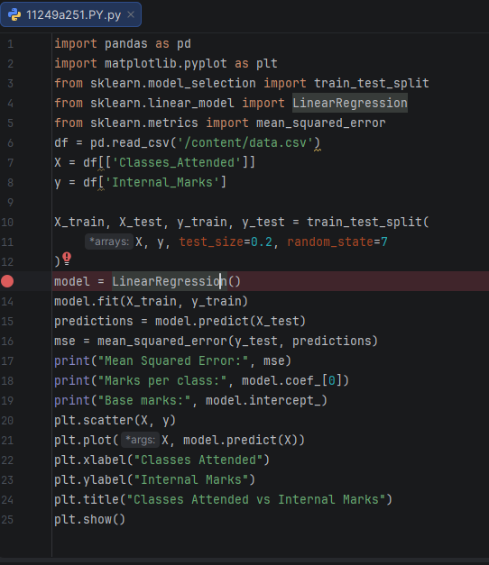

OUTPUT:
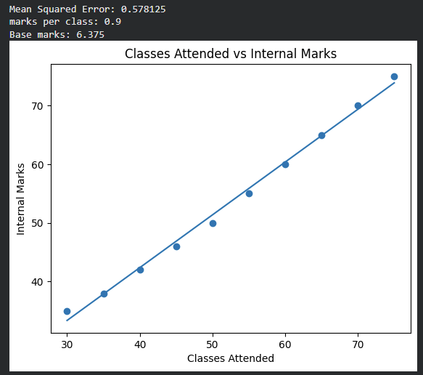
Result: Basic operations using these libraries were performed successfully

Ex No:02 Date:12-02-26
Perform Data exploration and preprocessing in Python

Aim:To perform data exploration and preprocessing in Python.

Program:

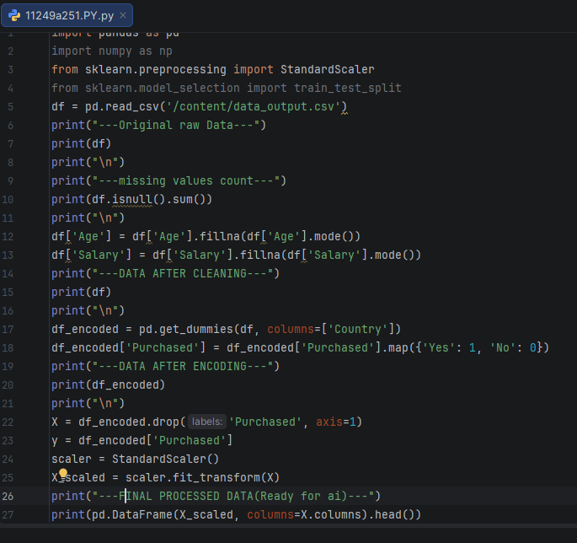

OUTPUT:
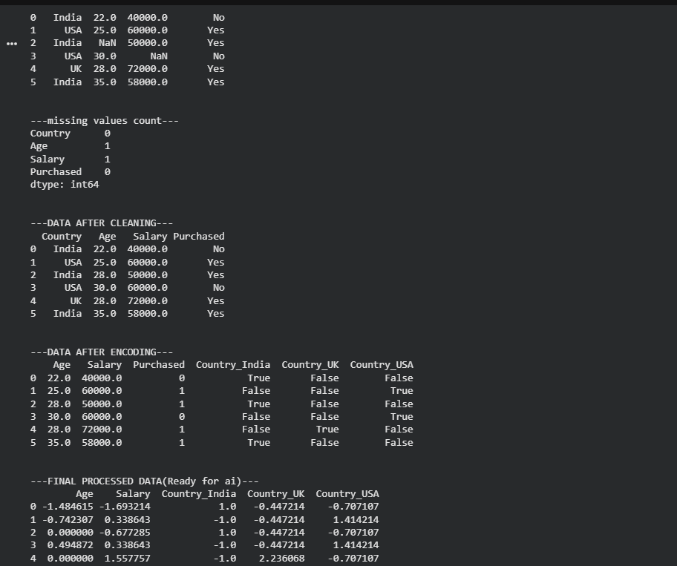
Result: Basic operations using these libraries were performed successfully

EXPERIMENT 3 DATE:19/3/26

Implement regularised Linear regression

Aim:To implement regularized linear regression to improve model performance and control overfitting.

Program:

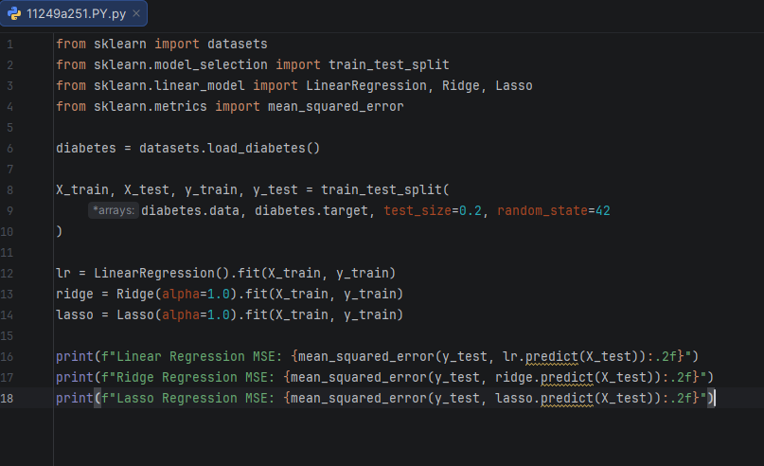

Result:The model was successfully implemented, and regularization helped reduce overfitting and improved prediction accuracy.

Ex No:04 Date:05-02-26

Implement Naive Bayes classifier for dataset stored as CSV file

Aim:
To implement the Naive Bayes classifier using a dataset stored in a CSV file for classification.

Program:

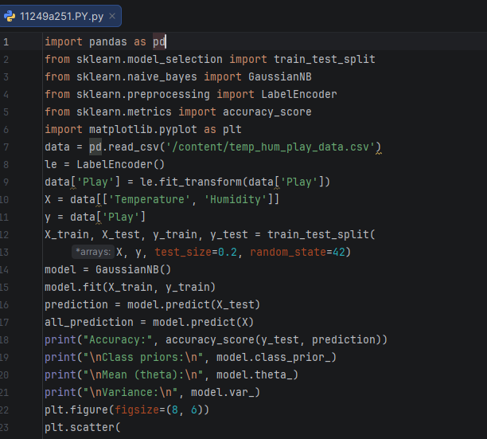

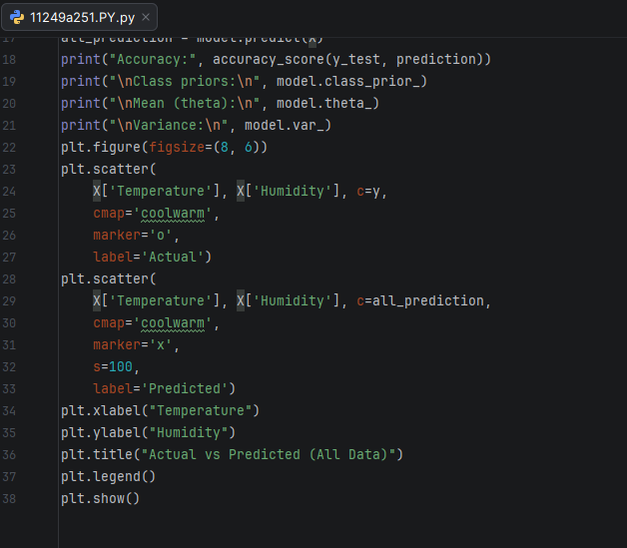
OUTPUT:
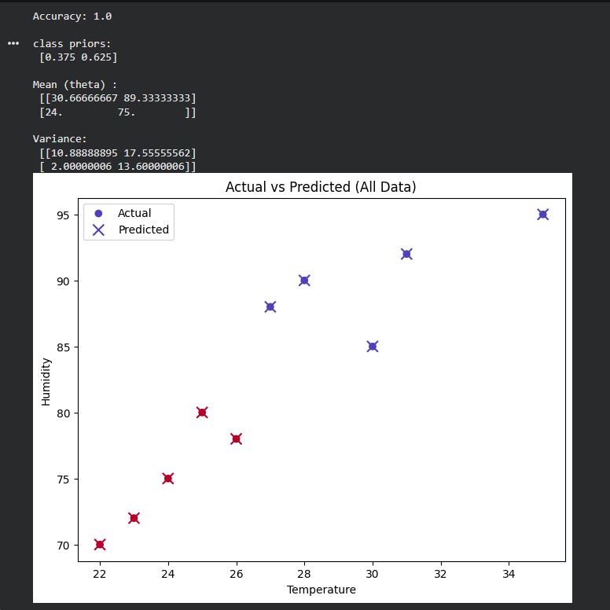

Result:
The Naive Bayes model was successfully implemented, and it effectively classified the data with good accuracy.

Ex No:05 Date:05-03-26

Implement regularized logistic regression

Aim:
To implement regularized logistic regression for classification while reducing overfitting.

Program:

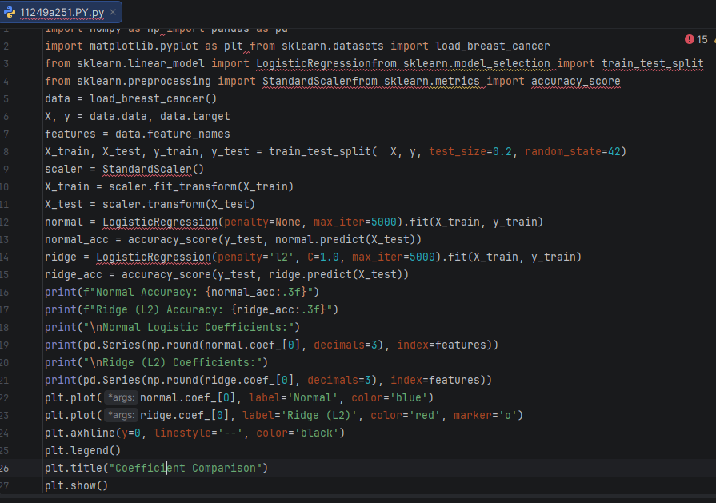

OUTPUT:
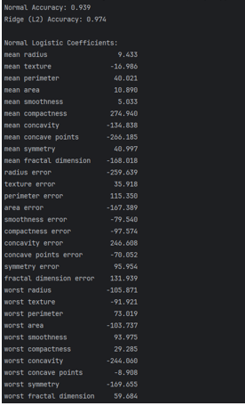
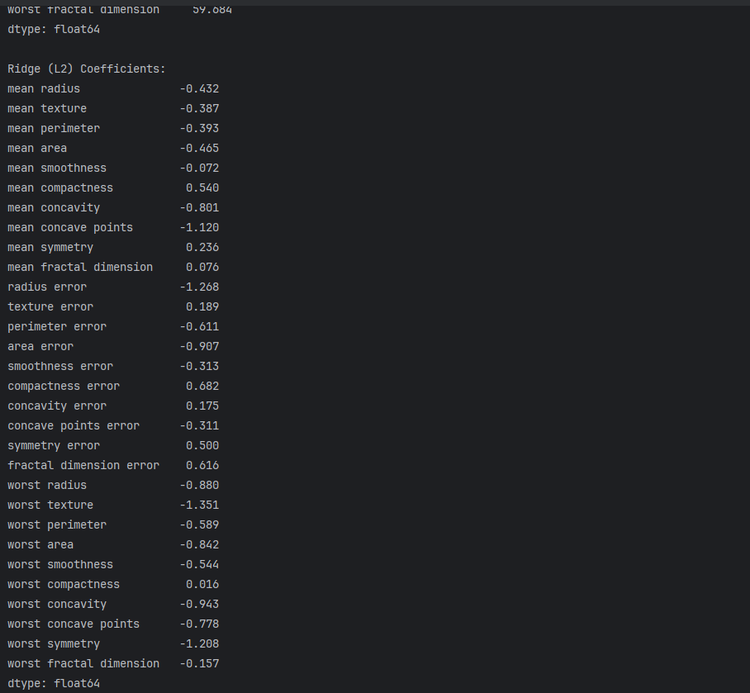
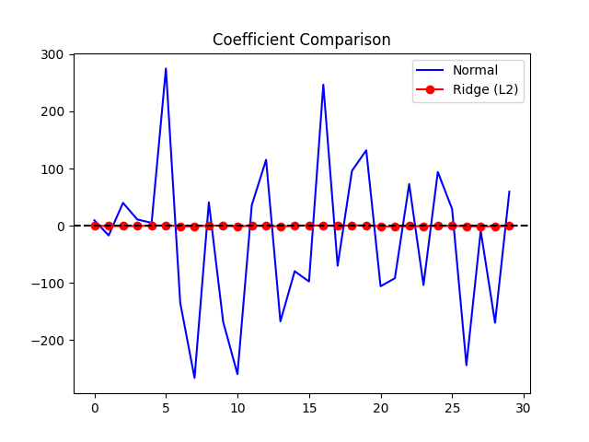
Result:
The model was successfully implemented, and regularization improved accuracy and prevented overfitting.

Ex No:06 Date:12-03-26

Build models using different Ensembling techniques
Aim:
To build models using different ensembling techniques to improve prediction performance
PROGRAM

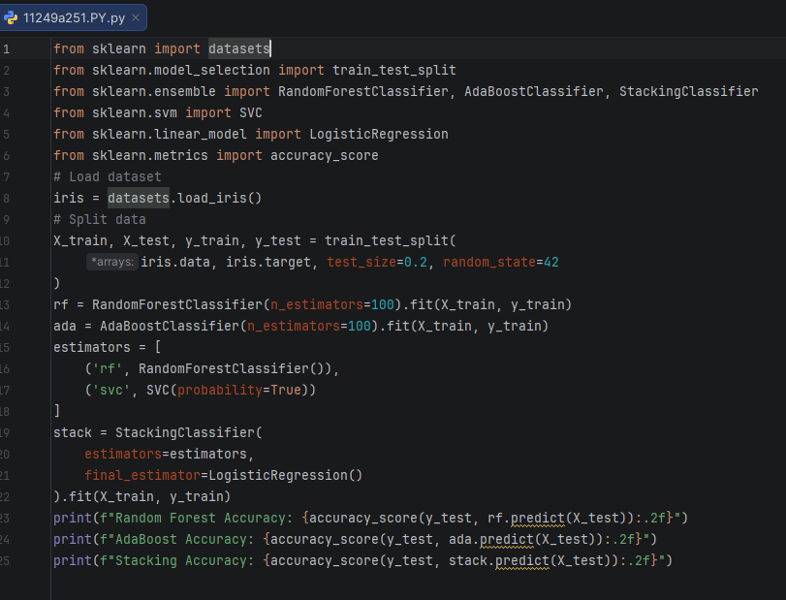

OUTPUT:
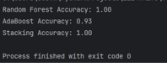
Result:
The ensemble models were successfully implemented, and they provided better accuracy compared to individual models.
Ex No:07 Date:12-03-26
Build models using Decision trees
Aim:
To build a model using Decision Trees for classification or prediction.
PROGRAM:

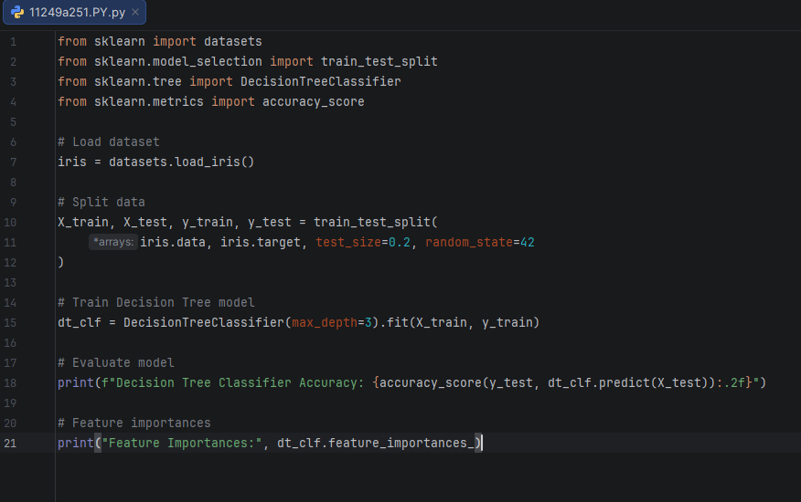
OUTPUT:

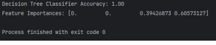

Result:
The Decision Tree model was successfully implemented and provided good prediction performance.
Ex No:08 Date:02-03-26
Build model using SVM with different kernels
Aim:
To build an SVM model using different kernel functions for classification.
Program:

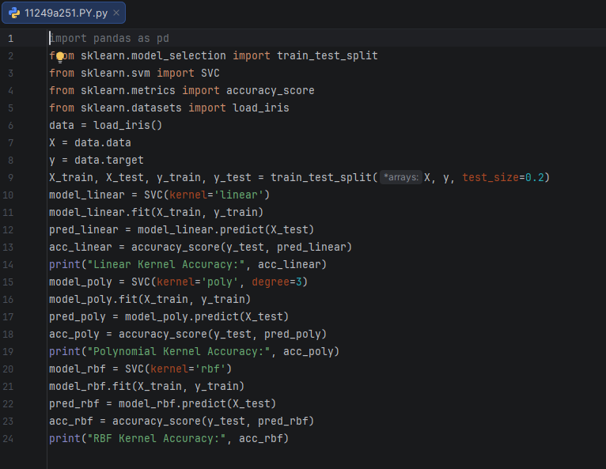
OUTPUT:

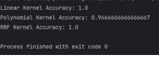
Result:
The SVM models were successfully implemented with various kernels, and they achieved good classification performance

Ex No:09 Date:02-03-26

Implement K-NN algorithm to classify a dataset

Aim:To implement the K-Nearest Neighbors (K-NN) algorithm to classify a dataset
Program:

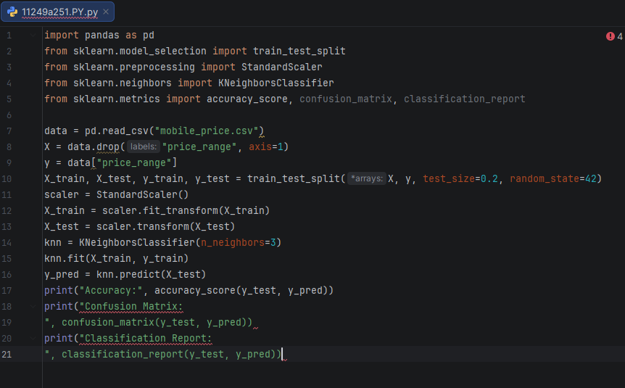

OUTPUT:

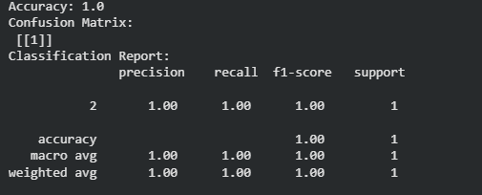
Result:
The K-NN model was successfully implemented and it classified the dataset with good accuracy

Ex No:10 Date:02-03-26

Build model to perform Clustering using K-means after applying PCA and determining

Aim:
To build a clustering model using K-Means after applying PCA for dimensionality reduction and determining optimal clusters.
PROGRAM:

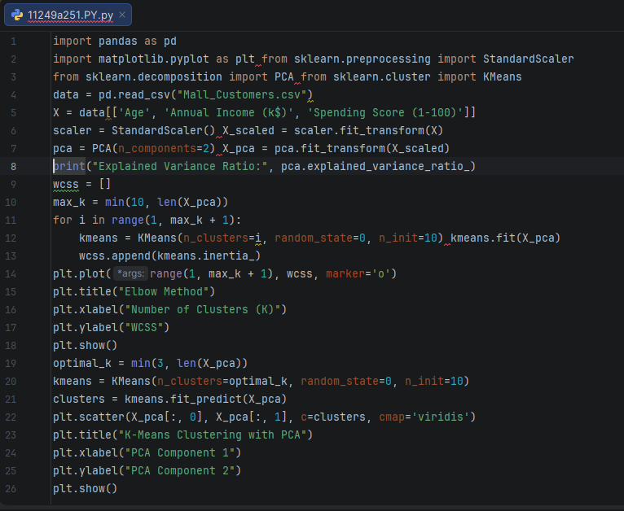

OUTPUT:
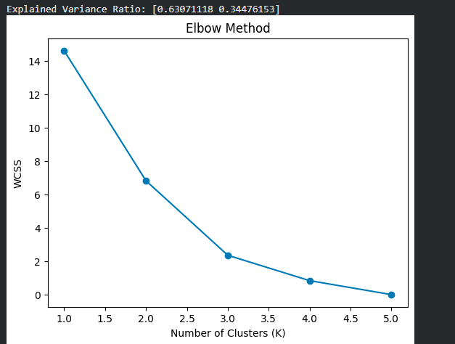

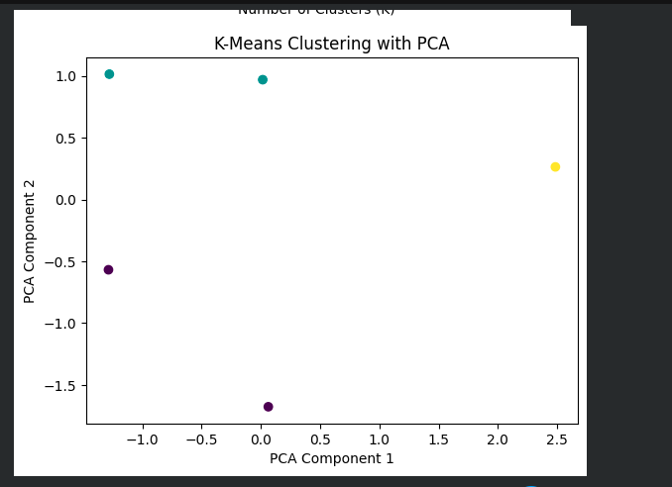

Result:
The K-Means clustering model was successfully implemented after PCA, and the data was grouped effectively into clusters

