

SRI CHANDRASEKHARENDRA SARASWATHI VISWA
MAHAVIDYALAYA

(
UNIVERSITY

ESTABLISHED UNDER

SECTION

3
OF

UGC ACT
1956)

ENATHUR,

KANCHIPURAM

–

631

561

DEPARTMENT

OF

COMPUTER

SCIENCE

&

ENGINEERING

Name

:

_

Reg.

No

:

Class

:

II

B.E.

)
CSE
(

Course code: BCSF244P60

Course

Name:

P.ADITHYA
111249A301

DATA SCIENCE TOOLKIT

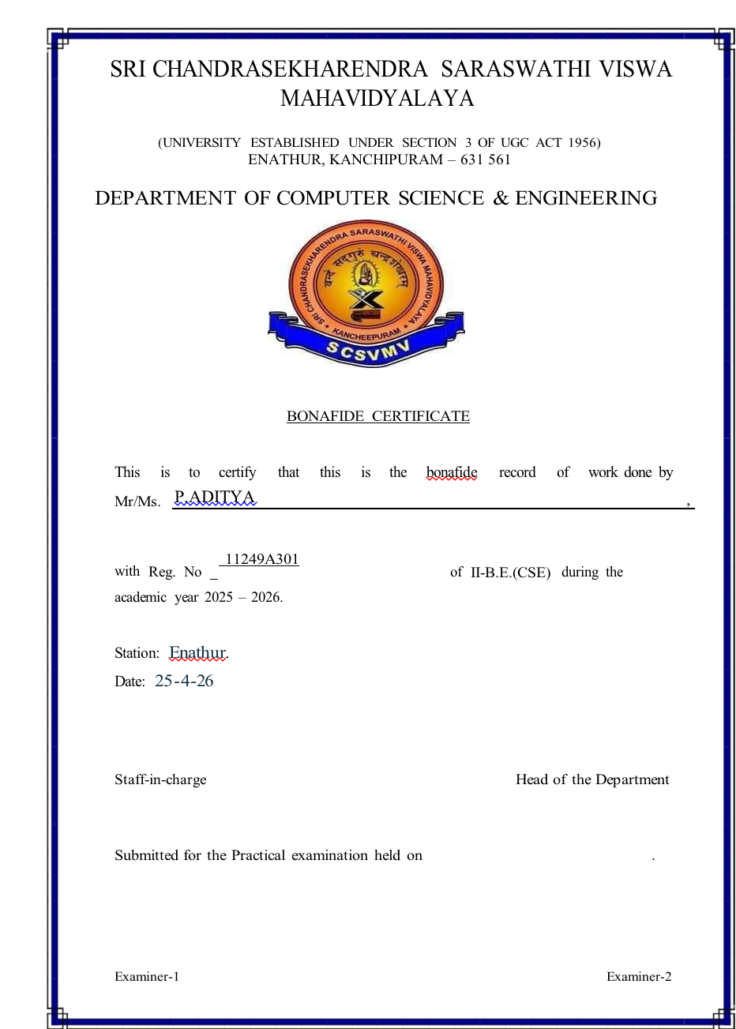

INDEX

SL.NO | Program Name | Date | Page no | Signature
1 | Introduction to python libraries | 29/1/26 | 1-10
a | Numpy | 29/1 | 1-10
b | Pandas | 29/1 | 1-10
c | Matplotlib | 5/2/26 | 1-10
d | Scikit-learn | 5/26 | 1-10
2 | Perform data exploration and preprocessing python | 13/2/26 | 11-12
3 | Implement Regularized Linear Regression | 19/2/26 | 13
4 | Implement Naïve Bayes Classifier | 5/3/26 | 14-15
5 | Implement Regularized Logistic Regression | 5/3/26 | 16-20
6 | Build models using ensembling techniques | 12/3/26 | 21-22
7 | Build models using decision tree | 12/3/26 | 23
8 | Support vector machines with different Kernels | 2/4/26 | 24
9 | Implement K-Nearest Neighbours Classification | 2/4/26 | 25-26
10 | K-Means clustering with PCA and elbow method | 2/4/26 | 27-29
- | - |  | - | -

Ex No:1 Date:05-02-26

Introduction to Python Libraries for Data Science
Aim:To learn basic Python libraries for Data Science (NumPy, Pandas, Matplotlib, Scikit learn).

Program:

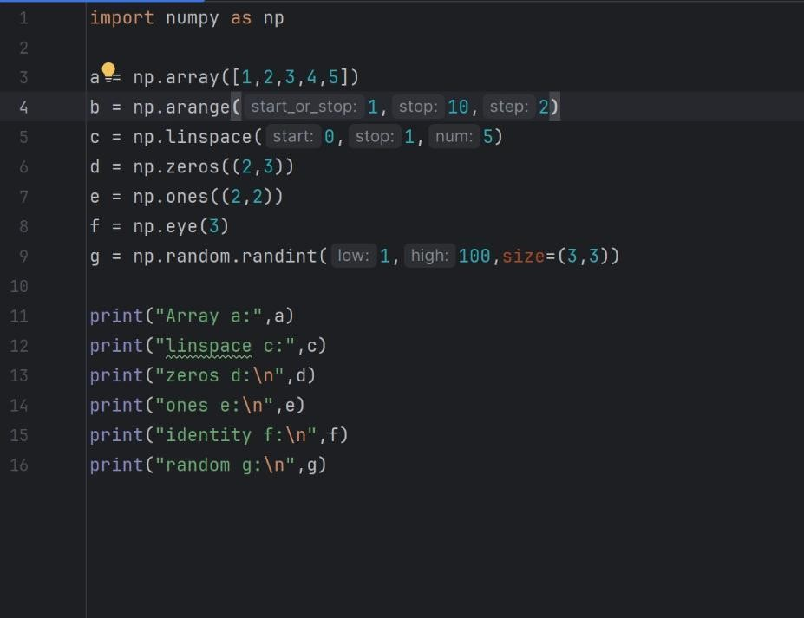

OUTPUT:
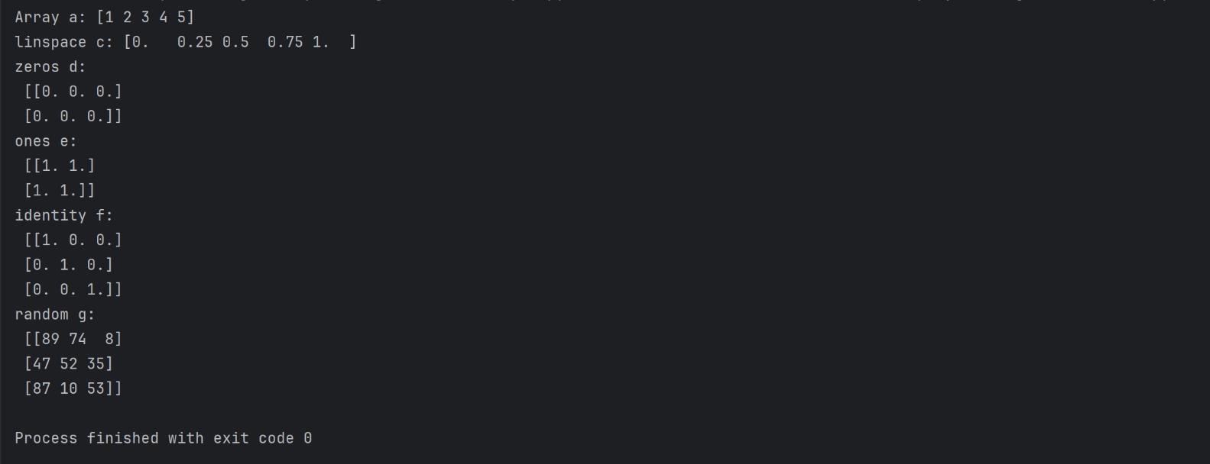

INPUT:
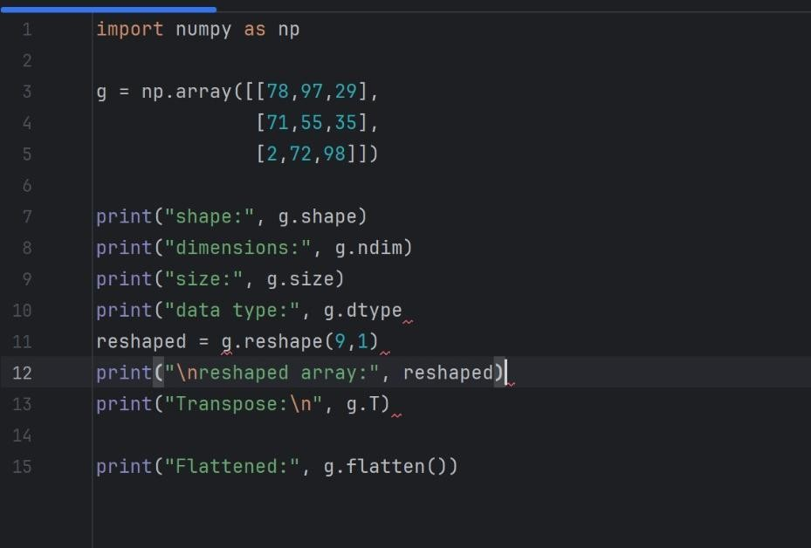

OUTPUT:
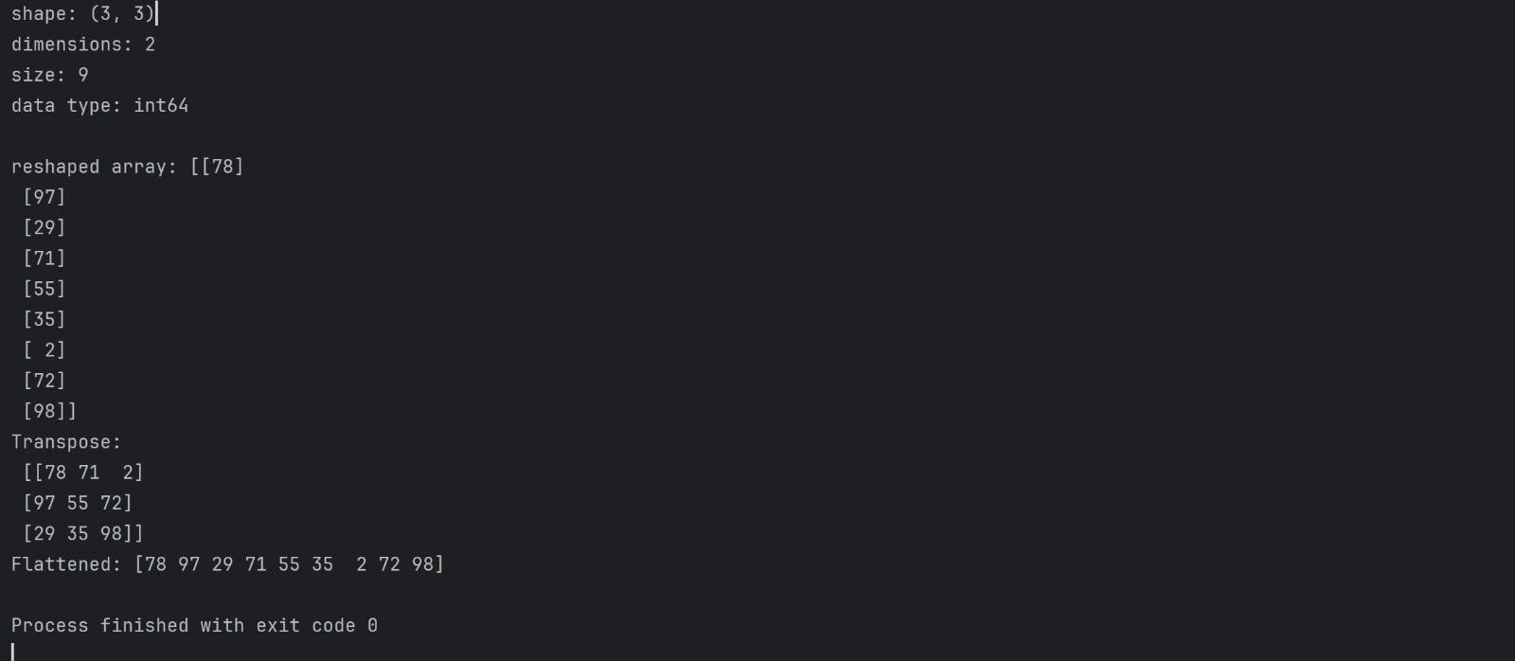
INPUT:
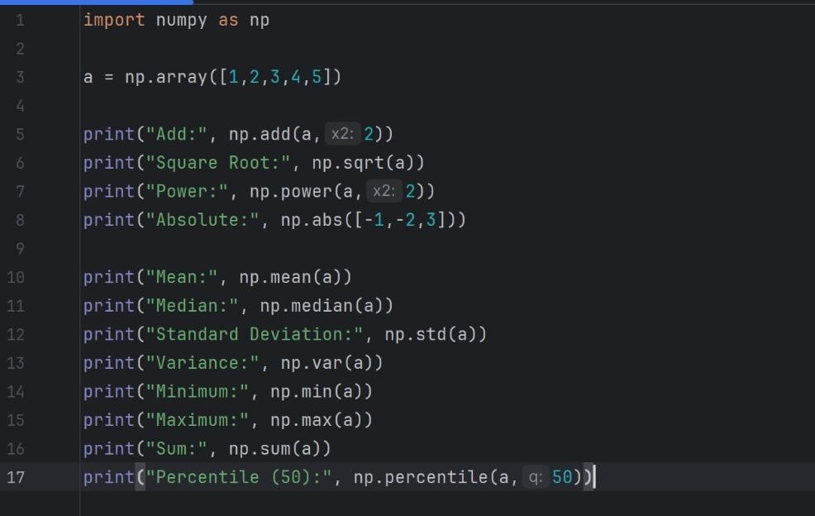

OUTPUT:

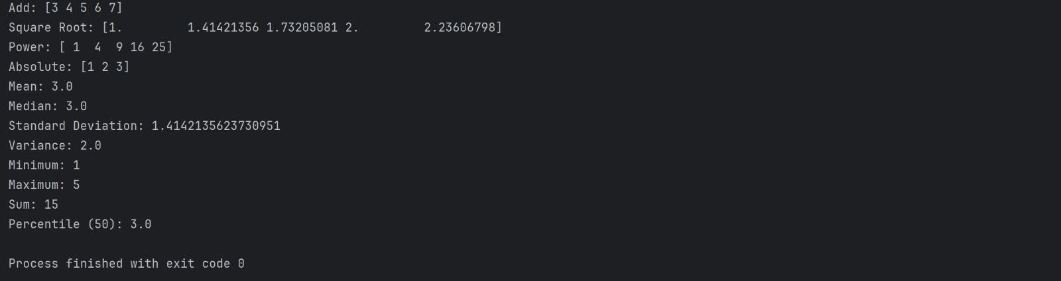

INPUT:
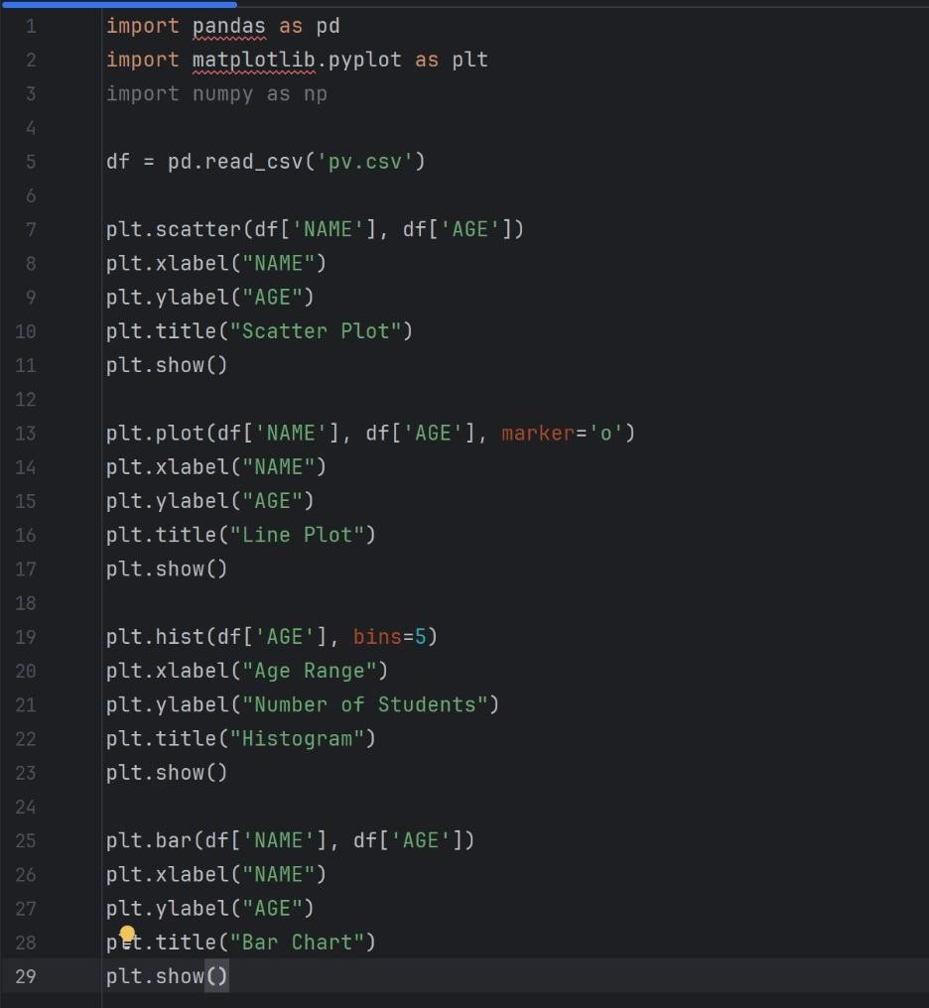

OUTPUT:
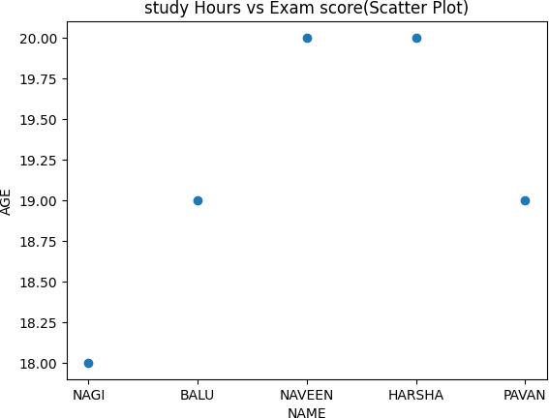

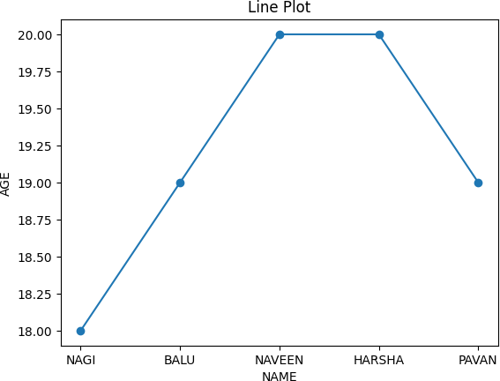

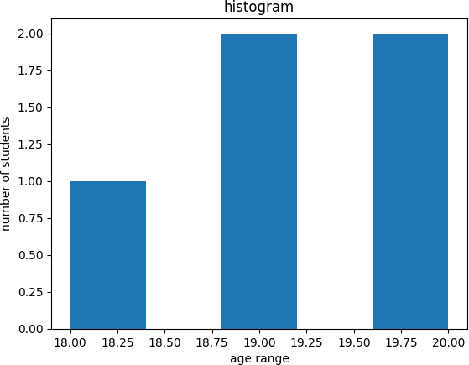

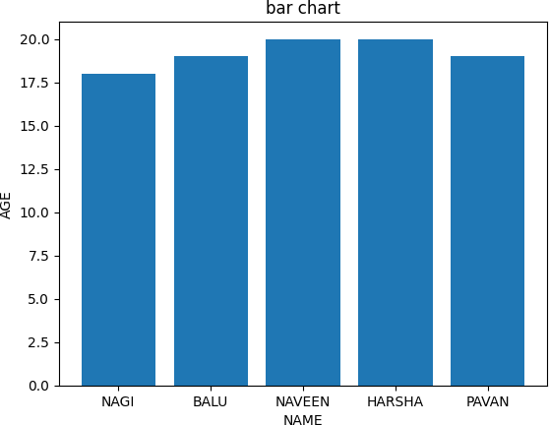

INPUT:
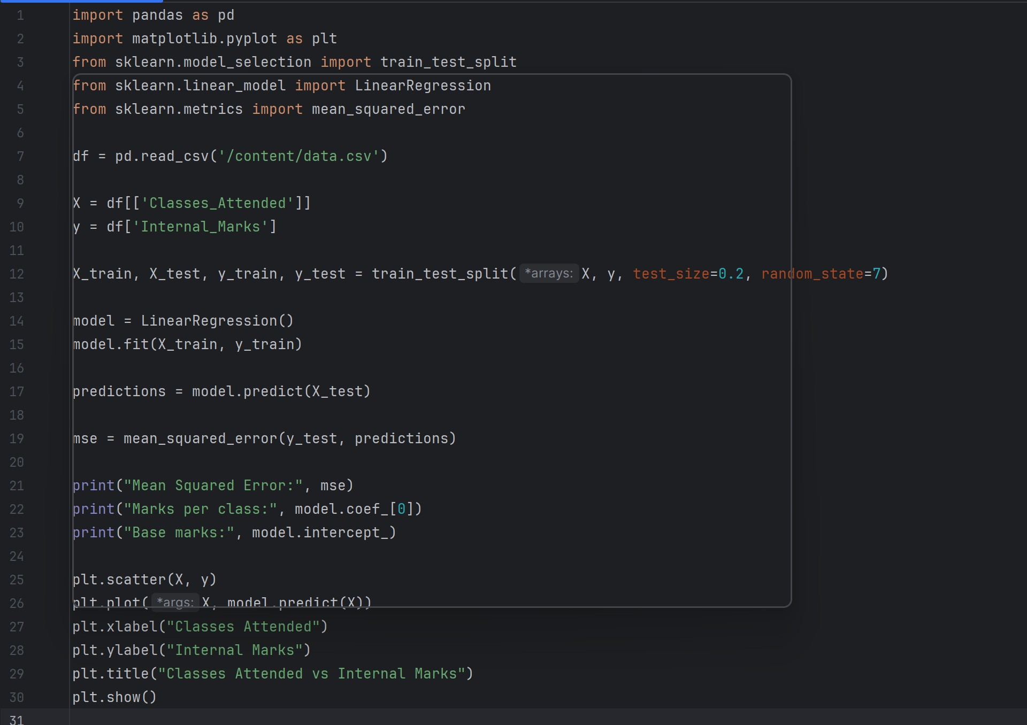

OUTPUT:
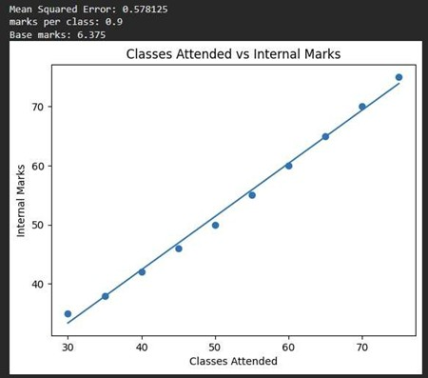

Result: Basic operations using these libraries were performed successfully.

Ex No:02 Date:12-02-26

Perform Data exploration and preprocessing in Python
Aim:To perform data exploration and preprocessing in Python. Program:
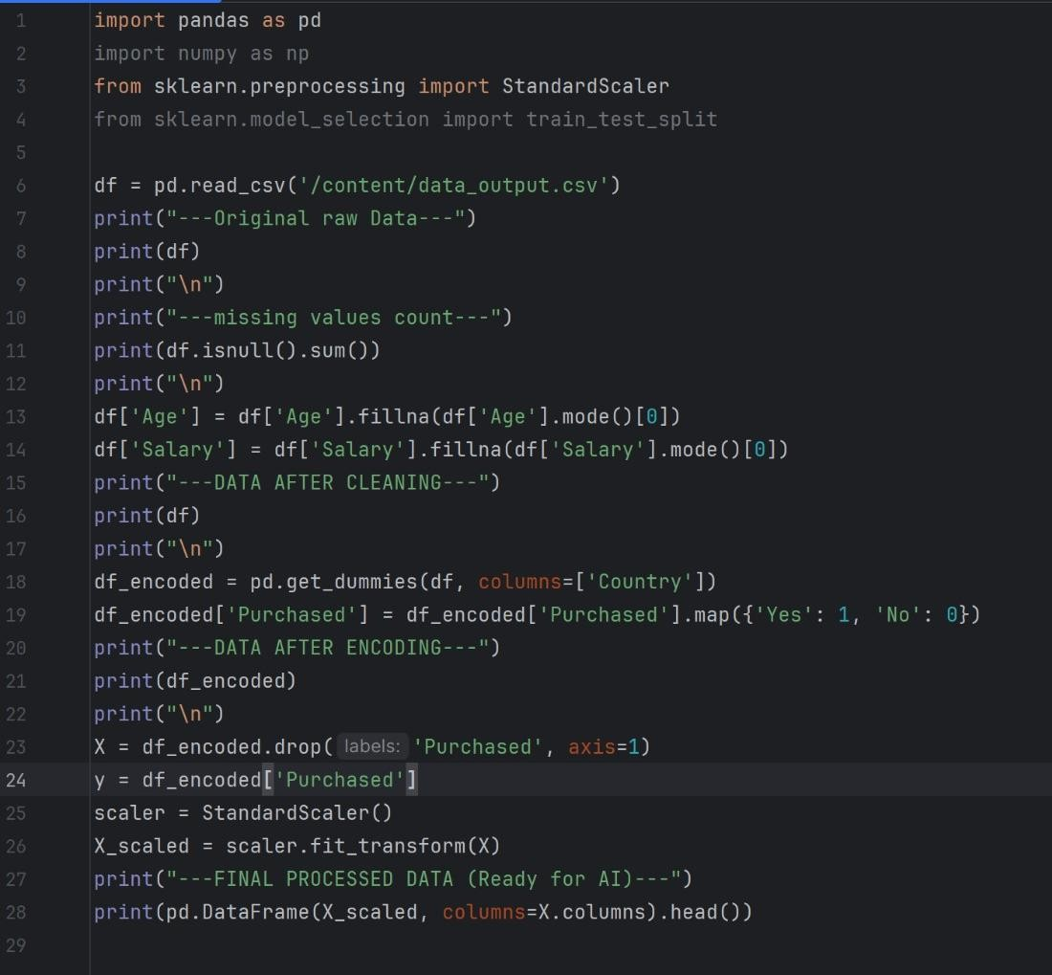

OUTPUT:
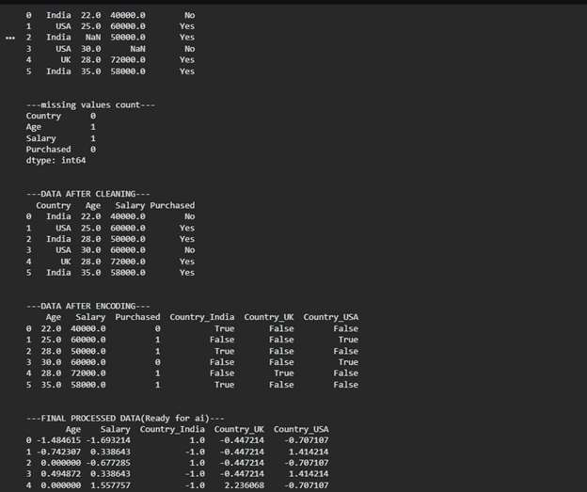

Result:Data was explored and preprocessed successfully using Python.

Ex No:03 Date:19-02-26

Implement regularised Linear regression

Aim:To implement regularized linear regression to improve model performance and control overfitting.

Program:
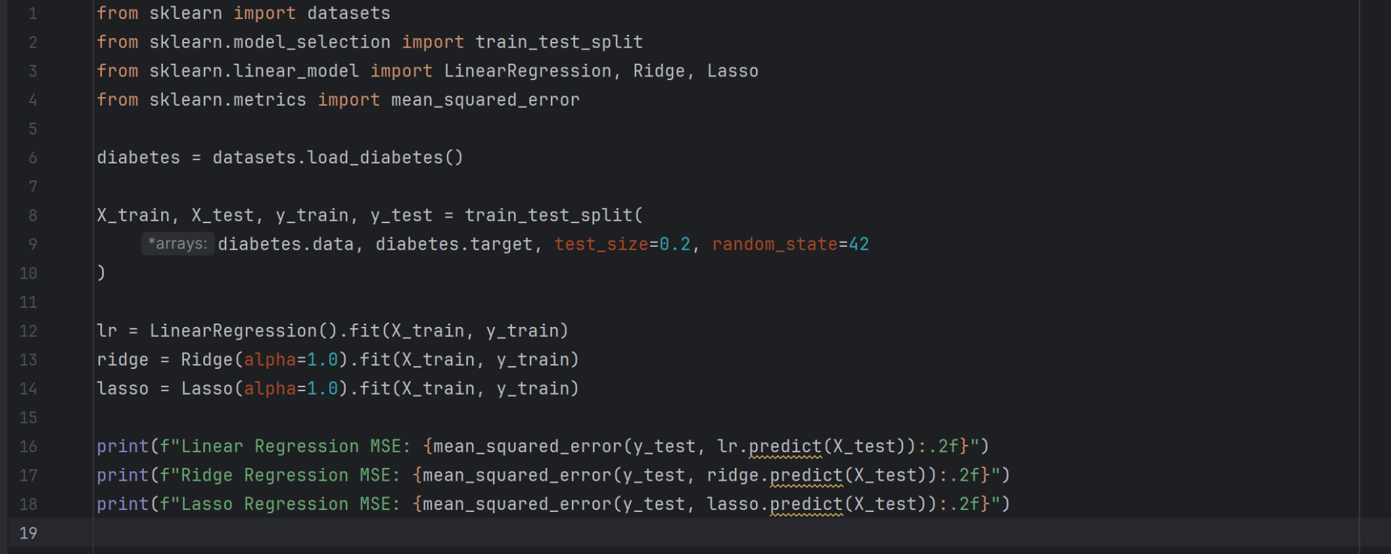
OUTPUT:

Result:The model was successfully implemented, and regularization helped reduce overfitting and improved prediction accuracy.

Ex No:04 Date:05-02-26
Implement Naive Bayes classifier for dataset stored as CSV file Aim:
To implement the Naive Bayes classifier using a dataset stored in a CSV file for classification.

Program:

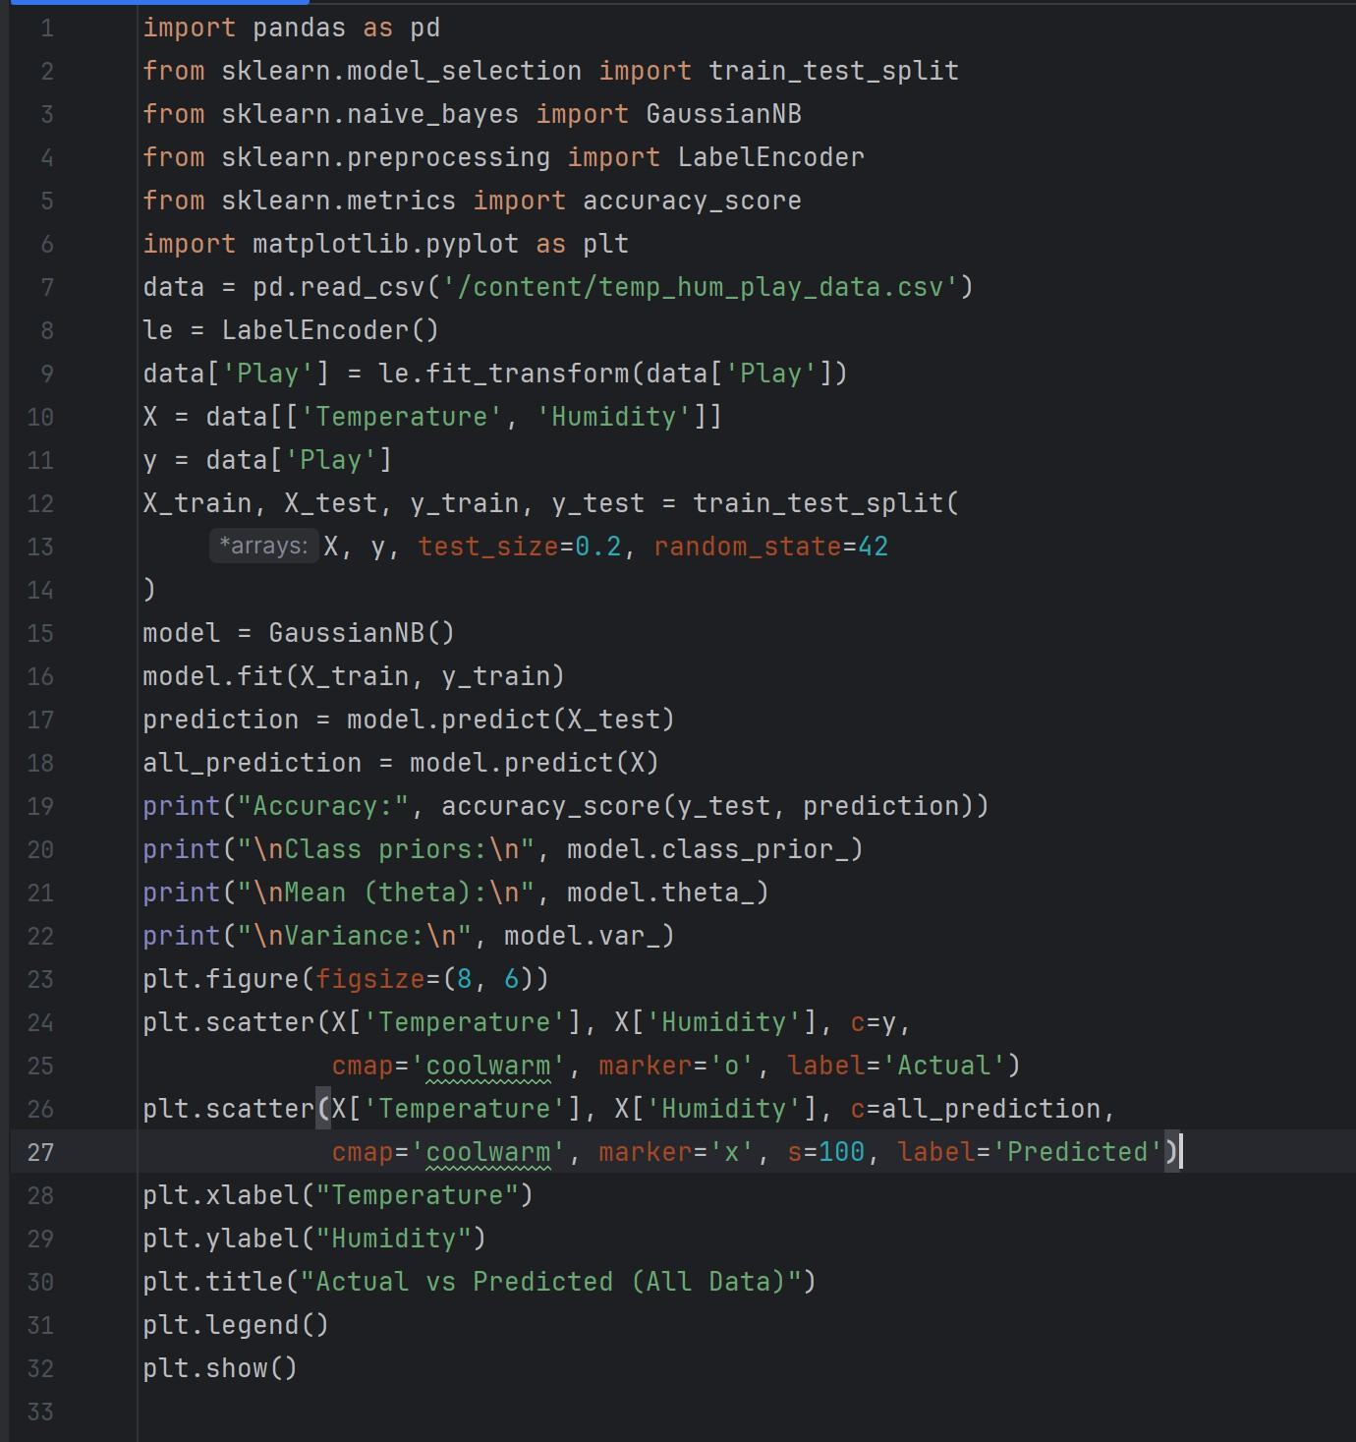

Output:
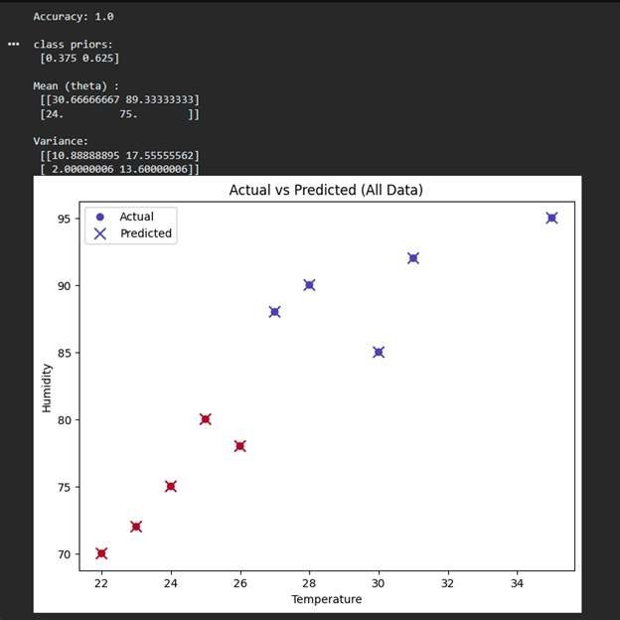

Result:
The Naive Bayes model was successfully implemented, and it effectively classified the data with good accuracy.

Ex No:05 Date:05-03-26
Implement regularized logistic regression Aim:
To implement regularized logistic regression for classification while reducing overfitting.

Program:
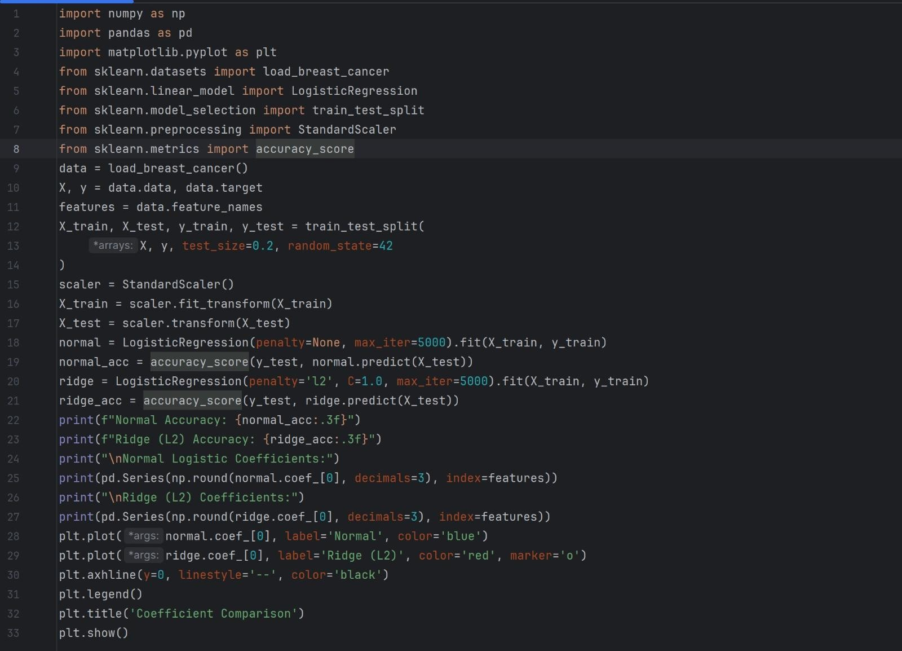

Output:
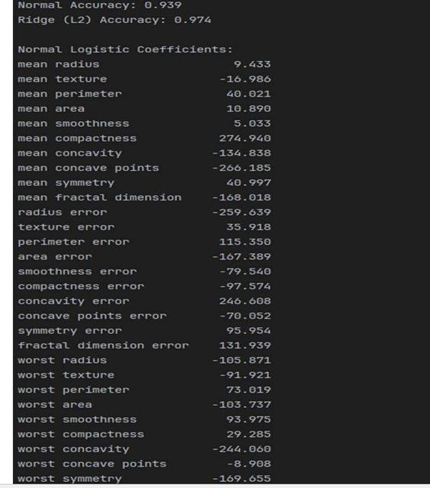

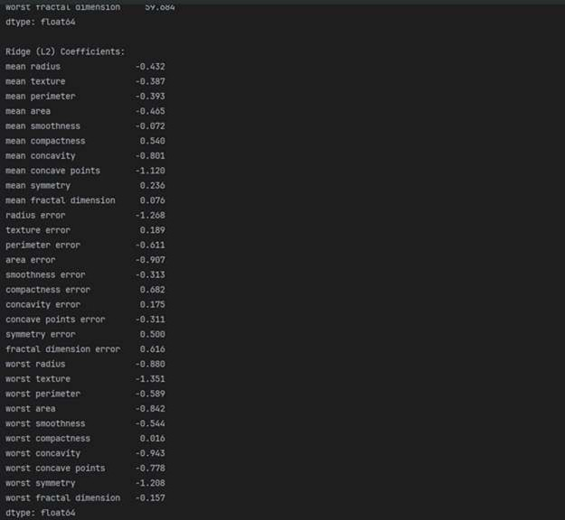

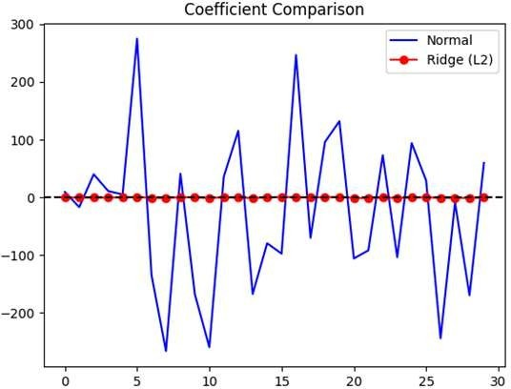

Result:
The model was successfully implemented, and regularization improved accuracy and prevented overfitting.

Ex No:06 Date:12-03-26

Build models using different Ensembling techniques Aim:
To build models using different ensembling techniques to improve prediction performance

Program:
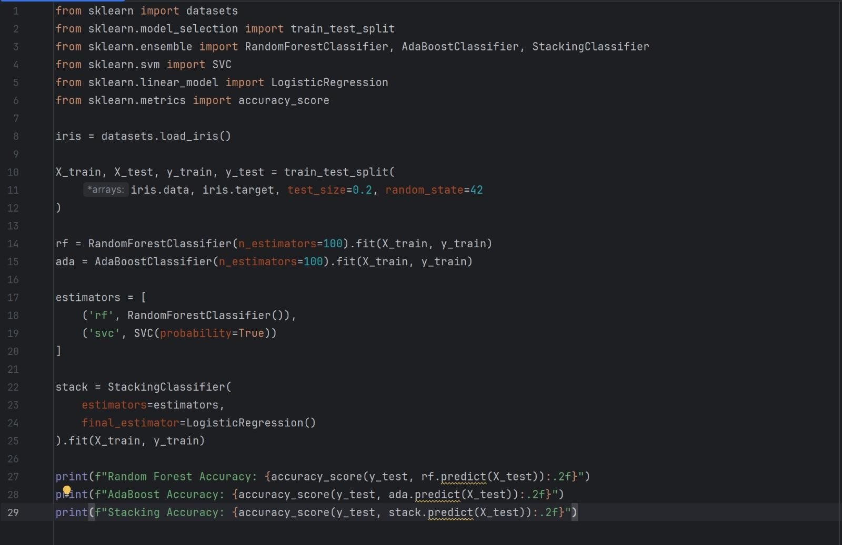

Output:
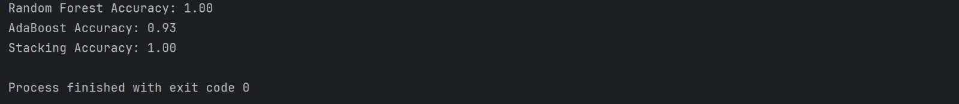

Result:
The ensemble models were successfully implemented, and they provided better accuracy compared to individual models.

Ex No:07 Date:12-03-26
Build models using Decision trees Aim:
To build a model using Decision Trees for classification or prediction.

Program:
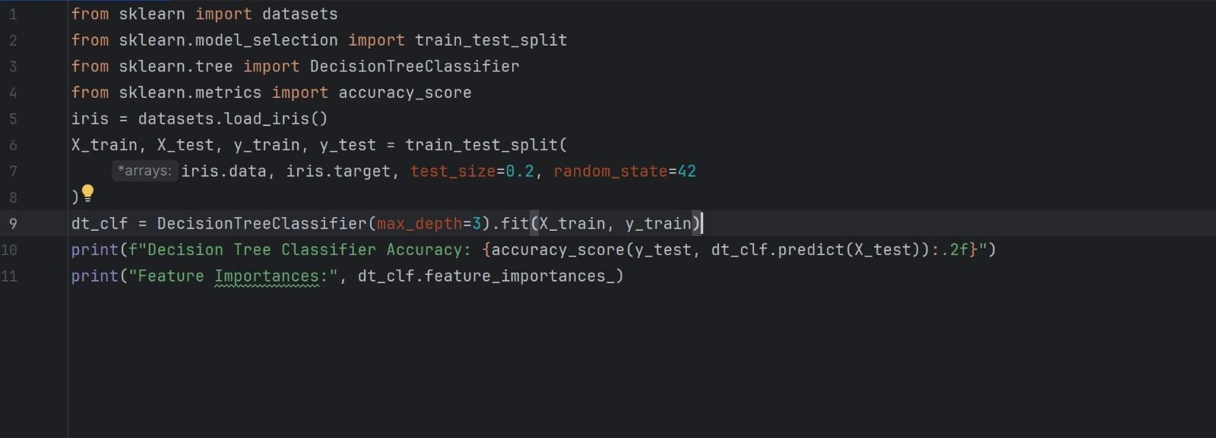

Output:
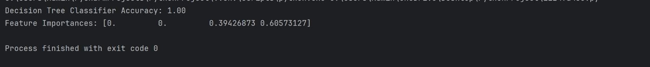

Result:
The Decision Tree model was successfully implemented and provided good prediction performance.

Ex No:08 Date:02-03-26

Build model using SVM with different kernels Aim:
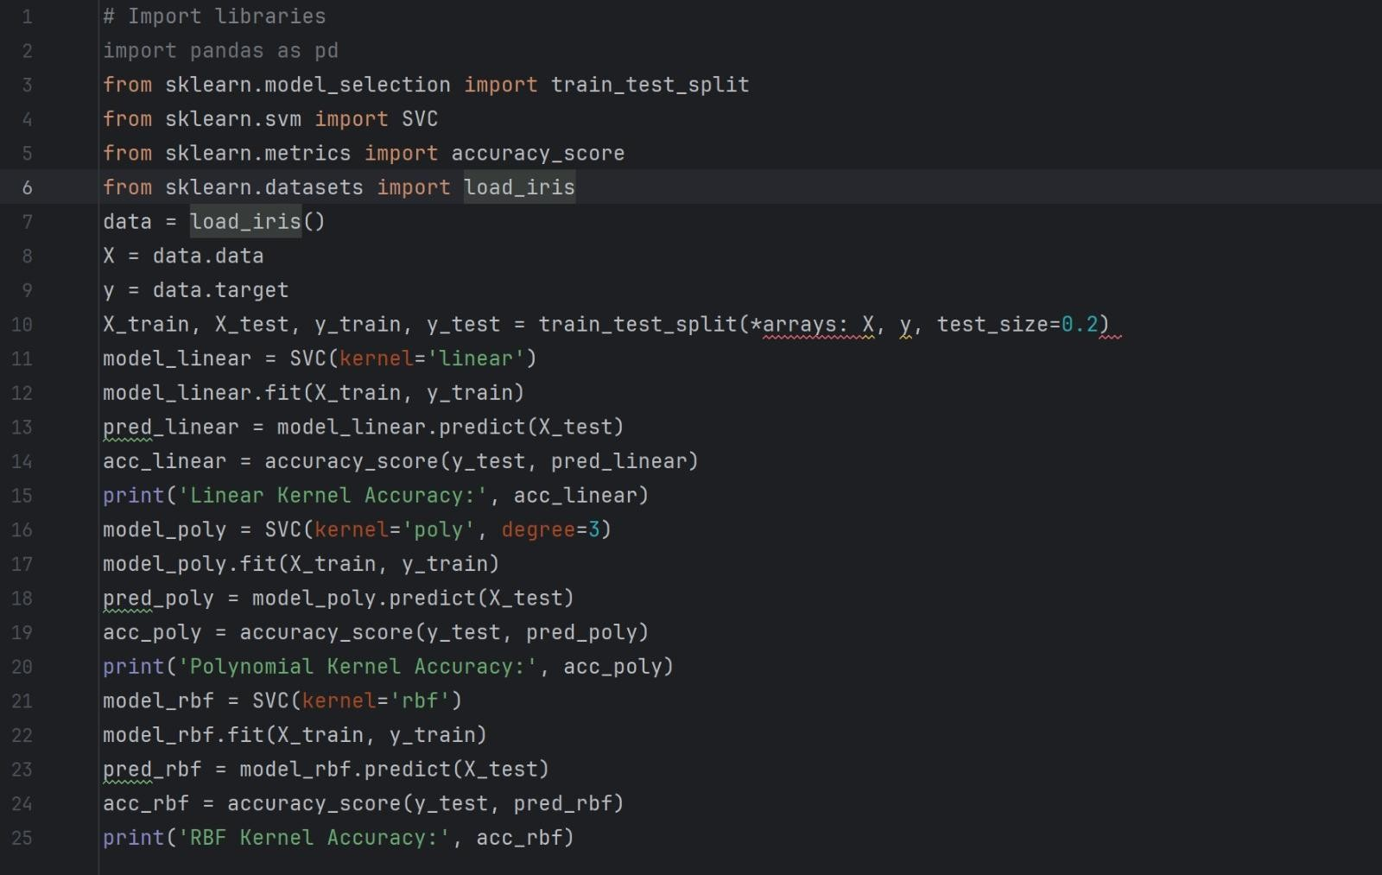
To build an SVM model using different kernel functions for classification. Program:
Output:

Result:
The SVM models were successfully implemented with various kernels, and they achieved good classification performance.

Ex No:09 Date:02-03-26

Implement K-NN algorithm to classify a dataset

Aim:To implement the K-Nearest Neighbors (K-NN) algorithm to classify a dataset
Program:
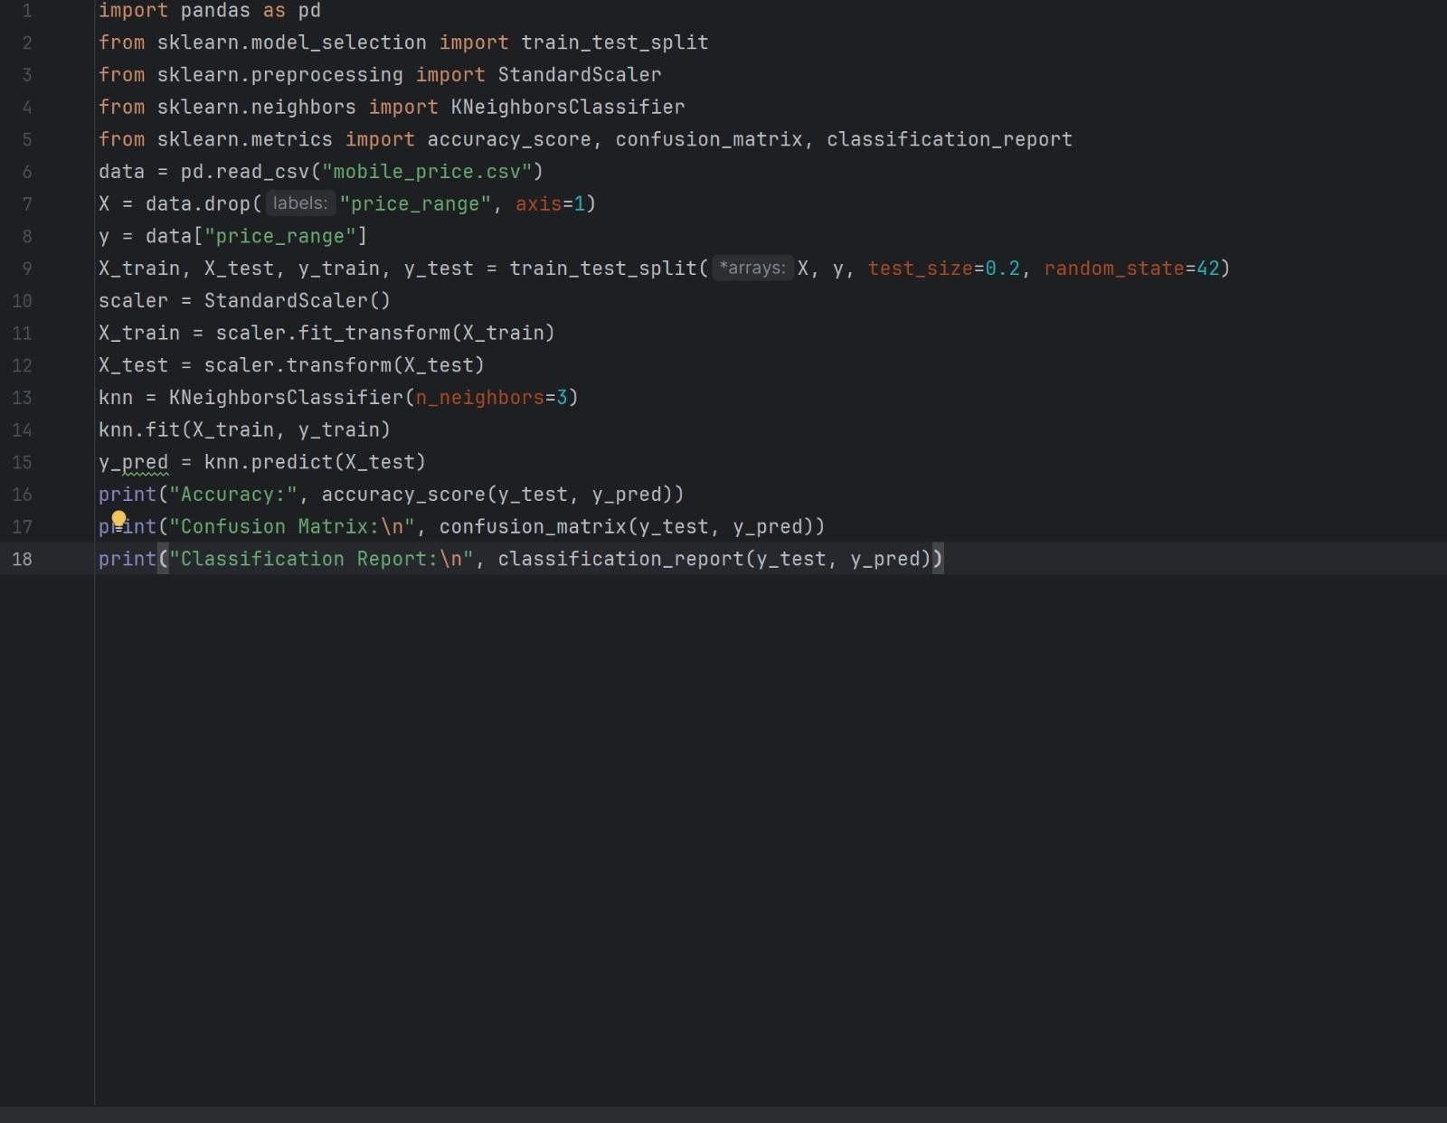

Output:
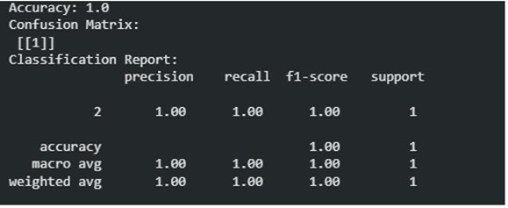

Result:
The K-NN model was successfully implemented and it classified the dataset with good accuracy

Ex No:10 Date:02-03-26

Build model to perform Clustering using K-means
after applying PCA and determining

Aim:
To build a clustering model using K-Means after applying PCA for dimensionality reduction and determining optimal clusters.

Program:
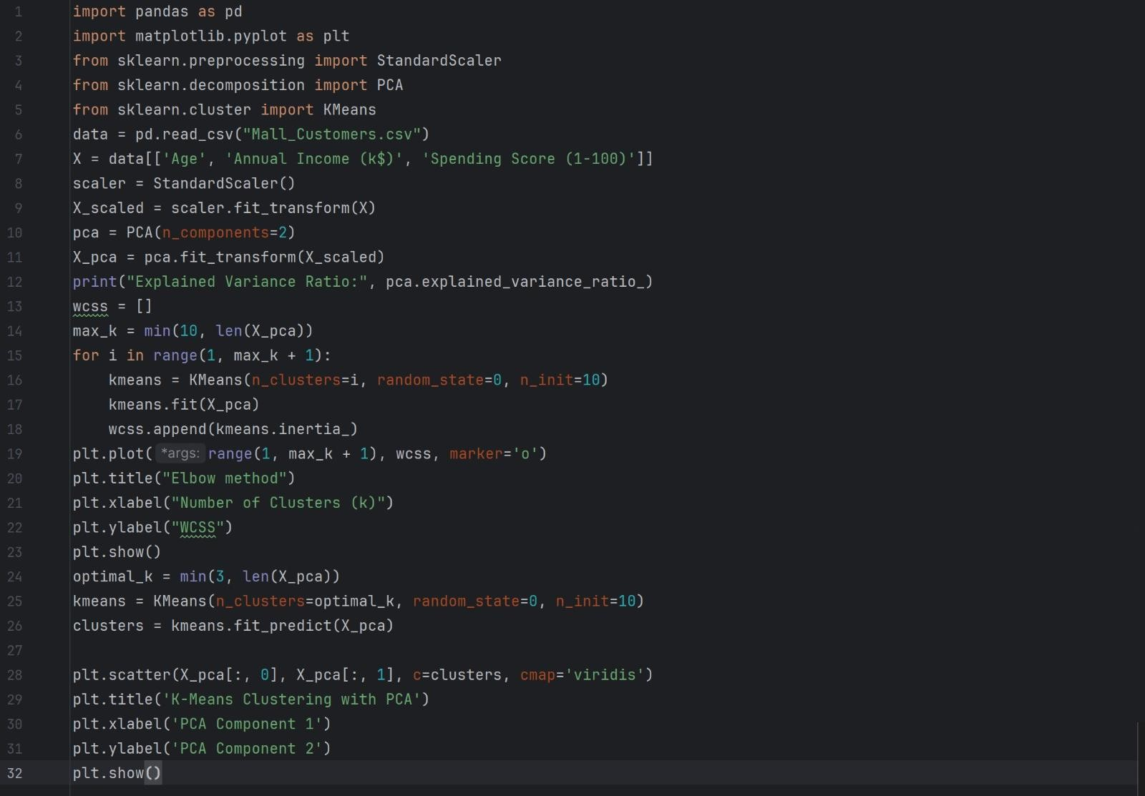

Output:
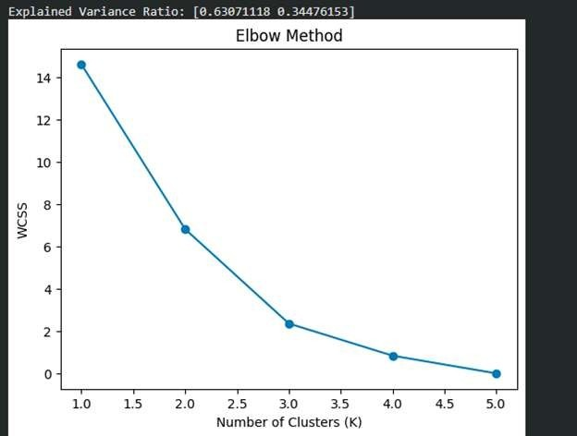

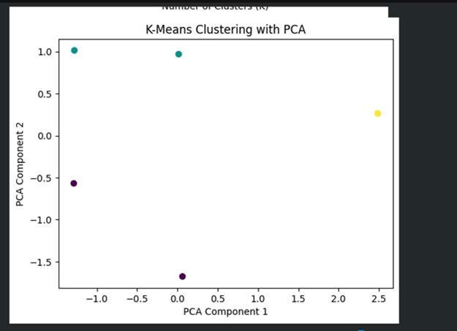

Result:
The K-Means clustering model was successfully implemented after PCA, and the data was grouped effectively into clusters

