+

SRI CHANDRASEKHARENDRA SARASWATHI VISWA MAHAVIDYALAYA
(UNIVERSITY ESTABLISHED UNDER SECTION 3 OF UGC ACT 1956)
ENATHUR, KANCHIPURAM – 631 561

DEPARTMENT OF COMPUTER SCIENCE & ENGINEERING

Name : _SADDA KEERTHI

Reg. No : 11249A322
Class : II B.E. (CSE)

Course Code: Course Name:

SRI CHANDRASEKHARENDRA SARASWATHI VISWA MAHAVIDYALAYA
(UNIVERSITY ESTABLISHED UNDER SECTION 3 OF UGC ACT 1956)
ENATHUR, KANCHIPURAM – 631 561
DEPARTMENT OF COMPUTER SCIENCE & ENGINEERING

BONAFIDE CERTIFICATE
This is to certify that this is the bonafide record of work done by

Mr/Ms SADDA KEERTHI

with Reg. No 11249A322 of II-B.E.(CSE) during the academic year 2025 – 2026.

Station:
Date:

Staff-in-charge Head of the Department

Submitted for the Practical examination held on .

Examiner-1 Examiner-2

EXP NO:01
STUDENT INFORMATION USING CLASS AND OBJECTS
DATE:22-08-2025

PROGRAM:
#include<iostream>
using namespace std;
class student
{
int year, reg, m1, m2, m3;
char name[10],dep[6];
float total,avg,per;
public:
void read();
void cal();
void display();
};
void student :: read()
{
cout<< “enter name”;
cin>>name;
cout<< “enter department”;
cin>>dep;
cout<< “enter year and registration number”;
cin>>year>>reg;
cout<< “enter marks of student”;
cin>>m1>>m2>>m3;
}
void student :: cal()
{
total=m1+m2+m3;
avg=total/3;
per=(total/300)*100;
}
void student :: display()
{
cout<< “Name of the Student is:”<<name<<endl;
cout<< “Department of the Student is:”<<dep<<endl;
cout<< “Year of the Student is :”<<year<<endl;
cout<< “Registration number of the Student :”<<reg<<endl;
cout<< “Total marks of Student :”<<total<<endl;
cout<< “Percentage of Student is :”<<per<<endl;
if (per>90 && per<100)
cout<< “grade is S”;
if (per>80 && per<91)
cout<< “grade is A”;
if (per>70 && per<81)
cout<< “grade is B”;
if (per>60 && per<71)
cout<< “grade is C”;
if (per>50 && per<61)
cout<< “grade is D”;
if(per<50)
cout<< “FAIL”;
}
int main ()
{
student a;
a.read();
a.cal();
a.display();
return 0;
}

OUTPUT:
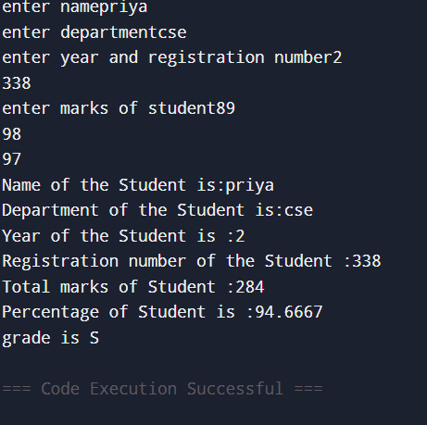

EXP NO:02
BOOK DETAILS USING CLASS AND OBJECTS AND DEFINING MEMBER FUNCTION OUTSIDE OF THE CLASS.
DATE:22-08-2025

PROGRAM:
#include<iostream>
using namespace std;
class bookdetails
{
int year, cost;
char title[20],name[10];
public:
void read();
void display();
};
void bookdetails :: read()
{
cout<< “Enter title name of the book :”;
cin>>title;
cout<< “Enter Author name of the book :”;
cin>>name;
cout<< “Enter year of the book :”;
cin>>year;
cout<< “Enter cost of the book : “;
cin>>cost;
}
void bookdetails :: display()
{
cout<< “The details of the Book are :”<<endl;
cout<< “Title of the Book is :”<<title<<endl;
cout<< “Author of the Book is :”<<name<<endl;
cout<< “Publication year of the Book is :”<<year<<endl;
cout<< “Price of the Book is :”<<cost <<endl;
}
int main()
{
bookdetails a;
a.read();
a.display();
return 0;
}

OUTPUT:
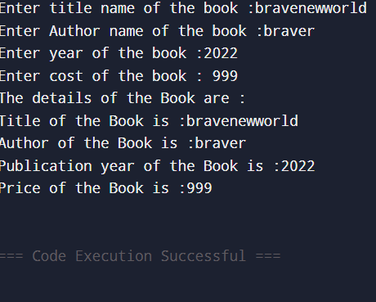

EXP NO:03
EMPLOYEE PAYSLIP USING CLASS AND OBJECTS.
DATE:29-08-2025

PROGRAM:
#include<iostream>
using namespace std;
class employee
{
int basicpay;
char name[10];
float da,hra,gs,tax,ns;
public:
void read();
void cal();
void display();
};
void employee :: read()
{
cout<< “Enter employee name :”;
cin>>name;
cout<< “Enter basicpay:”;
cin>>basicpay;
}
void employee :: cal()
{
da=basicpay*(70/100);
hra=basicpay*(10/100);
gs=basicpay+da+hra;
tax=gs*(20/100);
ns=gs-tax;
}
void employee :: display()
{
cout<< “Name of the employee :”<<name<<endl;
cout<< “Basicpay of the employee :”<<basicpay<<endl;
cout<< “Tax of the employee :”<<tax<<endl;
cout<< “Netsalary of the employee :”<<ns<<endl;
}
int main()
{
employee a;
a.read();
a.cal();
a.display();
return 0;
}

OUTPUT:
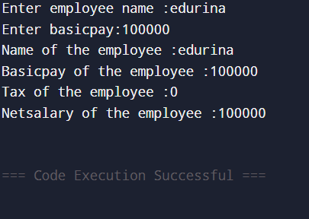

EXP NO:04
GENERATING ELECTRICITY BILL USING CLASS AND OBJECTS
DATE:29-08-2025

PROGRAM:
#include<iostream>
using namespace std;
class electricity
{
int con_num,pr;cr;
char name[20],type[10];
float total_units,bill_amount;
public:
void getdata()
{
cout<< “Enter consumer number :”;
cin>>con_num;
cout<< “Enter consumer name :”;
cin>>name;
cout<< “Enter previous month reading :”;
cin>>pr;
cout<< “Enter current month reading :”;
cin>>cr;
cout<< “Enter connection type :”;
cin>>type;
}
void cal()
{
total_units=cr-pr;
bill_amount =0;
if(type[0] == ‘d’|| type[0]== ‘D’)
{
if (total_units<=100)
bill_amount=total_units*1;
else is(total_units<=200)
bill_amount=100*1+(total_units -100)*2.5;
else if (total_units<=500)
bill_amount =100*1+100*2.5+(total_units-200)*4;
else
bill_amount=100*1+100*2.5+300*4+(total_units-500)*6;
}
else
{
if(total_units<=100)
bill_amount+total_units*2;
else if(total_units<=200)
bill_amount=100*2+(total_units-100)*4.5;
else if(total_units<=500)
bill_amount=100*2+100*4.5+300*6+(total_units-500)*7;
}
}
void display()
{
cout<< “Consumer number :”<<con_num<<endl;
cout<< “Consumer name :”<<name<<endl;
cout<< “Connection type :”<<type<<endl;
cout<< “Previous reading :”<<pr<<endl;
cout<< “Current reading :”<<cr<<endl;
cout<< “Total units :”<<total_units<<endl;
cout<<Total bill :”<<bill_amount<<endl;
}
};
int main()
{
electricity e;
e.getdata();
e.cal();
e.display();
return 0;
}

OUTPUT:
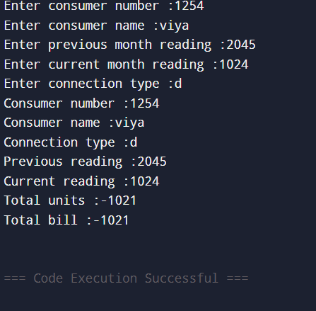

EXP NO:05
STUDENT INFORMATION USING CLASS AND OBJECTS FOR N STUDENTS.
DATE:05-09-2025

PROGRAM:
#include <iostream>
using namespace std;
class Student {
private:
int roll;
string name;
float marks;
public:
// Function to input student details
void getData() {
cout << "Enter Roll Number: ";
cin >> roll;
cout << "Enter Name: ";
cin >> ws; // to ignore newline
getline(cin, name);
cout << "Enter Marks: ";
cin >> marks;
}
// Function to display student details
void displayData() {
cout << "\nRoll Number : " << roll;
cout << "\nName : " << name;
cout << "\nMarks : " << marks;
cout << "\n-----------------------------\n";
}
};
int main() {
int n;
cout << "Enter number of students: ";
cin >> n;
// Create array of objects
Student s[n];
cout << "\n--- Enter Student Details ---\n";
for (int i = 0; i < n; i++) {
cout << "\nStudent " << i + 1 << ":\n";
s[i].getData();
}
cout << "\n\n--- Displaying Student Details ---\n";
for (int i = 0; i < n; i++) {
cout << "\nStudent " << i + 1 << " Details:";
s[i].displayData();
}
return 0;
}
OUTPUT:
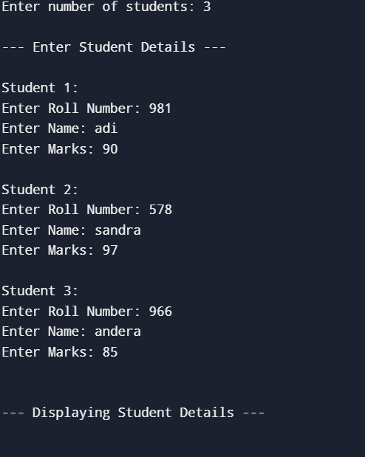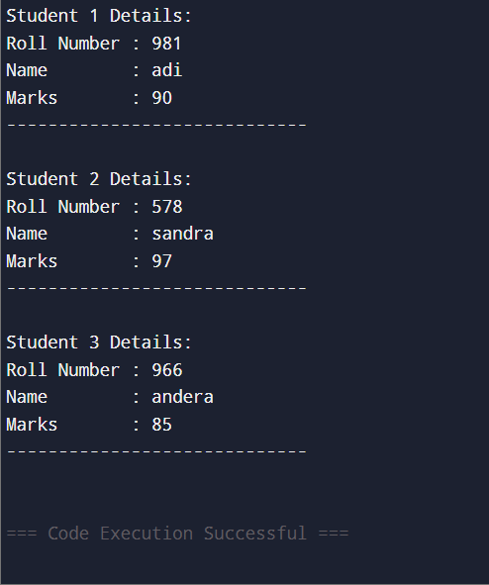

EXP NO:06
DEMONSTRATE THE CONSTRUCTOR AND DESTRUCTOR.
DATE:05-09-2025

PROGRAM:
#include<iostream>
using namespace std;
class marks
{
public:
int maths,science;
//constructor
marks()
{
cout<< “Inside constructor”<<endl;
cout<< “C++ object created”<<endl;
}
//destructor
~marks()
{
cout<< “Inside destructor”<<endl;
cout<< “ C++ object destroyed”<<endl;
}
};
int main()
{
marks m1;
marks m2;
return 0;
}
OUTPUT:
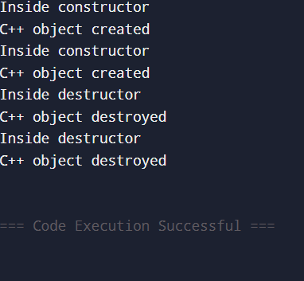

EXP NO:07
IMPLEMENT CONSTRUCTOR OVERLOADING.
DATE:12-09-2025

PROGRAM:
#include<iostream>
using namespace std;
class sample
{
int n;
public:
sample() //default constructor
{
n=0;
}
sample( int a)//parameterized constructor
{
n=a;
}
sample(sample &x)//copy constructor
{
n=x.n;
}
void display()
{
cout<<n<<endl;
}
};
int main()
{
sample a(100);
sample b(a);
sample c=a;
sample d;
d=a;
a.display();
b.display();
c.display();
d.display();
return 0;
}

OUTPUT:
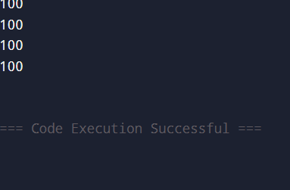

EXP NO:08
IMPLEMENT OBJECT AS FUNCTION ARGUMENTS.
DATE:12-09-2025

PROGRAM:
#include <iostream>
using namespace std;
class Number
{
private:
int value;
public:
// Constructor
Number(int v = 0)
{
value = v;
}
// Function that displays value
void display()
{
cout << "Value: " << value << endl;
}
// Function that takes an object as argument
void add(Number n) { // object passed as argument
cout << "Sum = " << value + n.value << endl;
}
};

int main() {
Number n1(10);
Number n2(20);
cout << "Object n1: ";
n1.display();
cout << "Object n2: ";
n2.display();
cout << "\nPassing object n2 to n1.add() function:\n";
n1.add(n2);
return 0;
}
OUTPUT:
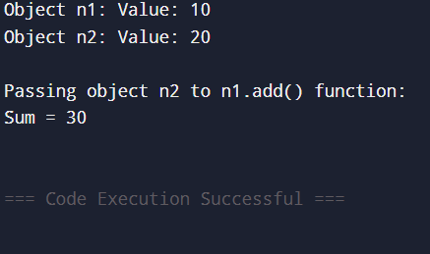

EXP NO:09
DEMONSTRATE FUNCTION OVERLOADING.
DATE:19-09-2025
PROGRAM:
#include <iostream>
using namespace std;
// Function to add two integers
int add(int a, int b)
{
return a + b;
}
// Function to add three integers
int add(int a, int b, int c)
{
return a + b + c;
}
// Function to add two double values
double add(double a, double b)
{
return a + b;
}
int main()
{
cout << "Addition of two integers: " << add(5, 10) << endl;
cout << "Addition of three integers: " << add(5, 10, 15) << endl;
cout << "Addition of two doubles: " << add(3.5, 2.7) << endl;

return 0;
}
OUTPUT:
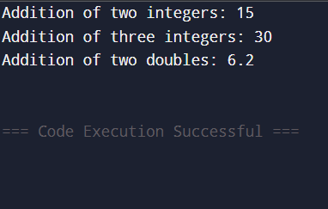

EXP NO: 10
INLINE FUNCTION
DATE:19-09-2025

PROGRAM:
#include<iostream>
using namespace std;
inline int add (int a,int b)
{
return (a+b);
}
int main()
{
int result=add(5,10)
cout<<” The result is ”<<result;
return o;
}
OUTPUT:
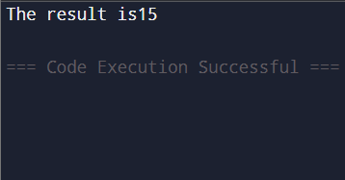

EXP NO:11
STATIC DATA MEMBERS AND STATIC MEMBER FUNCTION
DATE:19-09-2025
PROGRAM:
#include<iostream>
using namespace std;
Class A
{
public:
static int a,b;
static int add(int,int);
};
int A::add(int a,int b)
{
return(a+b);
}
int main()
{
A a,b,c;
int res;
res A::add(30,40);
cout<<res;
}

OUTPUT:

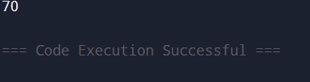

EXP NO:12
DEMONSTRATE THE USE OF MANIPULATORS
DATE:03-10-2025
PROGRAM:
#include<iostream>
#include<iomanip>
#include<math.h>
using namespace std;
int main()
{
cout<<”This is first line”<<endl;
cout<<”This is second line”<<endl;
cout<<123<<endl;
cout<<setw(3)<<10;
cout<<set precision(3);
cout<<sqrt(3)<<endl;
cout<<setw(5)<<10;
cout<<setw(5)<<257<<endl;
return o;
}

OUTPUT:
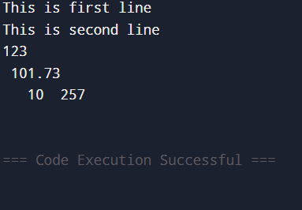

EXP NO:13
IMPLEMENTATION OF UNARY OPERATOR OVERLOADING.
DATE:03-10-2025
PROGRAM:
#include <iostream>
using namespace std;
class Sample {
private:
int x, y;
public:
Sample(int a, int b)
{
x = a;
y = b;
}
// Overload unary minus
void operator - ()
{
x = -x;
y = -y;
}
void display()
{
cout << "x = " << x << ", y = " << y << endl;
}
};

int main()
{
Sample s(5, -7);
cout << "Before applying unary - :" << endl;
s.display();
-s; // Calls operator-()
cout << "After applying unary - :" << endl;
s.display();
return 0;
}
OUTPUT:
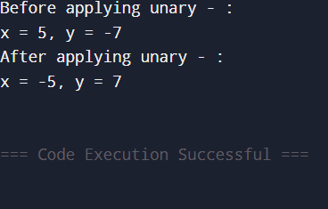

EXP NO:14
IMPLEMENTATION OF FRIEND FUNCTION.
DATE:10-10-2025
PROGRAM:
#include<iostream>
using namespace std;
class sample
{
int a, b;
public:
void setvalue()
{
cout<<"Enter value of a ";
cin>>a;
cout<<"Enter value of b ";
cin>>b;
}
Friend float mean(sample);
float mean(sample s)
{
return float(s.a+s.b)/2.0;
}
};
int main()
{
clrscr();
sample x;
x.setvalue();
cout<<"Mean value is: "<<mean(x);
return 0;
}
OUTPUT:
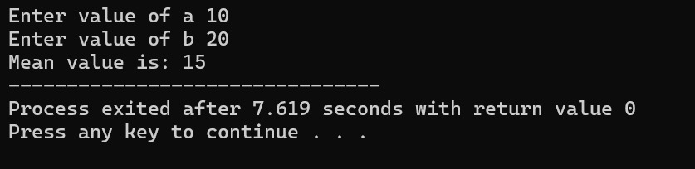

EXP NO:15
IMPLEMENTATION OF BINARY OPERATOR OVERLOADING.
DATE:10-10-2025
PROGRAM:
#include <iostream>
using namespace std;
class Complex
{
private:
float real, imag;
public:
// Constructor
Complex(float r = 0, float i = 0)
{
real = r;
imag = i;
}
// Overloading the + operator
Complex operator + (const Complex &obj)
{
Complex temp;
temp.real = real + obj.real;
temp.imag = imag + obj.imag;
return temp;
}

// Function to display result
void display()
{
cout << real << " + " << imag << "i" << endl;
}
};
int main() {
Complex c1(3.2, 5.4);
Complex c2(2.1, 3.6);
Complex c3 = c1 + c2; // Calls operator+
cout << "Result of addition: ";
c3.display();
return 0;
}
OUTPUT:
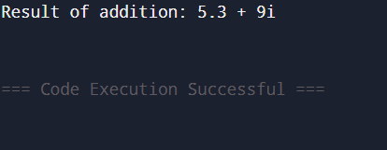

EXP NO:16
IMPLEMENTATION OF STRING CONCATENATION USING BINARY OVERLOADING (+).
DATE:17-10-2025
PROGRAM:
#include <iostream>
using namespace std;
class MyString {
private:
char str[100];
public:
// Constructor
MyString(const char s[] = "")
{
strcpy(str, s);
}
// Overloading + operator
MyString operator + (const MyString &obj)
{
MyString temp;
strcpy(temp.str, str); // Copy first string
strcat(temp.str, obj.str); // Concatenate second string
return temp;
}
// Display function
void display()
{
cout << str;
}
};
int main()
{
MyString s1("Hello ");
MyString s2("World!");
MyString s3 = s1 + s2; // String concatenation using + operator
cout << "Concatenated String: ";
s3.display();
return 0;
}
OUTPUT:
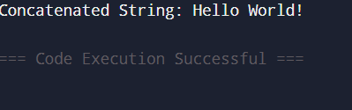

EXP NO:17
DEMONSTRATE SINGLE INHERITANCE.
DATE:17-10-2025
PROGRAM:
#include<iostream.h>
using namespace std;
class student
{
private:
char name[20];
int rno;
public:
void getstudent()
{
cout<<”enter name of the student=”;
cin>>name;
cout<<”enter roll number of the student=”;
cin>>rno;
}
void displaystudent()
{
cout<<”name of the student=”<<name;
cout<<”\nroll number of the student=”<<rno;
}
}; // class termination
class address : public student
{
private:
char city[20];
public:
void getaddress()
{
getstudent();
cout<<”\nenter city=”;
cin>>city;
}
void displayaddress()
{
displaystudent();
cout<<”\ncity=”<<city;
}
};
int main()
{
address a1;
clrscr();
a1.getaddress();
return 0;
}

OUTPUT:
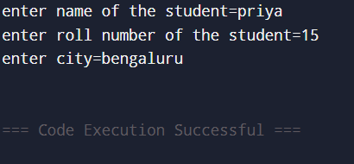

EXP NO:18
DEMONSTRATE MULTILEVEL INHERITANCE.
DATE:24-10-2025
PROGRAM:
#include<iostream.h>
using namespace std;
class student
{
private:
char name[20];
int rno;
public:
void getstudent()
{
cout<<”enter name of the student=”;
cin>>name;
cout<<”enter roll number of the student=”;
cin>>rno;
}
void displaystudent()
{
cout<<”name of the student=”<<name;
cout<<”\nroll number of the student=”<<rno;
}
};
class address
{
private:
char city[20];
public:
void getaddress()
{
cout<<”\nenter city=”;
cin>>city;
}
void displayaddress()
{
cout<<”\ncity=”<<city;
}
};
class account: public student, public address
{
private:
int tfee,submit,balance;
public:
void getaccount()
{
getstudent();
getaddress();
cout<<“\nenter total fee=“;
cin>>tfee;
cout<<“\nenter submit fee=“ ;
cin>>submit;
}
};
void displayaccount()
{
displaystudent();
displayaddress();
cout<<”\ntotal fee=”<<tfee;
cout<<”\nsubmit fee=”<<submit;
balance=tfee-submit;
cout<<“\nbalance fee=“<<balance;
}
int main()
{
account a1;
a1.getaccount();
a1.displayaccount();
return 0;
}
OUTPUT:
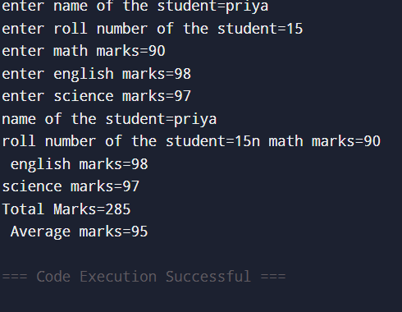

EXP NO:19
DEMONSTRATE MULTILEVEL INHERITANCE.
DATE:24-10-2025
PROGRAM:
#include<iostream.h>
#include<conio.h>
#include<stdio.h>
class student
{
private:
char name[20];
int rno;
public:
void getstudent()
{
cout<<”enter name of the student=”;
cin>>name;
cout<<”enter roll number of the student=”;
cin>>rno;
}
void displaystudent()
{
cout<<”name of the student=”<<name;
cout<<”\nroll number of the student=”<<rno;
}
};
class test: public student
{
protected:
int math,eng,sci;
public:
void gettest()
{
getstudent();
cout<<”enter math marks=”;
cin>>math;
cout<<”enter english marks=”;
cin>>eng;
cout<<”enter science marks=”;
cin>>sci;
}
void displaytest()
{
displaystudent();
cout<<”\n math marks=”<<math;
cout<<”\n english marks=”<<eng;
cout<<”\nscience marks=”<<sci;
}
};
class result : public test
{
private:
int total,avg;

public:
void getresult()
{
gettest();
total=math+eng+sci;
avg=total/3;
}
void displayresult()
{
displaytest();
cout<<”\nTotal Marks=”<<total;
cout<<”\n Average marks=”<<avg;
}
};
int main()
{
result r1;
clrscr();
r1.getresult();
clrscr();
r1.displayresult();
return 0;
}

OUTPUT:

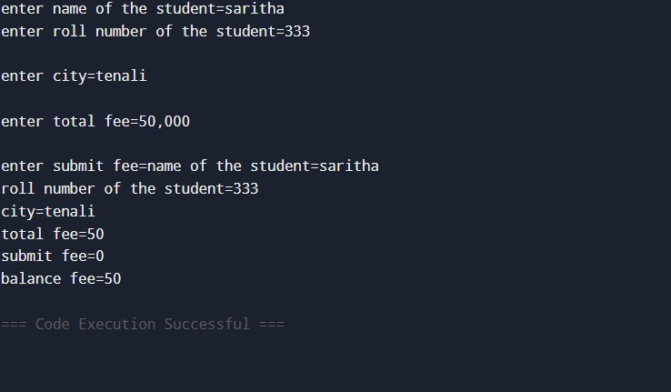

EXP NO:20
IMPLEMENTATION OF MEMORY MANAGEMENT OPERATOR
DATE:31-10-2025
PROGRAM:
#include <iostream>
using namespace std;
int main()
{
// Allocate memory for a single integer
int *a = new int;
*a = 10;
cout << "Value of a: " << *a << endl;
// Deallocate the memory
delete a;
// Allocate memory for an array of integers
int *arr = new int[5];
for (int i = 0; i < 5; ++i) {
arr[i] = i * 2;
}
// Deallocate the array memory
delete[] arr;
return 0;
}

OUTPUT:
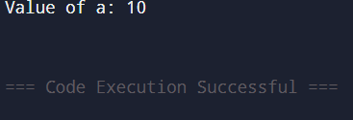

EXP NO:21
IMPLEMENTATION OF VIRTUAL FUNCTION.
DATE:31-10-2025
PROGRAM:
include <iostream>
using namespace std;
Class A
{
public:
virtual void display()
{
cout << "Base class is invoked"<<endl;
}
};
class B:public A
{
public:
void display()
{
cout << "Derived Class is invoked"<<endl;
}
};
int main()
{
A* a; //pointer of base class
B b; //object of derived class

a = &b;
a->display(); //Late Binding occurs
return 0;
}
OUTPUT:
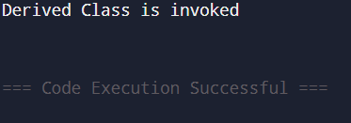

EXP NO:22
IMPLEMENTATION OF THIS POINTER
DATE:07-11-2025
PROGRAM:
#include<iostream>
using namespace std;
class num
{
int a,b;
public:
num(int x, int y)
{
a=x;b=y;
}
void display()
{
cout<<"a="<<a<<" and b="<<b<<endl;
}
num add(num);
};
num num:: add(num x)
{
a=a+x.a;
b=b+x.b;
return *this;
}
int main()
{
clrscr();
num obj1(1,2),obj2(3,4);
obj1.display();
obj2.display();
obj1.add(obj2);
obj1.display();
return 0;
}
OUTPUT:
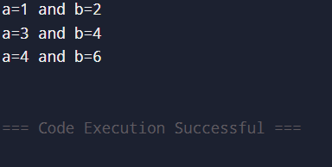

EXP NO:23a
DEMONSATRATE THE FUNCTION TEMPLATE.
DATE: 07-11-2025
PROGRAM:
#include<iostream>
using namespace std;template<typename T>
T sum(T n1,T n2){
T rs;
rs=n1+n2;
return rs;
}
int main(){
int a=10,b=20,c;
long l=11,j=22,k;
c=sum(a,b);
cout<< “sum of integer values”<<c<<endl;
k=sum(l,j);
cout<< “sum of long values”<<k<<endl;
return 0;
}
OUTPUT:
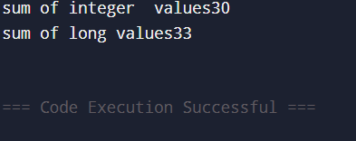

EXP NO:23b
DEMONSTRATE CLASS TEMPLATE
DATE: 07-11-2025
PROGRAM:
#include<iostream>
using namespace std;
template<class T>
class addition
{
public:
T add(T,T);
};
template<class T>
T addition<T>::add(T n1, T n2)
{
T rs;
rs=n1+n2;
return rs;
}
int main()
{
addition<int>obj1;
addition<long>obj2;
int a=10,b=20,c;
long l=11,j=22,k;
c=obj1.add(a,b);
cout<< “sum of integers “<<c<<endl;
k=obj2.add(l,j);
cout<< “sum of long values<<k<<endl;
return 0;
}
OUTPUT:
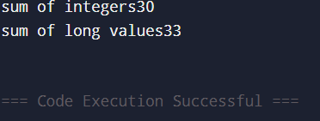

EXP NO:24
EXPECTION HANDLING
DATE: 07-11-2025
PROGRAM:
#include <iostream>
using namespace std;
int main()
{
int a = 10, b = 0;
try
{
if (b == 0)
throw "Division by zero not allowed!"; // throwing an exception
cout << "Result: " << a / b << endl;
}
catch (const char* msg) { // catching the exception
cout << "Error: " << msg << endl;
}
cout << "Program continues..." << endl;
return 0;
}

OUTPUT:
