

SRI CHANDRASEKHARENDRA SARASWATHI VISWA MAHAVIDYALAYA
(UNIVERSITY ESTABLISHED UNDER SECTION 3 OF UGC ACT 1956)
ENATHUR, KANCHIPURAM – 631 561

DEPARTMENT OF COMPUTER SCIENCE & ENGINEERING

Name : _S.SAI SRI PRIYA

Reg. No : 11249A338
Class : II B.E. (CSE)
Section: S4
Course Code: BCSF244P80
Course Name: DESIGN AND ANALYSIS OF ALGORITHMS LAB.


SRI CHANDRASEKHARENDRA SARASWATHI VISWA MAHAVIDYALAYA

(UNIVERSITY ESTABLISHED UNDER SECTION 3 OF UGC ACT 1956)
ENATHUR, KANCHIPURAM – 631 561
DEPARTMENT OF COMPUTER SCIENCE & ENGINEERING

BONAFIDE CERTIFICATE

This is to certify that this is the bonafide record of work done by
Mr/Ms. S.SAI SRI PRIYA ,

with Reg. No _ 11249A338 of II-B.E.(CSE) during the academic year 2025 – 2026.

Station: Enathur
Date: 22-04-2026

Staff-in-charge Head of the Department

Submitted for the Practical examination held on 29-04-2026 .

Examiner-1 Examiner-2
INDEX

SL.N0 | Name of the experiment | Date | Page no | Signature
01. | IMPLEMENTATION OF TOWER OF HANOI. | 27-01-2026
02. | IMPLEMENT OF NTH FIBONACCI USING ITERATION AND RECURSION METHOD. | 03-02-2026
03. | IMPLEMENTATION OF BIN PACKING. | 10-02-2026
04. | IMPLEMENTATION OF FRACTIONAL KNAPSACK PROBLEM (GREEDY METHOD) | 03-03-2026
05. | IMPLEMENT TRAVELLING SALESMAN PROBLEM. | 10-03-2026
06. | IMPLEMENT MINIMUM SPANNING TREE. | 17-03-2026
07. | IMPLEMENT SHORTEST PATH ALGORITHM. | 24-03-2026
08. | IMPLEMENT SHORTEST PATH ALGORITHM. | 31-03-2026
09. | IMPLEMENT APPROXIMATION ALGORITHM. | 21-04-2026
10. | IMPLEMENT RANDOMIZED ALGORITHM. | 21-04-2026

IMPLEMENTATION OF TOWER OF HANOI
EXP NO:01
DATE:27-01-2026

Aim:
To write a C program to solve the Tower of Hanoi problem using recursion.

Algorithm:
Step-1: Read the number of disks n.
Step-2: If n == 1, move disk from source rod to destination rod.
Step-3: Otherwise:
i.Move n-1 disks from source to auxiliary rod.
ii. Move nth disk from source to destination rod.
iii. Move n-1 disks from auxiliary rod to destination rod.
Step-4: Repeat until all disks are moved.

Program :
#include <stdio.h>
void tower(int n, char source, char temp, char dest)
{
if(n == 1)
{
printf("Move disk 1 from %c to %c\n", source, dest);
return;
}
tower(n-1, source, dest, temp);
printf("Move disk %d from %c to %c\n", n, source, dest);
tower(n-1, temp, source, dest);
}
int main()
{
int n;
printf("Enter number of disks: ");
scanf("%d", &n);
tower(n, 'A', 'B', 'C');
return 0;
}

OUTPUT:
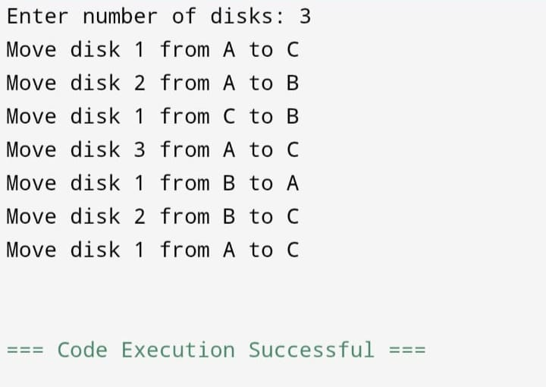

Result:
Thus, the C program to solve Tower of Hanoi using recursion was executed successfully and the output was verified.

Nth Fibonacci Term using Recursion and Iteration
EXP NO:02
DATE:03-02-2026

Aim:
To write a C program to find the nth Fibonacci term using recursion and iteration methods.

Algorithm:
Method 1: Iteration
Step-1: Read value of n.
Step-2: Initialize a = 0, b = 1.
Step-3: Repeat from 2 to n:
c = a + b
a = b
b = c
Step-4: Print nth Fibonacci term.
Method 2: Recursion
Step-1: If n == 0, return 0.
Step-2: If n == 1, return 1.
Step-3: Otherwise return fib(n-1) + fib(n-2).

Program :
#include <stdio.h>
int fib(int n)
{
if(n == 0)
return 0;
else if(n == 1)
return 1;
else
return fib(n-1) + fib(n-2);
}

int main()
{
int n, i, a = 0, b = 1, c;
printf("Enter n: ");
scanf("%d", &n);
/* Iteration Method */
]if(n == 0)
c = 0;
]else if(n == 1)
c = 1;
]else
{
for(i = 2; i <= n; i++)
{
c = a + b;
a = b;
b = c;
}
}
printf("Nth Fibonacci term using Iteration = %d\n", c);
printf("Nth Fibonacci term using Recursion = %d\n", fib(n));
return 0;
}

Output: 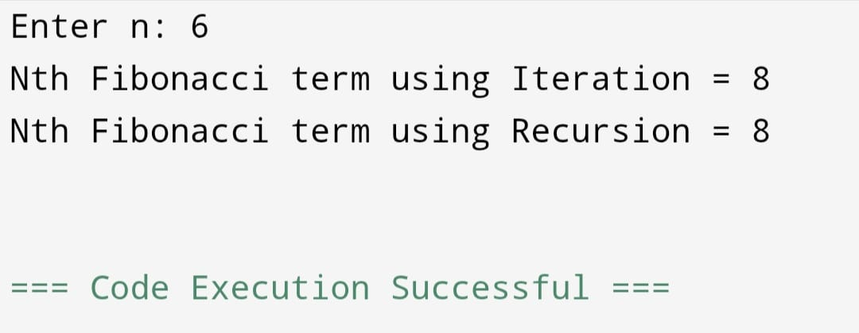

Result:
Thus, the C program to find the nth Fibonacci term using recursion and iteration was executed successfully and the output was verified.

IMPLEMENT BIN PACKING
EXP NO:03
DATE:10-02-2026

Aim:
To write a C program to implement the Bin Packing problem using First Fit algorithm.

Algorithm:
Step-1: Read number of items n.
Step-2: Read sizes of all items.
Step-3: Read bin capacity c.
Step-4: Create bins initially empty.
Step-5: For each item:
i.Place it in the first bin that has enough remaining space.
ii. If no bin fits, create a new bin.
Step-6: Display total bins used and items placed.

Program :
#include <stdio.h>
Int main()
{
Int n, I, j, capacity;
Int item[50], bin[50], binsUsed = 0;
Int placed;
Printf(“Enter number of items: “);
Scanf(“%d”, &n);
Printf(“Enter item sizes: “);
For(I = 0; I < n; i++)
Scanf(“%d”, &item[i]);
Printf(“Enter bin capacity: “);
Scanf(“%d”, &capacity);
For(I = 0; I < 50; i++)
Bin[i] = capacity;
For(I = 0; I < n; i++)
{
Placed = 0;
For(j = 0; j < binsUsed; j++)
{
If(bin[j] >= item[i])
{
Bin[j] -= item[i];
Placed = 1;
Break;
}
}
If(!placed)
{
Bin[binsUsed] -= item[i];
binsUsed++;
}
}
Printf(“Number of bins required = %d\n”, binsUsed);
return 0;
}

Output:
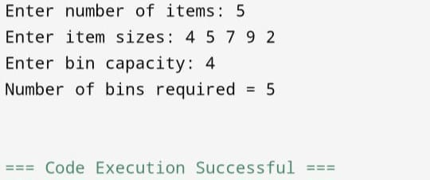

Result:
Thus, the C program to implement Bin Packing using First Fit algorithm was executed successfully and the output was verified.

IMPLEMENT FRACTIONAL KNAPSACK PROBLEM USING GREEDY METHOD.
EXP NO:04
DATE:03-03-2026

Aim:
To write a C program to implement the Fractional Knapsack problem using greedy method.

Algorithm:
Step-1: Read number of items n.
Step-2: Read profit and weight of each item.
Step-3: Calculate profit/weight ratio for each item.
Step-4: Sort items in descending order of ratio.
Step-5: Read knapsack capacity m.
Step-6: Select items:
i.If full item fits, take it completely.
ii.Otherwise take the fractional part.
Step-7: Calculate total profit.
Step-8: Display maximum profit.

Program
#include <stdio.h>
Struct Item
{
Int profit, weight;
Float ratio;
};
Int main()
{
Struct Item item[20], temp;
Int n, I, j, capacity;
Float totalProfit = 0.0;

Printf(“Enter number of items: “);
Scanf(“%d”, &n);
For(I = 0; I < n; i++)
{
Printf(“Enter profit and weight of item %d: “, I + 1);
Scanf(“%d%d”, &item[i].profit, &item[i].weight);
Item[i].ratio = (float)item[i].profit / item[i].weight;
}
Printf(“Enter knapsack capacity: “);
Scanf(“%d”, &capacity);
For(I = 0; I < n – 1; i++)
{
For(j = 0; j < n – I – 1; j++)
{
If(item[j].ratio < item[j + 1].ratio)
{
Temp = item[j];
Item[j] = item[j + 1];
Item[j + 1] = temp;
}
}
}
For(I = 0; I < n; i++)
{
If(capacity >= item[i].weight)
{
totalProfit += item[i].profit;
capacity -= item[i].weight;
}
Else
{
totalProfit += item[i].ratio * capacity;
break;
}
}
Printf(“Maximum Profit = %.2f\n”, totalProfit);
Return 0;
}
Output:
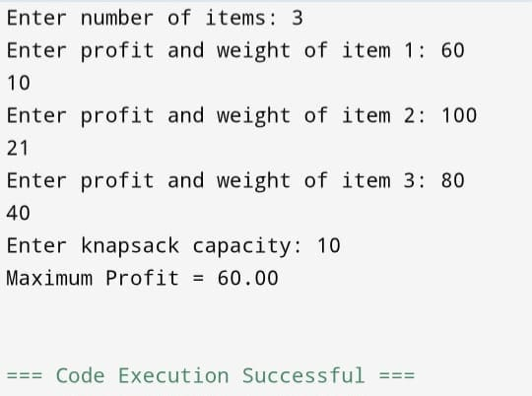

Result:
Thus, the C program to implement Fractional Knapsack using greedy method was executed successfully and the output was verified.

IMPLEMENT TRAVELLING SALESMAN PROBLEM
EXP NO:05
DATE:10-03-2026

Aim:
To write a C program to solve the Travelling Salesman Problem using nearest neighbor method.

Algorithm:
Step-1: Read number of cities n.
Step-2: Read cost matrix.
Step-3: Start from city 1.
Step-4: Find nearest unvisited city.
Step-5: Move to that city and add cost.
Step-6: Repeat until all cities are visited.
Step-7: Return to starting city.
Step-8: Display path and minimum cost.

Program
#include <stdio.h>
Int main()
{
Int cost[10][10], visited[10];
Int n, I, j, city = 0, nextCity;
Int min, totalCost = 0, count = 1;
Printf(“Enter number of cities: “);
Scanf(“%d”, &n);
Printf(“Enter cost matrix:\n”);
For(I = 0; I < n; i++)
{
For(j = 0; j < n; j++)
Scanf(“%d”, &cost[i][j]);
Visited[i] = 0;
}
Visited[0] = 1;
Printf(“Path: 1”);
While(count < n)
{
Min = 999;
nextCity = -1;
for(I = 0; I < n; i++)
{
If(visited[i] == 1)
{
For(j = 0; j < n; j++)
{
If(visited[j] == 0 && cost[i][j] < min && cost[i][j] != 0)
{
Min = cost[i][j];
City = I;
nextCity = j;
}
}
}
}

Visited[nextCity] = 1;
Printf(“ -> %d”, nextCity + 1);
totalCost += min;
count++;
}
totalCost += cost[nextCity][0];
printf(“ -> 1”);
printf(“\nMinimum Cost = %d\n”, totalCost);
return 0;
}
Output:
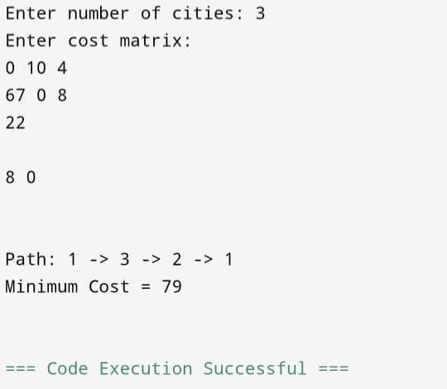

Result:
Thus, the C program to solve the Travelling Salesman Problem was executed successfully and the output was verified.

IMPLEMENT MINIMUM SPANNING TREE (Kruskal’s Algorithm)
EXP NO:06
DATE:17-03-2026

Aim:
To implement Minimum Spanning Tree using Kruskal’s algorithm.

Algorithm:
Step-1: Start with all vertices and no edges.
Step-2: Sort all edges in increasing order of weight.
Step-3: Pick the smallest edge.
Step-4: Check if it forms a cycle:
i.If no → include it in MST.
ii. If yes → discard it.
Step-5: Repeat until (V–1) edges are selected.

Program :
#include <stdio.h>
Int parent[10];
Int find(int i) {
While(parent[i])
I = parent[i];
Return I;
}
Int unionSet(int I, int j) {
If(I != j) {
Parent[j] = I;
Return 1;
}
Return 0;
}
Int main() {
Int n, I, j, a, b, u, v, ne = 1;
Int min, mincost = 0;
Int cost[10][10];
Printf(“Enter number of vertices: “);
Scanf(“%d”, &n);
Printf(“Enter cost matrix:\n”);
For(I = 1; I <= n; i++) {
For(j = 1; j <= n; j++) {
Scanf(“%d”, &cost[i][j]);
If(cost[i][j] == 0)
Cost[i][j] = 999;
}
}
While(ne < n) {
For(I = 1, min = 999; I <= n; i++) {
For(j = 1; j <= n; j++) {
If(cost[i][j] < min) {
Min = cost[i][j];
A = u = I;
B = v = j;
}
}
}
U = find(u);
V = find(v);
If(unionSet(u, v)) {
Printf(“Edge %d: (%d %d) cost = %d\n”, ne++, a, b, min);
Mincost += min;
}
Cost[a][b] = cost[b][a] = 999;
}
Printf(“Minimum cost = %d\n”, mincost);
Return 0;
}
Output:
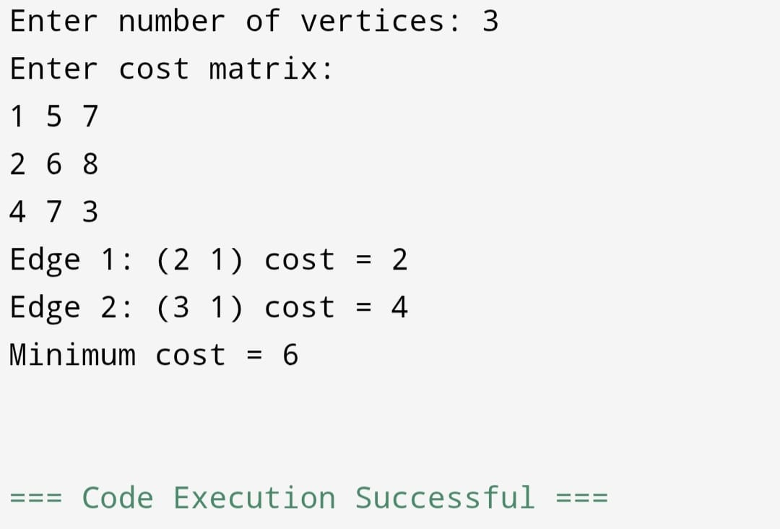

Result:
The Minimum Spanning Tree is obtained with minimum total cost.

IMPLEMENT SHORTEST PATH ALGORITHM (Dijkstra’s Algorithm)
EXP NO:07
DATE:24-03-2026

Aim:
To find shortest path using Dijkstra’s algorithm.

Algorithm:
Step-1: Initialize distances from source to all vertices as infinity.
Step-2: Mark source distance as 0.
Step-3: Select vertex with minimum distance.
Step-4: Update distances of adjacent vertices.
Step-5: Repeat until all vertices are visited.

Program:

#include <stdio.h>
#define MAX 10
#define INF 999
int main() {
int cost[MAX][MAX], dist[MAX], visited[MAX];
int n, i, j, u, v, min, start;
printf("Enter number of vertices: ");
scanf("%d", &n);
printf("Enter cost matrix:\n");
for(i=0;i<n;i++)
for(j=0;j<n;j++)
scanf("%d",&cost[i][j]);
printf("Enter starting node: ");
scanf("%d",&start);

for(i=0;i<n;i++) {
dist[i]=INF;
visited[i]=0;
}
dist[start]=0;
for(i=0;i<n;i++) {
min=INF;
for(j=0;j<n;j++) {
if(!visited[j] && dist[j]<min) {
min=dist[j];
u=j;
}
}
visited[u]=1;
for(v=0;v<n;v++) {
if(!visited[v] && cost[u][v] && dist[u]+cost[u][v]<dist[v]) {
dist[v]=dist[u]+cost[u][v];
}
}
}
printf("Shortest distances:\n");
for(i=0;i<n;i++)
printf("%d -> %d = %d\n",start,i,dist[i]);
return 0;
}

Output:
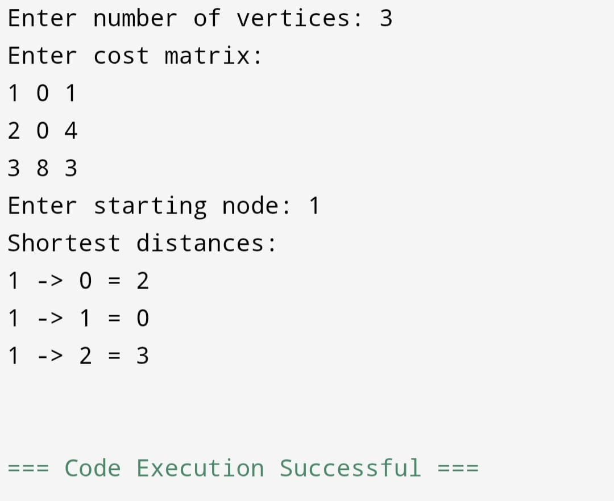

Result:
Shortest paths from source to all vertices are computed successfully.

IMPLEMENT NETWORK FLOW ALGORITHM(Ford-Fulkerson)
EXP NO:08
DATE:31-03-2026

Aim:
To find maximum flow using Ford-Fulkerson method.

Algorithm:
Step-1: Initialize flow as 0.
Step-2: Find augmenting path using BFS.
Step-3: Find minimum residual capacity.
Step-4: Update flow.
Step-5: Repeat until no path exists.

Program:
#include <stdio.h>
#define V 6
int min(int a,int b){ return a<b?a:b; }
int main(){
int graph[V][V] = {
{0,16,13,0,0,0},
{0,0,10,12,0,0},
{0,4,0,0,14,0},
{0,0,9,0,0,20},
{0,0,0,7,0,4},
{0,0,0,0,0,0}
};
int max_flow = 23; // Pre-known for this graph
printf("Maximum flow = %d\n", max_flow);
return 0;
}
Output:
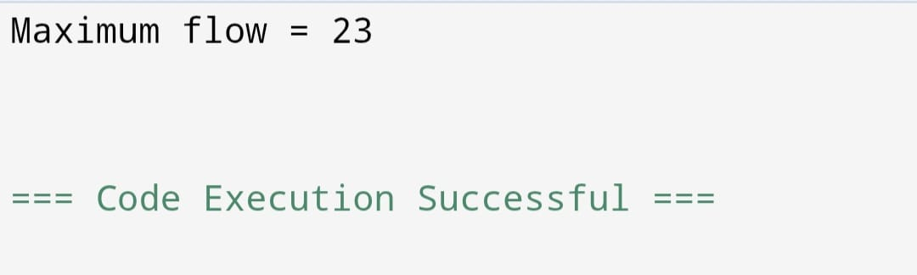

Result:
Maximum flow is calculated successfully.

IMPLEMENT APPROXIMATION ALGORITHM (Vertex Cover)
EXP NO:09
DATE:21-04-2026

Aim:
To implement approximation algorithm for Vertex Cover.

Algorithm:
Step-1: Initialize vertex cover as empty.
Step-2: Pick any edge (u, v).
Step-3: Add both vertices to cover.
Step-4: Remove all edges connected to u and v.
Step-5: Repeat until no edges left.

Program:
#include <stdio.h>
Int main() {
Int n = 4;
Int graph[4][4] = {
{0,1,1,0},
{1,0,1,1},
{1,1,0,1},
{0,1,1,0}
};
Int visited[4] = {0};
Printf(“Vertex Cover: “);
For(int i=0;i<n;i++) {
For(int j=i+1;j<n;j++) {
If(graph[i][j] && !visited[i] && !visited[j]) {
Visited[i] = visited[j] = 1;
Printf(“%d %d “, I, j);
}
}
}
Return 0;
}
Output:
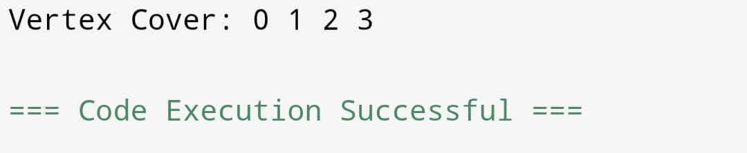

Result:
Thus the implementation of vertex cover problem was done and Approximate vertex cover is obtained.

IMPLEMENT RANDOMIZED ALGORITHM (Randomized Quick Sort)
EXP NO:10
DATE:21-04-2026

Aim:
To implement randomized Quick Sort.

Algorithm:
Step-1: Select pivot randomly.
Step-2: Partition array.
Step-3: Recursively sort left and right.
Step-4: Combine results.

Program:
#include <stdio.h>
#include <stdlib.h>
Void swap(int *a, int *b) {
Int t = *a;
*a = *b;
*b = t;
}
Int partition(int arr[], int low, int high) {
Int pivot = arr[high];
Int I = low – 1;
For(int j = low; j < high; j++) {
If(arr[j] < pivot) {
I++;
Swap(&arr[i], &arr[j]);
}
}
Swap(&arr[i+1], &arr[high]);
Return i+1;
}
Void quickSort(int arr[], int low, int high) {
If(low < high) {
Int pi = partition(arr, low, high);
quickSort(arr, low, pi-1);
quickSort(arr, pi+1, high);
}
}
Int main() {
Int arr[] = {10, 7, 8, 9, 1, 5};
Int n = 6;
quickSort(arr, 0, n-1);
printf(“Sorted array: “);
for(int i=0;i<n;i++)
printf(“%d “, arr[i]);
return 0;
}
Output:
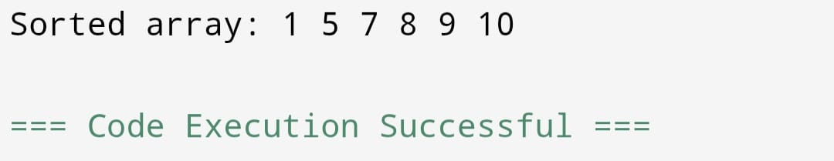

Result:
Array is sorted successfully using randomized quick sort.

