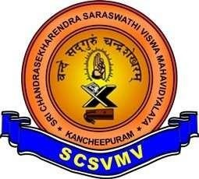

SRI CHANDRASEKHARENDRA SARASWATHI VISWA MAHAVIDYALAYA
(UNIVERSITY ESTABLISHED UNDER SECTION 3 OF UGC ACT 1956)
ENATHUR, KANCHIPURAM – 631 561

DEPARTMENT OF COMPUTER SCIENCE & ENGINEERING

Name : _S.SAI SRI PRIYA

Reg. No : 11249A338
Class : II B.E. (CSE)
Section : S4
Course Code:
Course Name: Data Science Toolkit Lab.


SRI CHANDRASEKHARENDRA SARASWATHI VISWA

MAHAVIDHYALAYA
(UNIVERSITY ESTABLISHED UNDER SECTION 3 OF UGC ACT 1956)
ENATHUR, KANCHIPURAM – 631 561
DEPARTMENT OF COMPUTER SCIENCE & ENGINEERING

BONAFIDE CERTIFICATE

This is to certify that this is the bonafide record of work done by
Mr/Ms. S.SAI SRI PRIYA ,

with Reg. No 11249A338_ of II-B.E.(CSE) during the academic year 2025 – 2026.

Station: Enathur.
Date: 22-04-2026.

Staff-in-charge Head of the Department

Submitted for the Practical examination held on .

Examiner-1 Examiner-2
INDEX

SL.N0 | Name of the experiment | Date | Page no | Signature
01. | NUMPY, PANDAS, MATPLOTLIB, SCIKIT-LEARN PROGRAMS | 02-02-2026
02. | PERFORM DATA EXPLORATION AND PREPROCESSING IN PYTHON. | 14-02-2026
03. | IMPLEMENT REGULARIZED LINEAR REGRESSION. | 14-02-2026
04. | IMPLEMENT NAÏVE BAYES CLASSIFICATION. | 23-02-2026
05. | IMPLEMENT REGULARIZED LOGISTIC REGRESSION. | 02-03-2026
06. | BUILD MODELS USING DIFFERENT ENSEMBLING TECHNIQUES. | 09-03-2026
07. | BUILD MODELS USING DECISION TREES. | 16-03-2026
08. | SVM WITH DIFFERENT KERNELS. | 16-03-2026
09. | IMPLEMENT KNN CLASSIFICATION. | 23-03-2026
10. | K-MEANS CLUSTERING WITH PCA AND ELBOW METHOD | 23-03-2026

NUMPY,PANDAS,MATPLOTLIB,SCIKIT-LEARN PROGRAMS
EXP NO: 01
DATE: 02-02-2026

AIM: To Study and Visualize data using numpy,pandas,matplotlib and scikitlearn in python
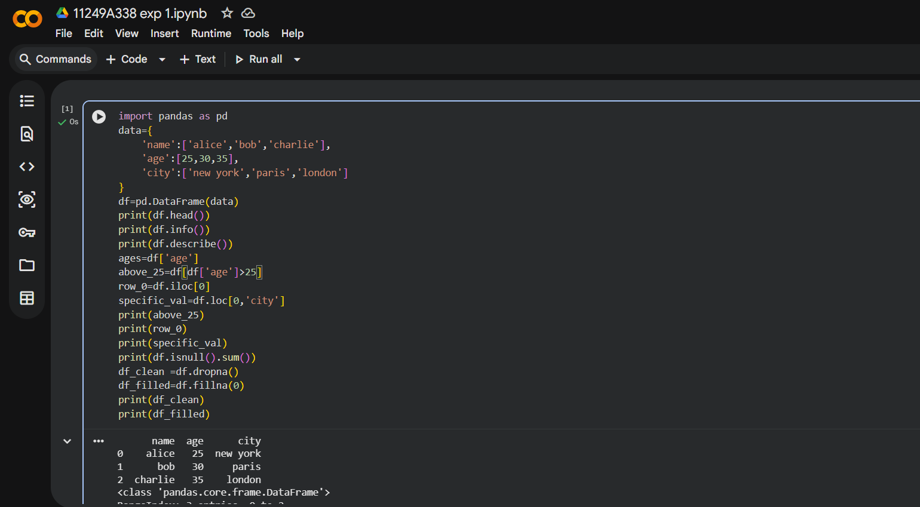
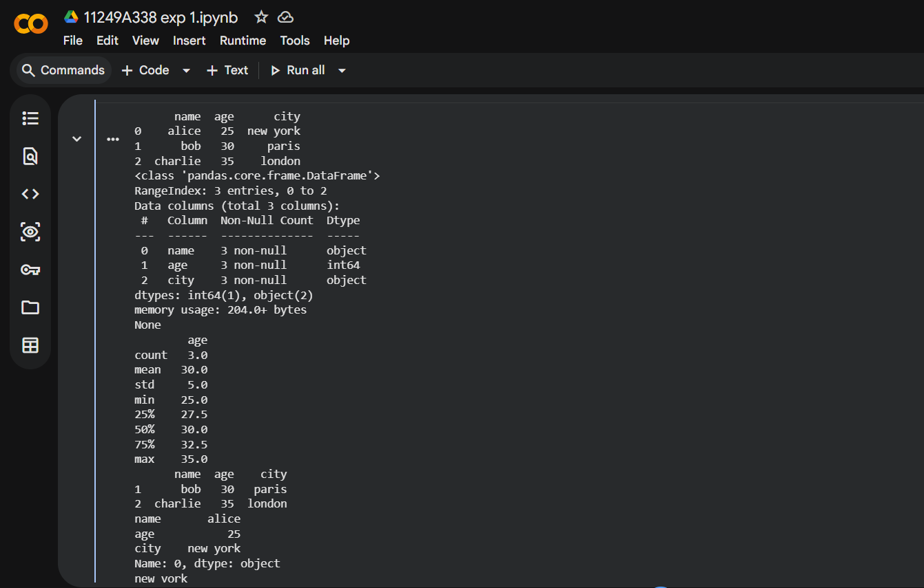
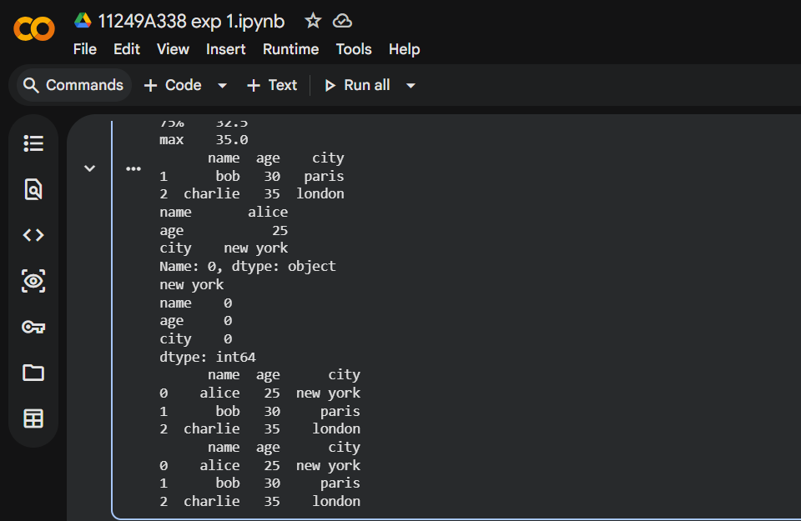

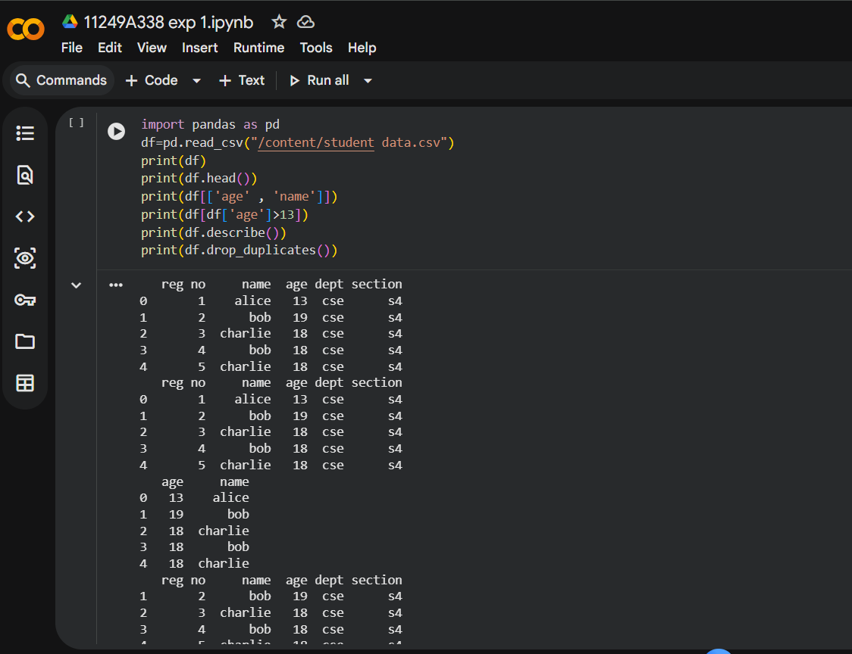
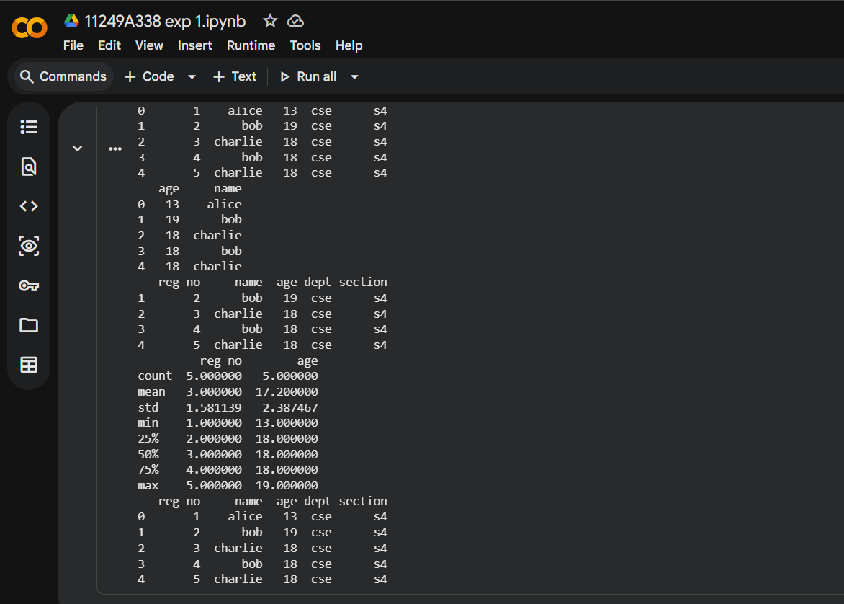

MATPLOTLIB
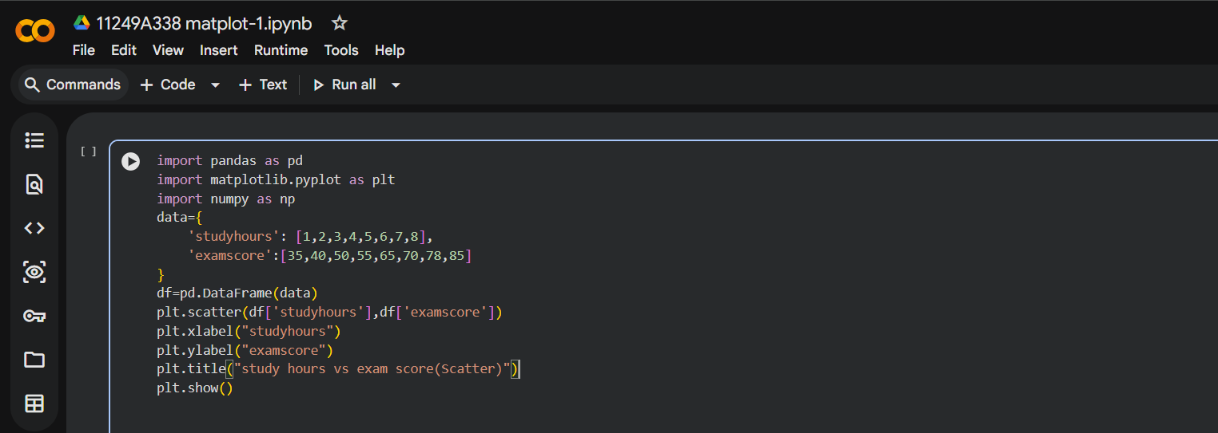
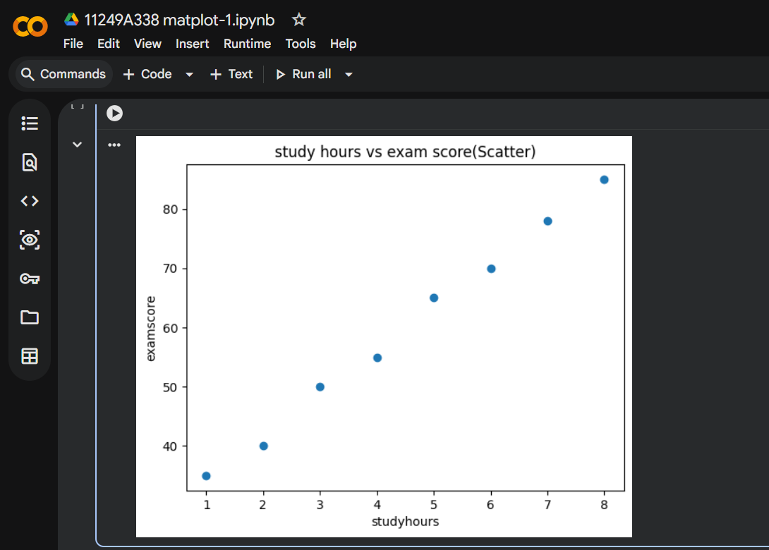

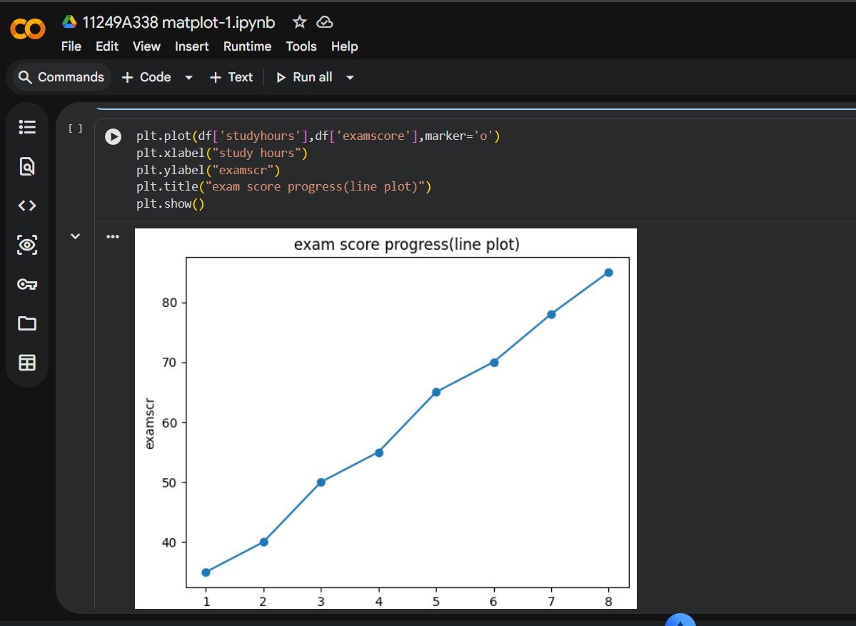
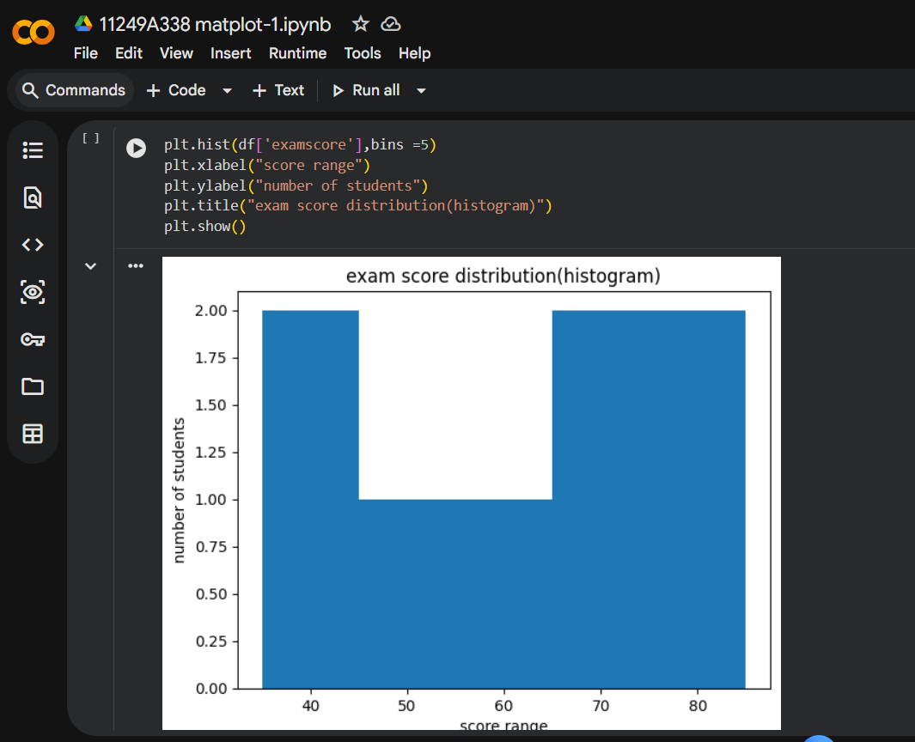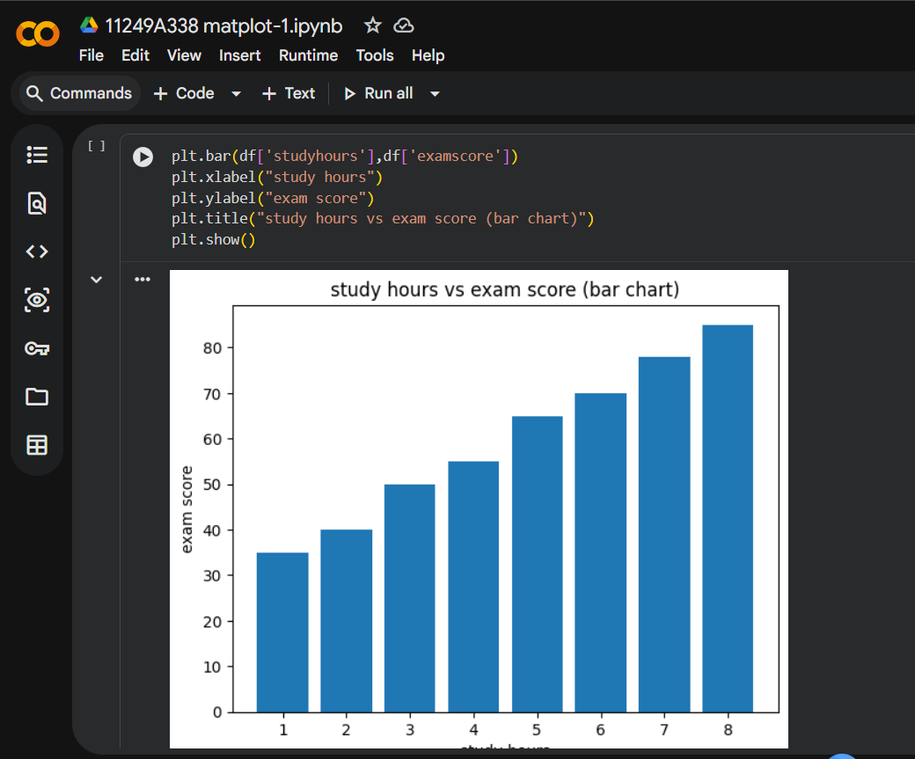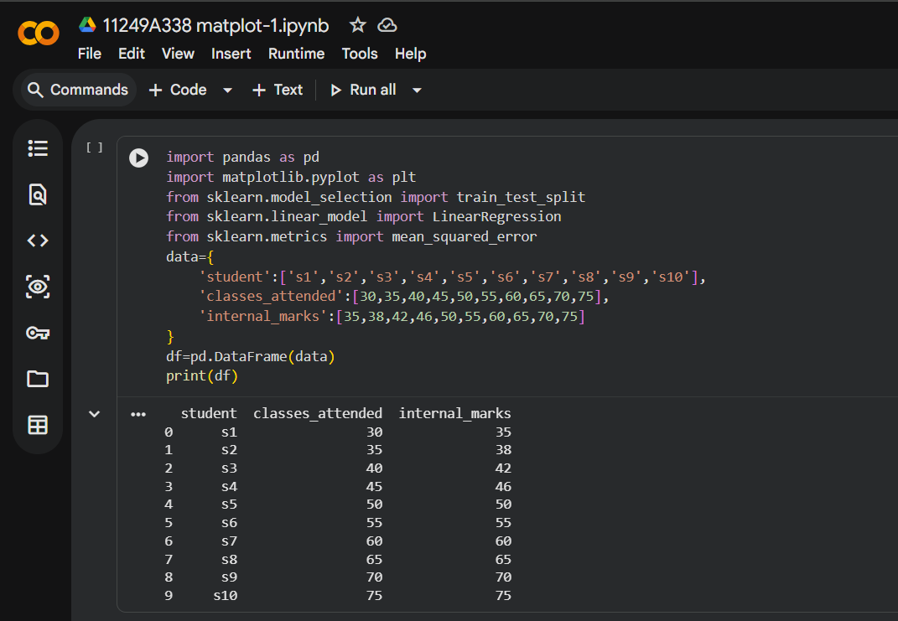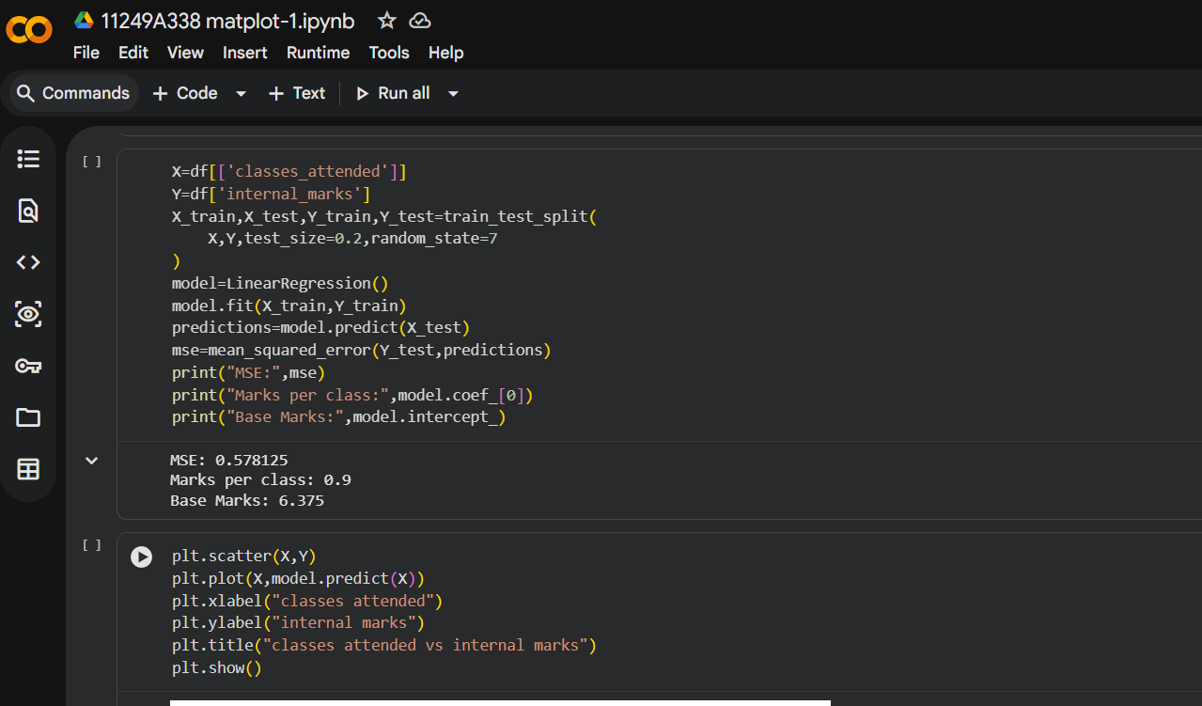

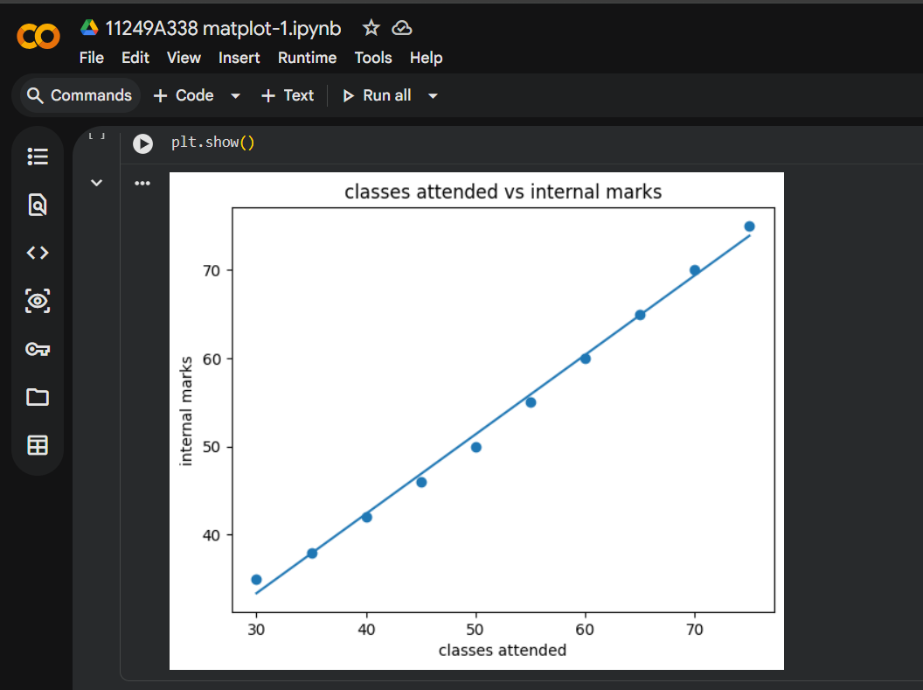

RESULT: The different types of graphs was plotted successfully and understood the data visualization techniques.

DATA EXPLORATION AND PREPROCESSING IN PYTHON
EXP NO: 02
DATE: 14-02-2026

AIM: To perform data exploration and preprocessing using python libraries like numpy and pandas.
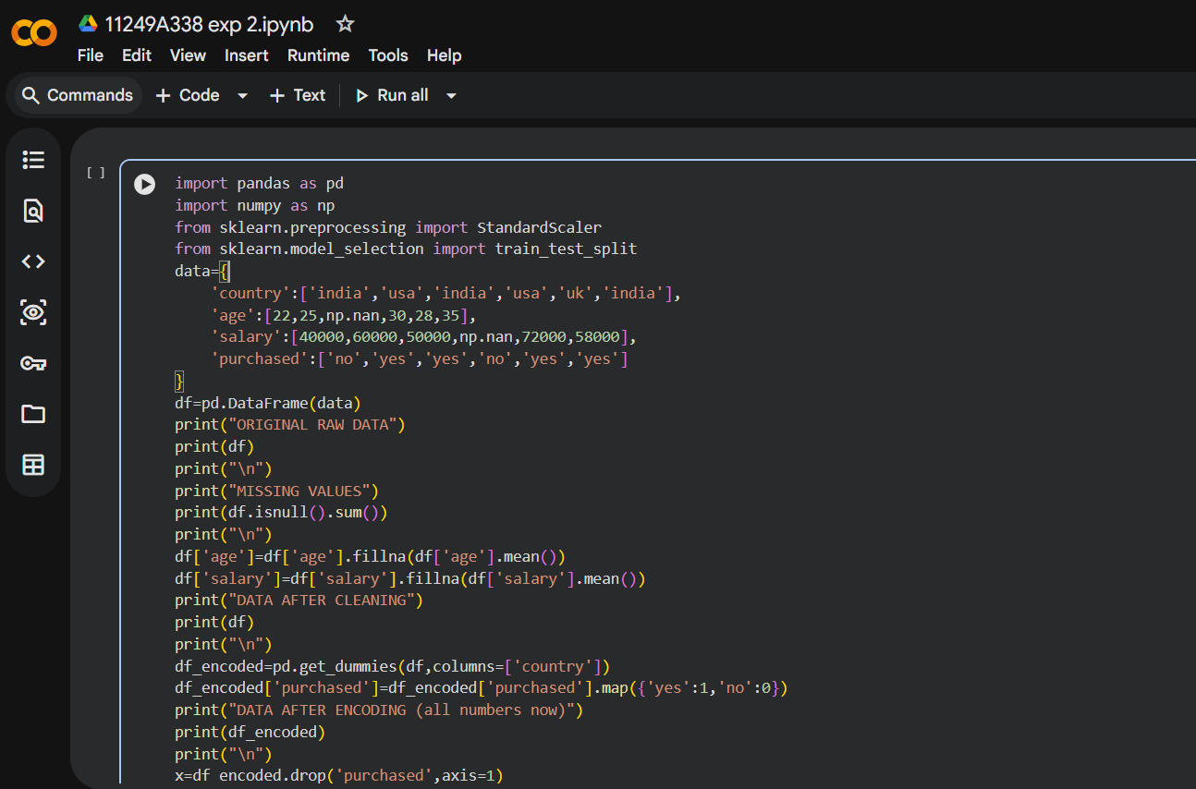
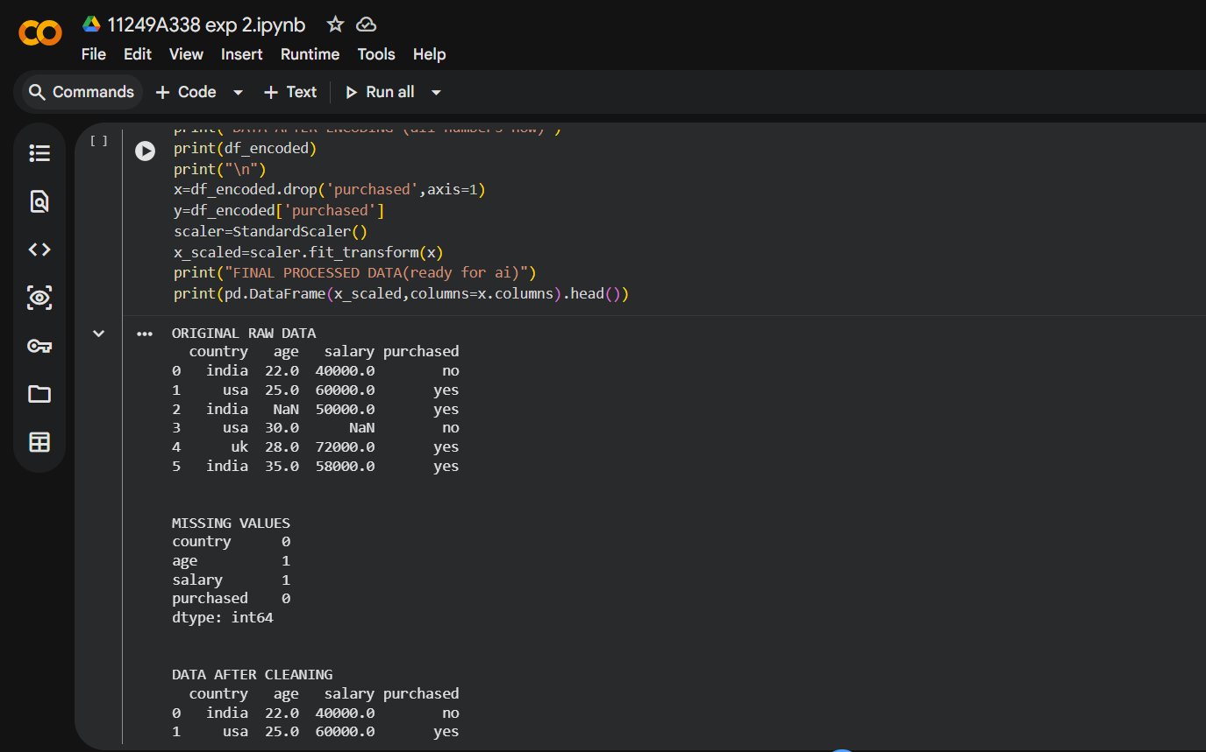

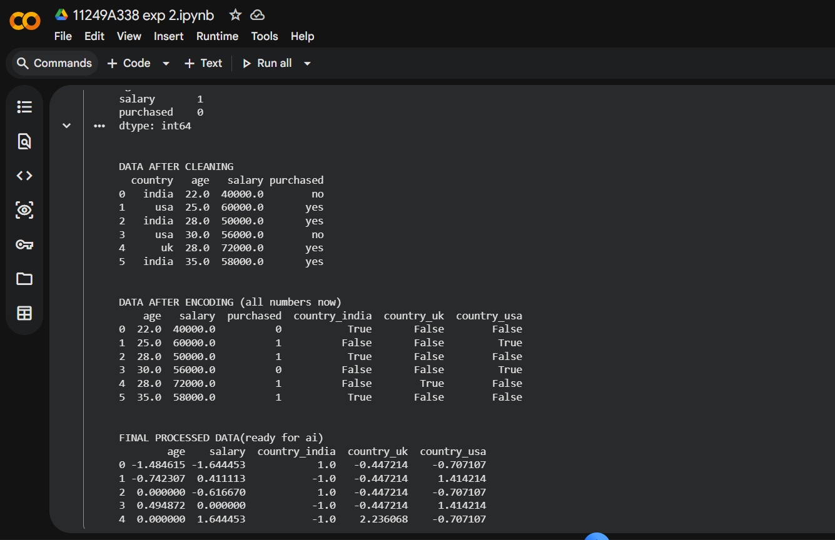
RESULT: The data was successfully cleaned, transformed and analyzed the dataset by handling missing values and preparing it for modelling.

IMPLEMENT REGULARIZED LINEAR REGRESSION
EXP NO: 03
DATE: 14-02-2026

AIM: To implement regularization to reduce overfitting and to improve model performance.
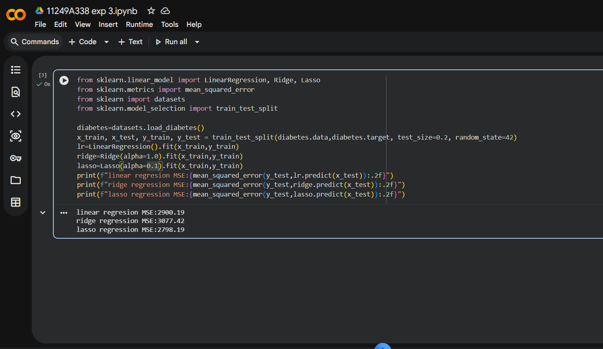

RESULT: The regularization was applied successfully to reduce overfitting and to improve model performance.

IMPLEMENT NAÏVE BAYES CLASSIFICATION
EXP NO: 04
DATE: 23-02-2026

AIM: To implement Naïve Bayes Classification for predicting class labels.
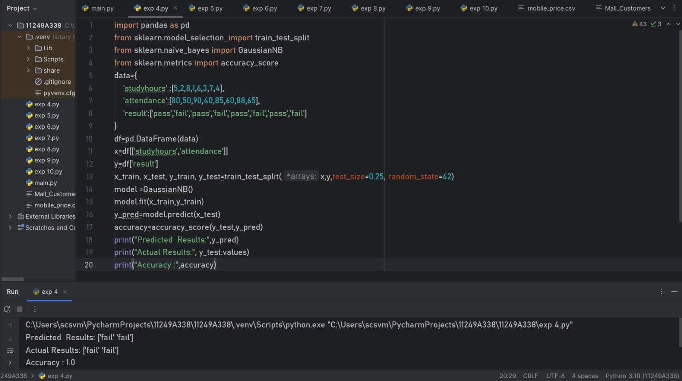

RESULT: Successfully built a probabilistic classifier and achieved accurate predictions on the dataset.

IMPLEMENT REGULARIZED LOGISTIC REGRESSION
EXP NO: 05
DATE: 02-03-2026

AIM: To implement Regularized Logistic Regression using python and analyze the effect of regularization in reducing overfitting and improving model performance.
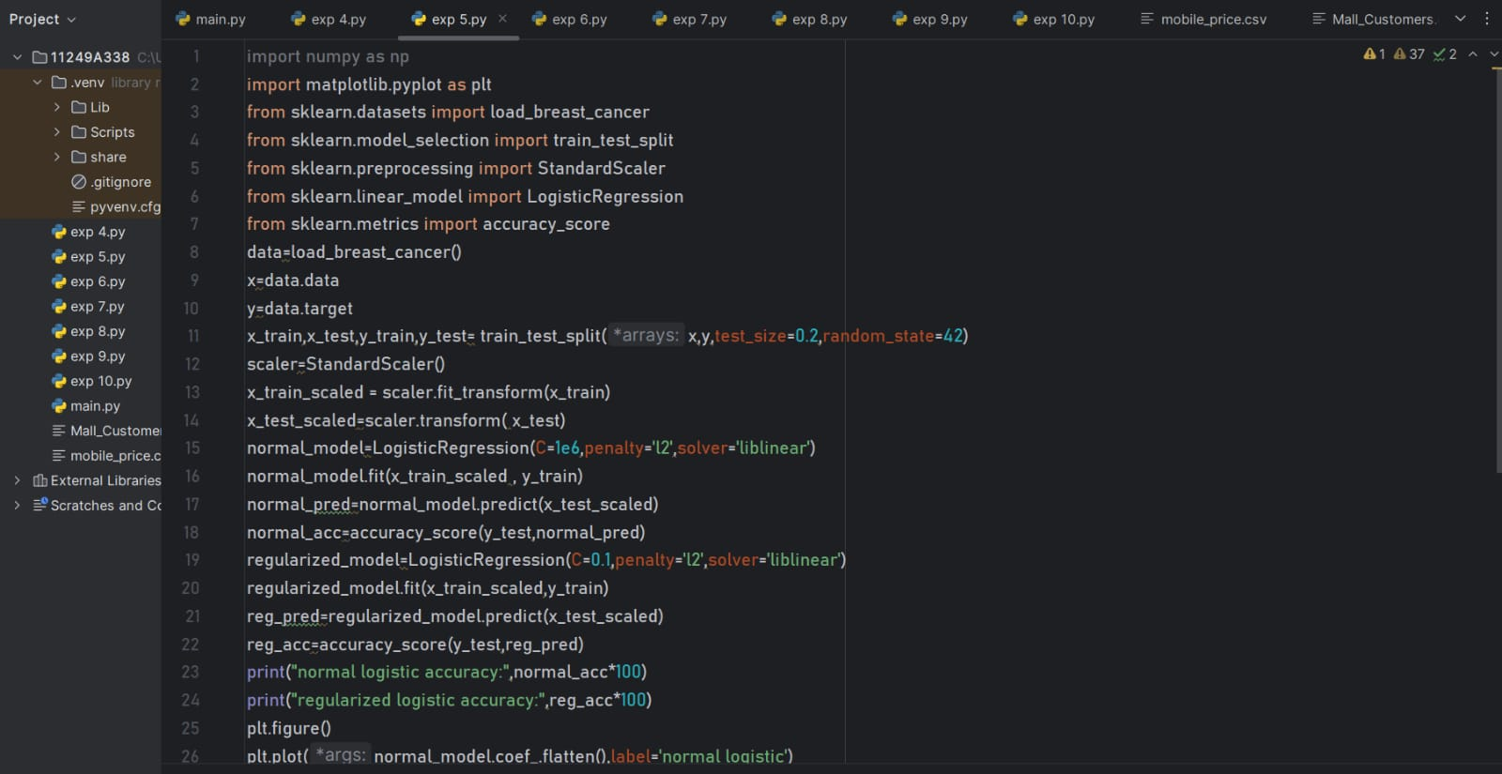
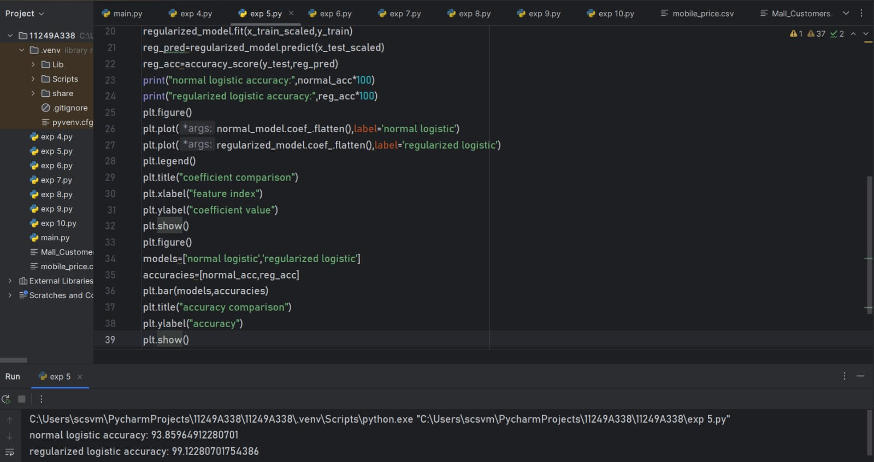
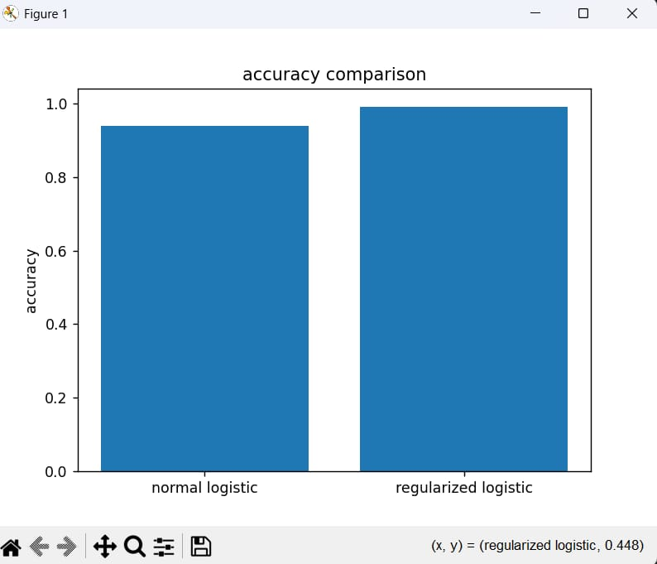

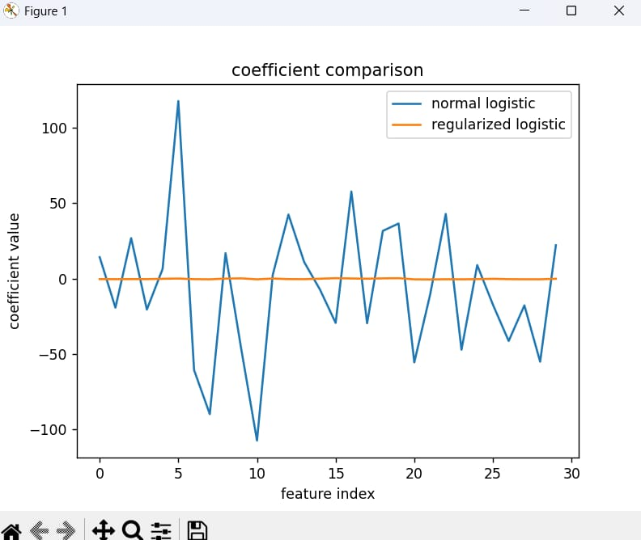

RESULT: Successfully implemented logistic regression and observed the regularization improves generalization by controlling model complexity, leading to better prediction.

BUILD MODELS USING DIFFERENT ENSEMBLING TECHNIQUES
EXP NO: 06
DATE: 09-03-2026

AIM: To build models using different ensemble techniques like Boosting, Random Forest.
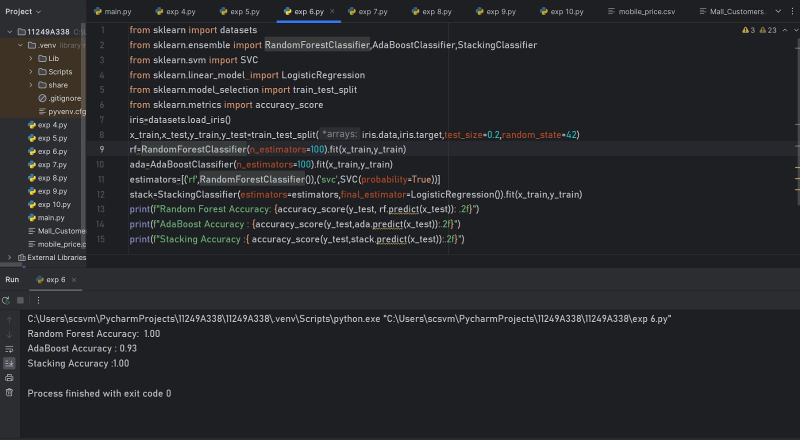

RESULT: Successfully improved prediction accuracy by combining multiple models.

BUILD MODELS USING DECISION TREES
EXP NO: 07
DATE: 16-03-2026

AIM: To build and analyze models using Decision Tree algorithms.
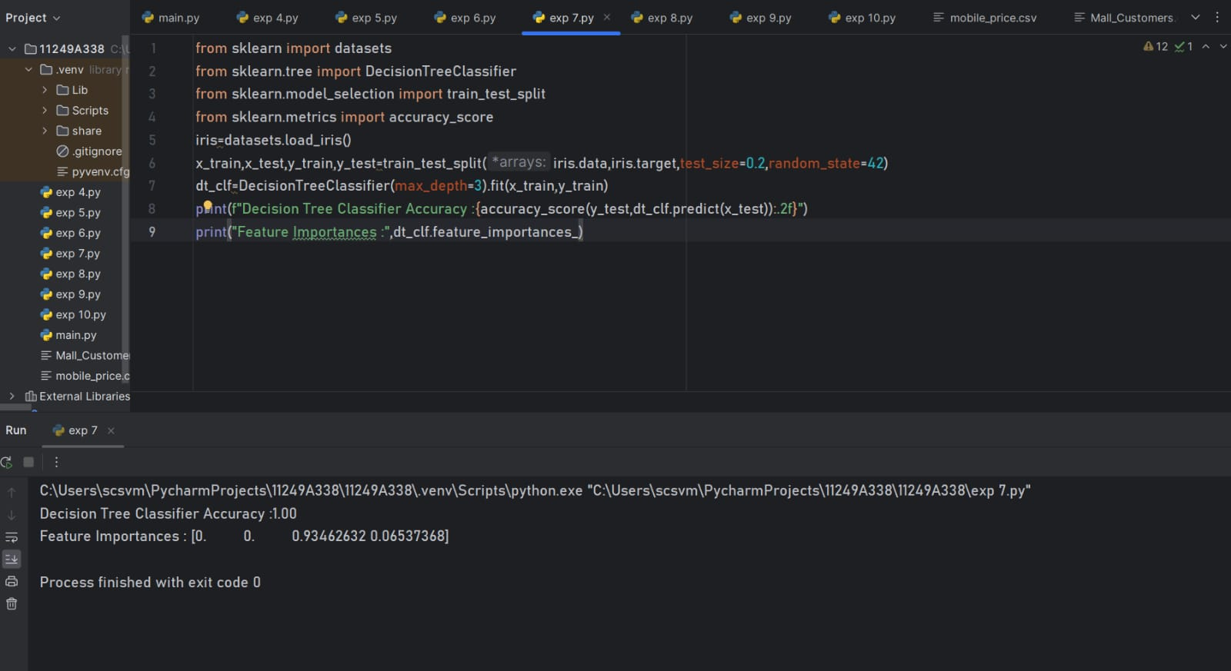

RESULT: Successfully created decision tree models and interpreted decision rules for classification.

SUPPORT VECTOR MACHINES (SVM) WITH DIFFERENT KERNELS
EXP NO: 08
DATE: 16-03-2026

AIM: To implement SVM with different kernels (linear,polynomial,RBF).
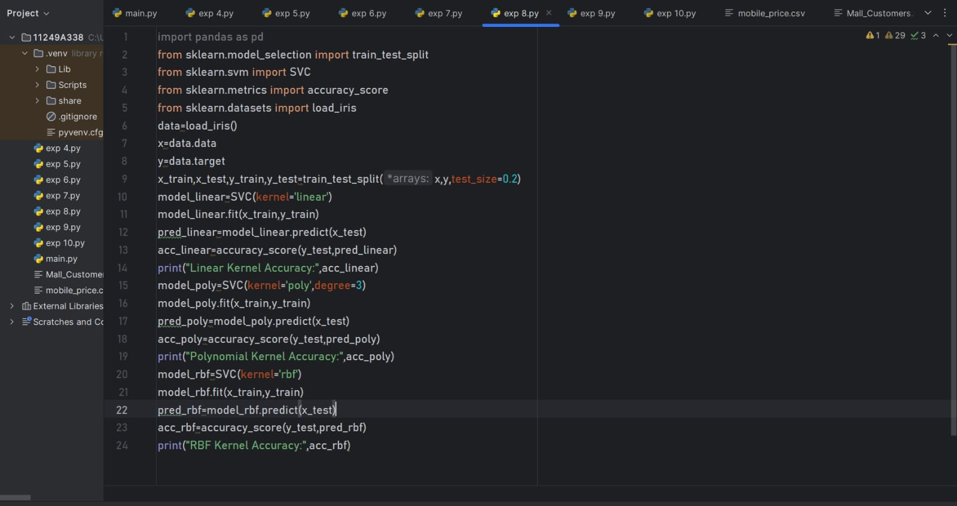
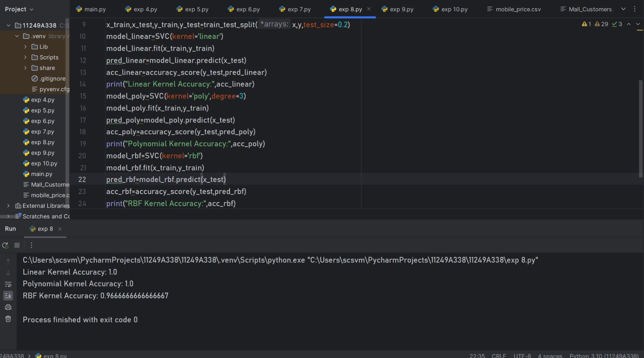
RESULT: Successfully classified data using SVM and compared performance.

IMPLEMENT KNN CLASSIFICATION
EXP NO: 09
DATE: 23-03-2026
AIM: To implement KNN classification algorithms.
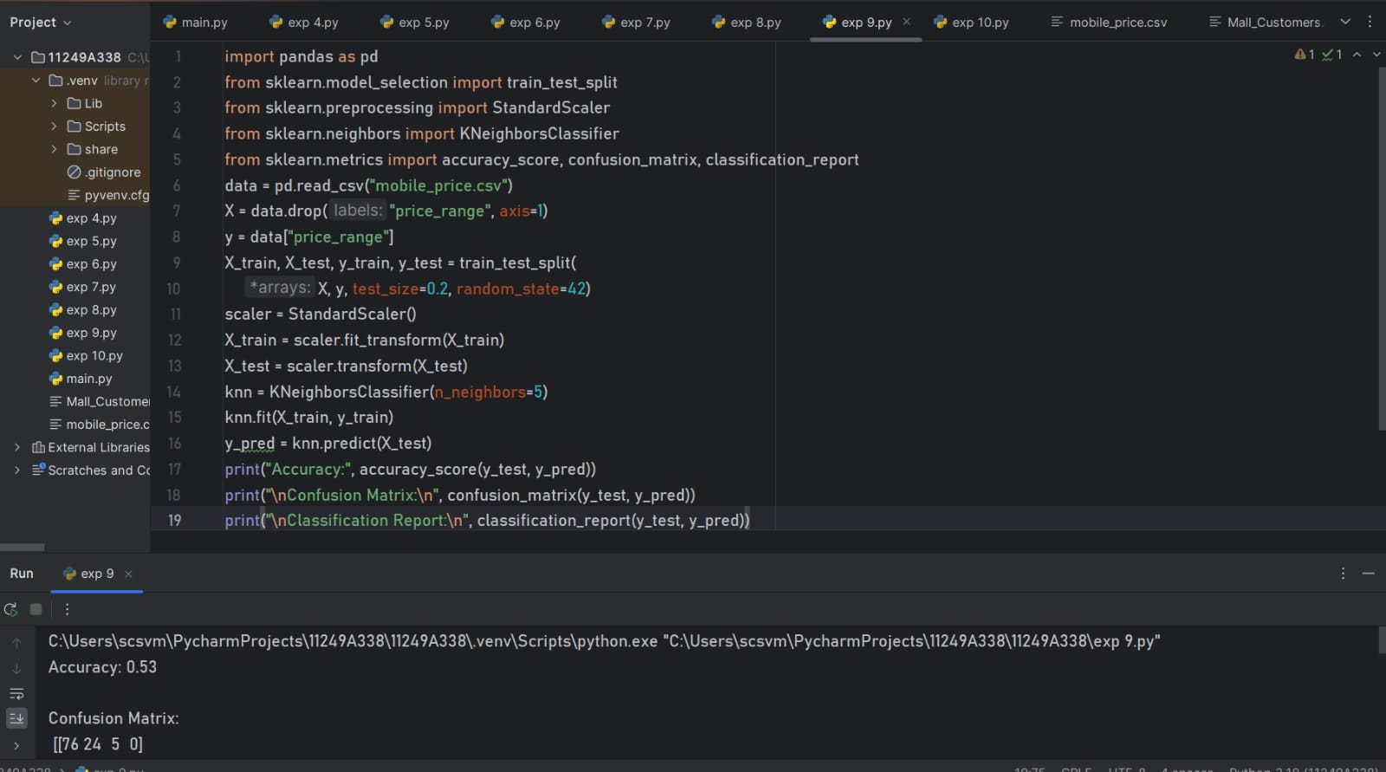
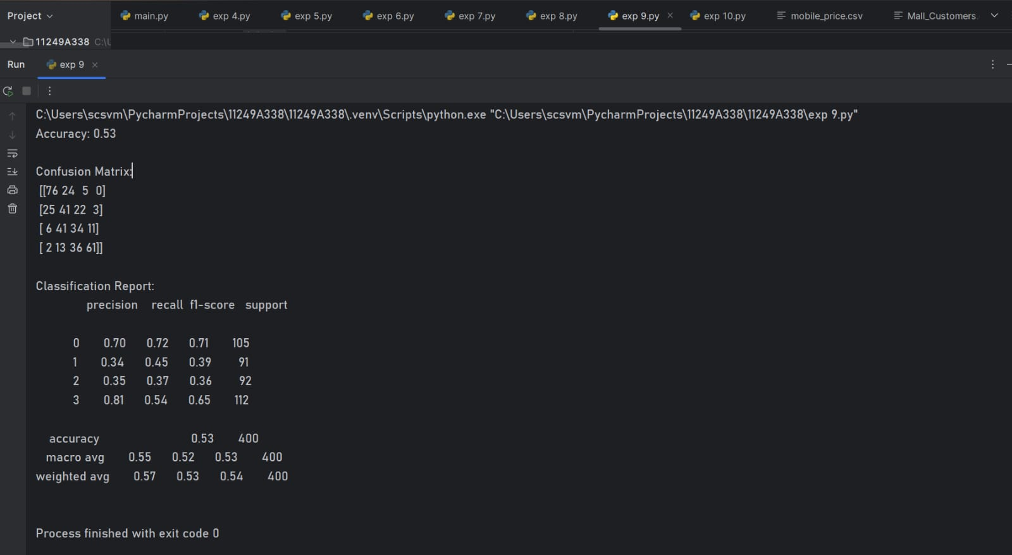
RESULT: Successfully classified data based on nearest neighbours.

K-MEANS CLUSTERING WITH PCA AND ELBOW METHOD
EXP NO: 10
DATE: 23-03-2026

AIM: To perform K-Means clustering and determine optimal clusters using PCA and Elbow method.
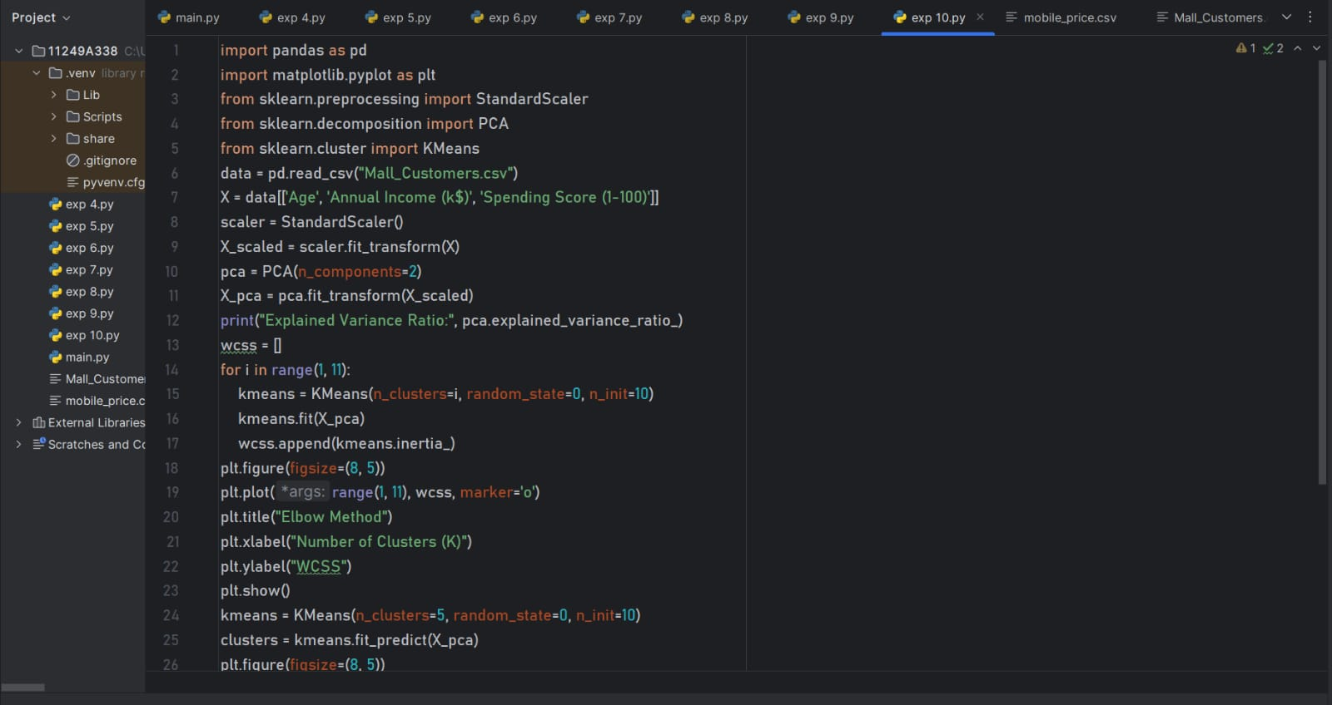
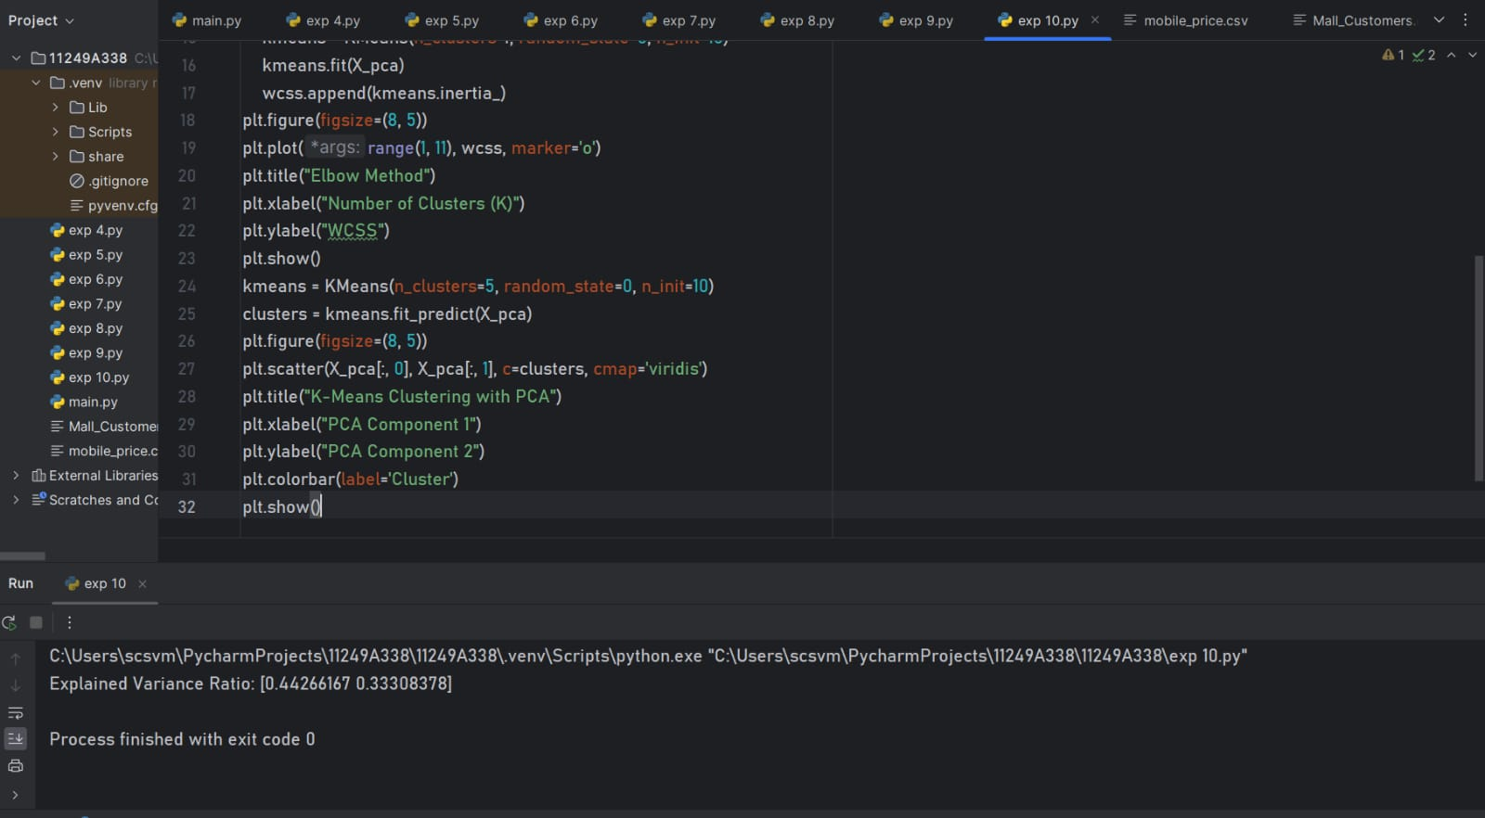
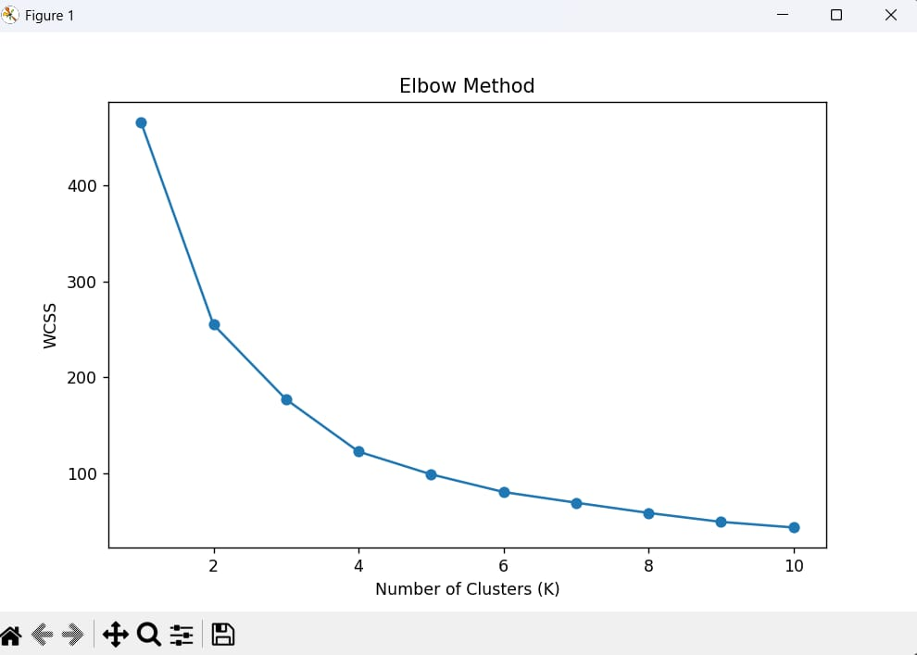
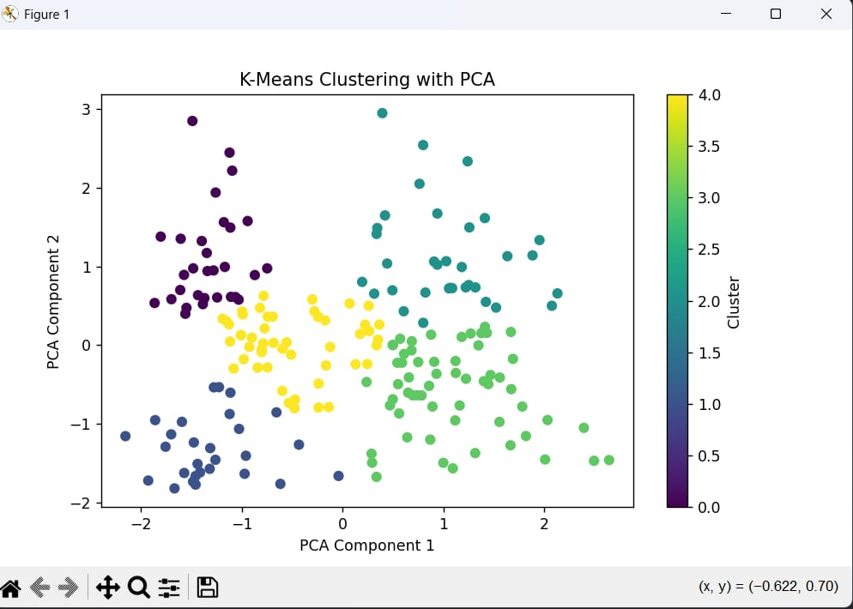
RESULT: Successfully reduced dimensionally using PCA and identified optimal clusters using the Elbow method.

