Name : Sudharsan S
Reg No : 11249A362
Sec : S6
Subject : R Programming Lab

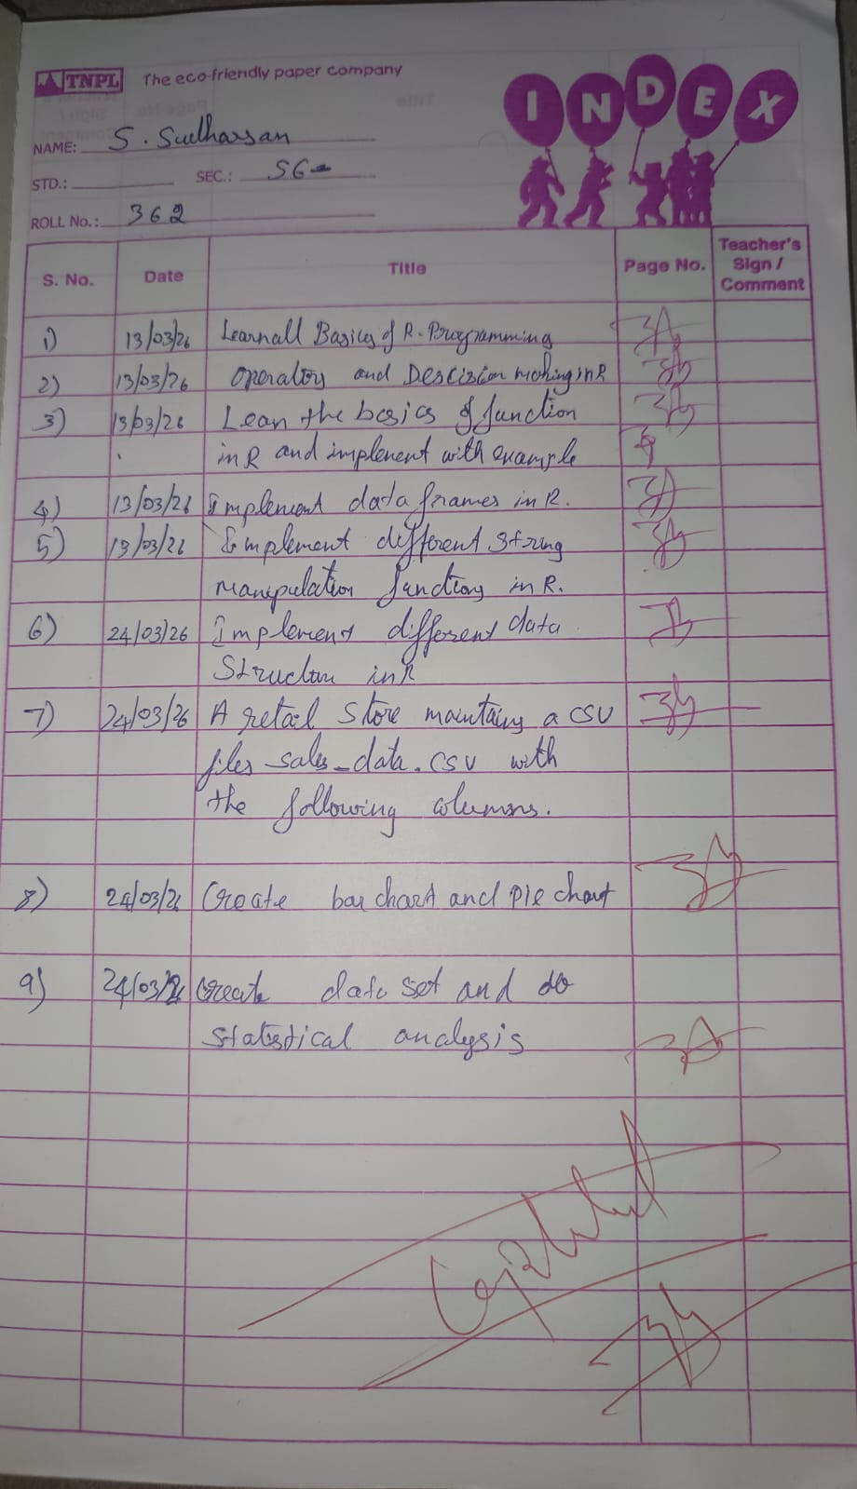
#Student Information System
> roll_no <- 362 # Integer
> name <- "Sudharsan" # Character
> cgpa <- 8.25 # Numeric
> pass <- TRUE # Logical
> roll_no
[1] 362
> name
[1] "Sudharsan"
> cgpa
[1] 8.25
> pass
[1] TRUE
> #Employee Salary Record
> emp_id <- 362
> salary <- 1000000
> department <- "CSE"
> is_permanent <- TRUE
> emp_id
[1] 362
> salary
[1] 1e+06
> department
[1] "CSE"
> is_permanent
[1] TRUE
> #Online Shopping Cart
> product_name <- "Laptop"
> price <- 90000
> stock_available <- 19
> discount_eligible <- TRUE
> product_name
[1] "Laptop"
> price
[1] 90000
> stock_available
[1] 19
> discount_eligible
[1] TRUE
> #Weather Monitoring System
> city <- "Karur"
> temperature <- 32.5
> rain <- FALSE
> wind_speed <- 10.2
> city
[1] "Karur"
> temperature
[1] 32.5
> rain
[1] FALSE
> wind_speed
[1] 10.2
> #Examination Result Processing
> subject <- "Computer Science"
> total_marks <- 100
> marks_obtained <- 90
> result <- marks_obtained >= 40
> subject
[1] "Computer Science"
> total_marks
[1] 100
> marks_obtained
[1] 90
> result
[1] TRUE
> #Banking Application
> account_no <- 362123456
> holder_name <- "Sudharsan"
> balance <- 1000000.00
> account_active <- TRUE
> account_no
[1] 362123456
> holder_name
[1] "Sudharsan"
> balance
[1] 1e+06
> account_active
[1] TRUE
> #Movie Rating System
> movie_title <- "Leo"
> rating <- 9.0
> reviews <- 362
> available <- TRUE
> movie_title
[1] "Leo"
> rating
[1] 9
> reviews
[1] 362
> available
[1] TRUE
> #Traffic Monitoring System
> vehicle_count <- 362
> location <- "Karur Main Road"
> avg_speed <- 50.5
> congested <- TRUE
> vehicle_count
[1] 362
> location
[1] "Karur Main Road"
> avg_speed
[1] 50.5
> congested
[1] TRUE
>

#Loan Eligibility Check
> age <- 20
> income <- 28000
> if(age > 21 & income > 30000){
+ print("Eligible for Loan")
+ } else {
+ print("Not Eligible for Loan")
+ }
[1] "Not Eligible for Loan"
> #Attendance Requirement
> attendance <- 68
> if(attendance >= 75){
+ print("Eligible for Exam")
+ } else {
+ print("Not Eligible for Exam")
+ }
[1] "Not Eligible for Exam"
> #Online Discount System
> amount <- 3500
> premium_member <- FALSE
> if(amount > 5000 | premium_member){
+ print("Discount Applied")
+ } else {
+ print("No Discount")
+ }
[1] "No Discount"
> #Electricity Bill Slab
> units <- 85
> if(units < 100){
+ print("Low Usage")
+ } else if(units <= 300){
+ print("Medium Usage")
+ } else {
+ print("High Usage")
+ }
[1] "Low Usage"
> #Employee Bonus Eligibility
> experience <- 4
> rating <- 3.8
> if(experience > 5 & rating > 4){
+ print("Bonus Eligible")
+ } else {
+ print("Not Eligible for Bonus")
+ }
[1] "Not Eligible for Bonus"
> #Password Validation
> password <- "pass12"
> if(nchar(password) >= 8){
+ print("Valid Password")
+ } else {
+ print("Invalid Password")
+ }
[1] "Invalid Password"
> #Temperature Warning System
> temperature <- 25
> if(temperature < 0 | temperature > 40){
+ print("Extreme Temperature Warning")
+ } else {
+ print("Normal Temperature")
+ }
[1] "Normal Temperature"
> #Grading System
> marks <- 67
> if(marks >= 90){
+ grade <- "A"
+ } else if(marks >= 75){
+ grade <- "B"
+ } else if(marks >= 50){
+ grade <- "C"
+ } else {
+ grade <- "Fail"
+ }
> print(grade)
[1] "C"
> #Bank Credit Card Approval System
> age <- 19
> income <- 22000
> credit_score <- 650
> if(age >= 21 & age <= 60 & income >= 25000 & credit_score >= 700){
+ print("Credit Card Approved")
+ } else {
+ print("Credit Card Rejected")
+ }
[1] "Credit Card Rejected"
> bp <- 128
> sugar <- 165
> if(bp > 140 & sugar > 200){
+ risk <- "High Risk"
+ } else if((bp >= 120 & bp <= 140) | (sugar >= 140 & sugar <= 200)){
+ risk <- "Medium Risk"
+ } else {
+ risk <- "Low Risk"
+ }
> print(risk)
[1] "Medium Risk"
> vehicle_count <- 85
> if(vehicle_count > 200){
+ print("Long Green Signal")
+ } else if(vehicle_count >= 100){
+ print("Medium Green Signal")
+ } else {
+ print("Short Green Signal")
+ }
[1] "Short Green Signal"
> #Employee Performance Appraisal System
> attendance <- 85
> performance <- 7.2
> project_completed <- FALSE
> if(attendance >= 90 & performance >= 8 & project_completed){
+ print("Eligible for Appraisal")
+ } else {
+ print("Not Eligible for Appraisal")
+ }
[1] "Not Eligible for Appraisal"
> face_detected <- FALSE
> multiple_faces <- FALSE
> performance <- 7.2
> project_completed <- FALSE
> if(attendance >= 90 & performance >= 8 & project_completed){
+ print("Eligible for Appraisal")
+ } else {
+ print("Not Eligible for Appraisal")
+ }
[1] "Not Eligible for Appraisal"
> face_detected <- FALSE
> multiple_faces <- FALSE
> internet_connected <- TRUE
> if(!face_detected | multiple_faces | !internet_connected){
+ print("Exam Disqualified")
+ } else {
+ print("Exam Allowed")
+ }
[1] "Exam Disqualified"
> #Dynamic Pricing in Ride-Hailing App
> high_demand <- TRUE
> available_drivers <- 55
> if(high_demand & available_drivers < 50){
+ print("Surge Pricing Applied")
+ } else {
+ print("Normal Pricing")
+ }
[1] "Normal Pricing"
> #Industrial Machine Safety System
> temperature <- 68
> pressure <- 110
> vibration <- 5
> if(temperature > 80 | pressure > 120 | vibration > 7){
+ print("Machine Shutdown")
+ } else {
+ print("Machine Running Normally")
+ }
[1] "Machine Running Normally"
> entrance_score <- 65
> twelfth_marks <- 72
> age <- 26
> if(entrance_score >= 70 & twelfth_marks >= 75 & age <= 25){
+ print("Admission Granted")
+ } else {
+ print("Admission Rejected")
+ }
[1] "Admission Rejected"
>

students <- data.frame(
+ RollNo = c(101, 102, 103),
+ Name = c("Raven", "Meenamma", "Karthikeyan"),
+ Dept = c("CSE", "ECE", "IT")
+ )
> marks <- data.frame(
+ Marks = c(88, 82, 91)
+ )
> student_data <- cbind(students, marks)
> student_data
RollNo Name Dept Marks
1 101 Raven CSE 88
2 102 Meenamma ECE 82
3 103 Karthikeyan IT 91
> new_students <- data.frame(
+ RollNo = 104,
+ Name = "Anjan",
+ Dept = "CSE",
+ Marks = 88
+ )
> final_data <- rbind(student_data, new_students)
> final_data
RollNo Name Dept Marks
1 101 Raven CSE 88
2 102 Meenamma ECE 82
3 103 Karthikeyan IT 91
4 104 Anjan CSE 88
> employee_details <- data.frame(
+ EmpID = c(1, 2, 3),
+ Name = c("Amirtha", "Snehan", "Rajan"),
+ Dept = c("HR", "IT", "Finance")
+ )
> salary_details <- data.frame(
+ Salary = c(350000, 455000, 150000)
+ )
> employees <- cbind(employee_details, salary_details)
> employees
EmpID Name Dept Salary
1 1 Amirtha HR 350000
2 2 Snehan IT 455000
3 3 Rajan Finance 150000
> new_employee <- data.frame(
+ EmpID = 4,
+ Name = "Nehan",
+ Dept = "IT",
+ Salary = 480000
+ )
> employees <- rbind(employees, new_employee)
> employees
EmpID Name Dept Salary
1 1 Amirtha HR 350000
2 2 Snehan IT 455000
3 3 Rajan Finance 150000
4 4 Nehan IT 480000
> patient_info <- data.frame(
+ PatientID = c(201, 202),
+ Name = c("Soorya", "Lakshman"),
+ Age = c(45, 38)
+ )
> treatment_cost <- data.frame(
+ Cost = c(12000, 15000)
+ )
> patient_records <- cbind(patient_info, treatment_cost)
> patient_records
PatientID Name Age Cost
1 201 Soorya 45 12000
2 202 Lakshman 38 15000
> new_patient <- data.frame(
+ PatientID = 203,
+ Name = "Arya",
+ Age = 50,
+ Cost = 18000
+ )
> patient_records <- rbind(patient_records, new_patient)
> patient_records
PatientID Name Age Cost
1 201 Soorya 45 12000
2 202 Lakshman 38 15000
3 203 Arya 50 18000
> products <- data.frame(
+ ProductID = c(1, 2, 3),
+ ProductName = c("Pen", "Book", "Bag")
+ )
> stock <- data.frame(
+ Quantity = c(100, 50, 30)
+ )
> inventory <- cbind(products, stock)
> inventory
ProductID ProductName Quantity
1 1 Pen 100
2 2 Book 50
3 3 Bag 30
> new_product <- data.frame(
+ ProductID = 4,
+ ProductName = "Bottle",
+ Quantity = 75
+ )
> inventory <- rbind(inventory, new_product)
> inventory
ProductID ProductName Quantity
1 1 Pen 100
2 2 Book 50
3 3 Bag 30
4 4 Bottle 75
> students <- data.frame(
+ RollNo = c(1, 2, 3),
+ Name = c("Aruna", "Balaji", "Charanya"),
+ Dept = c("CSE", "ECE", "IT")
+ )
> marks <- data.frame(
+ Sem1 = c(78, 82, 90),
+ Sem2 = c(80, 85, 88)
+ )
> attendance <- data.frame(
+ Attendance = c(92, 88, 95)
+ )
> student_records <- cbind(students, marks, attendance)
> student_records
RollNo Name Dept Sem1 Sem2 Attendance
1 1 Aruna CSE 78 80 92
2 2 Balaji ECE 82 85 88
3 3 Charanya IT 90 88 95
> new_students <- data.frame(
+ RollNo = c(4, 5),
+ Name = c("Deepa", "Eshan"),
+ Dept = c("CSE", "IT"),
+ Sem1 = c(85, 89),
+ Sem2 = c(87, 91),
+ Attendance = c(90, 93)
+ )
> final_records <- rbind(student_records, new_students)
> final_records
RollNo Name Dept Sem1 Sem2 Attendance
1 1 Aruna CSE 78 80 92
2 2 Balaji ECE 82 85 88
3 3 Charanya IT 90 88 95
4 4 Deepa CSE 85 87 90
5 5 Eshan IT 89 91 93
> emp_details <- data.frame(
+ EmpID = c(101, 102),
+ Name = c("Rahul", "Sneha"),
+ Dept = c("IT", "HR")
+ )
> salary <- data.frame(
+ Basic = c(30000, 35000),
+ HRA = c(6000, 7000),
+ DA = c(3000, 3500)
+ )
> rating <- data.frame(
+ Rating = c(4.5, 4.2)
+ )
> payroll <- cbind(emp_details, salary, rating)
> payroll
EmpID Name Dept Basic HRA DA Rating
1 101 Rahul IT 30000 6000 3000 4.5
2 102 Sneha HR 35000 7000 3500 4.2
> new_emp <- data.frame(
+ EmpID = 103,
+ Name = "Kiran",
+ Dept = "Finance",
+ Basic = 40000,
+ HRA = 8000,
+ DA = 4000,
+ Rating = 4.8
+ )
> payroll <- rbind(payroll, new_emp)
> payroll
EmpID Name Dept Basic HRA DA Rating
1 101 Rahul IT 30000 6000 3000 4.5
2 102 Sneha HR 35000 7000 3500 4.2
3 103 Kiran Finance 40000 8000 4000 4.8
> products <- data.frame(
+ ProductID = c(1, 2, 3),
+ ProductName = c("Mobile", "Laptop", "Tablet")
+ )
> sales_qty <- data.frame(
+ UnitsSold = c(120, 80, 60)
+ )
> revenue <- data.frame(
+ Revenue = c(1200000, 4000000, 1800000)
+ )
> sales_data <- cbind(products, sales_qty, revenue)
> sales_data
ProductID ProductName UnitsSold Revenue
1 1 Mobile 120 1200000
2 2 Laptop 80 4000000
3 3 Tablet 60 1800000
> new_product <- data.frame(
+ ProductID = 4,
+ ProductName = "Smart Watch",
+ UnitsSold = 90,
+ Revenue = 900000
+ )
> sales_data <- rbind(sales_data, new_product)
> sales_data
ProductID ProductName UnitsSold Revenue
1 1 Mobile 120 1200000
2 2 Laptop 80 4000000
3 3 Tablet 60 1800000
4 4 Smart Watch 90 900000
> field_info <- data.frame(
+ FieldID = c(1, 2),
+ Crop = c("Rice", "Wheat")
+ )
> sensor_data <- data.frame(
+ Moisture = c(45, 38),
+ Temp = c(32, 29)
+ )
> yield <- data.frame(
+ ExpectedYield = c(4.5, 3.8)
+ )
> agri_data <- cbind(field_info, sensor_data, yield)
> agri_data
FieldID Crop Moisture Temp ExpectedYield
1 1 Rice 45 32 4.5
2 2 Wheat 38 29 3.8
> new_field <- data.frame(
+ FieldID = 3,
+ Crop = "Maize",
+ Moisture = 40,
+ Temp = 31,
+ ExpectedYield = 4.1
+ )
> agri_data <- rbind(agri_data, new_field)

names <- c("KIRAN", "DEEPA", "VARUN")
> upper_names <- toupper(names)
> name_length <- nchar(upper_names)
> upper_names
[1] "KIRAN" "DEEPA" "VARUN"
> name_length
[1] 5 5 5
> emails <- c("MEENA@gmail.com", "ARUN@yahoo.com", "KAVYA@outlook.com")
> usernames <- sub("@.*", "", emails)
> usernames
[1] "MEENA" "ARUN" "KAVYA"
> input <- c(" Machine Learning ", " Cloud Computing ", " Big Data ")
> clean_input <- trimws(input)
> clean_input
[1] "Machine Learning" "Cloud Computing" "Big Data"
> product_codes <- c("PRD601", "PRD602", "XYZ603")
> valid_codes <- startsWith(product_codes, "PRD")
> valid_codes
[1] TRUE TRUE FALSE
> report <- "warning in module, warning in code, warning detected"
> updated_report <- gsub("warning", "notice", report)
> updated_report
[1] "notice in module, notice in code, notice detected"
> password <- "KAVYA2024"
> if (nchar(password) >= 8) {
+ print("Strong Password")
+ } else {
+ print("Weak Password")
+ }
[1] "Strong Password"
> sentence <- "Python is widely used in data analysis"
> word_count <- length(strsplit(sentence, " ")[[1]])
> word_count
[1] 7
> files <- c("notes.txt", "presentation.pptx", "photo.jpg")
> extensions <- sub(".*\\.", "", files)
> extensions
[1] "txt" "pptx" "jpg"
> names <- c("PRAVEEN", "SANGEETHA", "HARISH")
> abbr <- substr(names, 1, 3)
> abbr
[1] "PRA" "SAN" "HAR"
> names <- c("KARTHIK", "ANITA", "SURESH", "DIVYA")
> matched_names <- grep("A", names, value = TRUE)
> matched_names
[1] "KARTHIK" "ANITA" "DIVYA"
> students <- data.frame(
+ Name = c(" Kavya ", "ARUN ", " meera"),
+ Email = c("Kavya@UNIV.edu", "arun@univ.edu", "meera@gmail.com"),
+ Department = c(" it", "CSE ", " Ece ")
+ )
> students$Name <- tools::toTitleCase(trimws(tolower(students$Name)))
> students$Email <- tolower(trimws(students$Email))
> students$Department <- toupper(trimws(students$Department))
> students
Name Email Department
1 Kavya kavya@univ.edu IT
2 Arun arun@univ.edu CSE
3 Meera meera@gmail.com ECE
> products <- data.frame(
+ Product = c(" oneplus phone ", "LG-TV ", " hp laptop"),
+ Code = c("PRD-401-ONE", "PRD-402-LG", "PRD-403-HP")
+ )
> products$Product <- trimws(products$Product)
> products$Product <- tools::toTitleCase(tolower(products$Product))
> products$ProductCode <- sub("PRD-[0-9]+-", "", products$Code)
> products
Product Code ProductCode
1 Oneplus Phone PRD-401-ONE ONE
2 Lg-Tv PRD-402-LG LG
3 Hp Laptop PRD-403-HP HP
> comments <- data.frame(
+ User = c("X", "Y", "Z"),
+ Comment = c(
+ "This service is poor",
+ "Really POOR quality",
+ "Not poor at all"
+ )
+ )
> comments$Comment <- tolower(comments$Comment)
> comments$CleanComment <- gsub(
+ "poor",
+ "unsatisfactory",
+ comments$Comment
+ )
> comments
User Comment CleanComment
1 X this service is poor this service is unsatisfactory
2 Y really poor quality really unsatisfactory quality
3 Z not poor at all not unsatisfactory at all

>

total
[1] 393
> average
[1] 78.6
> highest
[1] 91
> temperature <- c(25, 27, 31, 29, 33, 28, 30)
> min_temp <- min(temperature)
> max_temp <- max(temperature)
> min_temp
[1] 25
> max_temp
[1] 33
> employee <- list(
+ ID = 401,
+ Name = "Karthik",
+ Salary = 68000,
+ Department = "HR"
+ )
> employee
$ID
[1] 401

$Name
[1] "Karthik"

$Salary
[1] 68000

$Department
[1] "HR"

> employee$Name
[1] "Karthik"
> employee$Salary
[1] 68000
> patient <- list(
+ PatientID = 602,
+ Name = "Suresh",
+ Age = 42,
+ TestResults = c(110, 135, 128)
+ )
> patient
$PatientID
[1] 602

$Name
[1] "Suresh"

$Age
[1] 42

$TestResults
[1] 110 135 128

> patient$TestResults
[1] 110 135 128
> students <- data.frame(
+ RollNo = c(31, 32, 33),
+ Name = c("RAHUL", "SNEHA", "DIVYA"),
+ Dept = c("IT", "CSE", "ECE"),
+ Marks = c(88, 76, 90)
+ )
> students
RollNo Name Dept Marks
1 31 RAHUL IT 88
2 32 SNEHA CSE 76
3 33 DIVYA ECE 90
> sales <- data.frame(
+ Month = c("Apr", "May", "Jun"),
+ Sales = c(150000, 720000, 880000)
+ )
> total_sales <- sum(sales$Sales)
> total_sales
[1] 1750000
> prices <- c(1800, 1200, 650)
> customer <- list(
+ CustomerID = 402,
+ Name = "MEERA",
+ City = "Bangalore"
+ )
> orders <- data.frame(
+ Item = c("Tablet", "Keyboard", "Mouse"),
+ Price = prices
+ )
> prices
[1] 1800 1200 650
> customer
$CustomerID
[1] 402

$Name
[1] "MEERA"

$City
[1] "Bangalore"

> orders
Item Price
1 Tablet 1800
2 Keyboard 1200
3 Mouse 650
> subject_marks <- c(82, 91, 85)
> student_profile <- list(
+ Name = "Kiran",
+ RollNo = 205,
+ Marks = subject_marks
+ )
> class_results <- data.frame(
+ RollNo = c(401, 402, 403),
+ Total = c(250, 265, 275)
+ )
> student_profile
$Name
[1] "Kiran"

$RollNo
[1] 205

$Marks
[1] 82 91 85

> class_results
RollNo Total
1 401 250
2 402 265
3 403 275
> balances <- c(60000, 58000, 62000)
> customer_account <- list(
+ AccountNo = 84521,
+ Name = "RAVI"
+ )
> transactions <- data.frame(
+ Date = c("05-01", "06-01", "07-01"),
+ Amount = c(-800, 1500, -300)
+ )
> balances
[1] 60000 58000 62000
> customer_account
$AccountNo
[1] 84521

$Name
[1] "RAVI"

> transactions
Date Amount
1 05-01 -800
2 06-01 1500
3 07-01 -300
> scores <- c(88, 92, 95)
> profile <- list(
+ Name = "KARTHIK",
+ Age = 22,
+ Scores = scores
+ )
> records <- data.frame(
+ Subject = c("English", "Math", "Science"),
+ Marks = scores
+ )
> profile
$Name
[1] "KARTHIK"

$Age
[1] 22

$Scores
[1] 88 92 95

> records
Subject Marks
1 English 88
2 Math 92
3 Science 95
>

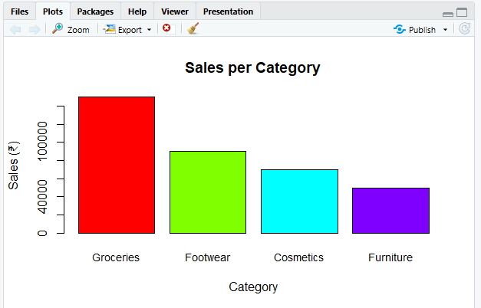

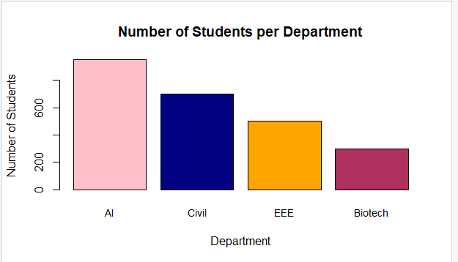

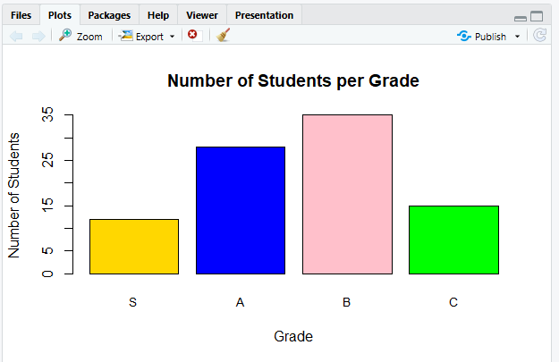
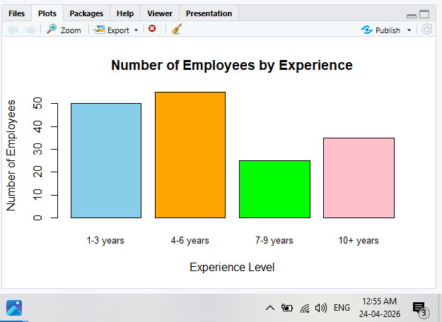

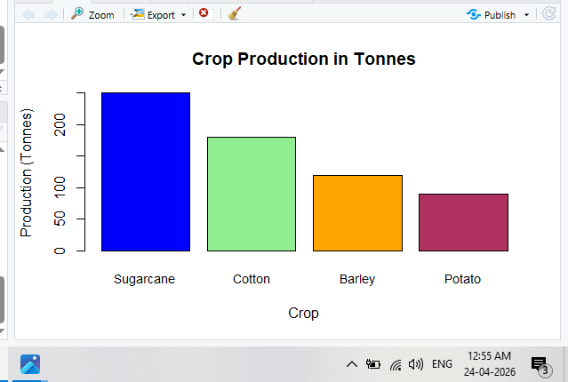

mean_marks
Maths Science English
84.2 85.2 84.2
> median_marks
Maths Science English
84 88 84
> sd_marks
Maths Science English
7.330302 7.814516 8.134973
> top_student
Name Maths Science English Total
10 MANOJ 92 91 95 278
> above_avg_math
Name Maths Science English Total
3 ARUN 91 78 83 252
4 MEENA 88 74 90 252
7 VARUN 86 72 85 243
9 KAVYA 95 94 72 261
10 MANOJ 92 91 95 278
> sales <- data.frame(
+ Product = c("TV","Fridge","Microwave","Fan","AC","Mixer","Grinder"),
+ Day1 = c(18,30,20,12,25,15,28),
+ Day2 = c(16,25,60,14,40,35,22),
+ Day3 = c(28,48,52,35,55,38,30),
+ Day4 = c(38,50,45,13,15,28,34),
+ Day5 = c(45,38,30,20,50,40,26)
+ )
> sales_stats <- data.frame(
+ Product = sales$Product,
+ Mean = apply(sales[,2:6], 1, mean),
+ Max = apply(sales[,2:6], 1, max),
+ Min = apply(sales[,2:6], 1, min),
+ Variance = apply(sales[,2:6], 1, var)
+ )
> max_avg_product <- sales_stats[
+ which.max(sales_stats$Mean),
+ ]
> sales_stats
Product Mean Max Min Variance
1 TV 29.0 45 16 157.0
2 Fridge 38.2 50 25 119.2
3 Microwave 41.4 60 20 264.8
4 Fan 18.8 35 12 91.7
5 AC 37.0 55 15 282.5
6 Mixer 31.2 40 15 102.7
7 Grinder 28.0 34 22 20.0
> max_avg_product
Product Mean Max Min Variance
3 Microwave 41.4 60 20 264.8
> patients <- data.frame(
+ PatientID = 301:310,
+ Name = c("KIRAN","MEENA","ARUN","SURESH","RAVI",
+ "KAVYA","GANESH","LATHA","VIKRAM","ANITA"),
+ Age = c(42,36,55,30,62,47,53,38,44,49)
+ )
> mean_age <- mean(patients$Age)
> median_age <- median(patients$Age)
> range_age <- range(patients$Age)
> sd_age <- sd(patients$Age)
> older_patients <- patients[
+ patients$Age > 50,
+ ]
> mean_age
[1] 45.6
> median_age
[1] 45.5
> range_age
[1] 30 62
> sd_age
[1] 9.628661
> older_patients
PatientID Name Age
3 303 ARUN 55
5 305 RAVI 62
7 307 GANESH 53
> employees <- data.frame(
+ EmpID = 201:210,
+ Name = c("ARUN","KAVYA","MEENA","DIVYA","RAHUL",
+ "SURESH","ANITA","KIRAN","POOJA","MANOJ"),
+ Dept = c("HR","IT","Finance","HR","IT",
+ "Finance","HR","IT","Finance","HR"),
+ Salary = c(520000,720000,250000,340000,310000,
+ 760000,820000,400000,450000,360000)
+ )
> dept_stats <- aggregate(
+ Salary ~ Dept,
+ data = employees,
+ function(x)
+ c(Mean = mean(x), Median = median(x))
+ )
> dept_stats <- do.call(data.frame, dept_stats)
> overall_avg <- mean(employees$Salary)
> high_earners <- employees[
+ employees$Salary > overall_avg,
+ ]
> dept_stats
Dept Salary.Mean Salary.Median
1 Finance 486666.7 450000
2 HR 510000.0 440000
3 IT 476666.7 400000
> high_earners
EmpID Name Dept Salary
1 201 ARUN HR 520000
2 202 KAVYA IT 720000
6 206 SURESH Finance 760000
7 207 ANITA HR 820000
> ratings <- data.frame(
+ ProductID = 11:20,
+ Product = c("TV","Fridge","Microwave","Fan","AC",
+ "Mixer","Grinder","Iron","Cooler","Heater"),
+ Rating = c(8,6,5,7,4,6,5,9,8,7)
+ )
> mean_rating <- mean(ratings$Rating)
> median_rating <- median(ratings$Rating)
> var_rating <- var(ratings$Rating)
> # Mode function
> getmode <- function(v) {
+ uniqv <- unique(v)
+ uniqv[which.max(tabulate(match(v, uniqv)))]
+ }
> mode_rating <- getmode(ratings$Rating)
> top_rated <- ratings[
+ ratings$Rating > mean_rating,
+ ]
> mean_rating
[1] 6.5
> median_rating
[1] 6.5
> mode_rating
[1] 8
> var_rating
[1] 2.5
> top_rated
ProductID Product Rating
1 11 TV 8
4 14 Fan 7
8 18 Iron 9
9 19 Cooler 8
10 20 Heater 7
>

