SRI CHANDRASEKHARENDRA SARASWATHI VISWA MAHAVIDYALAYA

(UNIVERSITY ESTABLISHED under section 3 of UGC Act 1956)

ENATHUR, KANCHIPURAM – 631 561



PROBLEM SOLVING TECHNIQUES LAB

LABORATORY RECORD

Name : R. RAJALAKSHMI

Reg. No : 112534037

Class : I YEAR BCA

Subject : UCAF251T50 - PST IN C LAB

SRI CHANDRASEKHARENDRA SARASWATHI

VISWA MAHAVIDYALAYA
(University Established under section 3 of UGC Act 1956)



BONAFIDE CERTIFICATE

This is to Certify that this is the bonafide record of work done by Ms. R.RAJALAKSHMI, with Reg. No 112534037 of I Year BCA in the Problem Solving Techniques Lab during the year 2025.

Staff-in-charge Head of the Department

Submitted for the Practical Examination held on ________________________

Internal Examiner External Examiner.

INDEX

S.No. | Date | Title | Page No. | Signature
1 | 24 Jul 2025 | CELSIUS TO FAHRENHEIT | 1
2 | 31 Jul 2025 | FIBONNACI SERIES | 4
3 | 07 Aug 2025 | SQUARE AND CUBE OF NUMBERS | 7
4 | 14 Aug 2025 | GENERATE ODD NUMBERS | 10
5 | 21 Aug 2025 | GENERATE GRADE | 13
6 | 28 Aug 2025 | GENERATE TOWER | 16
7 | 04 Sep 2025 | PALINDROME OR NOT | 19
8 | 25 Sep 2025 | STRING HANDLING | 22
9 | 25 Sep 2025 | ARRAY SORTING | 26
10 | 09 Oct 2025 | FACTORIAL | 29
11 | 09 Oct 2025 | SWAPPING OF NUMBER | 31
12 | 23 Oct 2025 | USING STRUCTURES | 33
13 | 23 Oct 2025 | FILE PROGRAMMING | 36

1 | CELSIUS TO FAHRENHEIT | DATE: 24 Jul 2025

AIM:

Write a C program to Convert temperature from Celsius to Fahrenheit and vice versa.

ALGORITHM:

Step 1: Start the program.
Step 2: Display the menu options:
- Option 1 → Convert Celsius to Fahrenheit
- Option 2 → Convert Fahrenheit to Celsius
Step 3: Read the user’s choice.
Step 4: if the choice = 1 goto step 5, else goto step 9
Step 5: Read the Celsius value.
Step 6: Convert Celsius to Fahrenheit using the formula: Fahrenheit=(Celsius×9/5) +32
Step 7: display the converted Fahrenheit value.
Step 8: Goto step 15.
Step 9: if the choice is 2: goto step 11. Else goto step 14.
Step 10: Read the Fahrenheit value.
Step 11: Convert it to Celsius using the formula: Celsius=(Fahrenheit−32) ×5/9.
Step 12: Display the converted Celsius value.
Step 13: Display an error message: “Invalid choice! Please run the program again and choose 1 or
2.”
Step 14: End the program.

FLOW CHART:

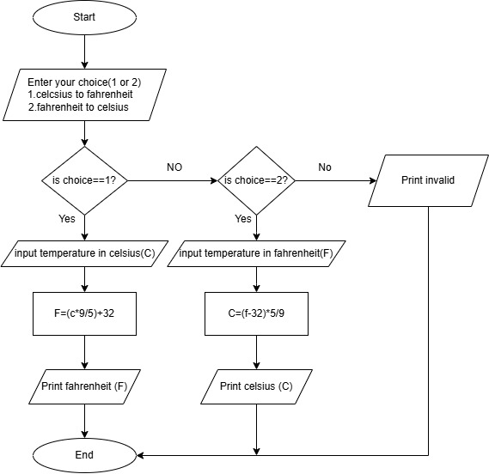

SOURCE CODE:

https://github.com/murugamuruga123/clab/blob/main/CELSIUS%20TO%20FAHRENHEIT.c

OUTPUT:
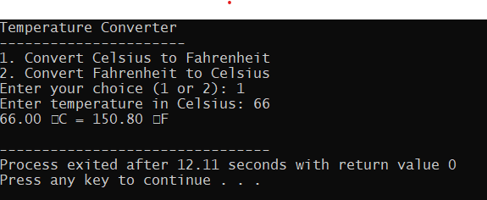

RESULT:

Thus the program is compiled and executed successfully with verified output.

2 | FIBONACCI SERIES | DATE: 31 Jul 2025

AIM:
Write a C program to generate a Fibonacci series.

ALGORITHM:
Step 1: Start the program.
Step 2: Declare variables:
n (number of terms),
t1 = 0 (first term),
t2 = 1 (second term),
next Term (to store next Fibonacci number),
i (loop counter).
Step 3: Read the number of terms n.
Step 4: i=3
Step 5: Calculate next Term = t1 + t2.
Step 6: Print next Term.
Step 7: t1 = t2,
t2 = next Term.
i=i+1
Step 8: if i<n repeat step 5, else continue
Step 9: End the program.

FLOW CHART:
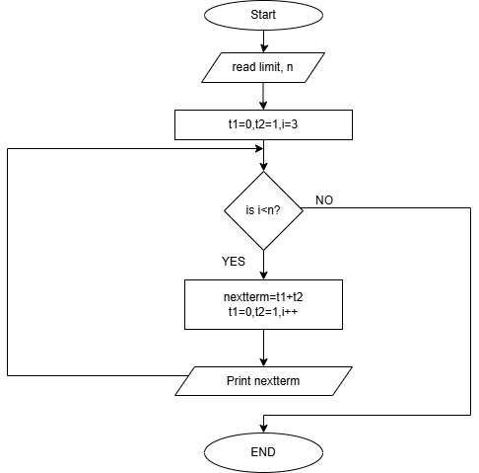

SOURCE CODE:

https://github.com/murugamuruga123/clab/blob/main/fibonnaci%20series.c

OUTPUT:
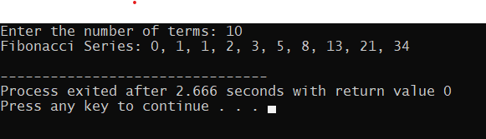

RESULT:

Thus the program is compiled and executed successfully with verified output.

3 | SQUARE AND CUBE OF NUMBERS | DATE:07 Aug 2025

AIM:

Write a C program to calculate the square and cube of 1 to n numbers

ALGORITHM:
Step 1: Start
Step 2: Declare integer variables limit(n) and counter (i)
Step 3: Read the value n
Step 4: Use a for loop that runs from i = 1
Step 5: Calculate square = i * i
Step 6: Calculate cube = i * i * i
Step 7: Display i, square, and cube
Step 8: i = i + 1
Step 9: If i < n go to step 5, else go to step 10
Step 10: stop

FLOWCHART:

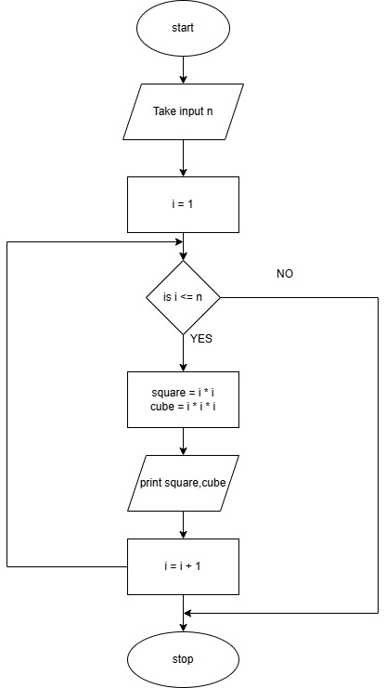

SOURCE CODE :

https://github.com/Rohith-Tech-king/c-lab/blob/main/square%20and%20cube%20for%20numbers.c

OUTPUT:

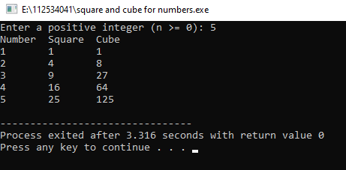

RESULT:

Thus the program is compiled and executed successfully with verified output.

4 | GENERATE ODD NUMBERS | DATE:14 Aug 2025

AIM:
Write a C program to display odd numbers from 1 to n

ALGORITHM:

Step 1: Start
Step 2: Declare integer variables limit (n) and counter (i)
Step 3: Read the value of n
Step 4: Use a for loop that runs from i = 1
Step 5: if i % 2! = 0 (i.e., i is odd) go to step 6, else go to step 7
Step 6: Print i
Step 7: i=i+1
Step 8: if i<n Go to Step 5, else goto step 9
Step 9: Stop

FLOWCHART:

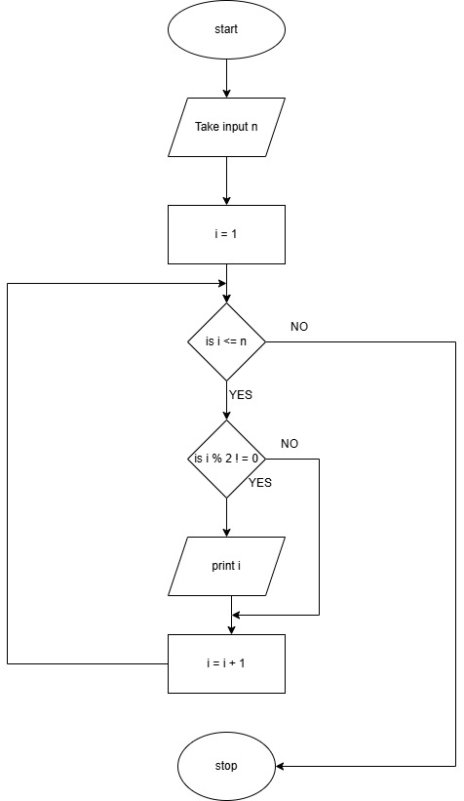
SOURCE CODE:

https://github.com/Rohith-Tech-king/c-lab/blob/main/odd%20num.c

OUTPUT:

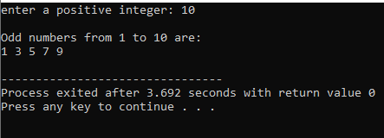

RESULT:

Thus the program is compiled and executed successfully with verified output.

5 | GENERATE GRADE | DATE:21 Aug 2025

AIM:

To write a C program that reads marks (from 0 to 100) and prints the corresponding grade using a switch-case statement based on this grading:

ALGORITHM:

Step 1: Start

Step 2: Declare a variable(n) to store marks

Step 3: Enter marks

Step 4: Check if 0 <= marks <= 100 continue else go to step 8

Step 5: Calculate range=marks/10

Step 6: Use switch case to decide the grade:
If range (80-100) grade= A
If range (60-79) grade =B
If range (50-59) grade =C
If range (40-49) grade =D
If range (0-39) grade=F

Step 7: Print the grade.

Step 8: End

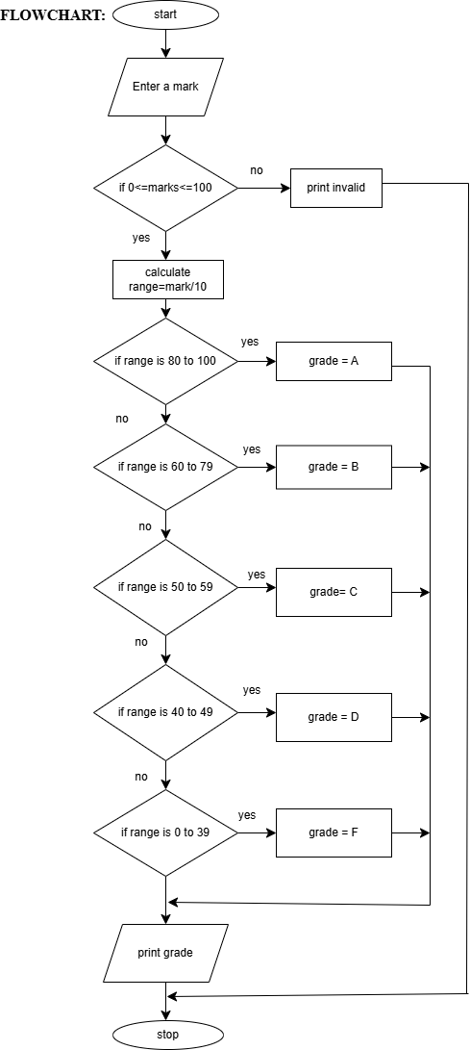

SOURCE CODE:

https://github.com/sruthisruthi18112007/c-lab/blob/main/grade.c

OUTPUT:

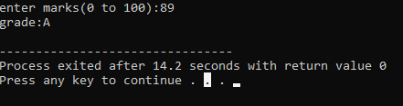

RESULT:

Thus the program is compiled and executed successfully with verified output.

6 | GENERATE TOWER | DATE:28 Aug 2025

AIM:

To write a C program that prints a right angled triangle pattern using a given character and number of lines.

ALGORITHM:

Step 1: Start.

Step 2: Declare variables: Limit (n), counters (i, j).

Step 3: Enter a character to print, ch.

Step 4: Enter a limit n.

Step 5: i=1.

Step 6: j=1.

Step 7: Print character.

Step 8: j++.

Step 9: If j<i, goto step 7, else continue

Step 10: i++.

Step 11: Print ‘\n’

Step 12: if i<n, goto step 6, else continue

Step 13: Stop.

FLOWCHART:

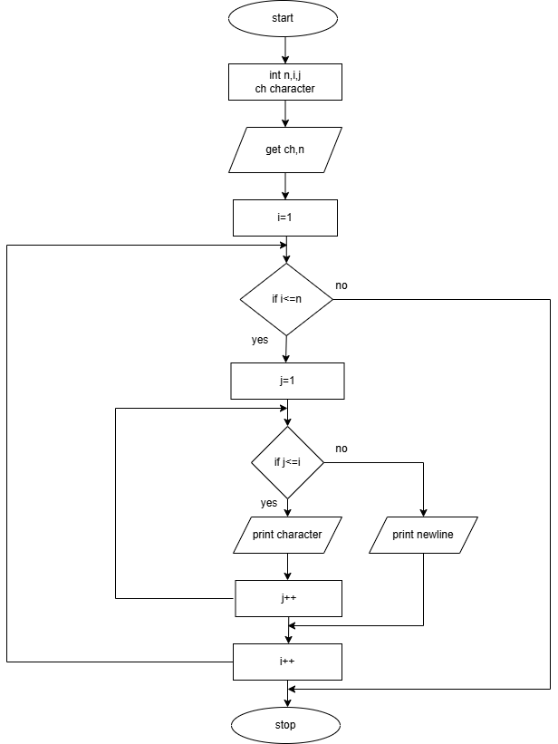

SOURCE CODE:

https://github.com/sruthisruthi18112007/c-lab/blob/main/tower.c

OUTPUT:

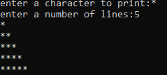

RESULT:

Thus the program is compiled and executed successfully with verified output.

7 | PALINDROME OR NOT | DATE: 04 Sep 2025

AIM:

To write a C Program to check if a given positive integer number is a palindrome or not.

ALGORITHM:

Step 1: Start
Step 2: Read a positive integer number (num)
Step 3: If num <0,
Display “Please enter a positive integer” and stop
Step 4: Set originalNum = num
reversedNum = 0
Step 5: If num! =0 Continue, else goto step 10
Step 6: remainder = num%10
Step 7: reversedNum = (reversedNum*10) + remainder
Step 8: num = num/10
Step 9: goto step 5
Step 10: If originalNum == reversedNum
Display “The number is a palindrome” and goto step 11
Else
Display “The number is not a palindrome”
Step 11: Stop

FLOWCHART:

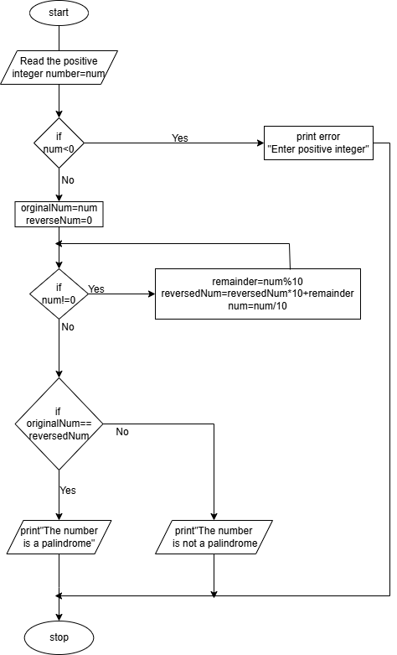

SOURCE CODE:

https://github.com/raghavi2008/c-lab/blob/main/positive%20palindrome%20or%20not.c

OUTPUT:

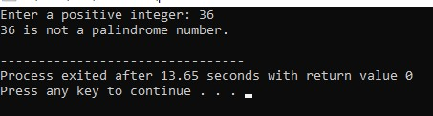

RESULT:

Thus the program is compiled and executed successfully with verified output

8 | STRING HANDLING | DATE:25 Sep 2025

AIM:

Program to check Implement your own string length and string reversal function

ALGORITHM:

Step 1: Start
Step 2: Read a string (str) from the user
Step 3: Print string length (using stringlength () user defined function)
Step 4: Print string reverse (using stringreverse () user defined function)
Step 5: Stop

String Length () Algorithm:

Step 1: length=0
Step 2: If str [length] is not equal to the null charcter (‘\0’)
length=length+1, and repeat step 2, else goto step 3
Step 3 : Return length

String Reverse () Algorithm:

Step 1: Initialize start=0 and end=len-1
Step 2: Repeat if start<end, else goto step 9
Step 3: store str[start] in temp
Step 4: str[start]=str[end]
Step 5: str[end]=temp
Step 6: start=start+1
Step 7: end=end-1
Step 8: Goto step 2
Step 9: Output
Display the original string length
Display the reversed string
Step 10: Stop
FLOWCHART:

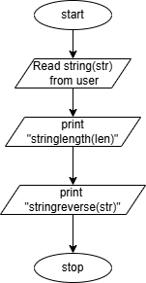

Flowchart for Stringlength(str):

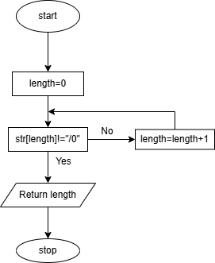

Flowchart for StringReverse (str, len):

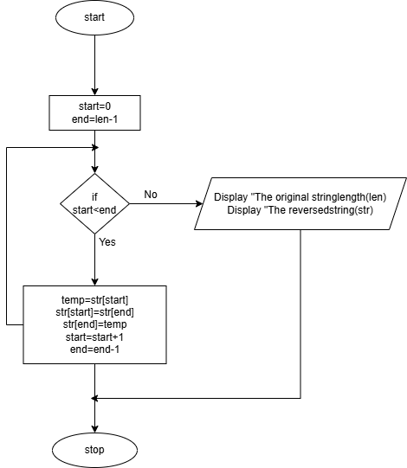
SOURCE CODE:

https://github.com/raghavi2008/c-lab/blob/main/string%20handling.c

OUTPUT:

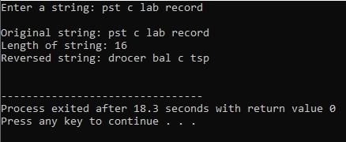

RESULT:

Thus the program is compiled and executed successfully with verified output

9 | ARRAY SORTING | DATE: 25 Sep 2025

AIM:

To write in C Program to sort an array.

ALGORITHM:

Step 1: Declare counter variables (i, j) temporary variable (temp), array to store elements.
Step 2: Read number of element n.
Step 3: If (n<=0 || n>100) goto step 21 else continue.
Step 4: i=0
Step 5: Read arr(i)
Step 6: If i<n goto step 5 else continue.
Step 7: i=0
Step 8: j=0
Step 9: If arr[j]>arr[j+1] continue else goto step 13.
Step 10: temp=arr[j]
Step 11: arr[j]=arr[j+1]
Step 12: arr[j+1] =temp
Step 13: j=j+1
Step 14: If j<(n-1-i) goto step 9 else continue
Step 15: i=i+1
Step 16: If i<n-1 goto step 8 else continue
Step 17: i=0
Step 18: Printf arr(i)
Step 19: i=i+1
Step 20: If i<n goto step 18, else goto step 22
Step 21: Print “n value should be 1 to 100”
Step 22: Stop

FLOWCHART:
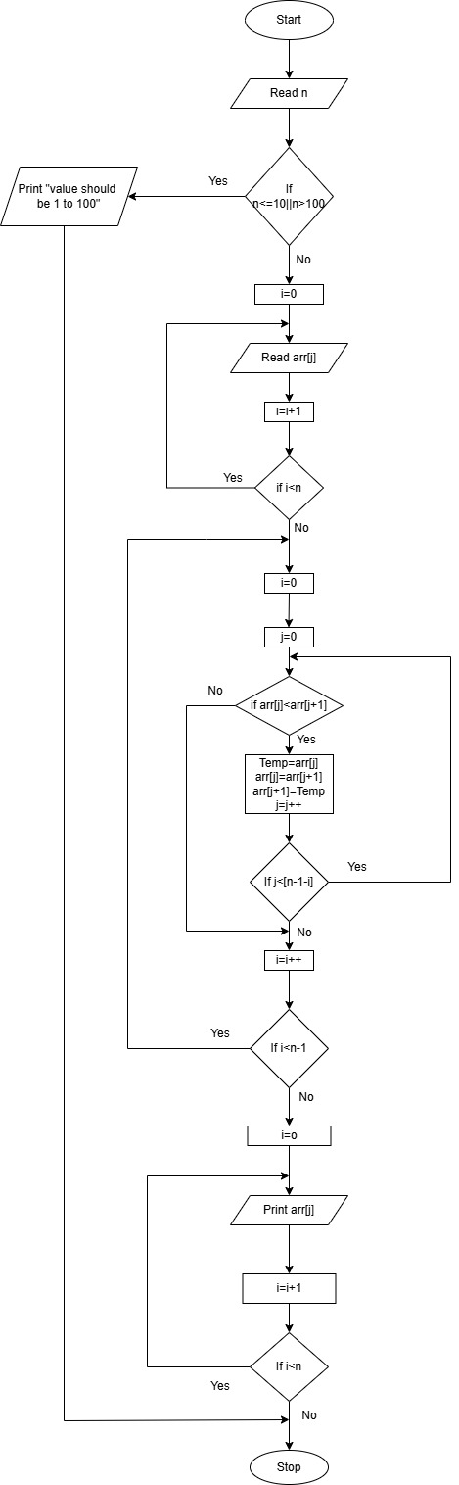

SOURCE CODE:

c-lab/arraysorted.c at main · rajlaxmi8327/c-lab

OUTPUT:

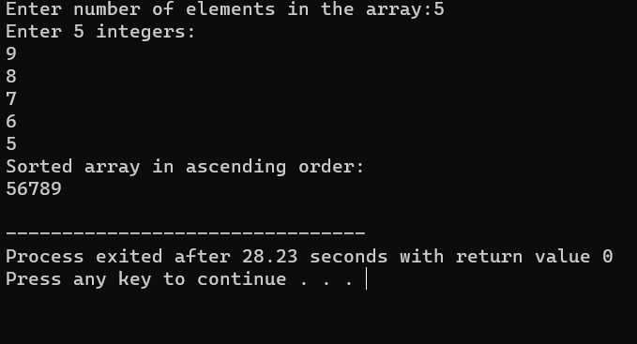

RESULT :

Thus the program is compiled and executed successfully with verified output.

10 | FACTORIAL | DATE:09 Oct 2025

AIM:

Write a C program to find the factorial of an integer using recursive function

ALGORITHM:

Step 1: Start
Step 2: Read limit, n
Step 3: If n< 0 print “Give positive numbers” and go to step 5 else continue
Step 4: Print factorial (n)
Step 5: Stop
Algorithm for factorial (int n)
- If n=0 or n=1, return 1else, return n*factorial (n-1)

FLOWCHART:

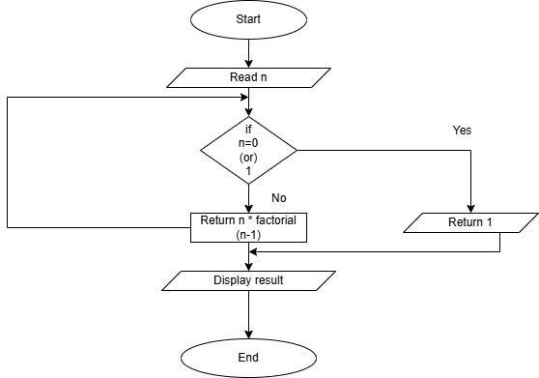

SOURCE CODE:

https://github.com/vaibav77/c-lab-vaibav/blob/main/factorial.c

OUTPUT:

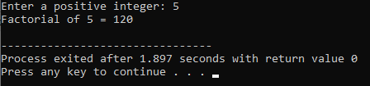
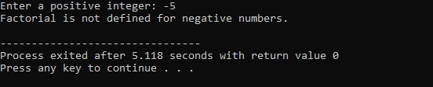

RESULT:

Thus the program is compiled and executed successfully with verified output.

11 | SWAPPING OF NUMBERS | DATE: 09 Oct 2025

AIM:

Program to swap two values using function pointer

ALGORITHM:

Step 1: Start

Step 2: Declare variable int x, y, temp

Step 3: Get x, y

Step 4: x = temp

Step 5: y = x

Step 6: temp = y

Step 7: Print x, y

Step 8: Stop

FLOWCHART:

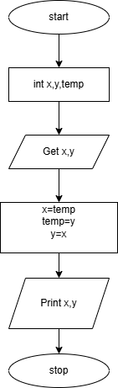

SOURCE CODE:

https://github.com/112534037/c-lab/blob/main/swapping%20of%20numbers.c

OUTPUT:

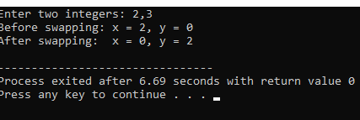

RESULT:

Thus the program is compiled and executed successfully with verified output.

12 | USING STRUCTURES | DATE: 23 Oct 2025

AIM :

To Program to store student’s information using structure

ALGORITHM:

Step 1: Start the program
Step 2: Define a structure named Student with the following members:
roll No → integer
name → character array (string)
marks → float
Step 3: Declare a variable s of type struct Student.
Step 4: Input the student’s roll number and store it in s. rollno.
Step 5: Input the student’s name and store it in s.name.
Step 6: Input the student’s marks and store them in s. marks.
Step 7: Display the message “--- Student Information ---”.
Step 8: Print the stored values:
Roll Number, Name, Marks.
Step 9: End the program.

FLOWCHART:
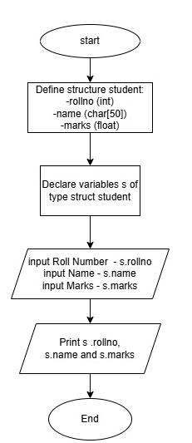

SOURCE CODE:

https://github.com/Tharnesh777/c-lab/blob/main/STRUCTURE.c

OUTPUT:

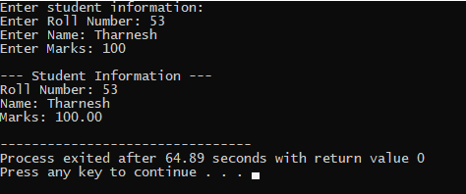

RESULT :

Thus the program is compiled and executed successfully with verified output.

13 | FILE PROGRAMMING | DATE:23 Oct 2025

AIM:

To Write a C Program to perform read and write operation on a file.

ALGORITHM:

Step 1: Start the Program.
Step 2: Declare filename (filename), character (ch),
Step 3: Read the filename
Step 4: Open file in Write mode using fopen (filename,” w”)
Step 5: If step 4 Fails, goto step 16 Else continue.
Step 6: Read the ch,
Step 7: If ch! =’~’ continue else goto step 10.
Step 8: Write ch into file using fput(c).
Step 9: Repeat the Step 6.
Step 10: Close the file.
Step 11: Read the Same file in read mode using fopen (filename,” r”)
Step 12: If Step 11 to fails goto Step 16, else continue.
Step 13: Read the next character in file using fgetch ()
Step 14: if ch! =EOF repeat Step 13 else goto Step 15.
Step 15: Close the file.
Step 16: End the Program.

FLOW CHART:
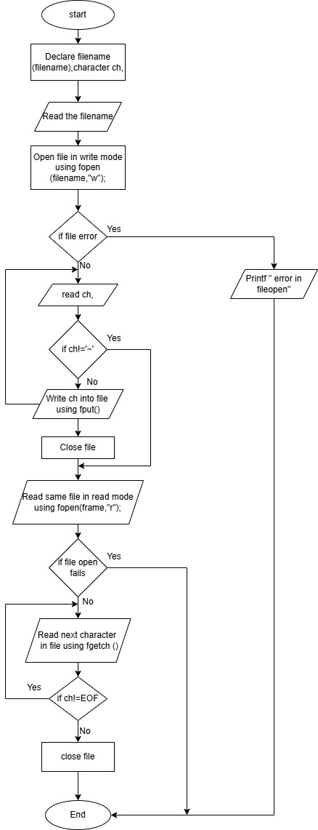

SOURCE CODE:

https://github.com/Tharnesh777/c-lab/blob/main/READ%20AND%20WRITE.c

OUTPUT:

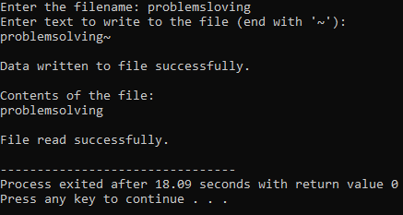

RESULT:

Thus the program is compiled and executed successfully with verified output.

