Program 1: Creating DataFrames Using Pandas
Aim: To create a Pandas DataFrame from a dictionary and display the first few rows, data types, non-null values, and statistical summary.
Algorithm:
- Import the Pandas library.
- Create a dictionary containing Name, Age, and City.
- Convert the dictionary into a DataFrame using pd.DataFrame().
- Display the first five rows using df.head().
- Display the DataFrame information using df.info().
- Display the statistical summary using df.describe().
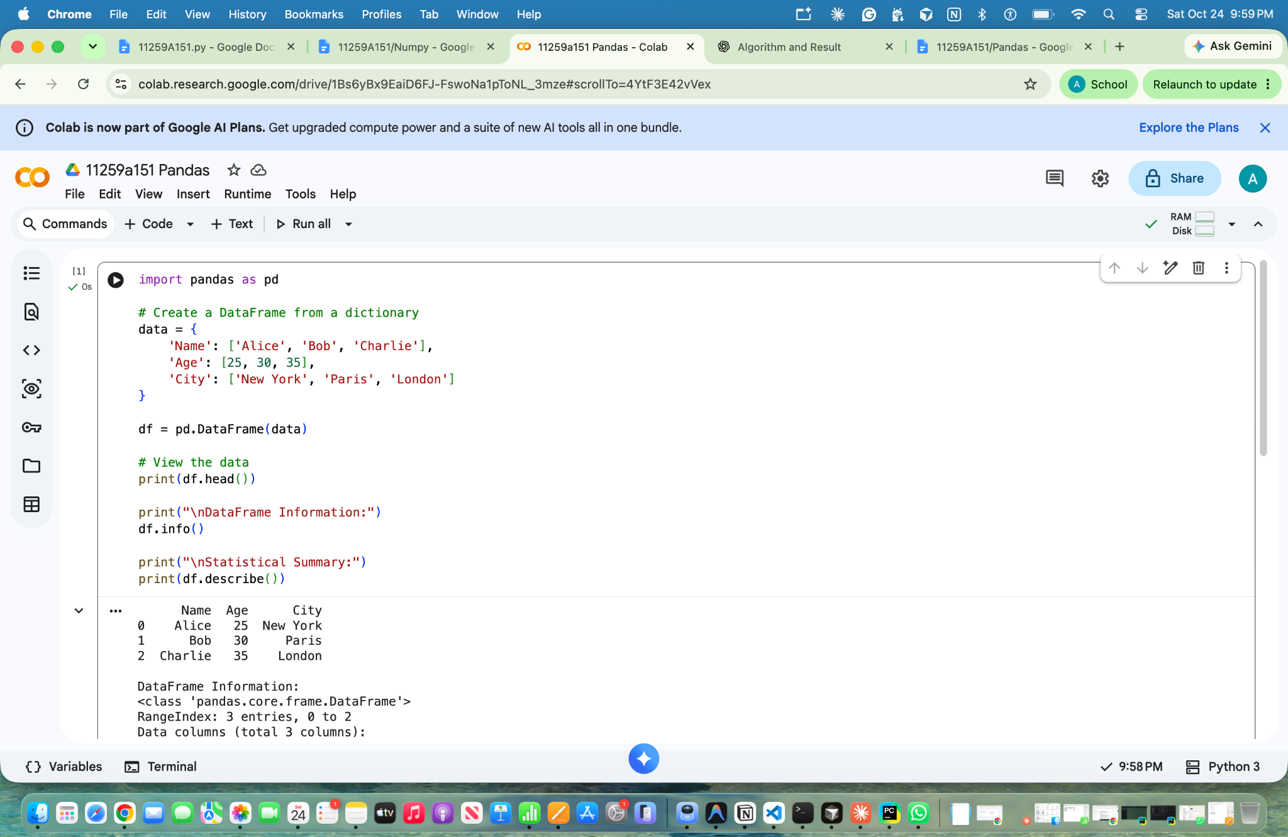
- Observe the output and stop.

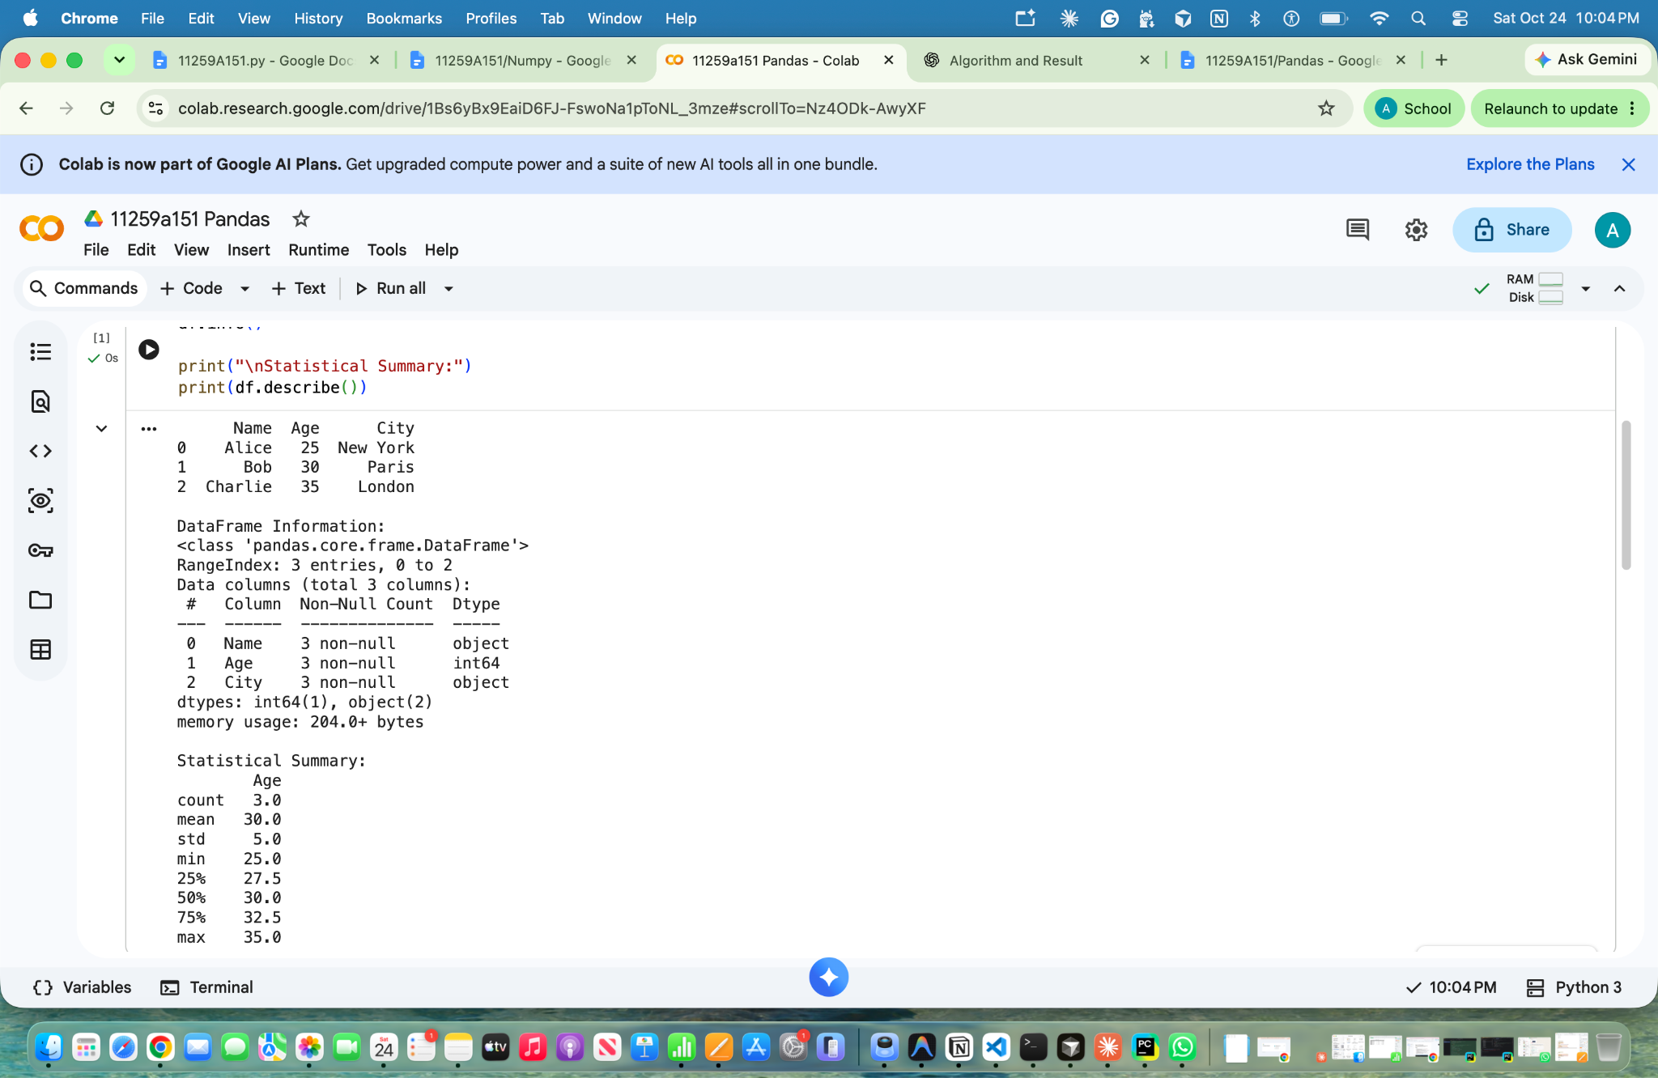

Result: A Pandas DataFrame was successfully created, and its records, data types, non-null counts, and statistical summary were displayed.

Program 2: Selection and Filtering Using Pandas
Aim: To select specific columns, filter rows based on conditions, and access data using iloc and loc in a Pandas DataFrame.
Algorithm:
- Import the Pandas library and create a DataFrame.
- Select the Age column using df['Age'].
- Filter rows where the age is greater than 25.
- Access the first row using df.iloc[0].
- Access the name at index 0 using df.loc[0, 'Name'].
- Display the selected and filtered data.
- Stop.
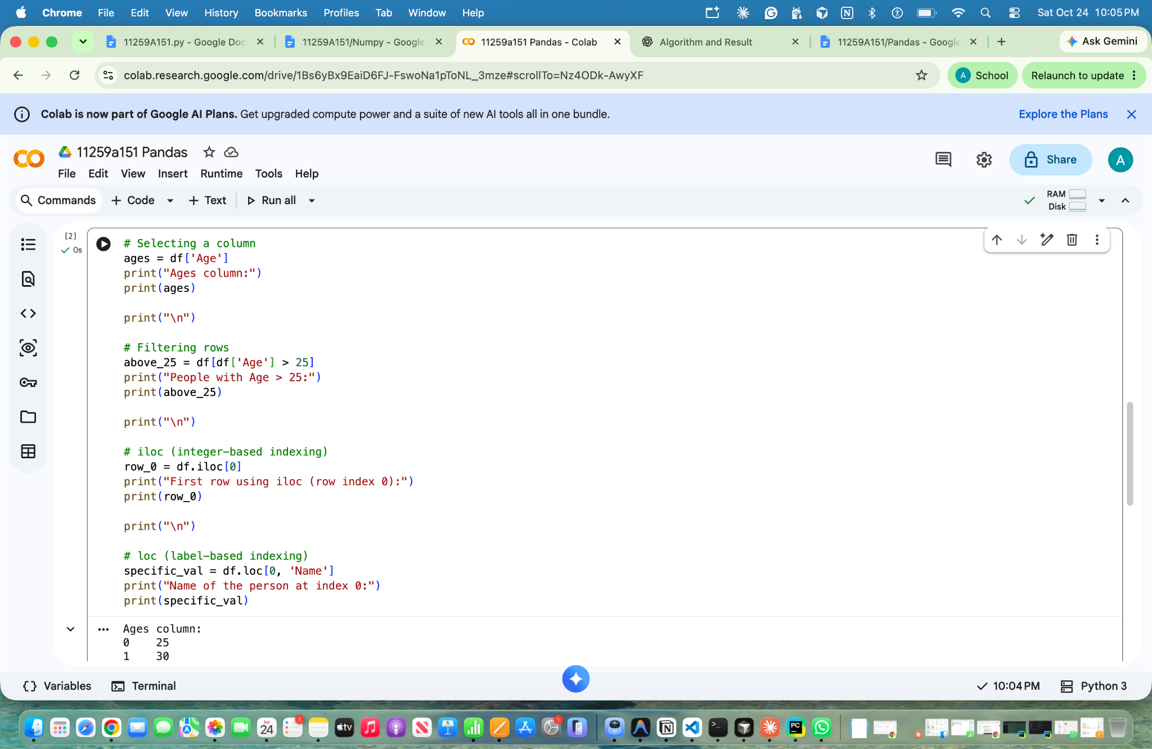

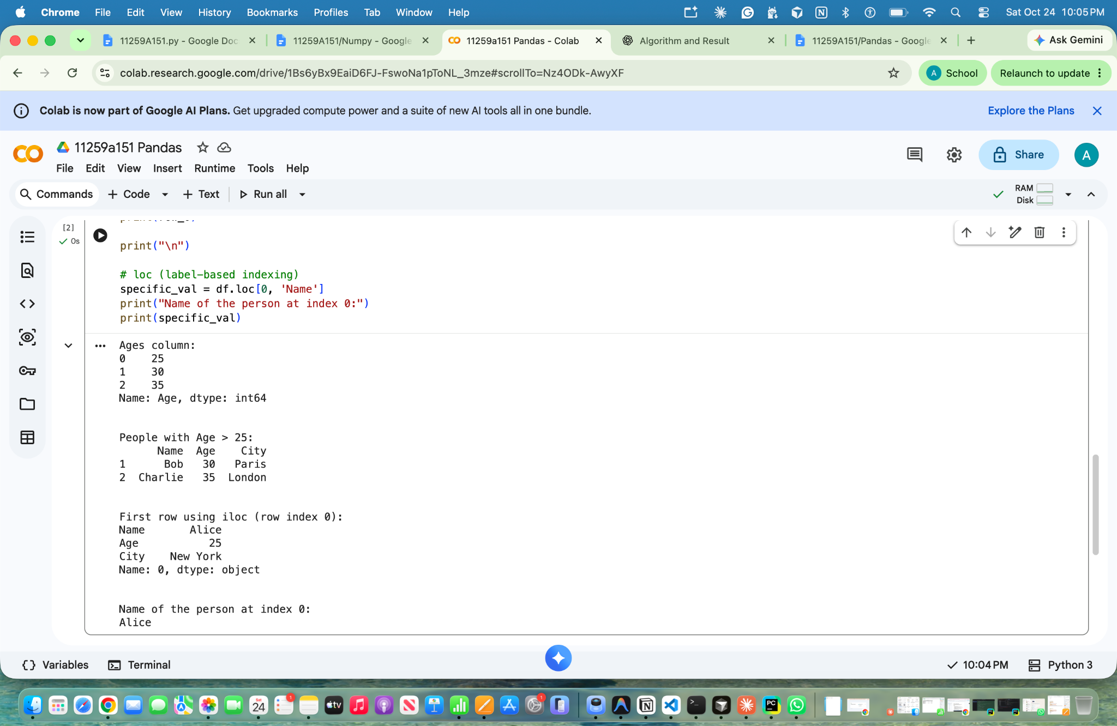

Result: Column selection, conditional filtering, and row access using iloc and loc were successfully performed.

Program 3: Data Cleaning (Handling Missing Values) Using Pandas
Aim: To identify and handle missing values in a Pandas DataFrame using methods such as isnull(), dropna(), and fillna().
Algorithm:
- Import the Pandas and NumPy libraries.
- Create a sample dataset containing missing values (NaN).
- Convert the dataset into a DataFrame.
- Display the original DataFrame.
- Identify missing values in each column using isnull().sum().
- Remove rows containing missing values using dropna().
- Replace all missing values with zero using fillna(0).
- Replace missing Age values with the column mean.
- Replace missing City values with "Unknown".
- Display the cleaned DataFrames and stop.
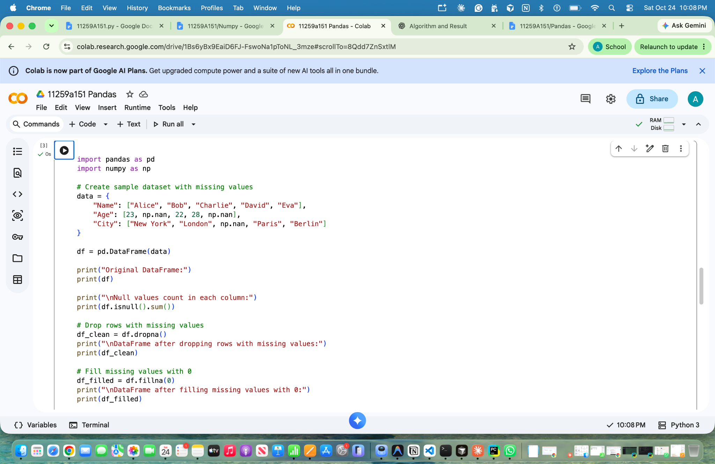

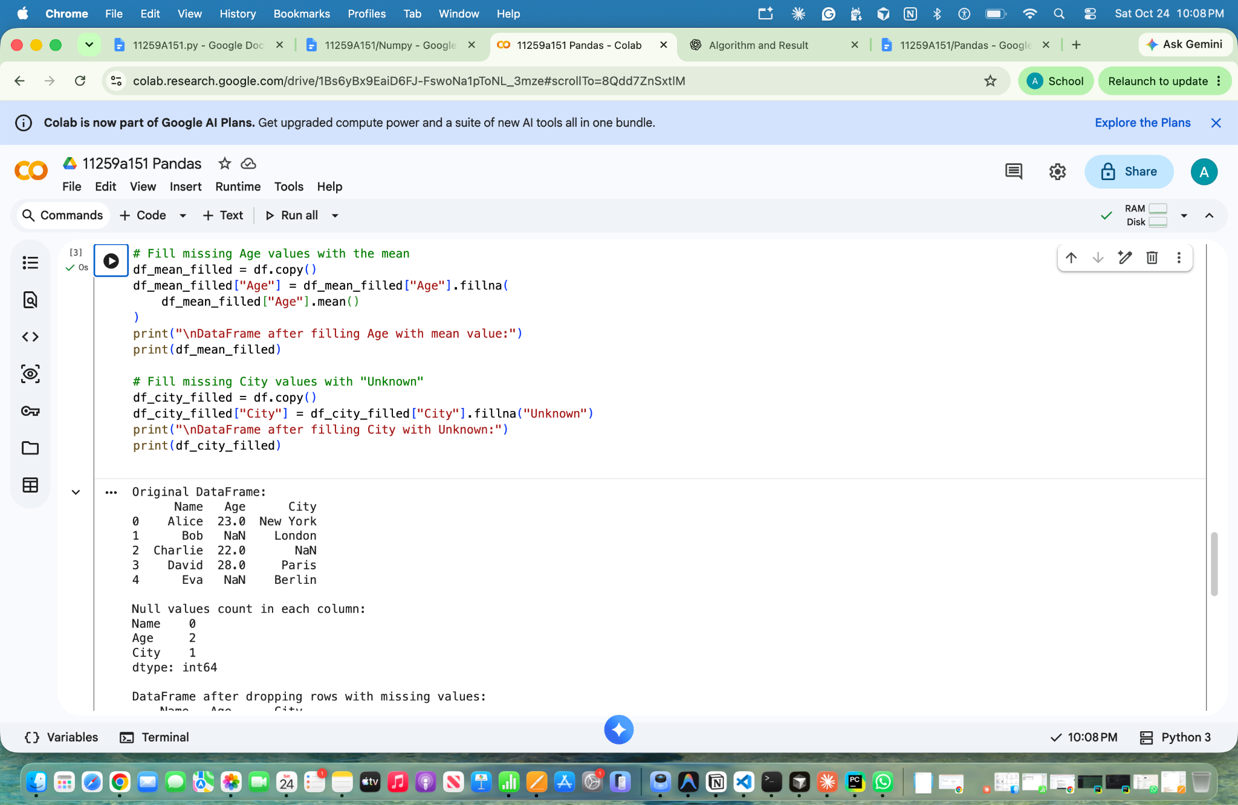

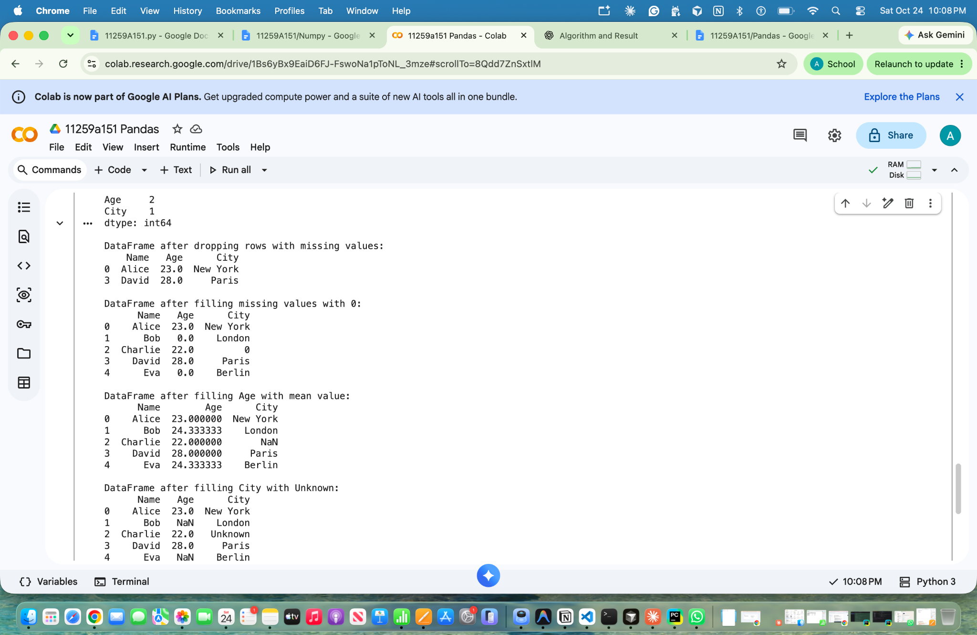
Result: Missing values were successfully identified and handled by removing rows, replacing missing values with zero, filling missing ages with the mean, and replacing missing cities with "Unknown".

