Program 1: Creating NumPy Arrays
Aim: To create and display different types of NumPy arrays, including one-dimensional arrays, two-dimensional arrays, zeros, ones, identity matrices, and range arrays.
Algorithm:
- Import the NumPy library.
- Create a one-dimensional array using np.array().
- Create a two-dimensional array using np.array().
- Create a matrix of zeros using np.zeros().
- Create a matrix of ones using np.ones().
- Create an identity matrix using np.eye().
- Generate a sequence of numbers using np.arange().
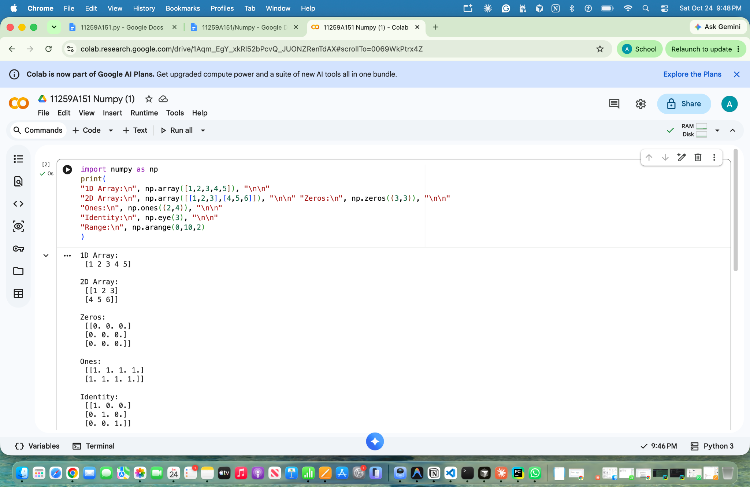
- Display all the arrays.

Result: Different types of NumPy arrays were successfully created and displayed.

Program 2: Array Operations Using NumPy
Aim: To perform arithmetic and mathematical operations on NumPy arrays, including addition, multiplication, scalar multiplication, square root, mean, and dot product.
Algorithm:
- Import the NumPy library.
- Create two NumPy arrays, a and b.
- Display both arrays.
- Perform addition and element-wise multiplication.
- Perform scalar multiplication by multiplying array a by 10.
- Calculate the square root of each element in a.
- Calculate the mean of array a.
- Calculate the dot product of arrays a and b.
- Display all the results.
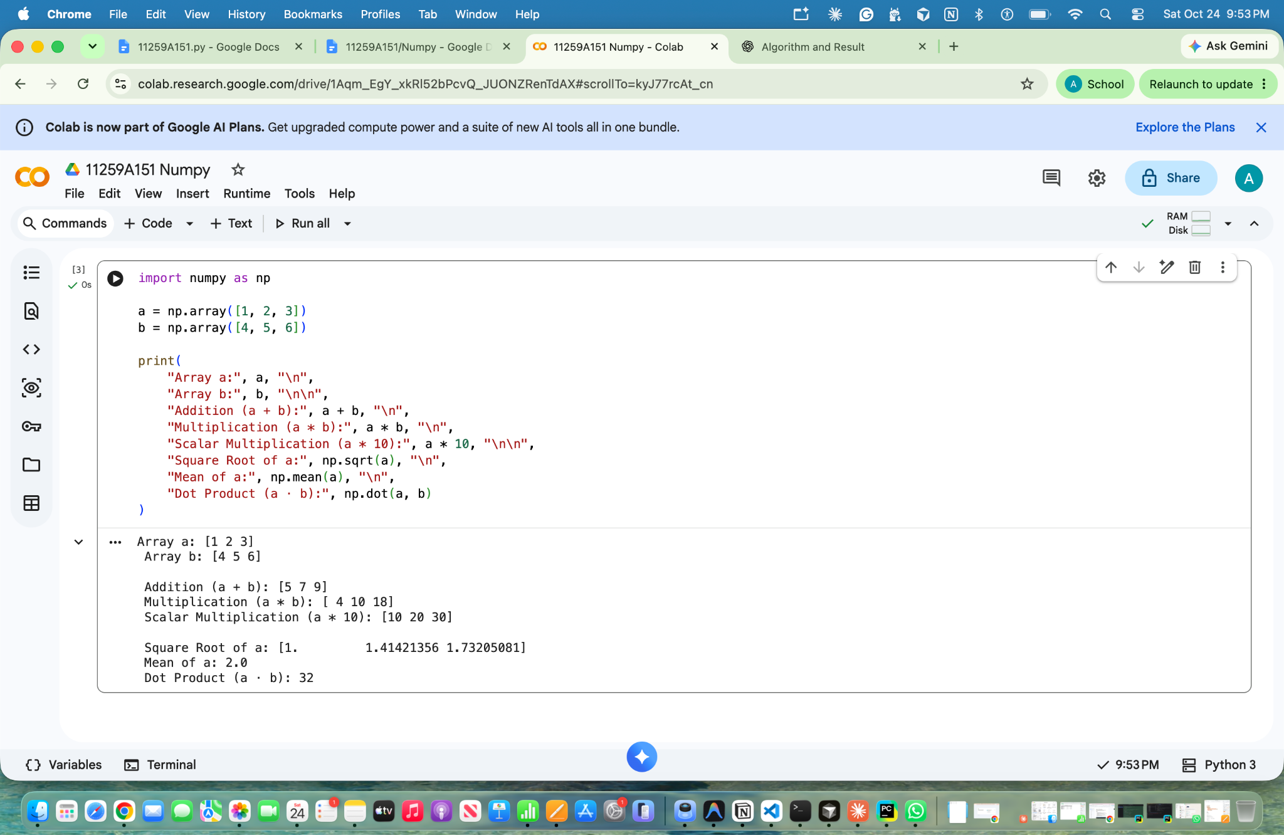
Result: Arithmetic and mathematical operations on NumPy arrays were successfully performed.

Program 3: Indexing and Slicing Using NumPy
Aim: To perform indexing and slicing operations on a two-dimensional NumPy array.
Algorithm:
- Import the NumPy library.
- Create a 3×3 matrix using np.array().
- Access and display a specific element using indexing.
- Extract and display a row from the matrix.
- Extract and display a column from the matrix.
- Perform slicing to display a submatrix.
- Display the results.
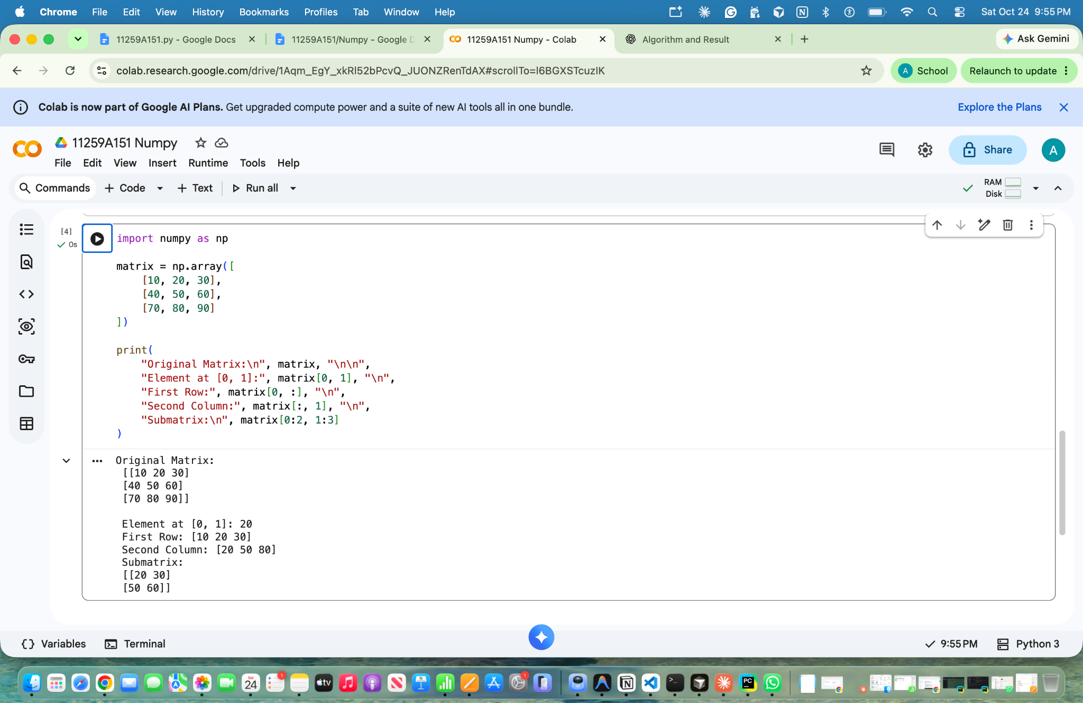

Result: Indexing and slicing operations were successfully performed on the NumPy matrix.

