EXNO:2 Data split and cross validation
2.1 Data splitting
Aim
To split a dataset into training data (80%) and testing data (20%) using the train_test_split() function from the Scikit-learn library.
Algorithm
- Start the program.
- Import the Pandas library and train_test_split from Scikit-learn.
- Load the dataset from the file data.csv.
- Select the input features: Hours_Studied, Attendance, and Assignments.
- Select the target variable: Result.
- Split the dataset into 80% training data and 20% testing data using train_test_split() with random_state=42.
- Display the training and testing datasets.
- Display the number of training and testing samples.
- Stop the program.
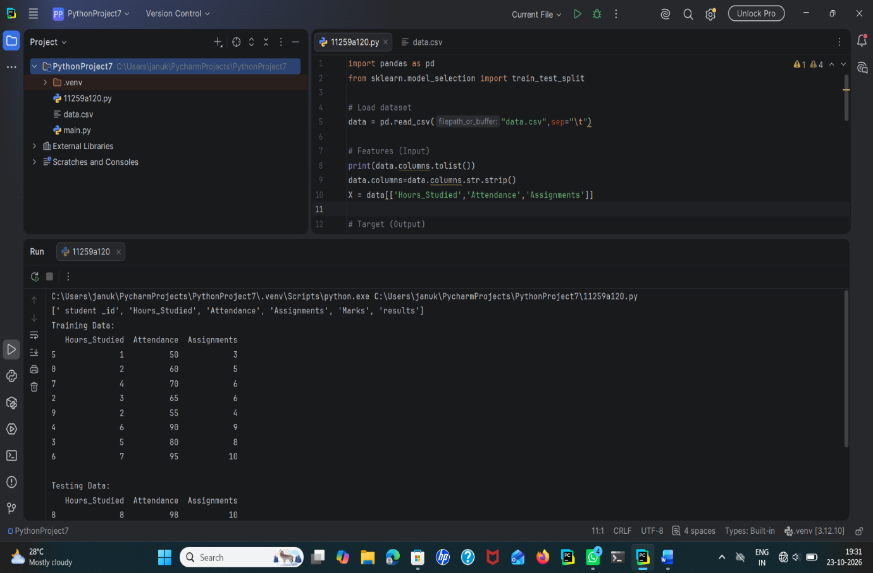
Result
The dataset is successfully loaded and divided into 80% training data and 20% testing data. The training and testing datasets are displayed along with their respective sample counts. The fixed random_state=42 ensures reproducible splitting results.

Data split up and cross validation

Aim
To divide the dataset into training and testing sets and evaluate the performance of a K-Nearest Neighbors (KNN) classifier using 5-fold cross-validation.
Algorithm
- Start the program.
- Import Pandas and the required Scikit-learn libraries.
- Load the dataset from data.csv.
- Select Hours_Studied, Attendance, and Assignments as input features.
- Select Result as the target variable.
- Split the dataset into 80% training data and 20% testing data using train_test_split().
- Display the sizes of the training and testing datasets.
- Create a KNN classifier with \(k=3\).
- Perform 5-fold cross-validation using cross_val_score().
- Display the cross-validation scores.
- Calculate and display the average accuracy of the model.
- Stop the program.

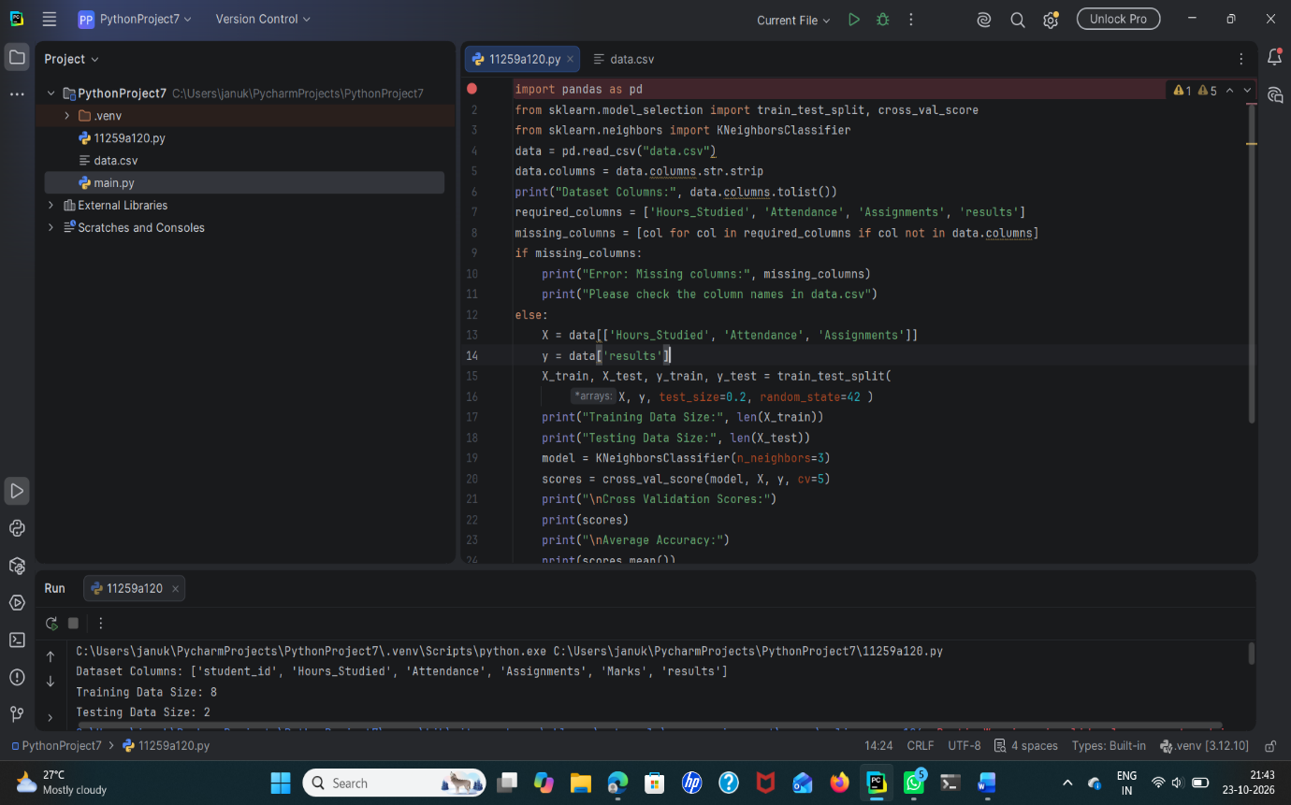

Result
The dataset is successfully split into training and testing sets in an 80:20 ratio. The KNN classifier with \(k=3\) is evaluated using 5-fold cross-validation. The cross-validation scores and average accuracy are calculated and displayed successfully.

