EXNO 3: Implement linear regression
Aim
To implement a Linear Regression model using Python and Pandas to predict students' marks based on the number of hours studied and evaluate the model's performance using Mean Squared Error (MSE) and R² Score.
Algorithm
- Start the program.
- Import the required libraries: Pandas, Matplotlib, and Scikit-learn.
- Load the dataset from the data.csv file.
- Select Hours_Studied as the input feature (X).
- Select Marks as the target variable (y).
- Split the dataset into training and testing sets using train_test_split().
- Create a Linear Regression model using LinearRegression().
- Train the model using model.fit().
- Predict the students' marks using model.predict().
- Evaluate the model using Mean Squared Error and R² Score.
- Display the predicted marks.
- Plot the actual data and regression line using Matplotlib.
- Stop the program.
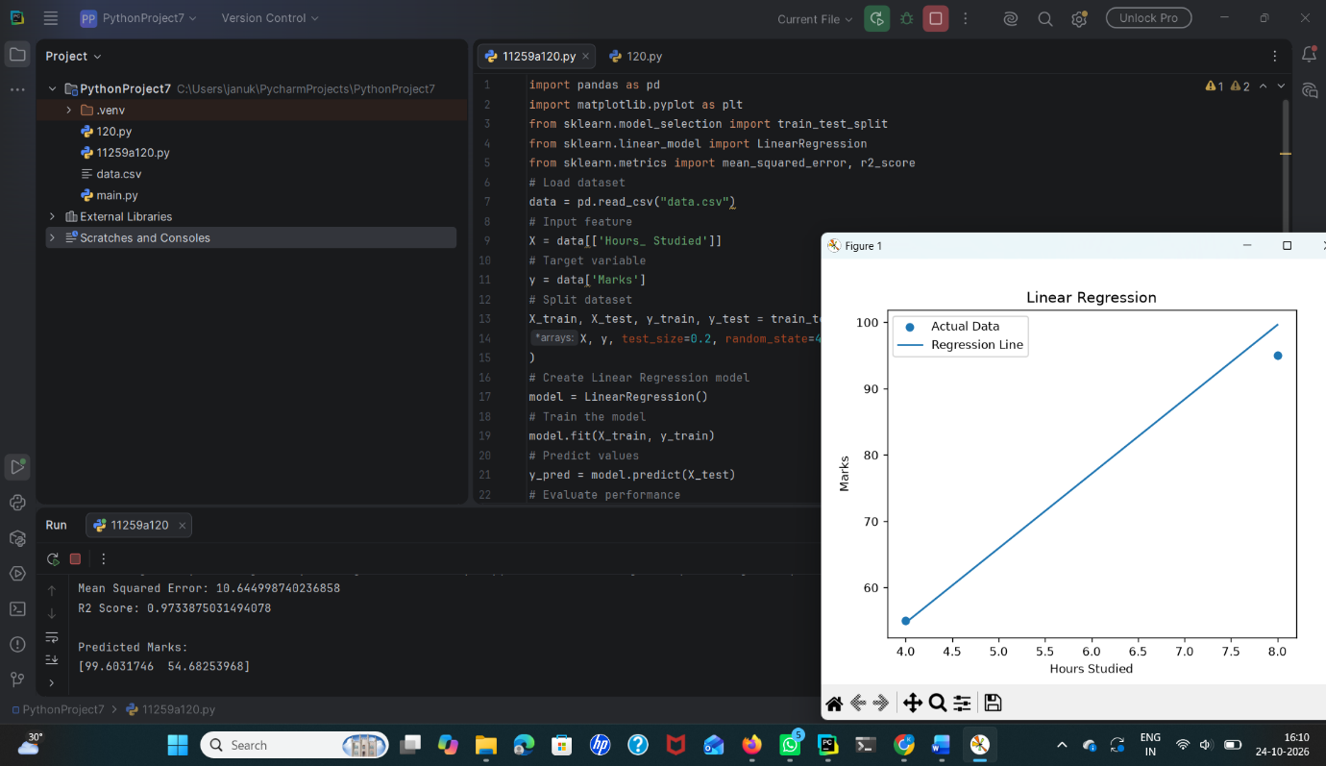
Result
Thus, the Linear Regression model was successfully implemented using Python. The model predicts students' marks based on hours studied, evaluates its performance using MSE and R² Score, and displays the results graphically.

