EXNO 4: Implement classification Model using KNN and Compute Evaluation Metrics

Aim
To implement a classification model using the K-Nearest Neighbors (KNN) algorithm and evaluate its performance using accuracy score, confusion matrix, and classification report.
Algorithm
- Import the required Python libraries: Pandas and Scikit-learn.
- Load the dataset from the data.csv file.
- Select the input features: Hours_Studied, Attendance, and Assignments.
- Select the target variable as Result.
- Split the dataset into training and testing sets using train_test_split() with a test size of 20%.
- Create the KNN classifier model with \(k = 3\).
- Train the model using the training dataset.
- Predict the results for the testing dataset.
- Calculate and display the accuracy score, confusion matrix, and classification report.
- Display the evaluation metrics to assess the model's performance.
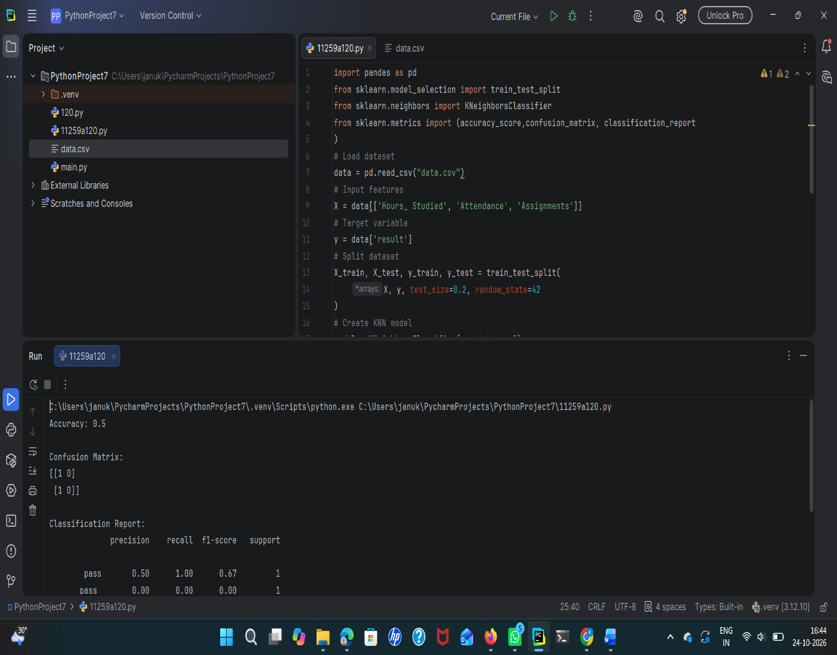

Result
Thus, the K-Nearest Neighbors (KNN) classification model was successfully implemented using Python. The model's performance was evaluated using the accuracy score, confusion matrix, and classification report.

EXNO 4: Implement Classification Model Using
SVM and compute Evaluation Metrics
Aim
To implement a classification model using Support Vector Machine (SVM) and evaluate its performance using accuracy score, confusion matrix, and classification report.
Algorithm
- Import the required libraries such as Pandas and Scikit-learn.
- Load the dataset from the data.csv file.
- Select the input features: Hours_Studied, Attendance, and Assignments.
- Select Result as the target variable.
- Split the dataset into training and testing sets using train_test_split() with a test size of 20%.
- Create an SVM model using SVC(kernel='linear').
- Train the model using the training data with model.fit().
- Predict the results for the test data using model.predict().
- Calculate and display the accuracy score, confusion matrix, and classification report.
10.Analyze the evaluation metrics to determine the model's performance.
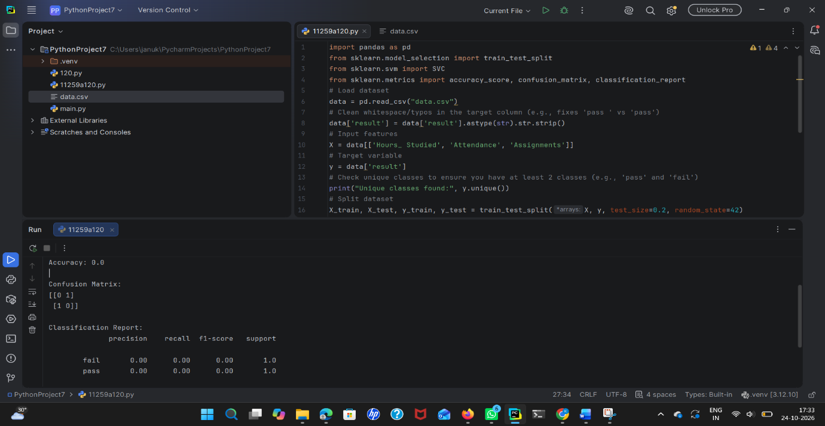

result
Thus, the Support Vector Machine (SVM) classification model was successfully implemented, and its performance was evaluated using the accuracy score, confusion matrix, and classification report.

