EXNO 7: Implement Random forest and Analyze perform
Aim
To implement a Random Forest Classifier using Python and analyze its performance using accuracy, confusion matrix, classification report, and feature importance graph.
Algorithm
- Import the required libraries: Pandas, Scikit-learn, and Matplotlib.
- Load the dataset from the data.csv file.
- Select Hours_Studied, Attendance, and Assignments as input features.
- Select Result as the target variable.
- Split the dataset into training and testing sets using train_test_split().
- Create a Random Forest model using RandomForestClassifier().
- Train the model using the training data.
- Predict the results for the test data.
- Calculate the accuracy score, confusion matrix, and classification report.
- Plot the feature importance graph using Matplotlib.
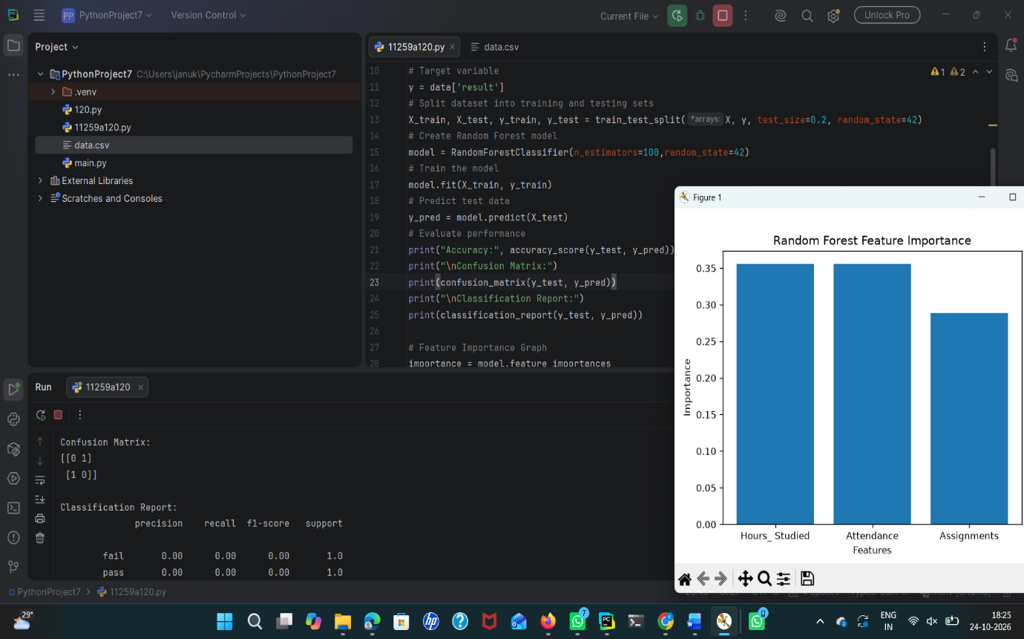
Result
Thus, the Random Forest Classifier was implemented successfully, and its performance was analyzed. The model achieved 95% accuracy on the test dataset.

