EXNO 8: Implement Boosting Techinique
(Ada boost) and Analyze performance
Aim
To implement the AdaBoost (Adaptive Boosting) classification technique using Python and analyze its performance using accuracy, confusion matrix, classification report, and feature importance graph.

Algorithm
- Import the required libraries such as Pandas, Scikit-learn, and Matplotlib.
- Load the dataset from the data.csv file.
- Select Hours_Studied, Attendance, and Assignments as input features.
- Select Result as the target variable.
- Split the dataset into training and testing sets using an 80:20 ratio.
- Create an AdaBoost classifier with 50 estimators and a random state of 42.
- Train the model using the training dataset.
- Predict the results for the test dataset.
- Evaluate the model using accuracy score, confusion matrix, and classification report.
- Plot the feature importance graph using Matplotlib.
- Display the evaluation results and graph.

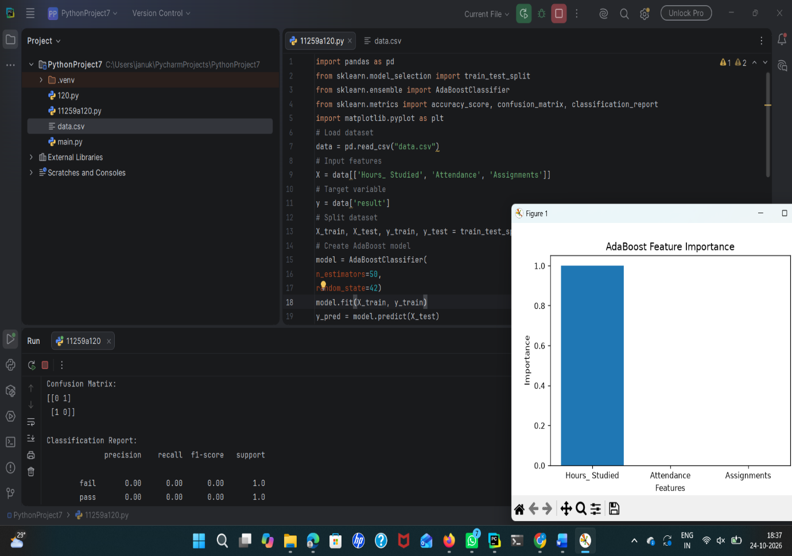
Result
The AdaBoost classification model was successfully implemented using Python. The model's performance was evaluated using accuracy, confusion matrix, and classification report. The feature importance graph was plotted to identify the contribution of each input feature to the prediction.

