EXNO 9: Implement a Basic Reinforment learning Model(Q-learning)
Aim
To implement a basic Reinforcement Learning model using the Q-Learning algorithm to find the optimal path based on a given rewards matrix.
Algorithm
- Import the NumPy library.
- Initialize the rewards matrix \(R\) with rewards and penalties for each state transition.
- Initialize the Q-table \(Q\) with zeros.
- Set the discount factor \(\gamma = 0.8\) and the number of episodes to 1000.
- Randomly select an initial state.
- Identify the possible actions from the current state.
- Select a random action and determine the next state.
- Update the Q-table using the Q-Learning formula:
\[ Q(s,a)=R(s,a)+\gamma\max Q(s',a') \]
- Repeat the process until the goal state is reached.
- Display the final Q-table.
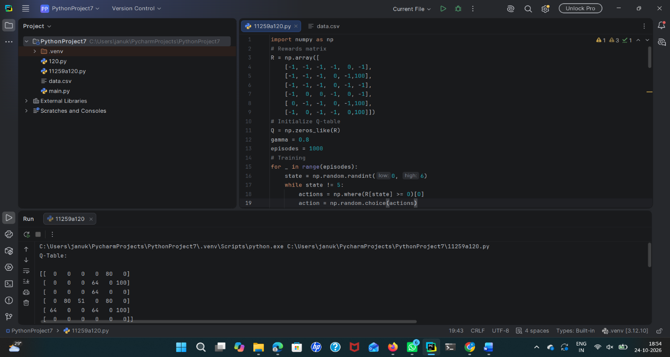
Result
Thus, the basic Reinforcement Learning model using the Q-Learning algorithm was implemented successfully. The Q-table was generated to identify the optimal path toward the goal state.

