EXNO 5: Implement k-means clustering

Aim
To implement the K-Means Clustering algorithm using Python to group student data based on the number of hours studied and marks obtained, and visualize the clusters with their centroids.

Algorithm
- Import the required libraries: Pandas, Matplotlib, and K-Means from Scikit-learn.
- Load the dataset from the data.csv file.
- Select the features Hours_Studied and Marks.
- Create a K-Means model with 3 clusters and a random state of 42.
- Fit the model to the selected features.
- Predict the cluster labels for each data point.
- Add the cluster labels to the dataset.
- Display the clustered dataset using the print() function.
- Plot the clusters using a scatter plot with different colors.
- Plot the centroids using the 'X' marker.
- Add axis labels, a title, and a legend, then display the graph.

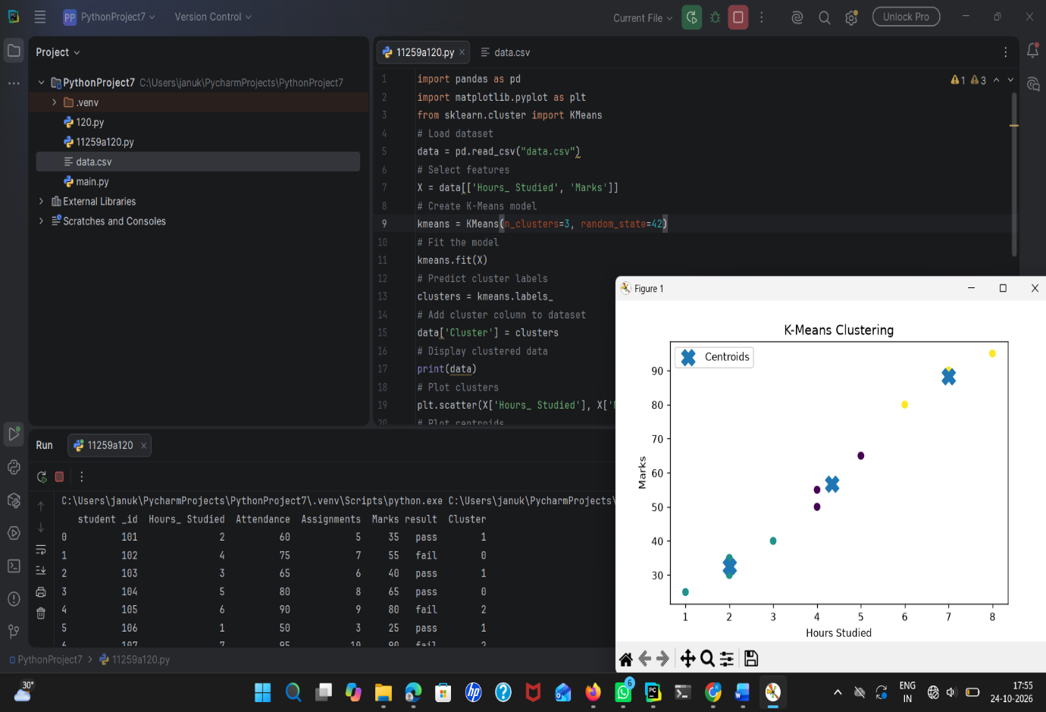
Result
Thus, the K-Means Clustering algorithm was successfully implemented using Python. The student data was grouped into 3 clusters based on hours studied and marks obtained, and the clusters and their centroids were visualized using Matplotlib.

