EXNO 6: Implement Hierarchical clustering
Aim
To implement Hierarchical Clustering using Python to group data points into clusters and visualize the results using a dendrogram and scatter plot.
Algorithm
- Import the required libraries: Pandas, Matplotlib, SciPy, and Scikit-learn.
- Load the dataset from the data.csv file.
- Select the features Hours_Studied and Marks.
- Create a linkage matrix using the Ward method.
- Plot the dendrogram to visualize the hierarchical relationships between data points.
- Apply Agglomerative Clustering with 3 clusters.
- Fit the model to the selected features and predict the cluster labels.
- Add the cluster labels to the dataset.
- Print the dataset with the cluster labels.
- Plot a scatter plot to visualize the clusters using different colors.
- Display the dendrogram and scatter plot.

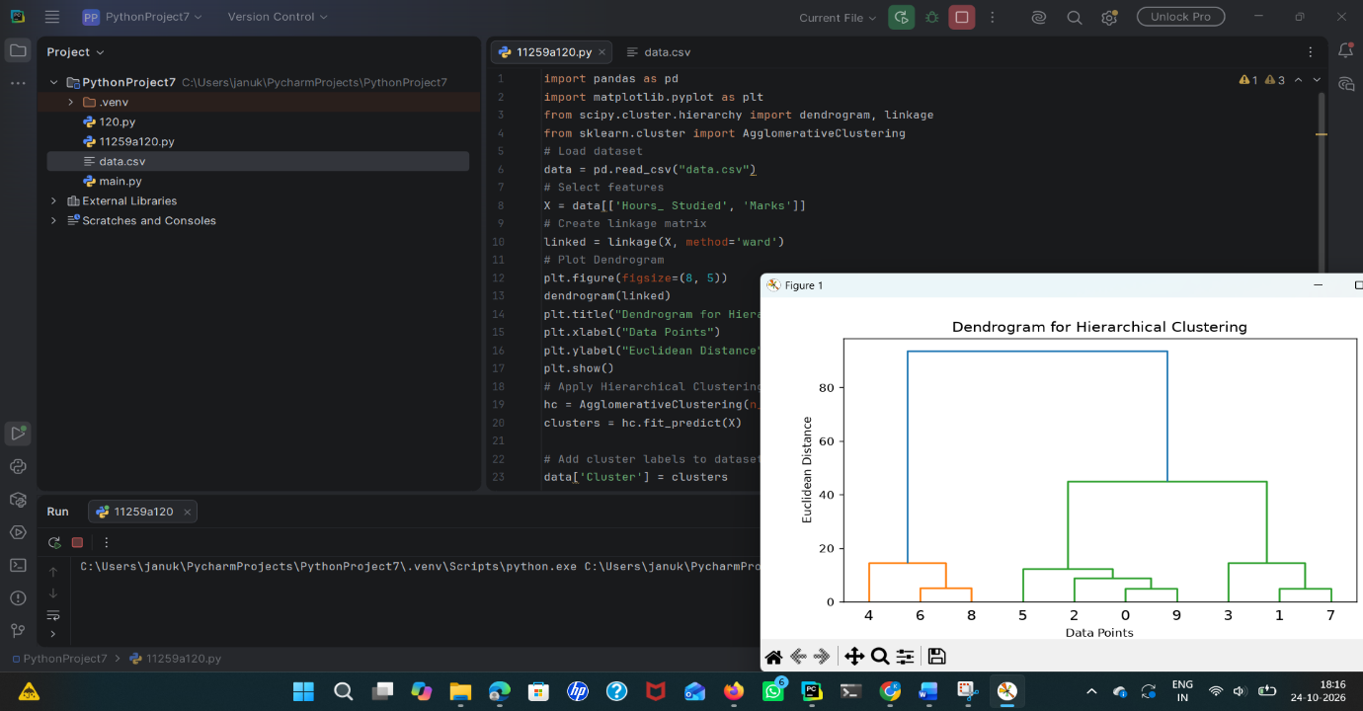
Result
Thus, Hierarchical Clustering was successfully implemented using Python. The dataset was divided into 3 clusters, and the results were visualized using a dendrogram and scatter plot.

