Ex No 5: Implement K-Means Clustering
Aim
To apply the K-Means clustering algorithm to group students into three clusters based on their Hours_Studied and Marks, and visualize the clusters and their centroids using Matplotlib.
Algorithm
- Import the Pandas library, Matplotlib's pyplot module, and KMeans from Scikit-learn.
- Load the dataset from the CSV file data.csv using pd.read_csv().
- Select the Hours_Studied and Marks columns as input features.
- Create a K-Means clustering model with three clusters using KMeans(n_clusters=3, random_state=42).
- Fit the model to the selected features using kmeans.fit(X).
- Obtain the cluster labels using kmeans.labels_.
- Add the cluster labels as a new column named Cluster to the original dataset.
- Display the clustered dataset.
- Plot the data points using a scatter plot, with colors representing their assigned clusters.
- Plot the cluster centroids using kmeans.cluster_centers_, with an X-shaped marker.
- Add axis labels, a title, and a legend to the graph.
- Display the final cluster visualization using plt.show().

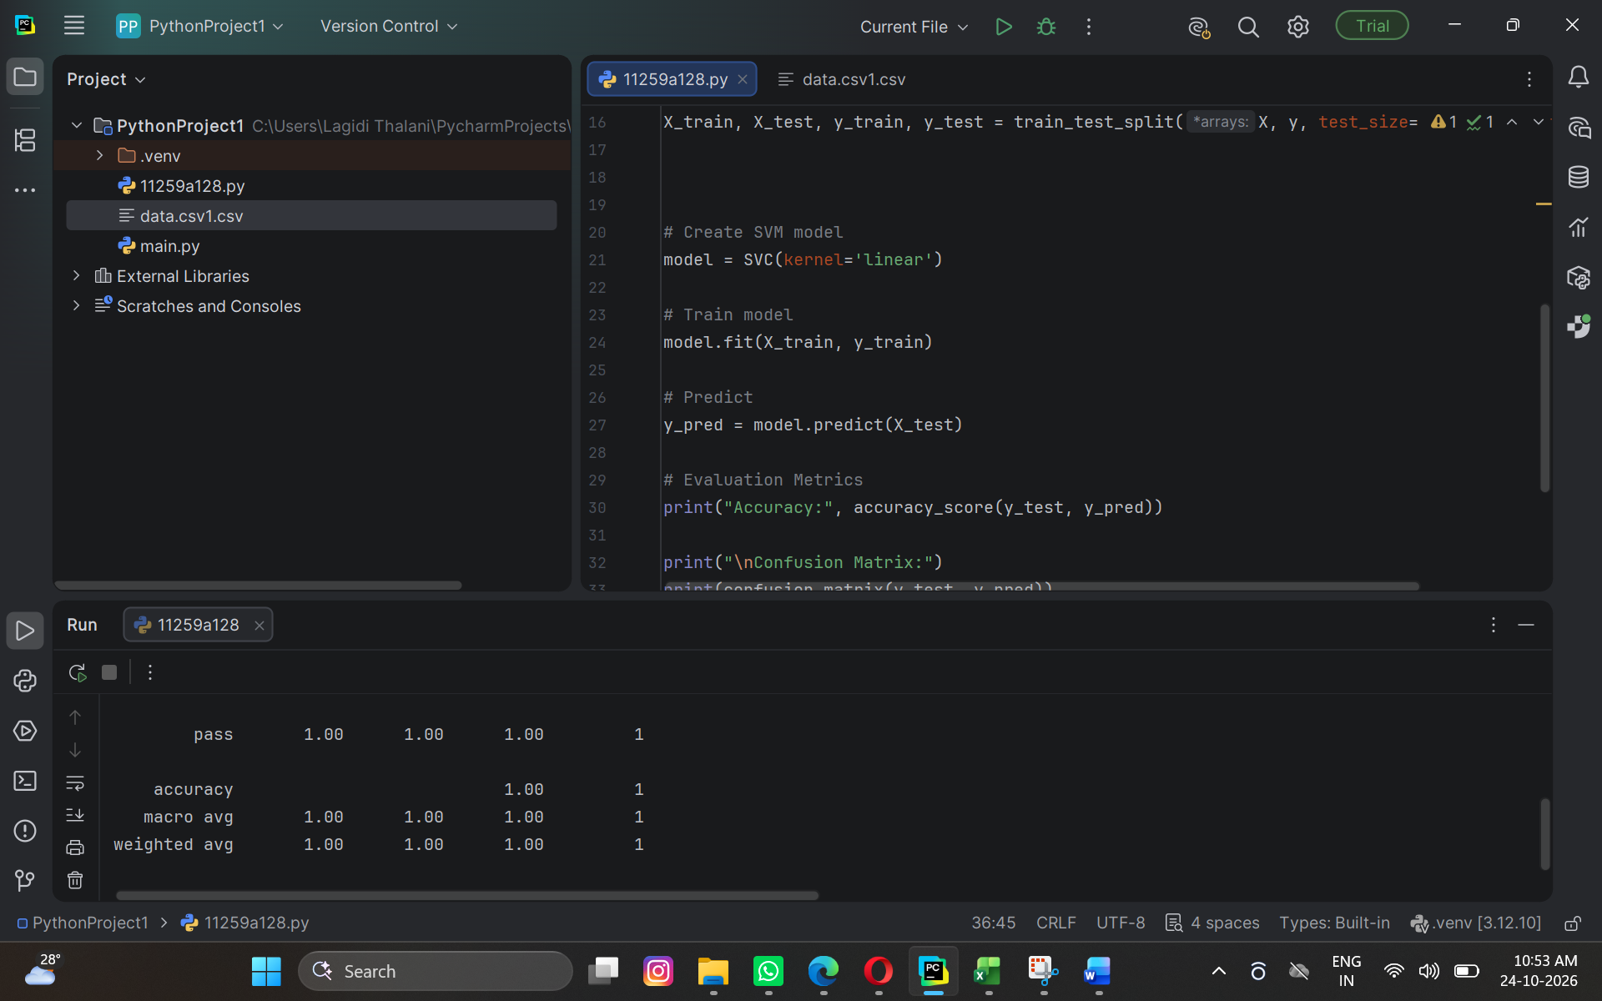

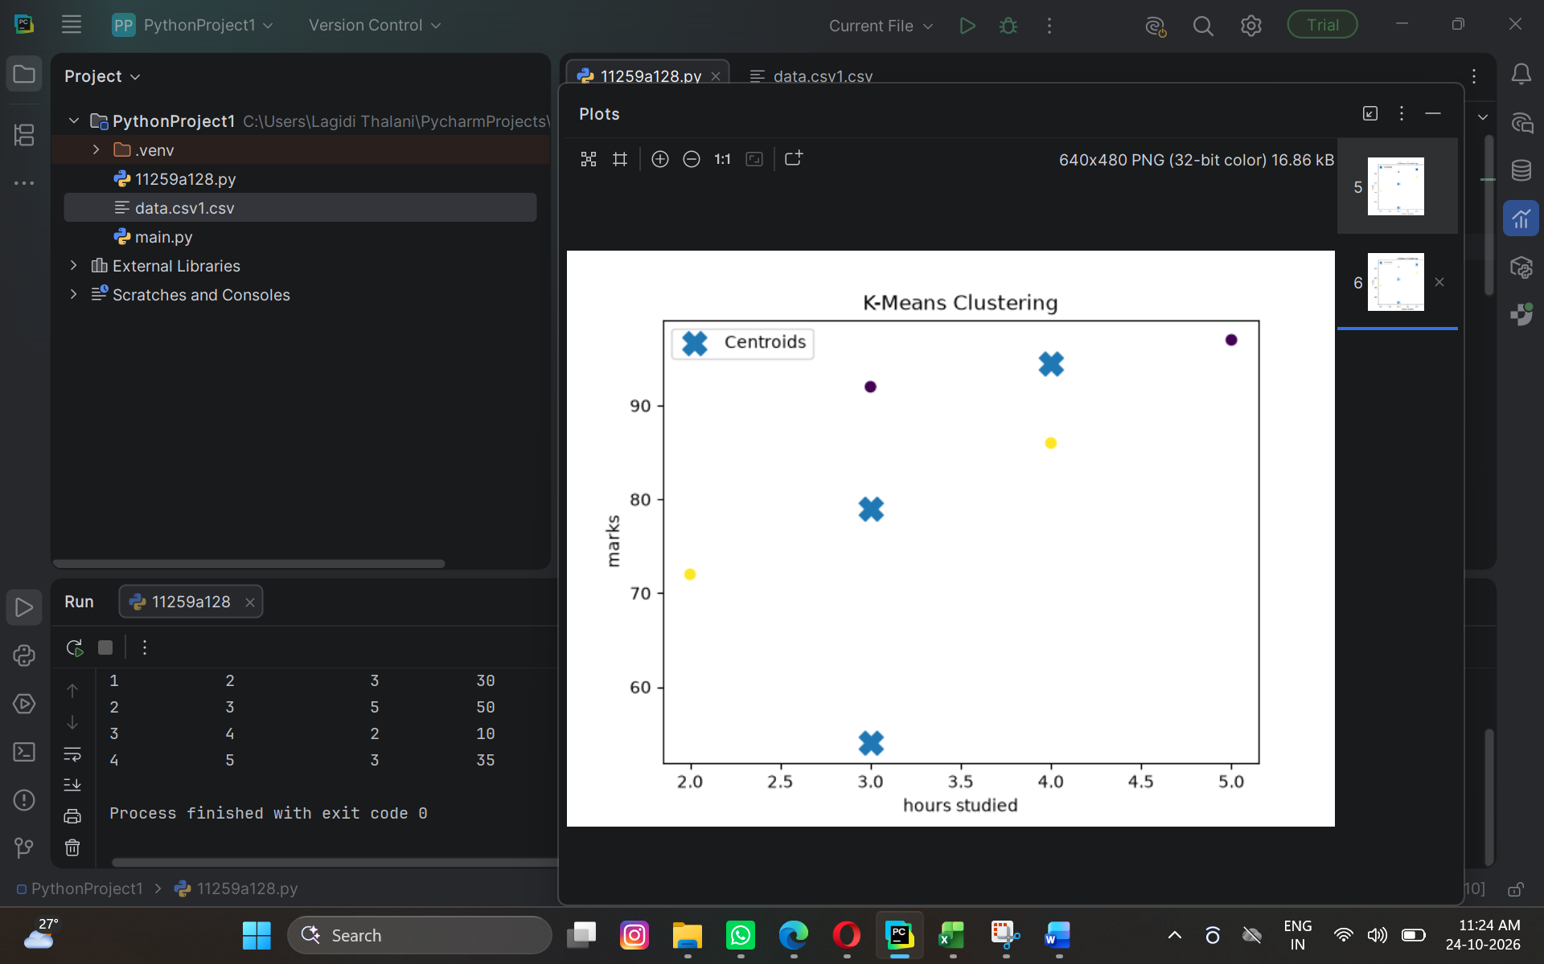

Result
The K-Means clustering algorithm successfully grouped the students into three clusters based on their study hours and marks. The cluster labels were added to the dataset, and a scatter plot was generated to visualize the clusters and their centroids.
Expected output:
- A dataset displaying the original columns along with a new Cluster column containing labels 0, 1, or 2.
- A scatter plot showing students grouped into three clusters using different colors.
- X-shaped markers representing the centroids of the three clusters

