EXNO 2: Data Split up and Cross validation

2.1 DataSplitting
Aim
To split a dataset into training and testing sets using the train_test_split() function from Scikit-learn, with 80% of the data used for training and 20% for testing.
Algorithm
- Import the Pandas library and train_test_split from sklearn.model_selection.
- Load the dataset from the CSV file data.csv using pd.read_csv().
- Select the input features (Hours_Studied, Attendance, and Assignments) and store them in X.
- Select the target output column (Result) and store it in y.
- Split the dataset into training and testing sets using train_test_split() with test_size=0.2 and random_state=42.
- Store the resulting data in X_train, X_test, y_train, and y_test.
- Display the training data.
- Display the testing data.
- Print the number of training and testing samples.

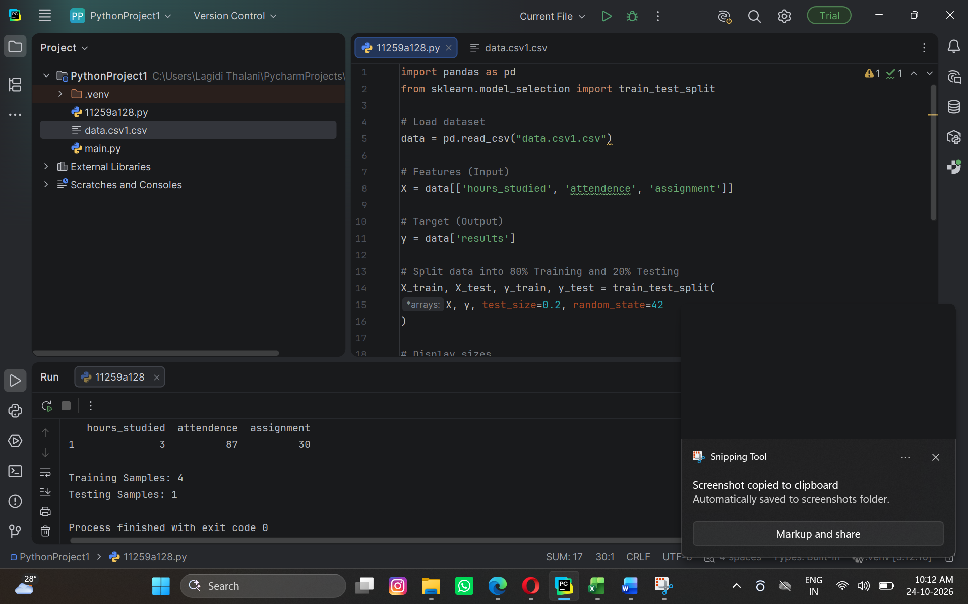

Result
The dataset was successfully divided into training and testing sets using the train_test_split() function.
- Training data: 80% of the dataset.
- Testing data: 20% of the dataset.
- Input features: Hours_Studied, Attendance, and Assignments.
- Target variable: Result.

Data Split up and Cross validation.

Aim
To evaluate the performance of a K-Nearest Neighbors (KNN) classification model using 5-fold cross-validation and calculate its average accuracy using Scikit-learn.
Algorithm
- Import the Pandas library and the required functions and classes from Scikit-learn.
- Load the dataset from the CSV file data.csv.
- Select the input features (Hours_Studied, Attendance, and Assignments) and store them in X.
- Select the target variable (Result) and store it in y.
- Split the dataset into training and testing sets using train_test_split() with 80% training data and 20% testing data.
- Display the sizes of the training and testing datasets.
- Create a KNN classification model using KNeighborsClassifier(n_neighbors=3).
- Perform 5-fold cross-validation using cross_val_score(model, X, y, cv=5).
- Display the accuracy score obtained for each of the five folds.
- Calculate and display the average accuracy using scores.mean().

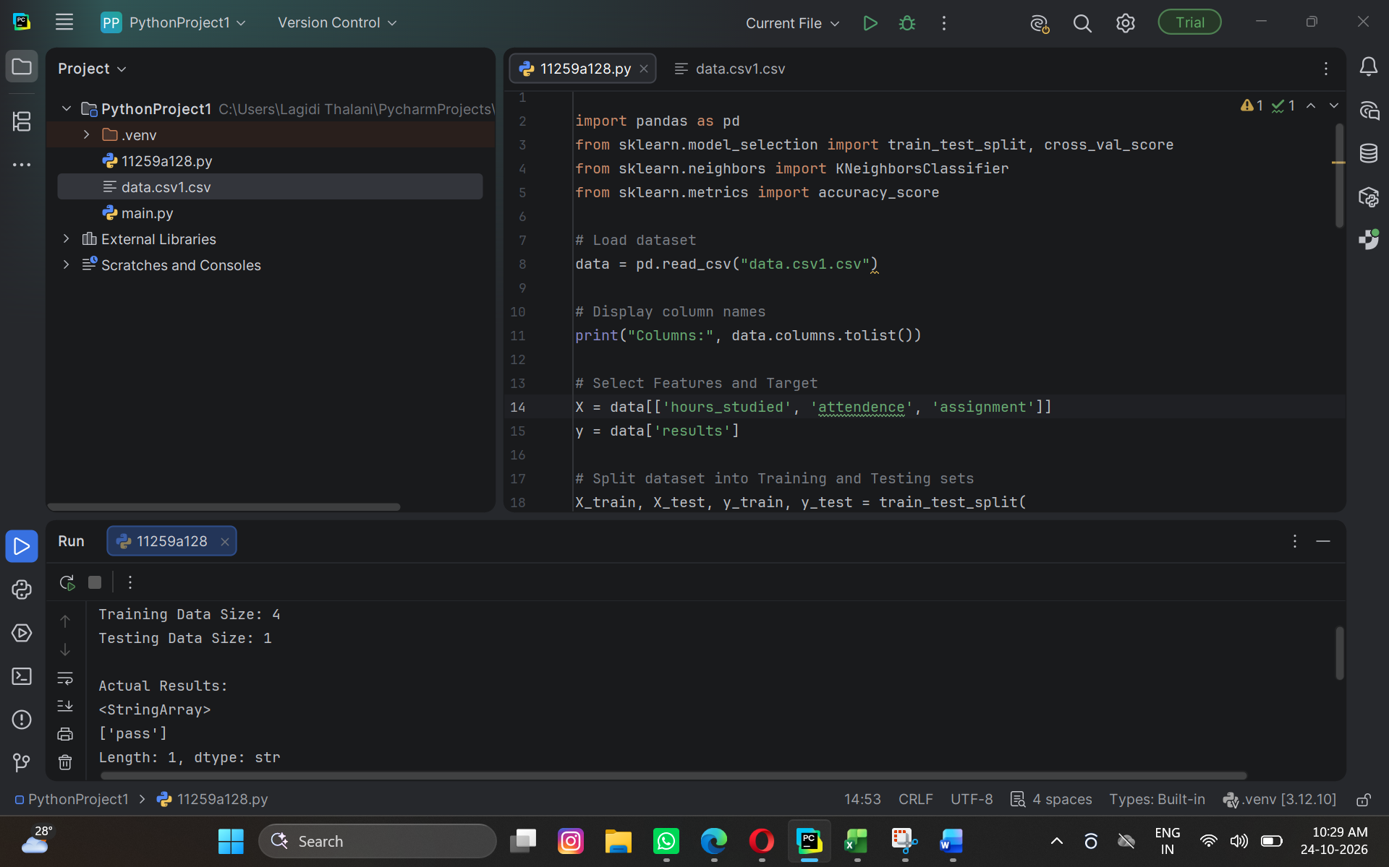

Result
The program successfully loaded the dataset, divided it into training and testing sets, and evaluated the KNN classifier using 5-fold cross-validation.
The output displays:
- The number of training samples.
- The number of testing samples.
- The accuracy scores for each of the five folds.
- The average accuracy of the KNN model

