Exno 3: Implement Linear Regression

Aim
To evaluate the performance of a K-Nearest Neighbors (KNN) classification model using 5-fold cross-validation and calculate its average accuracy using Scikit-learn.
Algorithm
- Import the Pandas library and the required functions and classes from Scikit-learn.
- Load the dataset from the CSV file data.csv.
- Select the input features (Hours_Studied, Attendance, and Assignments) and store them in X.
- Select the target variable (Result) and store it in y.
- Split the dataset into training and testing sets using train_test_split() with 80% training data and 20% testing data.
- Display the sizes of the training and testing datasets.
- Create a KNN classification model using KNeighborsClassifier(n_neighbors=3).
- Perform 5-fold cross-validation using cross_val_score(model, X, y, cv=5).
- Display the accuracy score obtained for each of the five folds.
- Calculate and display the average accuracy using scores.mean().

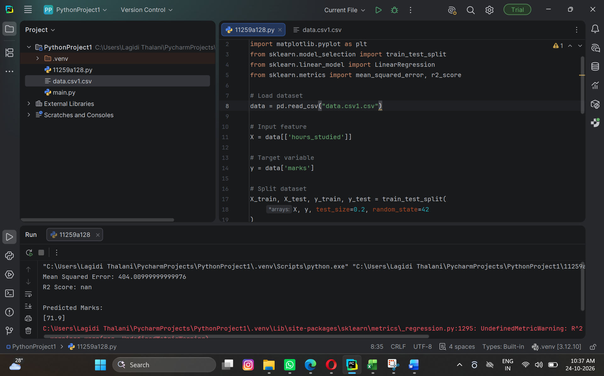

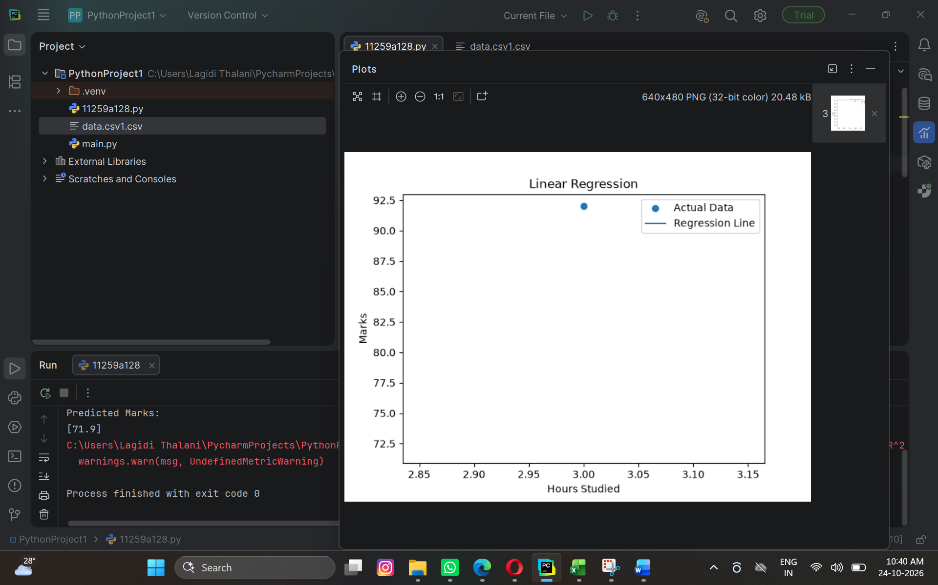

Result
The program successfully loaded the dataset, divided it into training and testing sets, and evaluated the KNN classifier using 5-fold cross-validation.
The output displays:
- The number of training samples.
- The number of testing samples.
- The accuracy scores for each of the five folds.
- The average accuracy of the KNN model

