Experiment 6: Implement Hierarchical Clustering

Aim
To perform hierarchical clustering on a dataset using the Agglomerative Clustering algorithm, visualize the hierarchical relationships using a dendrogram, and group students into three clusters based on their study hours and marks.
Algorithm
- Import the required libraries: Pandas, Matplotlib, dendrogram, linkage, and AgglomerativeClustering.
- Load the dataset from the CSV file data.csv using pd.read_csv().
- Select the Hours_Studied and Marks columns as input features.
- Create a linkage matrix using linkage(X, method='ward') to calculate the hierarchical relationships between data points.
- Plot the dendrogram using dendrogram(linked) to visualize the merging of clusters.
- Set the graph title, axis labels, and figure size, and display the dendrogram.
- Create an Agglomerative Clustering model with three clusters using AgglomerativeClustering(n_clusters=3).
- Apply the clustering algorithm using hc.fit_predict(X) to assign cluster labels to each data point.
- Add the cluster labels as a new column named Cluster to the original dataset.
- Display the updated dataset.
- Create a scatter plot of Hours_Studied against Marks, using different colors to represent the assigned clusters.
- Add axis labels and a title, and display the scatter plot.

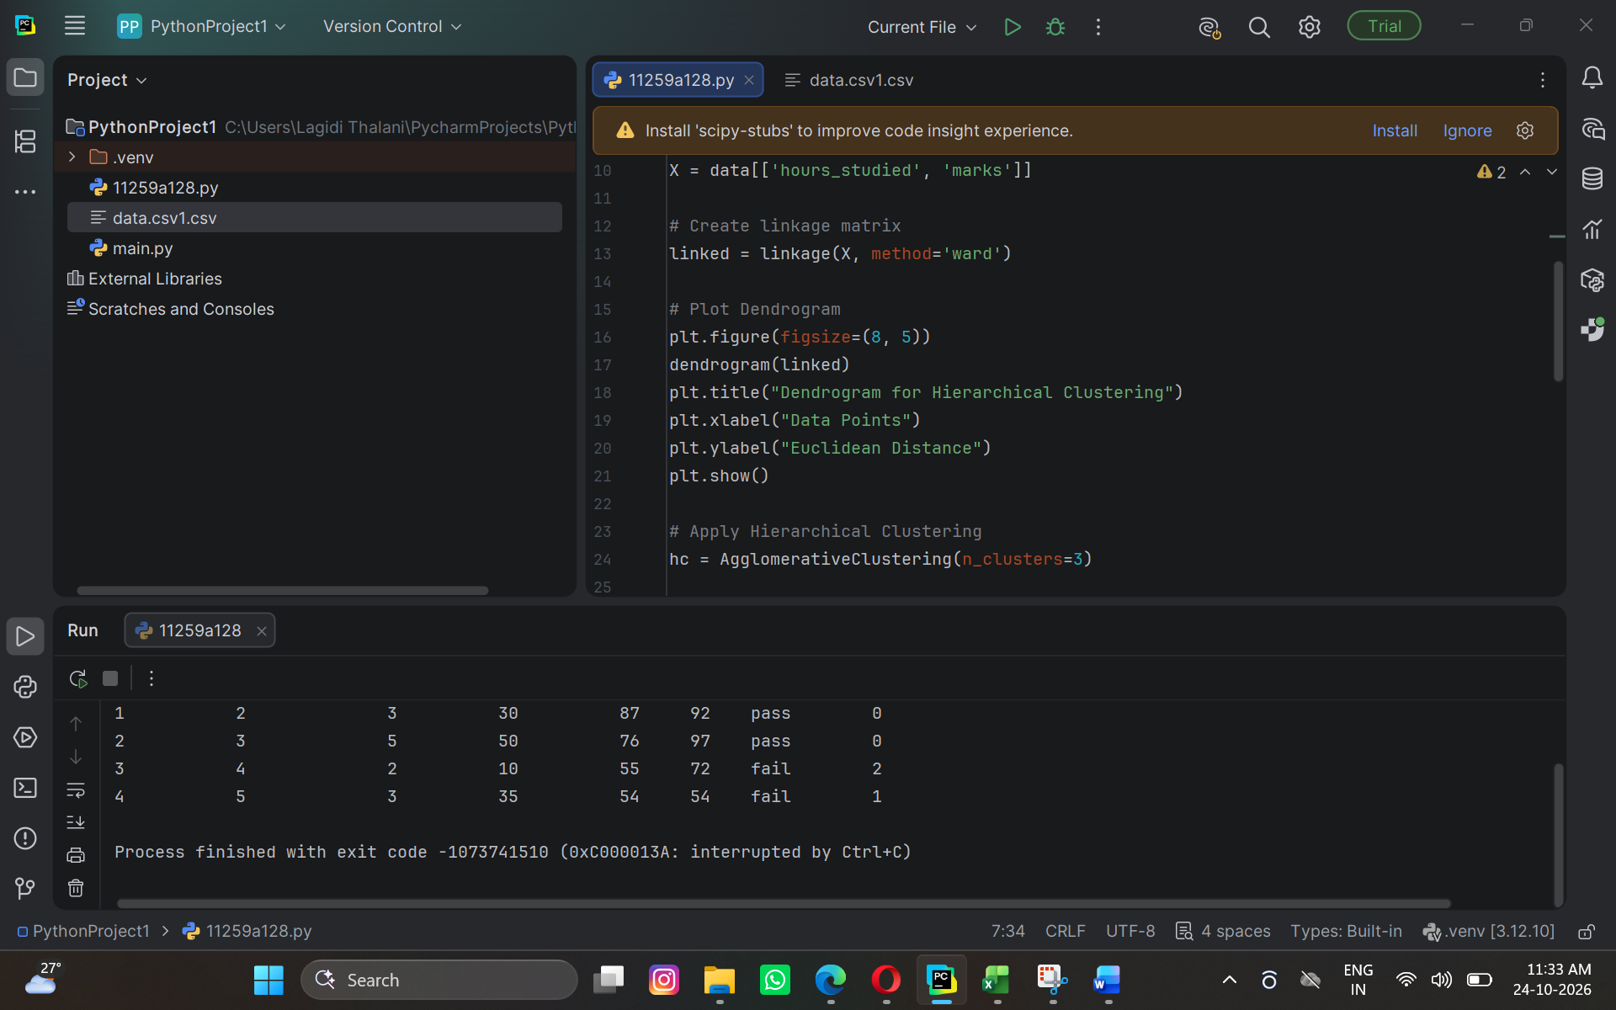

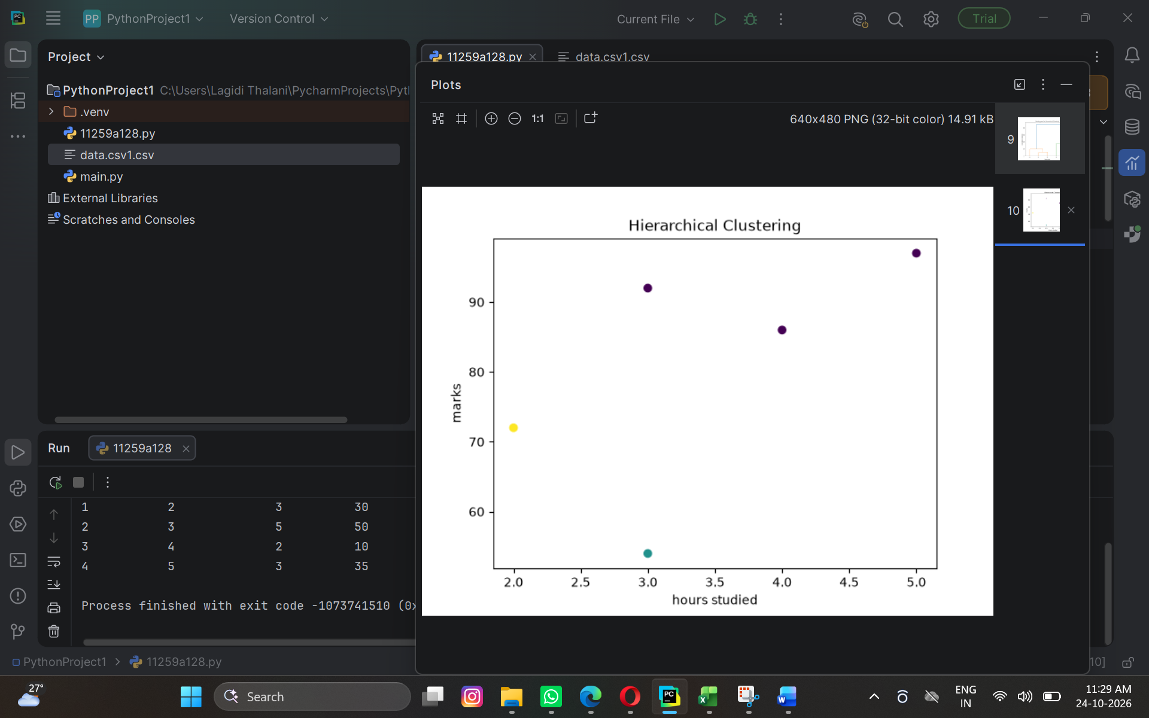
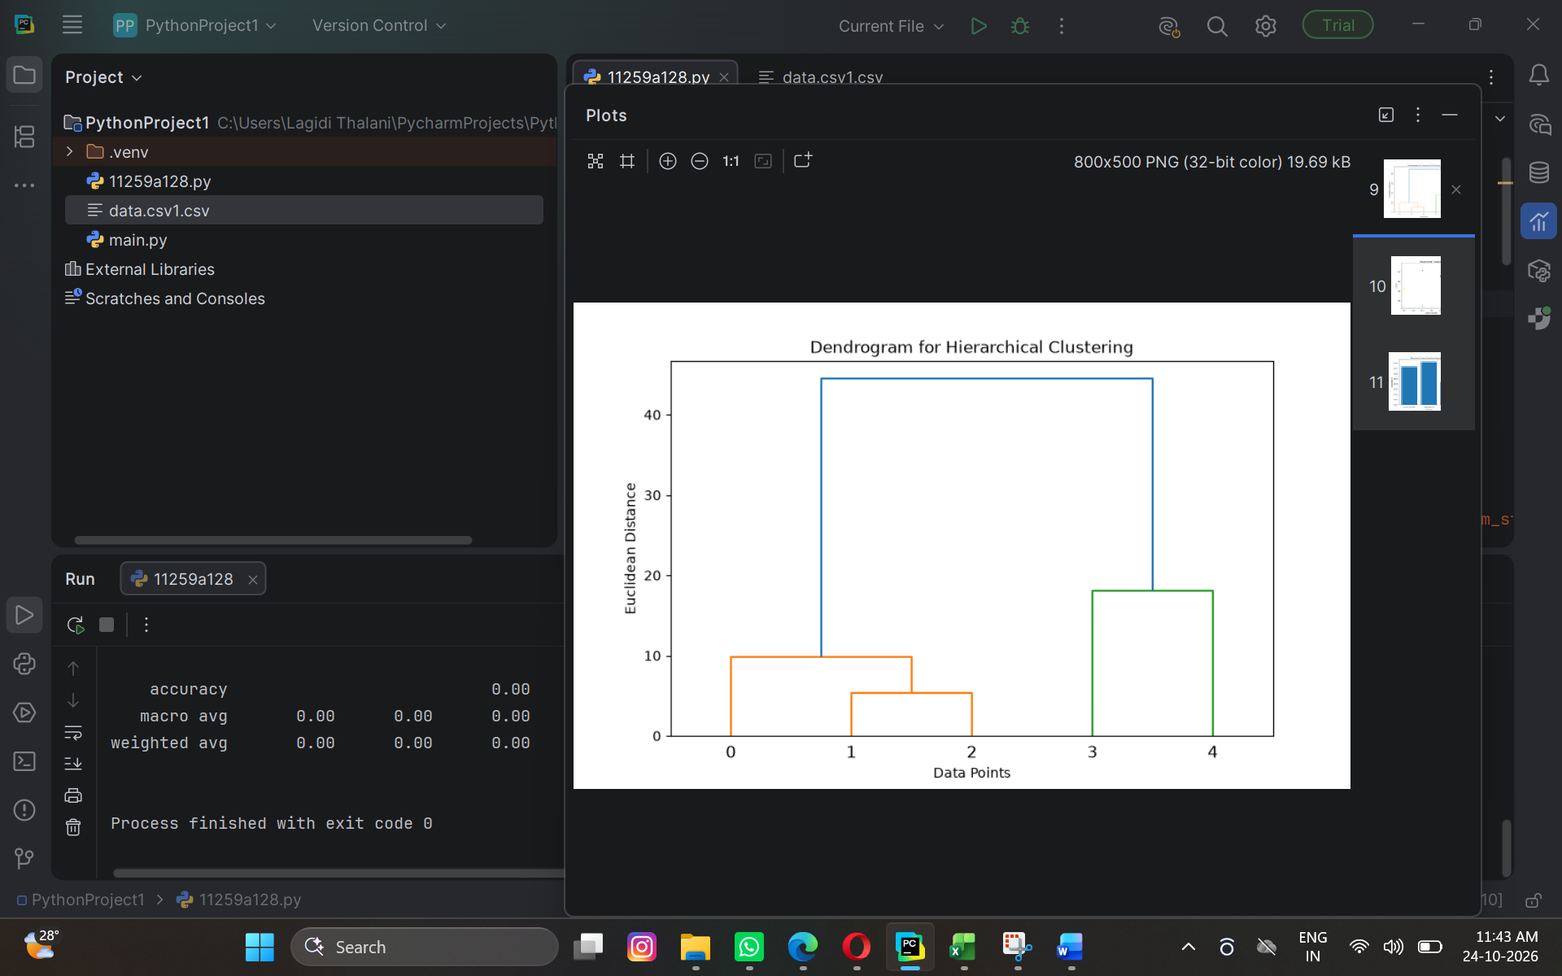

Result
The hierarchical clustering algorithm successfully grouped the dataset into three clusters based on students' study hours and marks.

