AIM: To implement the Q-Learning reinforcement learning algorithm using Python to calculate the Q-table based on the reward matrix and identify the optimal path to reach the goal state.

ALGORITHM:
1. Start the program.
2. Import the NumPy library.
3. Initialize the reward matrix R with rewards for each state transition.
4. Initialize the Q-table with zeros.
5. Set the discount factor (gamma = 0.8) and the number of episodes to 1000.
6. Select a random initial state.
7. Identify the possible actions from the current state.
8. Randomly select a valid action and determine the next state.
9. Update the Q-table using the reward and maximum future Q-value.
10. Repeat the process until the goal state is reached.
11.Repeat the training process for all episodes.
12.Display the final Q-table.
13.Stop the program.

OUTPUT:
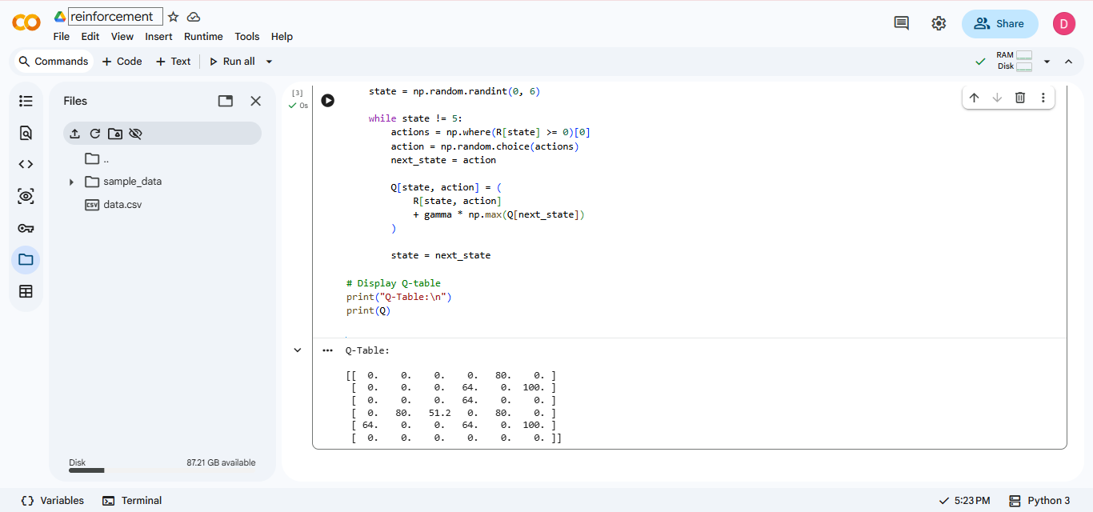

RESULT: Thus, the Q-Learning algorithm is implemented successfully to calculate the Q-table using the reward matrix.

