AIM:
To preprocess a dataset by handling missing values and normalizing numerical features using StandardScaler.
ALGORITHM:
1. Import Pandas and StandardScaler.
2. Read the dataset from data.csv.
3. Display the first five rows.
4. Check the missing values in each column.
5. Fill missing numerical values with their column means.
6. Select Hours_Studied, Attendance, Assignments, and Marks.
7. Apply StandardScaler to normalize the data.
8. Display the normalized dataset.
CODE AND OUTPUT:
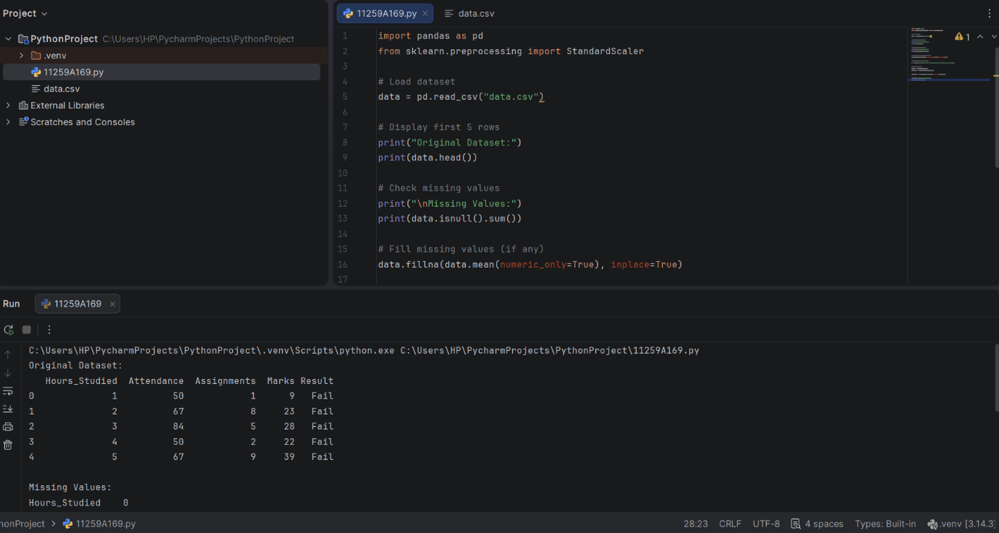
RESULT:
Data preprocessing was performed successfully by handling missing values and normalizing numerical features.

