AIM:
To split a dataset into training and testing sets using train_test_split().
ALGORITHM:
1. Import Pandas and train_test_split.
2. Load the dataset from data.csv.
3. Select the input features and target variable.
4. Split the data using an 80:20 ratio.
5. Display the training and testing data.
6. Display the number of training and testing samples.
CODE AND OUTPUT:
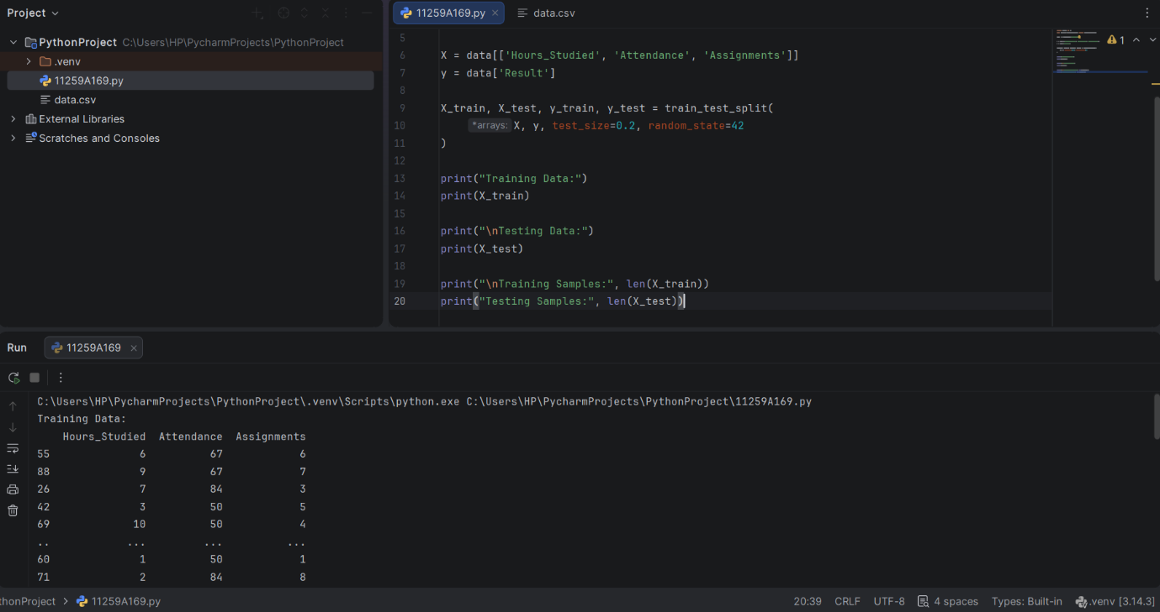
RESULT:
The dataset was successfully divided into training and testing sets.

AIM:
To evaluate a KNN classifier using five-fold cross-validation.
ALGORITHM:
1. Import the required libraries.
2. Load data.csv.
3. Select the input features and target variable.
4. Split the dataset into training and testing sets.
5. Create a KNN classifier with three neighbors.
6. Perform five-fold cross-validation.
7. Display the cross-validation scores and average score.
CODE AND OUTPUT:
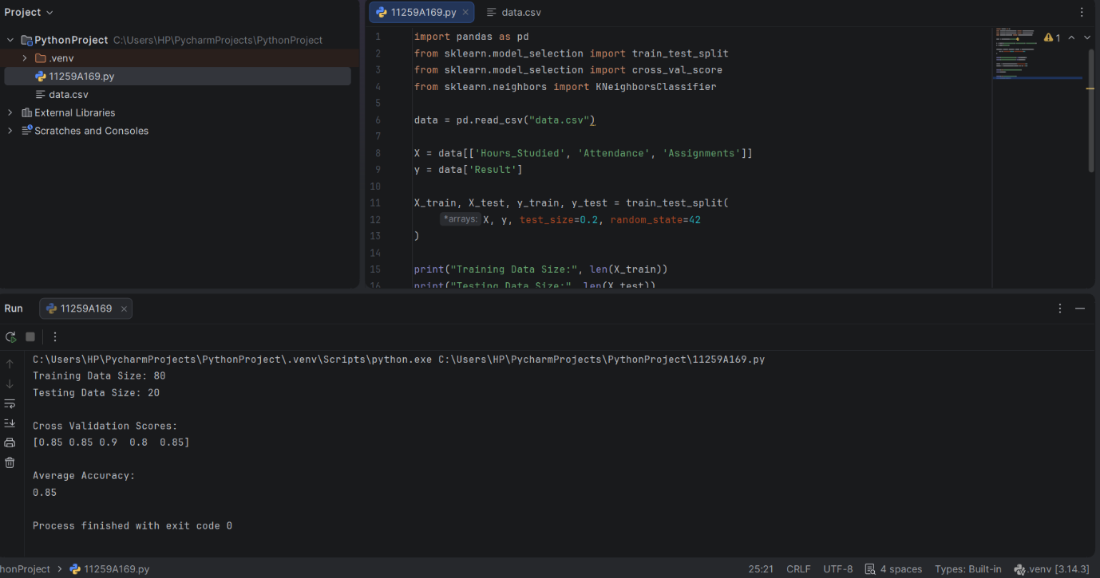
RESULT:
The KNN classifier was evaluated successfully using five-fold cross-validation.

