AIM:
To implement Linear Regression for predicting student marks based on study hours.
ALGORITHM:
1. Import the required libraries.
2. Load the dataset from data.csv.
3. Select Hours_Studied as the input feature and Marks as the target.
4. Split the dataset into training and testing sets.
5. Create and train the Linear Regression model.
6. Predict the marks for the test data.
7. Calculate Mean Squared Error and R2 Score.
8. Display the predicted marks and regression graph.
CODE AND OUTPUT:
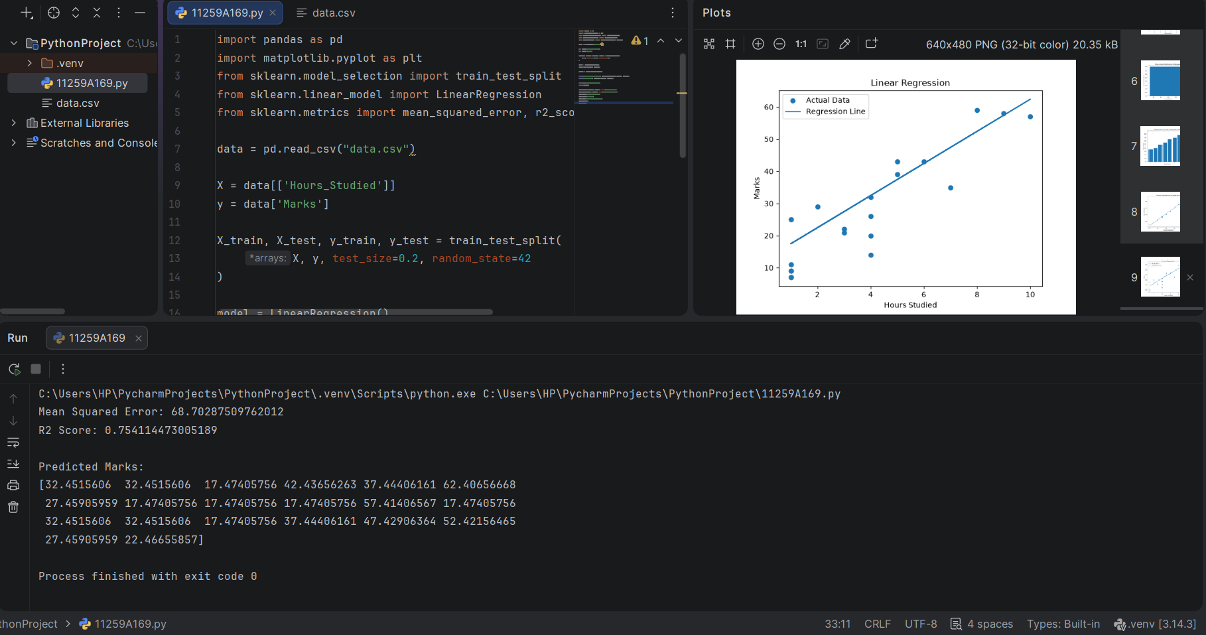
RESULT:
Linear Regression was implemented successfully to predict student marks.

