AIM:
To implement the K-Nearest Neighbors (KNN) classification algorithm and evaluate its performance using accuracy, confusion matrix, and classification report.
ALGORITHM:
1. Import the required libraries.
2. Load data.csv.
3. Select the input features and target variable.
4. Split the dataset into training and testing sets.
5. Create a KNN classifier with three neighbors.
6. Train the model using the training data.
7. Predict the test results.
8. Calculate accuracy, confusion matrix, and classification report.
CODE AND OUTPUT:
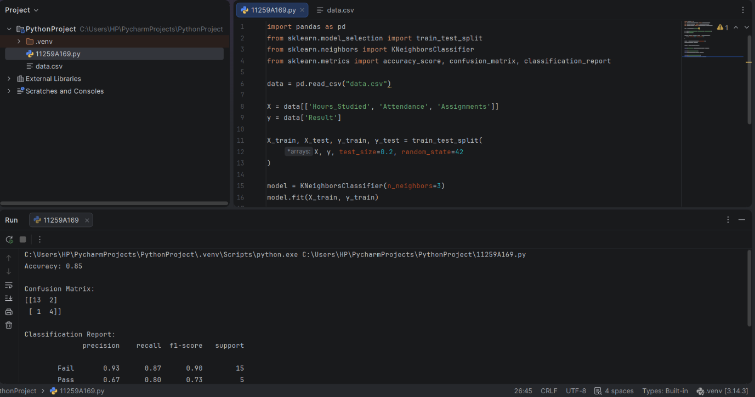

RESULT:
The KNN classification model was implemented successfully and its performance was evaluated using classification metrics.

AIM:
To implement a Support Vector Machine (SVM) classifier and evaluate its performance using classification metrics.
ALGORITHM:
1. Import the required libraries.
2. Load data.csv.
3. Select the input features and target variable.
4. Split the dataset into training and testing sets.
5. Create an SVM model using a linear kernel.
6. Train the model using the training data.
7. Predict the test results.
8. Calculate accuracy, confusion matrix, and classification report.
CODE AND OUTPUT:
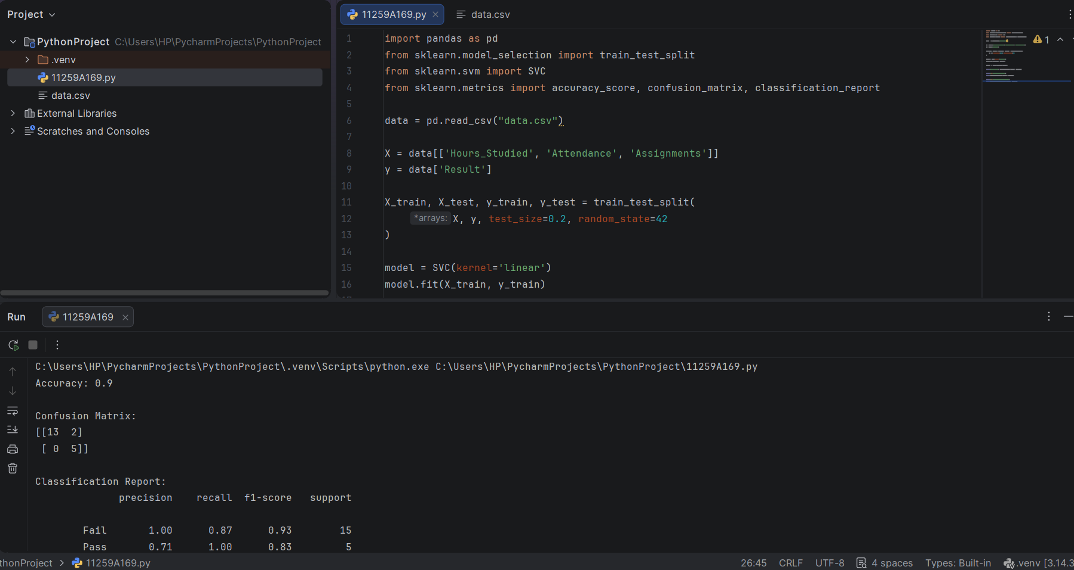
RESULT:
The SVM classification model was implemented successfully and its performance was evaluated using classification metrics.

