AIM:
To implement the K-Means clustering algorithm to group data based on study hours and marks.
ALGORITHM:
1. Import Pandas, Matplotlib, and KMeans.
2. Load data.csv.
3. Select Hours_Studied and Marks as features.
4. Create a K-Means model with three clusters.
5. Fit the model to the data.
6. Obtain the cluster labels.
7. Add the cluster labels to the dataset.
8. Display the clustered data and plot the clusters with centroids.
CODE AND OUTPUT:
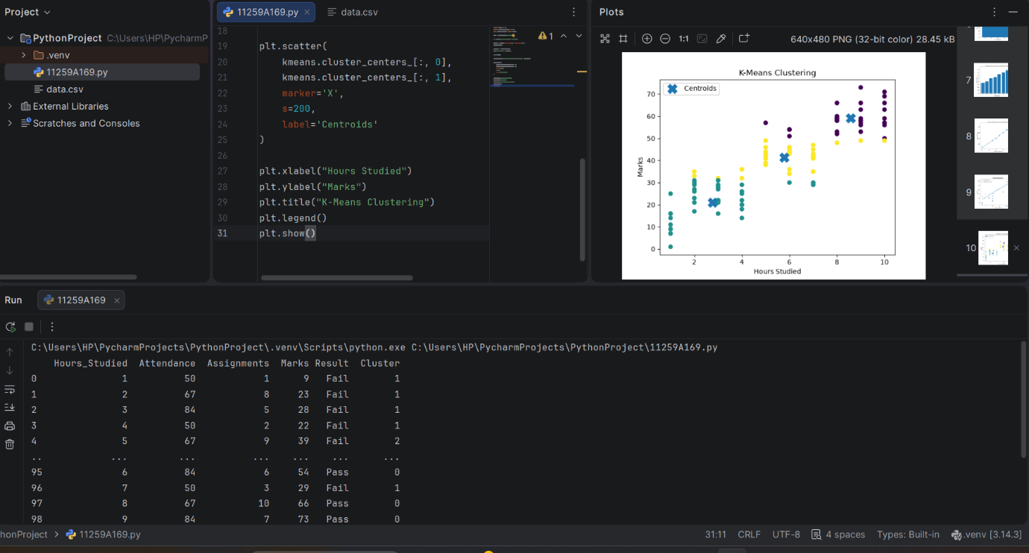
RESULT:
K-Means clustering was implemented successfully to group the data into three clusters.

