AIM:
To implement Hierarchical Clustering and visualize the clusters using a dendrogram and scatter plot.
ALGORITHM:
1. Import the required libraries.
2. Load data.csv.
3. Select Hours_Studied and Marks as features.
4. Create a linkage matrix using Ward's method.
5. Draw the dendrogram.
6. Apply Agglomerative Clustering with three clusters.
7. Add the cluster labels to the dataset.
8. Display the clustered data and scatter plot.
CODE AND OUTPUT:
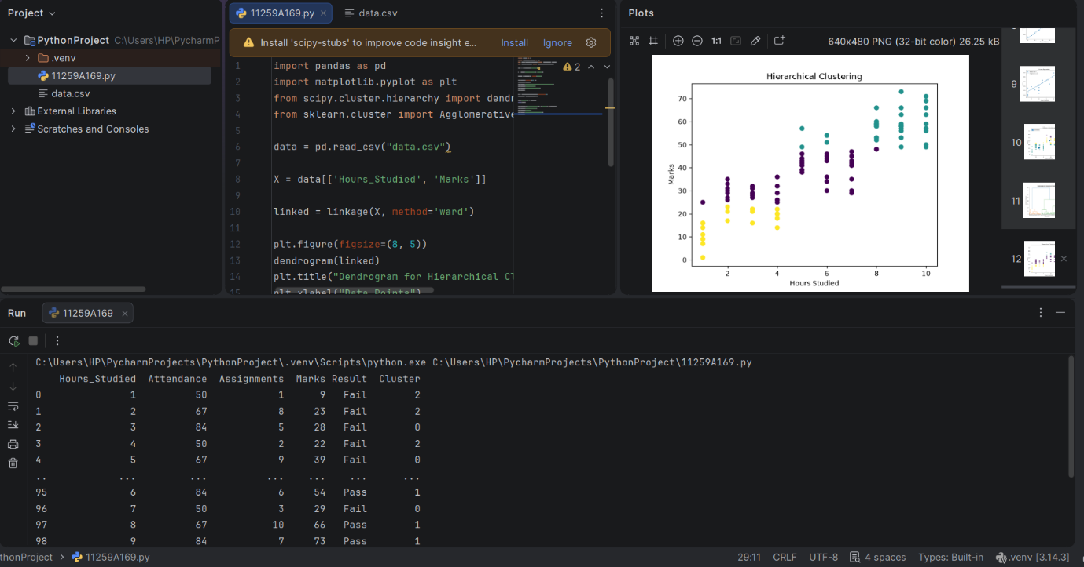
RESULT:
Hierarchical clustering was implemented successfully, and the clusters were visualized using a dendrogram and scatter plot.

