AIM:
To implement the Random Forest classification algorithm and analyze its performance using evaluation metrics and feature importance.
ALGORITHM:
1. Import the required libraries.
2. Load data.csv.
3. Select the input features and target variable.
4. Split the dataset into training and testing sets.
5. Create a Random Forest classifier with 100 estimators.
6. Train the model using the training data.
7. Predict the test results.
8. Calculate accuracy, confusion matrix, and classification report.
9. Display the feature importance graph.
CODE AND OUTPUT:
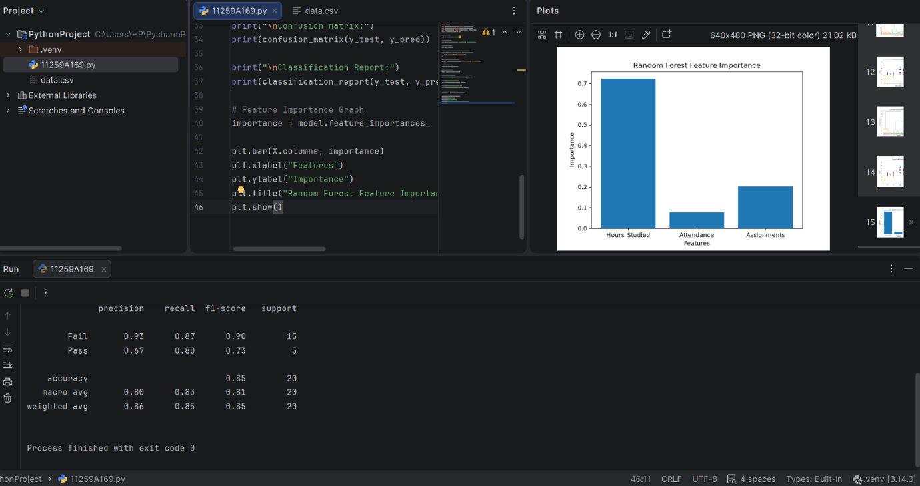
RESULT:
The Random Forest classification model was implemented successfully, and its performance and feature importance were analyzed.

