AIM:
To implement the AdaBoost classification algorithm and analyze its performance using evaluation metrics and feature importance.
ALGORITHM:
1. Import the required libraries.
2. Load data.csv.
3. Select the input features and target variable.
4. Split the dataset into training and testing sets.
5. Create an AdaBoost classifier with 50 estimators.
6. Train the model.
7. Predict the test results.
8. Calculate accuracy, confusion matrix, and classification report.
9. Display the feature importance graph.
CODE AND OUTPUT:
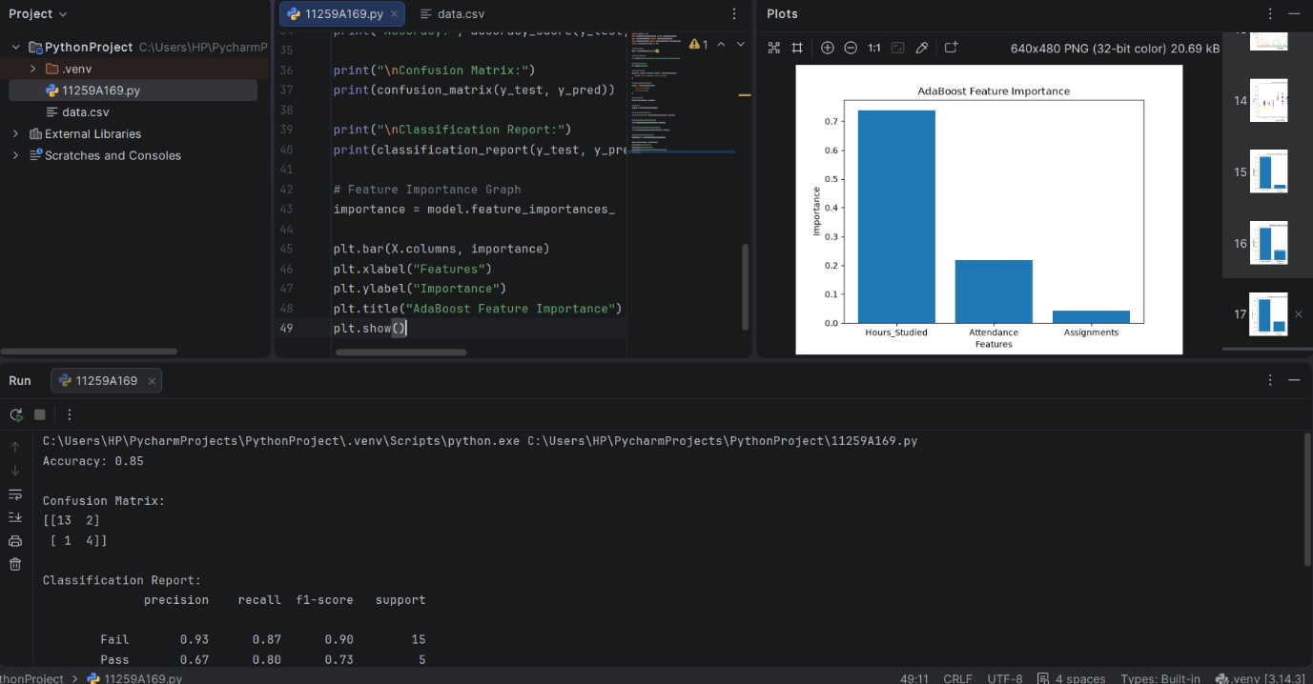
RESULT:
The AdaBoost classification model was implemented successfully, and its performance was analyzed using evaluation metrics and feature importance.

