AIM:
To implement a basic Reinforcement Learning model using the Q-Learning algorithm.
ALGORITHM:
1. Import the NumPy library.
2. Create the rewards matrix.
3. Initialize the Q-table with zeros.
4. Set the discount factor and number of episodes.
5. Select a random initial state.
6. Choose a valid action and calculate the Q-value.
7. Update the current state until the goal state is reached.
8. Repeat the training process for 1000 episodes.
9. Display the final Q-table.
CODE AND OUTPUT:
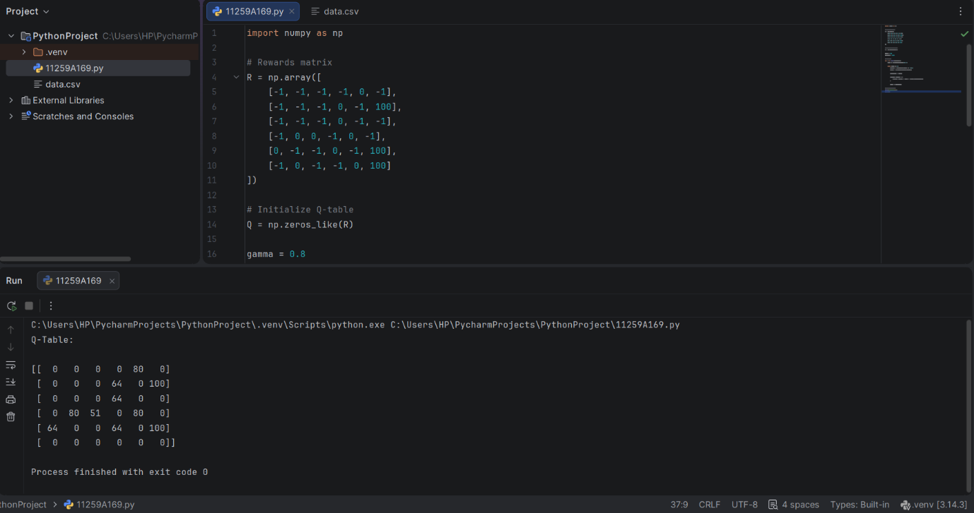
RESULT:
The Q-Learning algorithm was implemented successfully, and the learned Q-table was displayed.

