DATA VISUALIZATION
AIM:
To visualize data using scatter plots, line plots, histograms, and bar charts with Matplotlib.
ALGORITHM:
1. Import Pandas, Matplotlib, and NumPy.
2. Create a dataset containing study hours and exam scores.
3. Draw a scatter plot.
4. Draw a line plot.
5. Draw a histogram.
6. Draw a bar chart.
7. Display all the graphs.
CODE AND OUTPUT:
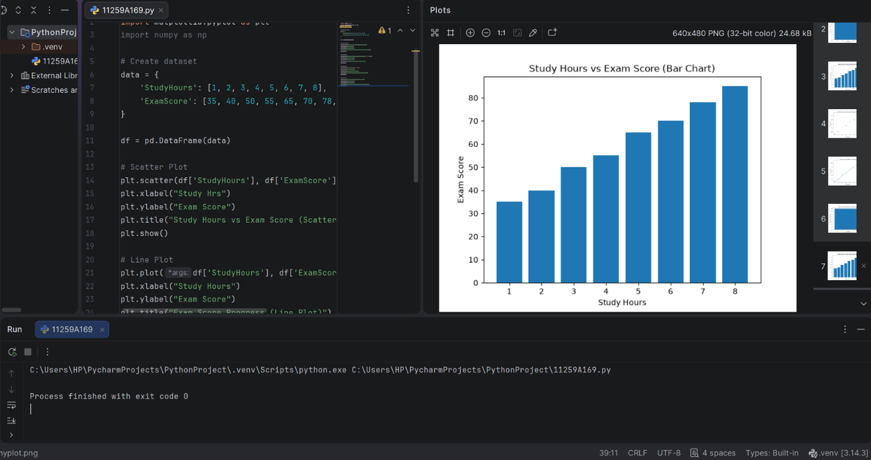

RESULT:
Data visualization was performed successfully using Matplotlib.

