1.CREATING ARRAYS
AIM:
To create and display one-dimensional arrays, two-dimensional arrays, zeros, ones, identity matrices, and range arrays using NumPy.
ALGORITHM:
1. Import the NumPy library.
2. Create one-dimensional and two-dimensional arrays.
3. Create arrays containing zeros and ones.
4. Create an identity matrix.
5. Create a range array using arange().
6. Display all the arrays.
CODE AND OUTPUT:
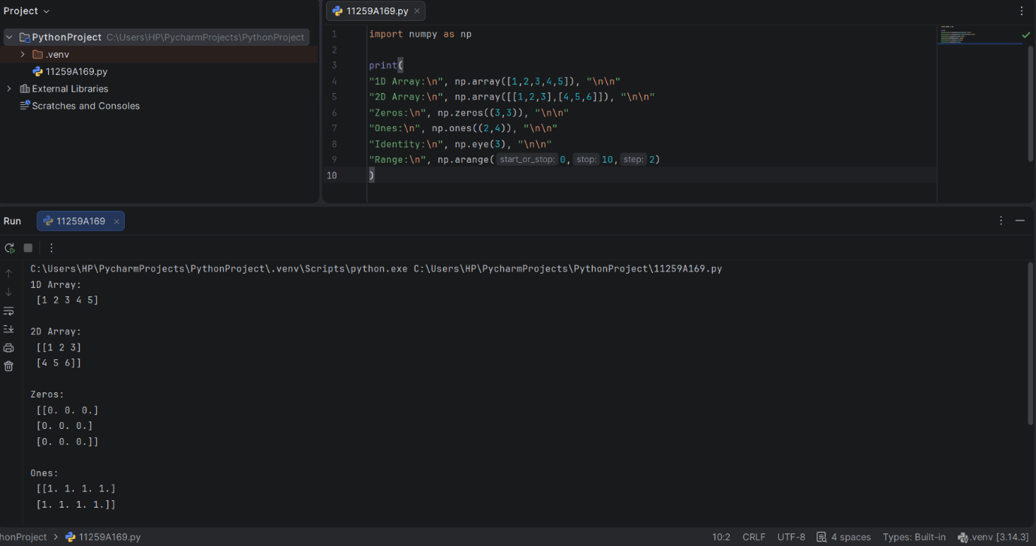
RESULT:
Various types of arrays were created and displayed successfully using NumPy.

2. ARRAY OPERATIONS
AIM:
To perform arithmetic and mathematical operations on NumPy arrays.
ALGORITHM:
1. Import the NumPy library.
2. Create two NumPy arrays.
3. Perform addition and multiplication.
4. Perform scalar multiplication.
5. Calculate the square root and mean.
6. Calculate the dot product.
7. Display the results.
CODE AND OUTPUT:
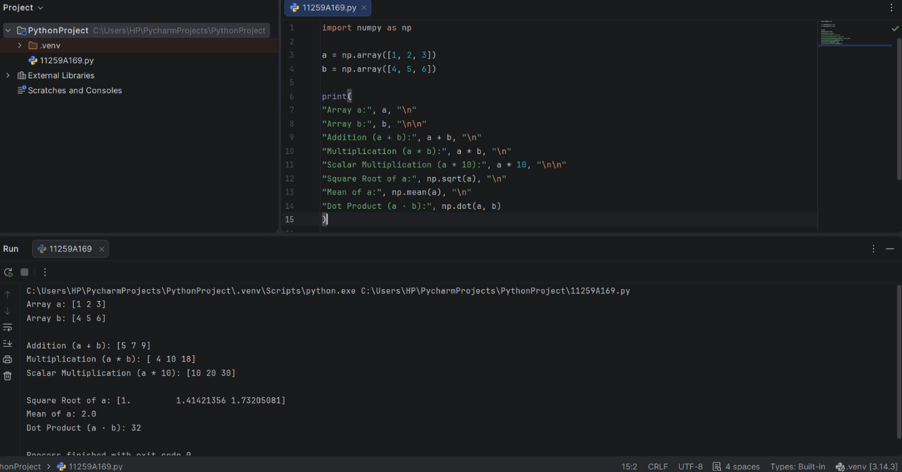

RESULT:
Arithmetic and mathematical operations on NumPy arrays were performed successfully.

3. INDEXING AND SLICING
AIM:
To perform indexing and slicing operations on a NumPy matrix.
ALGORITHM:
1. Import the NumPy library.
2. Create a 3 × 3 matrix.
3. Access an element using its index.
4. Extract the first row and second column.
5. Extract the top-left 2 × 2 sub-matrix.
6. Display the results.
CODE AND OUTPUT:
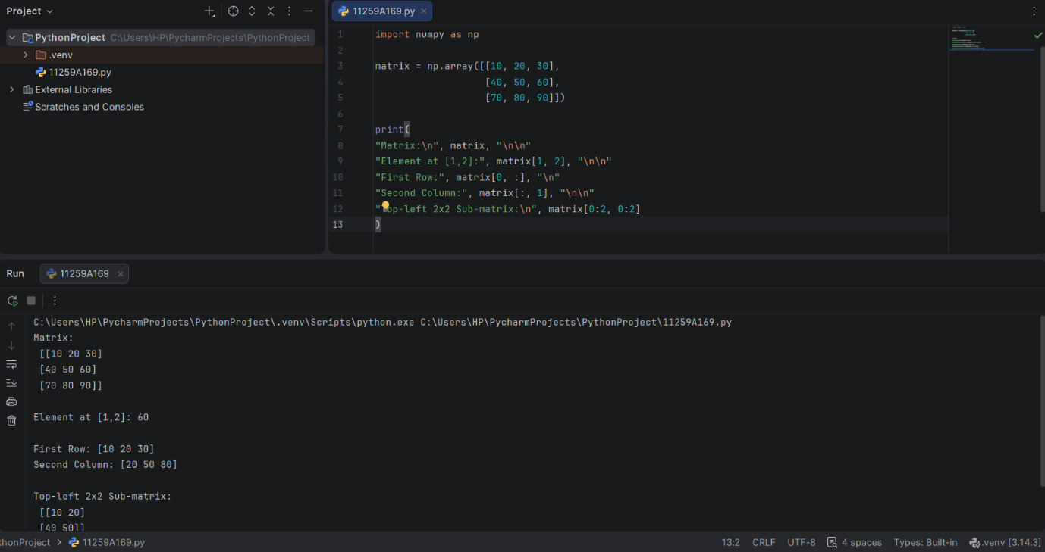

RESULT:
Indexing and slicing operations were performed successfully using NumPy.

