1. CREATING DATAFRAMES
AIM:
To create a Pandas DataFrame and display its basic information and statistical summary.
ALGORITHM:
1. Import the Pandas library.
2. Create a dictionary containing names, ages, and cities.
3. Convert the dictionary into a DataFrame.
4. Display the first five rows.
5. Display the data types and non-null counts.
6. Display the statistical summary.
CODE AND OUTPUT:
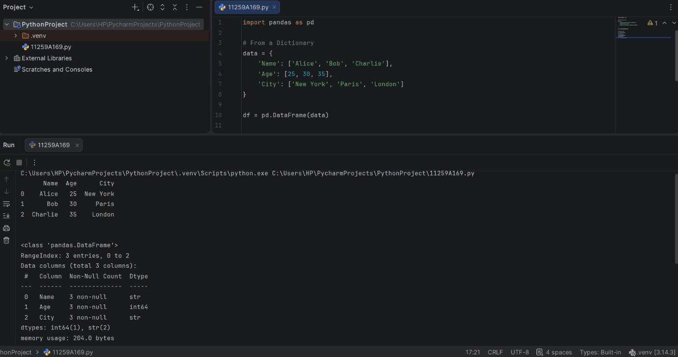
RESULT:
A Pandas DataFrame was created and its basic information and statistical summary were displayed successfully.

2. SELECTION AND FILTERING
AIM:
To select and filter specific rows and columns from a Pandas DataFrame.
ALGORITHM:
1. Create a DataFrame containing names, ages, and cities.
2. Select the required column.
3. Filter rows based on a condition.
4. Select a row using its index.
5. Access a specific value using loc.
6. Display the results.
CODE AND OUTPUT:
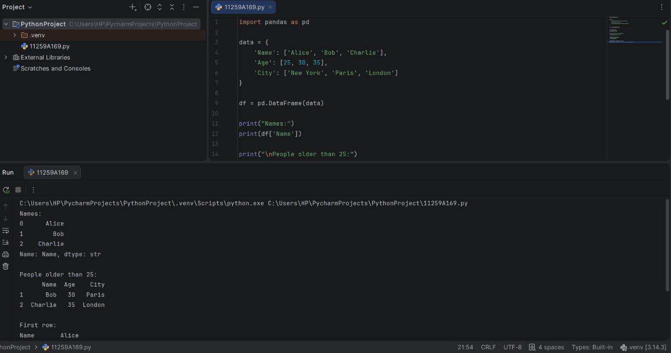

RESULT:
Selection and filtering operations were performed successfully using Pandas.

3. DATA CLEANING
AIM:
To handle missing values in a Pandas DataFrame using different data-cleaning techniques.
ALGORITHM:
1. Import Pandas and NumPy.
2. Create a dataset containing missing values.
3. Display the original DataFrame.
4. Count the missing values in each column.
5. Remove rows containing missing values.
6. Replace missing values with zero.
7. Replace missing ages with the mean age.
8. Replace missing cities with "Unknown".
9. Display the results.
CODE AND OUTPUT:
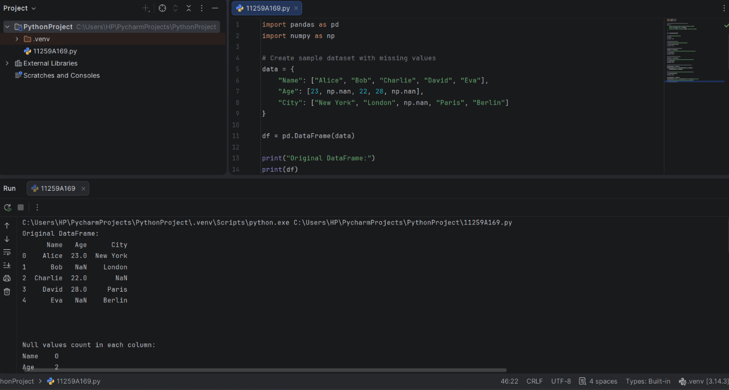
RESULT:
Missing values were handled successfully using dropna() and fillna() in Pandas.

