AIM:
To implement Linear Regression for predicting internal marks based on the number of classes attended.
ALGORITHM:
1. Import the required libraries.
2. Create a dataset containing student details, classes attended, and internal marks.
3. Separate the input feature and target variable.
4. Split the dataset into training and testing sets.
5. Create and train the Linear Regression model.
6. Predict the marks.
7. Calculate Mean Squared Error.
8. Display the model coefficients and plot the regression line.
CODE AND OUTPIT:
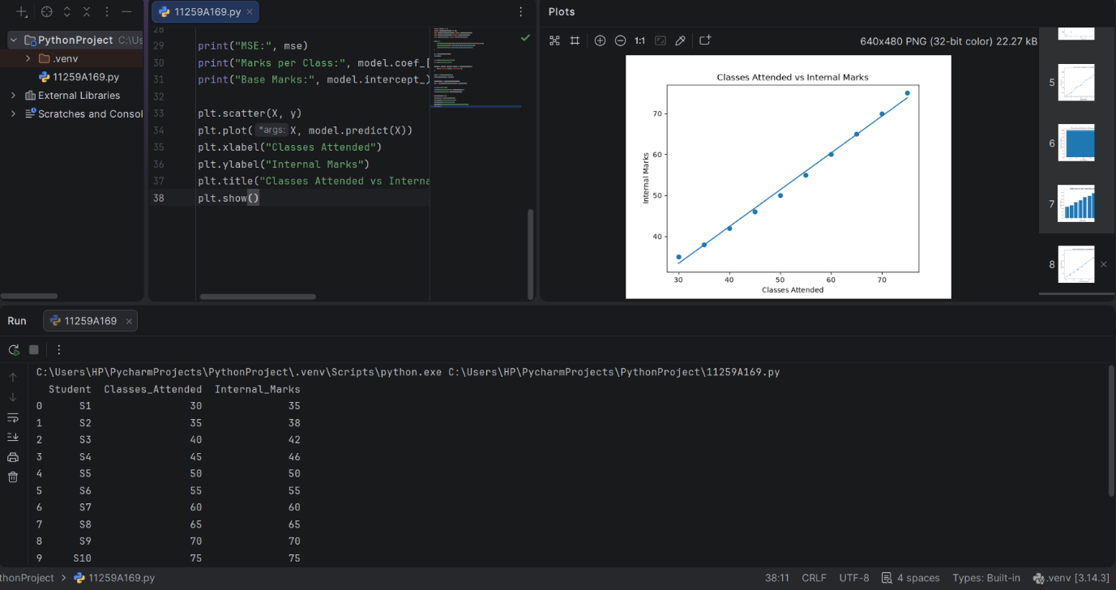
RESULT:
Linear Regression was implemented successfully to predict internal marks.

