INDEX
Ex. No. | Name of the Experiment | Date | Sign
1 | Data Preprocessing in Given Dataset
2 | Data Split-up and Cross Validation
3 | Implement Linear Regression
4 | Implement Classification Models Using KNN and SVM and Compute Evaluation Metrics
5 | Implement K-Means Clustering
6 | Implement Hierarchical Clustering
7 | Implement Random Forest and Analyze Performance
8 | Implement Boosting Technique (AdaBoost) and Analyze Performance
9 | Implement a Basic Reinforcement Learning Model (Q-Learning) and a Neural Network

EXPERIMENT NO: 1

DATA PREPROCESSING IN GIVEN DATASET

AIM:
To perform data preprocessing on the given dataset by checking and handling missing values and normalising the numerical features using Python (Pandas and Scikit-learn).
ALGORITHM:
- Start the program and import the required libraries (Pandas, StandardScaler).
- Load the dataset from data.csv using pd.read_csv() and display the first five rows.
- Check the number of missing values in every column using isnull().sum().
- Fill any missing numerical values with the mean of the respective column using fillna().
- Select the numerical columns Hours_Studied, Attendance, Assignments and Marks.
- Normalise the selected columns using StandardScaler (zero mean and unit variance) with fit_transform().
- Convert the scaled array back into a DataFrame and display the normalised dataset.
- Stop.
PROGRAM :
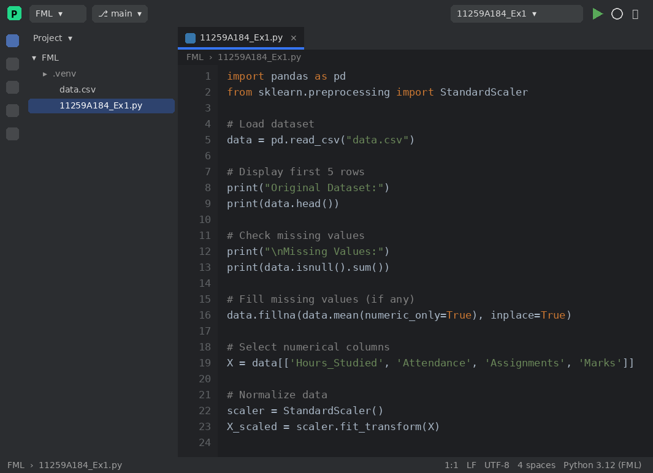
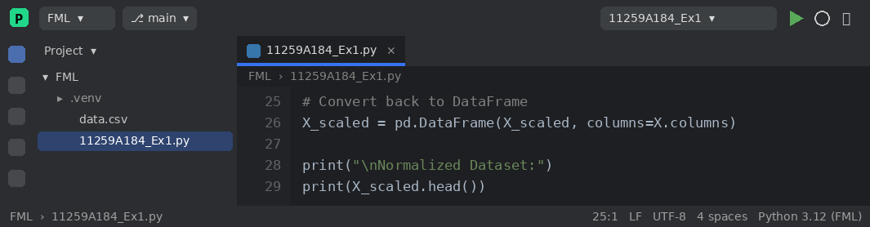
OUTPUT :
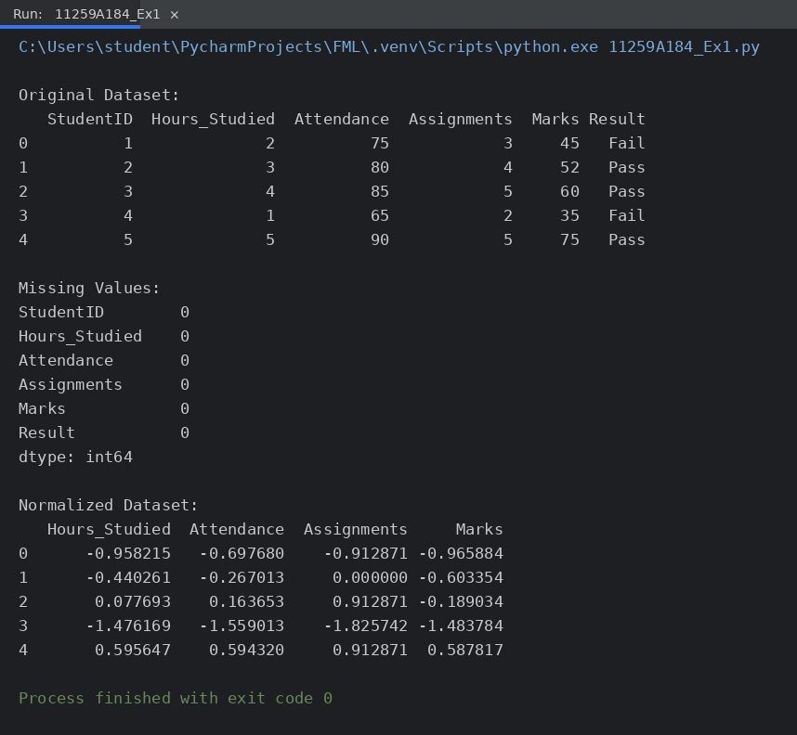
RESULT:
The dataset of 20 records was loaded and checked. No missing values were found in any column. The numerical features were normalised successfully using StandardScaler, so that each feature has mean 0 and standard deviation 1. Thus data preprocessing was executed successfully.

EXPERIMENT NO: 2

DATA SPLIT-UP AND CROSS VALIDATION

AIM:
To split the given dataset into training and testing sets and to evaluate a model using k-fold cross validation.
ALGORITHM:
- Start the program and import Pandas, train_test_split, cross_val_score and KNeighborsClassifier.
- Load the dataset from data.csv.
- Select Hours_Studied, Attendance and Assignments as the input features (X) and Result as the target (y).
- Split the data into 80% training and 20% testing sets using train_test_split() with random_state = 42.
- Display the training data, testing data and the number of samples in each set.
- Create a KNN classifier with n_neighbors = 3.
- Perform 5-fold cross validation using cross_val_score() and display the score of each fold.
- Compute and display the average accuracy.
- Stop.
PROGRAM :
2.1 Data Splitting
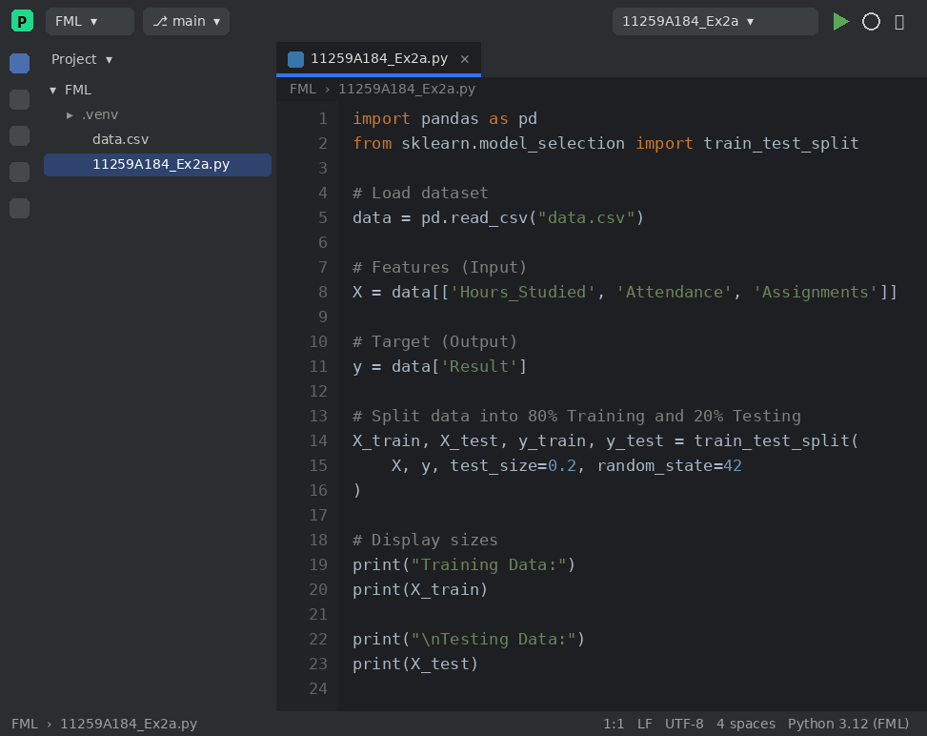
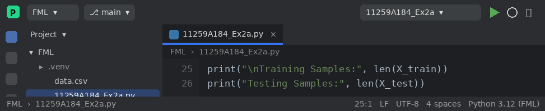
2.2 Cross Validation
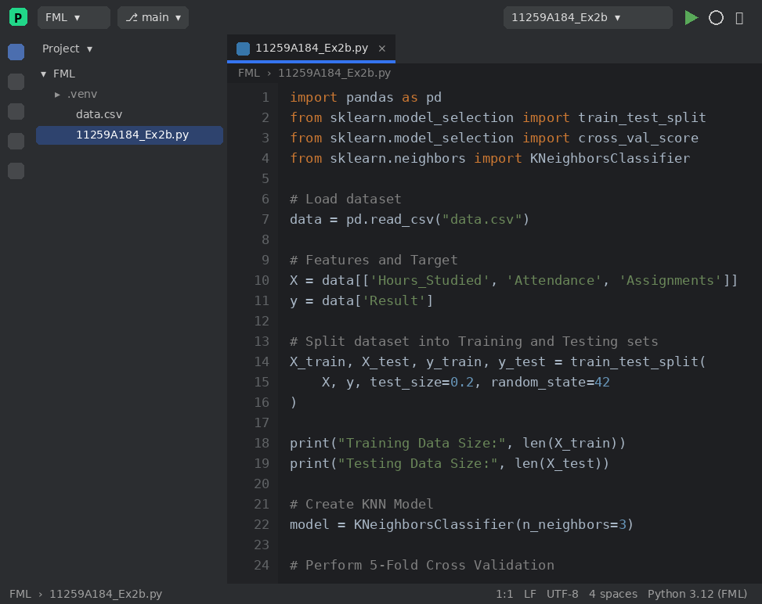
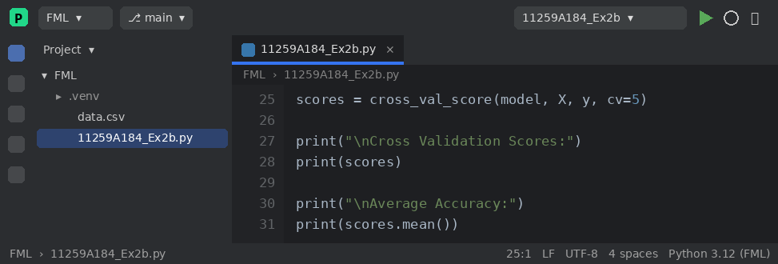
OUTPUT :
2.1 Data Splitting
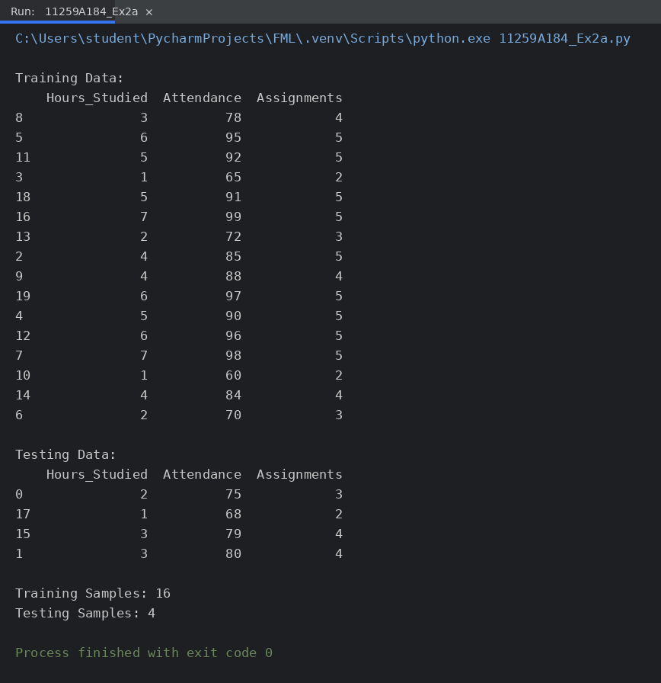
2.2 Cross Validation
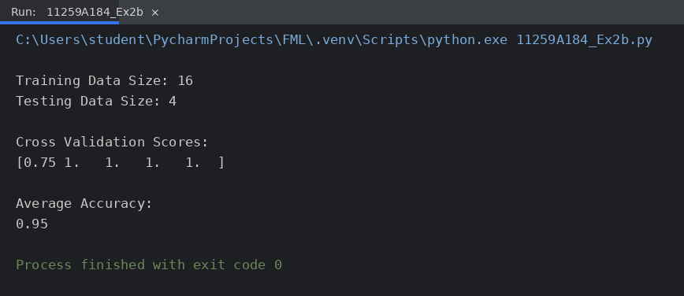
RESULT:
The dataset was split into 16 training samples and 4 testing samples. The 5-fold cross validation of the KNN model gave the fold scores 0.75, 1.0, 1.0, 1.0 and 1.0 with an average accuracy of 0.95 (95%). Thus data splitting and cross validation were implemented successfully.

EXPERIMENT NO: 3

IMPLEMENT LINEAR REGRESSION

AIM:
To implement a Linear Regression model that predicts the marks of a student from the number of hours studied, and to evaluate it using Mean Squared Error and R2 score.
ALGORITHM:
- Start the program and import Pandas, Matplotlib, LinearRegression and the metrics functions.
- Load the dataset from data.csv.
- Take Hours_Studied as the input feature (X) and Marks as the target variable (y).
- Split the dataset into training (80%) and testing (20%) sets.
- Create a LinearRegression model (y = mx + c) and train it using fit().
- Predict the marks for the test data using predict().
- Calculate the Mean Squared Error and the R2 score of the predictions.
- Plot the actual test data and the regression line.
- Stop.
PROGRAM :
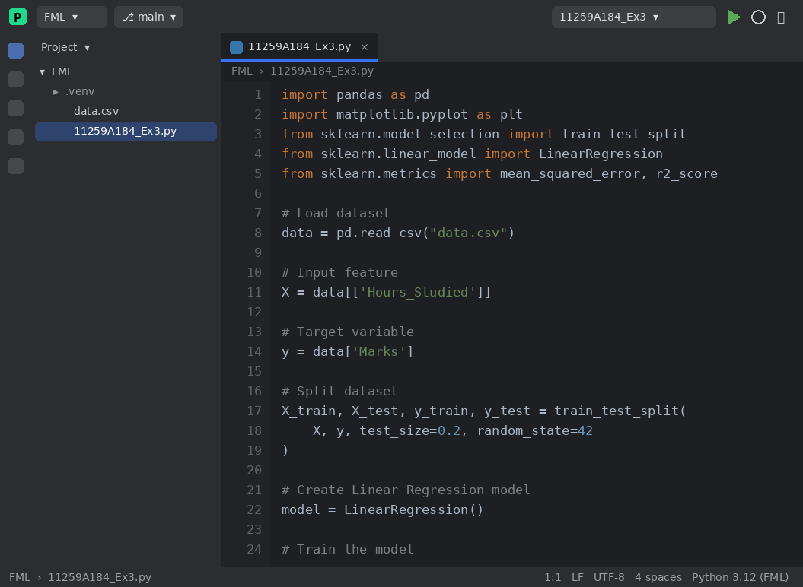
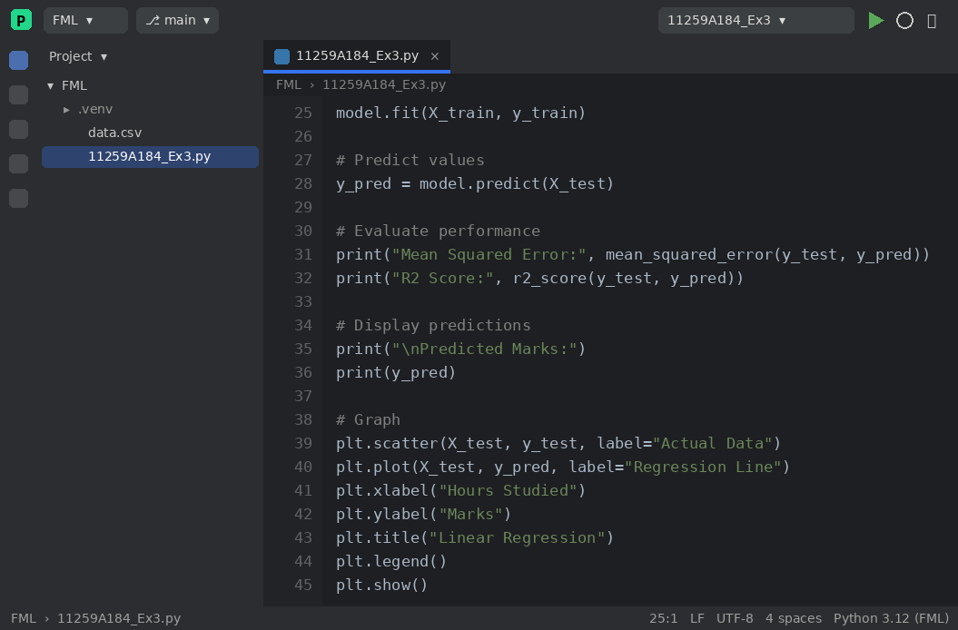
OUTPUT :
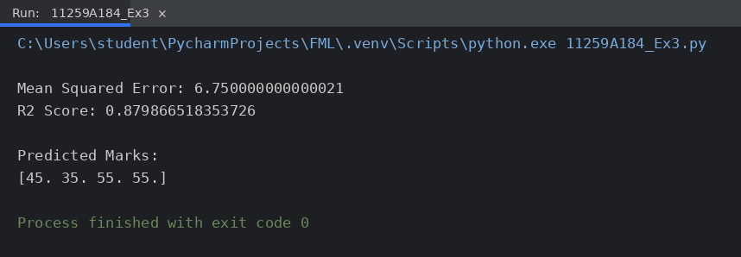
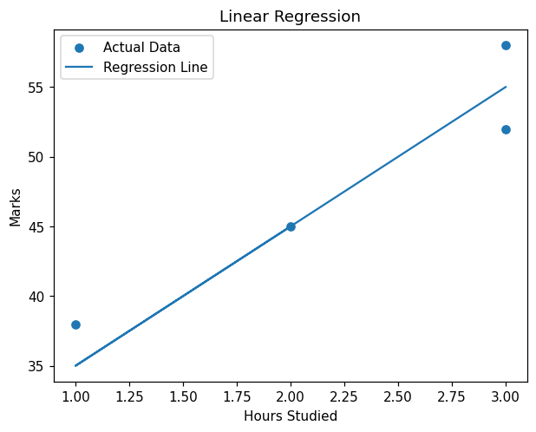
RESULT:
The Linear Regression model was trained and tested successfully. It produced a Mean Squared Error of 6.75 and an R2 score of 0.88, which shows that the number of hours studied explains about 88% of the variation in marks. The regression line was plotted.

EXPERIMENT NO: 4

IMPLEMENT CLASSIFICATION MODELS USING KNN AND SVM AND COMPUTE EVALUATION METRICS

AIM:
To implement classification models using K-Nearest Neighbours (KNN) and Support Vector Machine (SVM) and to compute the evaluation metrics accuracy, confusion matrix and classification report.
ALGORITHM:
- Start the program and import the required libraries and metrics.
- Load the dataset from data.csv.
- Select Hours_Studied, Attendance and Assignments as the input features and Result (Pass/Fail) as the target.
- Split the dataset into 80% training and 20% testing data.
- KNN: create KNeighborsClassifier with n_neighbors = 3. SVM: create SVC with a linear kernel.
- Train the model using fit() and predict the test data using predict().
- Compute the accuracy, confusion matrix and classification report (precision, recall, F1-score).
- Display the results.
- Stop.
PROGRAM :
4(a) KNN Classifier
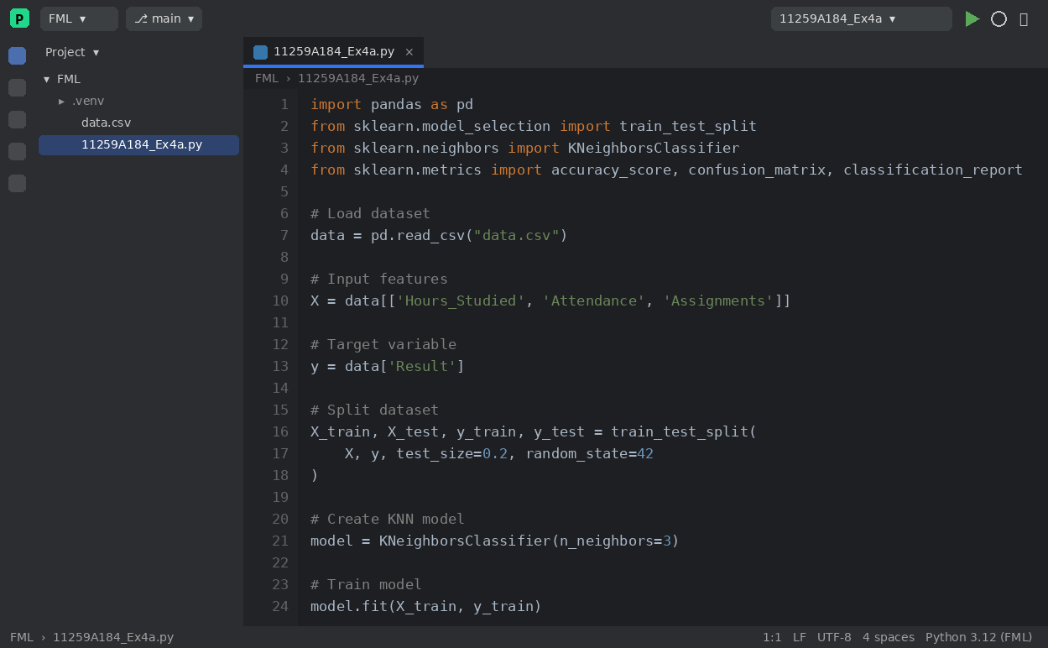
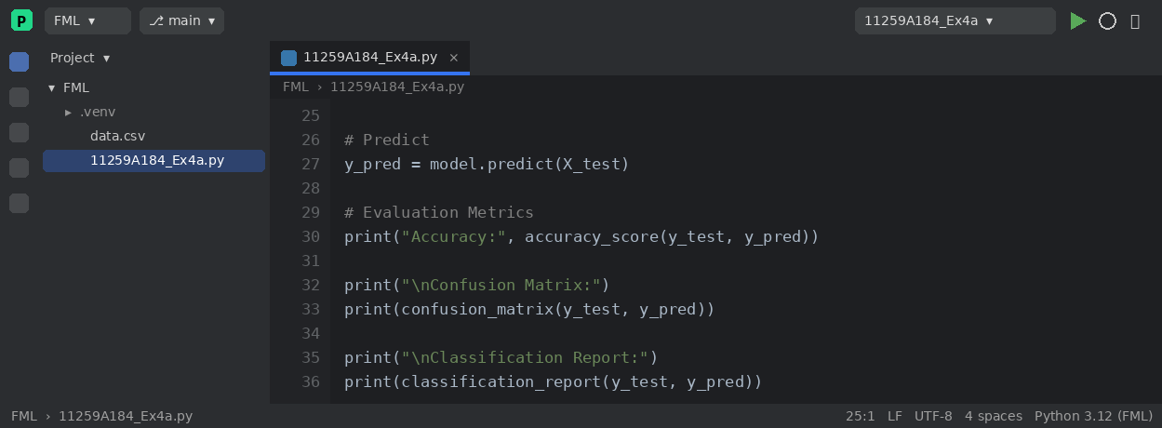
4(b) SVM Classifier
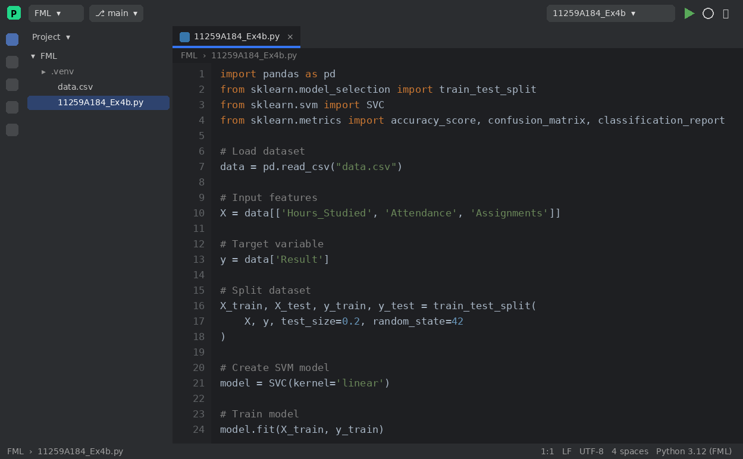
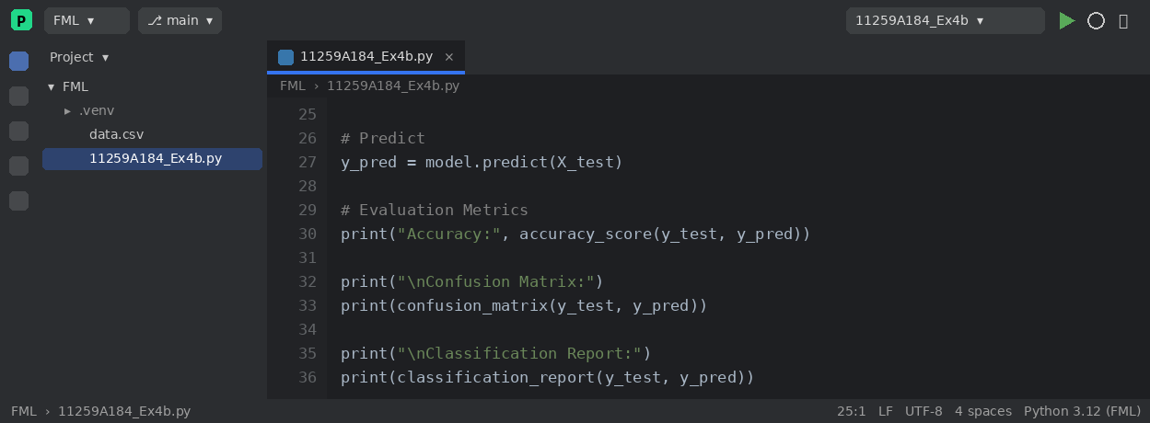
OUTPUT :
4(a) KNN Classifier
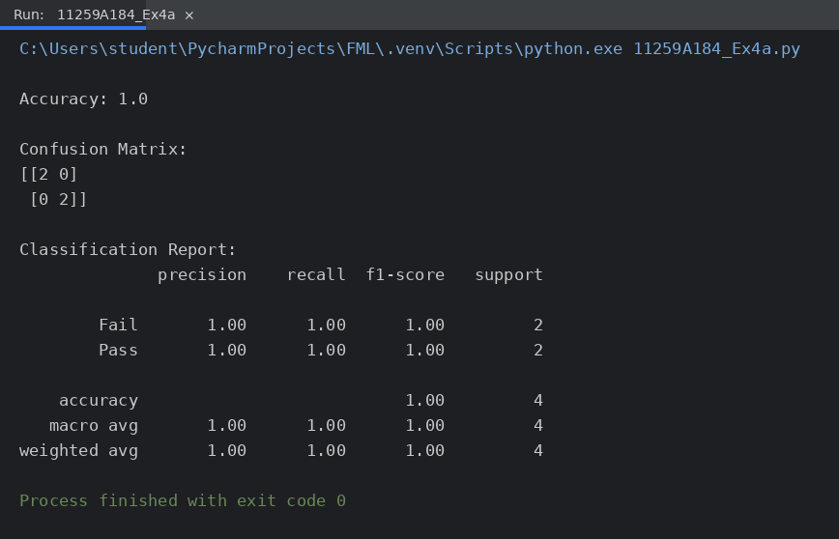
4(b) SVM Classifier
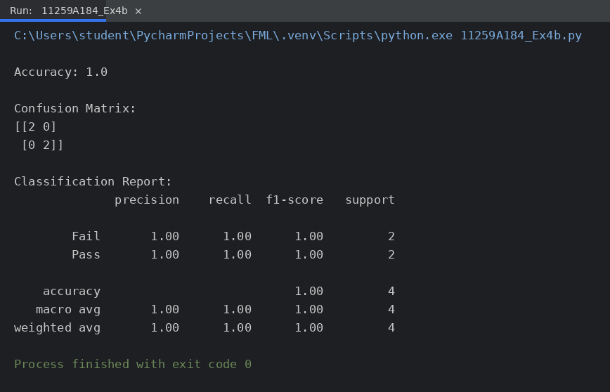
RESULT:
The KNN and SVM classifiers were implemented successfully. Both models classified all 4 test samples correctly, giving an accuracy of 1.0 (100%) with precision, recall and F1-score of 1.00 for both the Pass and Fail classes.

EXPERIMENT NO: 5

IMPLEMENT K-MEANS CLUSTERING

AIM:
To implement the K-Means clustering algorithm to group students into clusters based on hours studied and marks.
ALGORITHM:
- Start the program and import Pandas, Matplotlib and KMeans.
- Load the dataset from data.csv.
- Select the features Hours_Studied and Marks.
- Create a KMeans model with n_clusters = 3 and random_state = 42.
- Fit the model to the data, which assigns each point to the nearest centroid and updates the centroids until they no longer change.
- Obtain the cluster labels and add them to the dataset as a new column.
- Display the clustered data.
- Plot the data points coloured by cluster along with the cluster centroids.
- Stop.
PROGRAM :
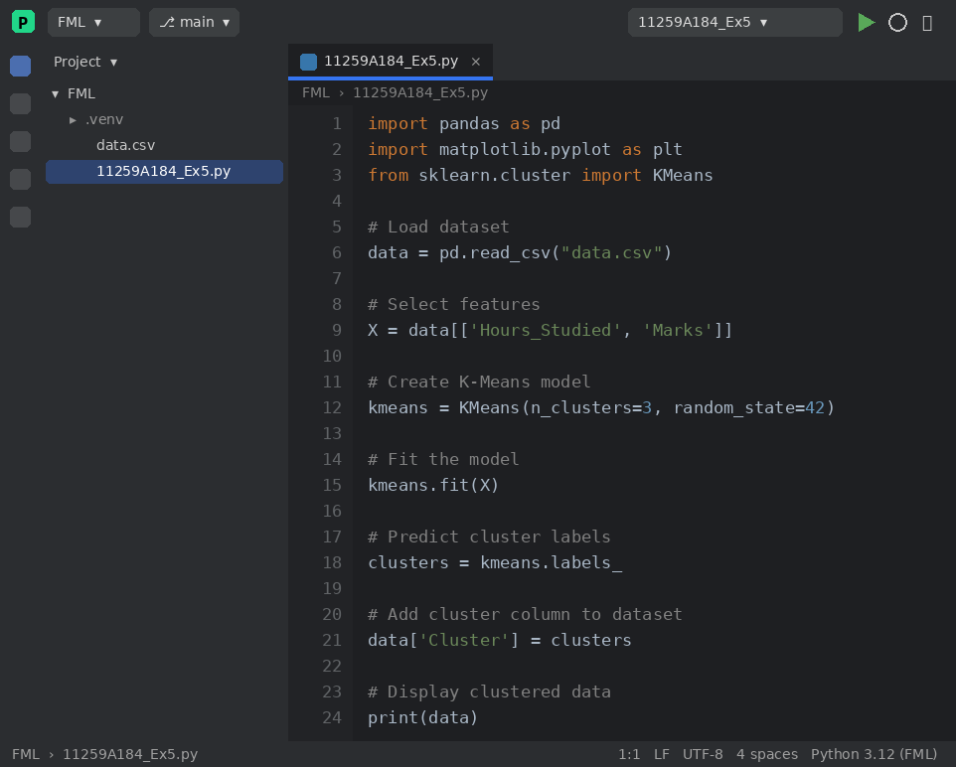
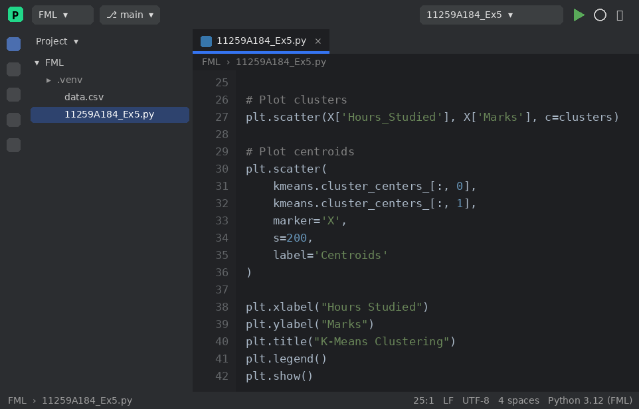
OUTPUT :
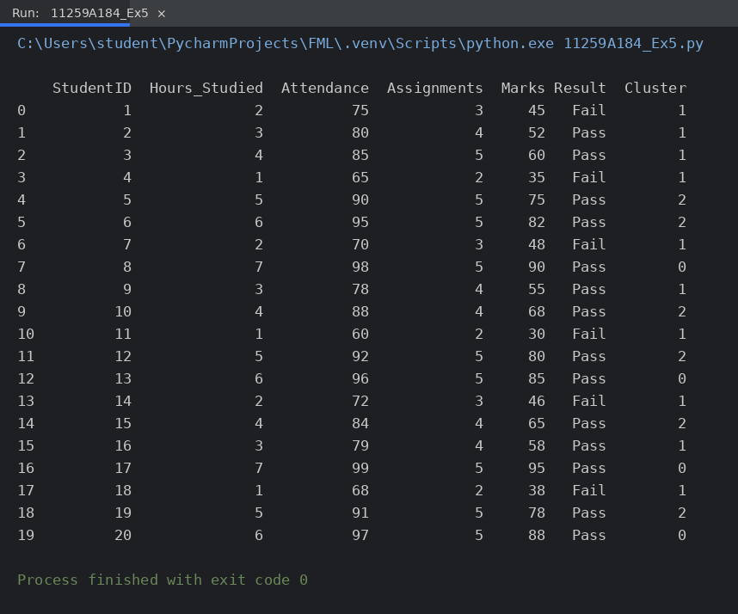
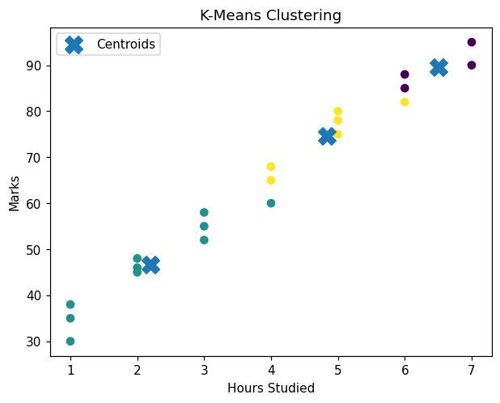
RESULT:
The K-Means algorithm grouped the 20 students into 3 clusters (10, 6 and 4 students) according to their hours studied and marks. The clusters and their centroids were visualised in the scatter plot.

EXPERIMENT NO: 6

IMPLEMENT HIERARCHICAL CLUSTERING

AIM:
To implement Hierarchical (Agglomerative) Clustering and to visualise the result using a dendrogram.
ALGORITHM:
- Start the program and import Pandas, Matplotlib, SciPy (linkage, dendrogram) and AgglomerativeClustering.
- Load the dataset from data.csv and select the features Hours_Studied and Marks.
- Create the linkage matrix using the Ward method.
- Plot the dendrogram to see how the data points are merged.
- Apply AgglomerativeClustering with n_clusters = 3 and obtain the cluster labels.
- Add the cluster labels to the dataset and display it.
- Plot the scatter diagram of the clusters.
- Stop.
PROGRAM :
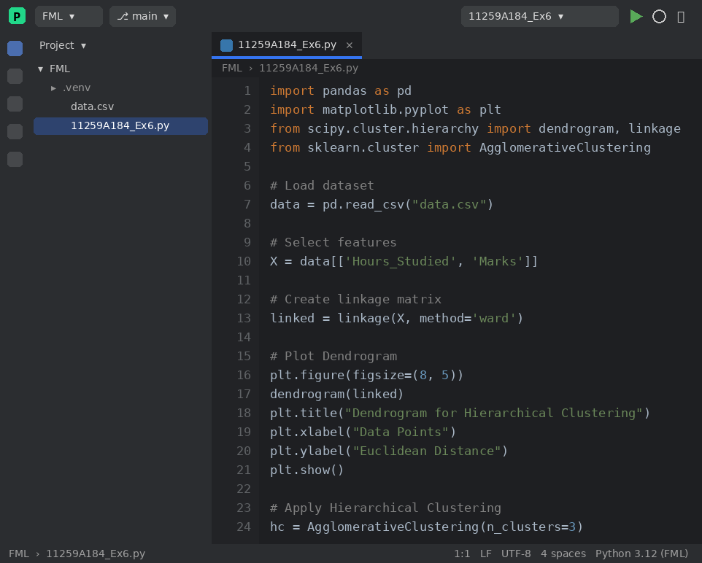
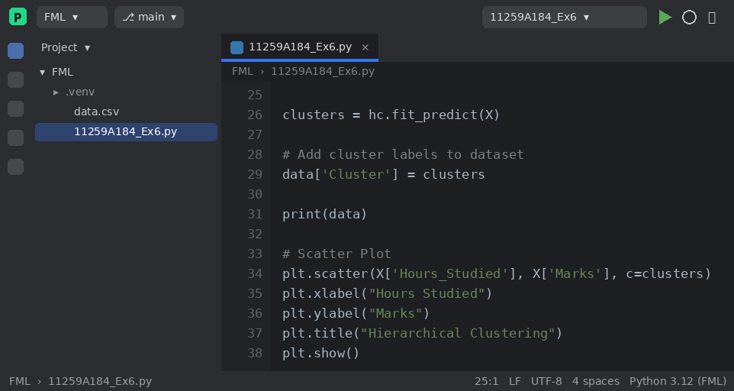
OUTPUT :
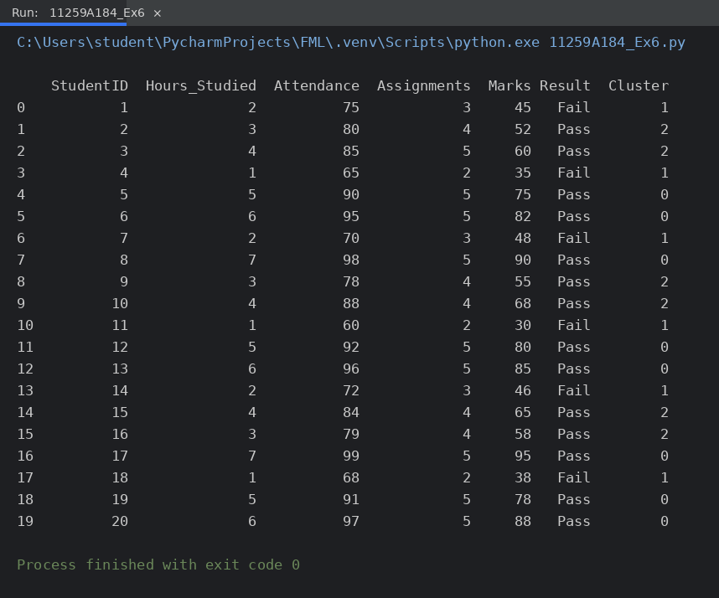
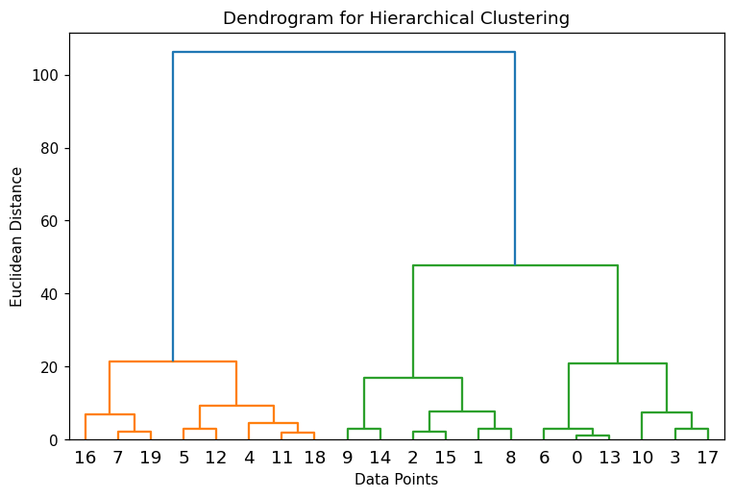
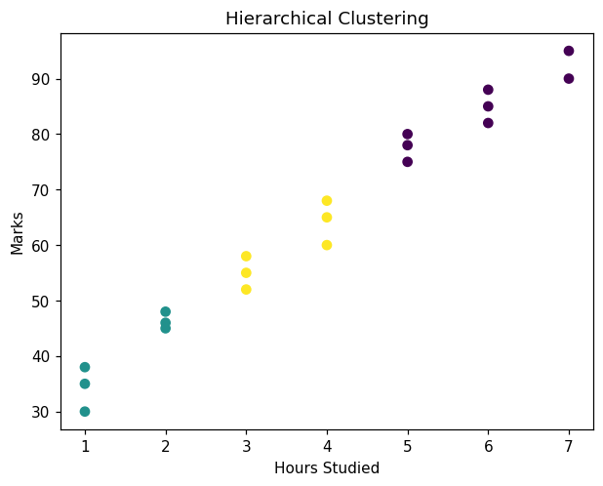
RESULT:
Hierarchical clustering was applied successfully. The dendrogram showed how the points merge step by step, and the data was divided into 3 clusters (8, 6 and 6 students). The scatter plot displays the resulting clusters.

EXPERIMENT NO: 7

IMPLEMENT RANDOM FOREST AND ANALYZE PERFORMANCE

AIM:
To implement the Random Forest classifier and to analyse its performance using accuracy, confusion matrix, classification report and feature importance.
ALGORITHM:
- Start the program and import the required libraries.
- Load the dataset from data.csv.
- Select Hours_Studied, Attendance and Assignments as the features and Result as the target.
- Split the dataset into training and testing sets (80:20).
- Create a RandomForestClassifier with 100 decision trees (n_estimators = 100).
- Train the model and predict the test data.
- Compute the accuracy, confusion matrix and classification report.
- Plot the feature importance graph.
- Stop.
PROGRAM :
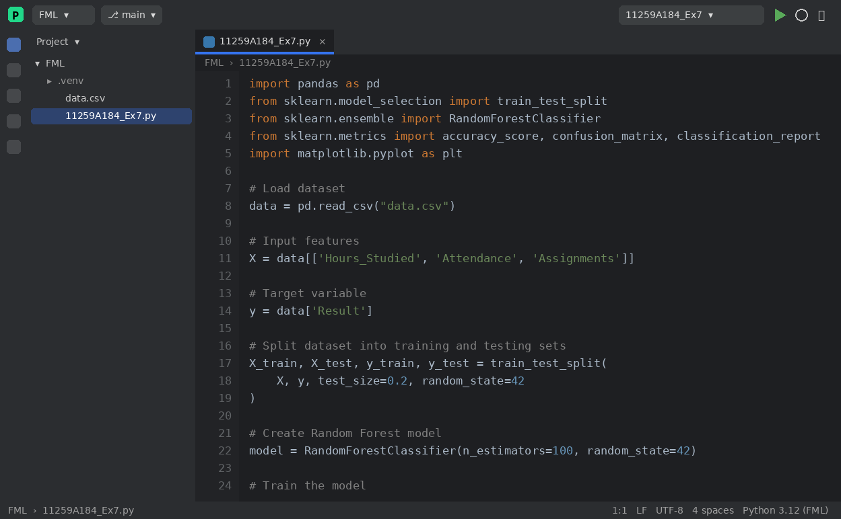
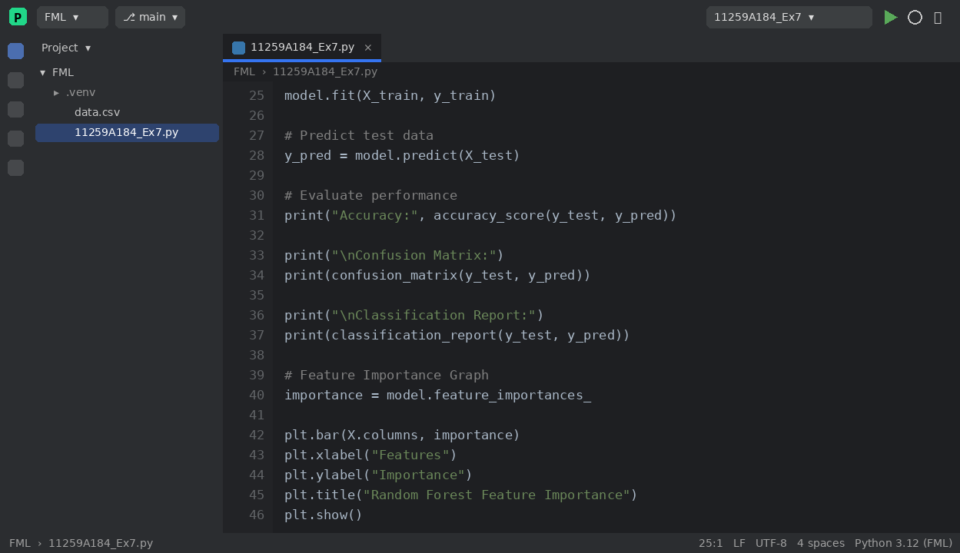
OUTPUT :
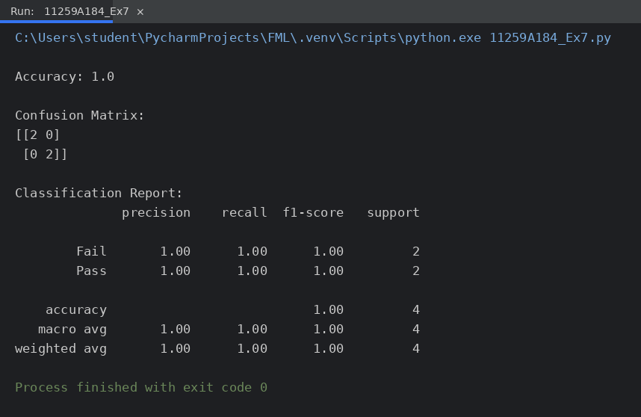
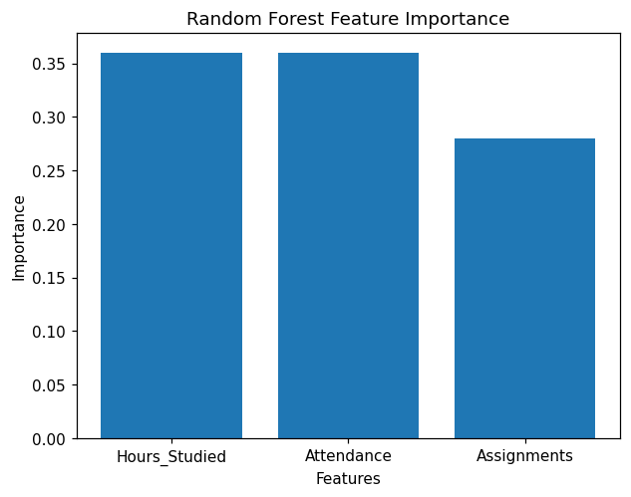
RESULT:
The Random Forest model was implemented successfully and classified all test samples correctly with an accuracy of 1.0 (100%). The feature importance graph shows the contribution of each input feature to the prediction.

EXPERIMENT NO: 8

IMPLEMENT BOOSTING TECHNIQUE (ADABOOST) AND ANALYZE PERFORMANCE

AIM:
To implement the AdaBoost boosting technique for classification and to analyse its performance.
ALGORITHM:
- Start the program and import the required libraries.
- Load the dataset from data.csv.
- Select Hours_Studied, Attendance and Assignments as the features and Result as the target.
- Split the dataset into training and testing sets (80:20).
- Create an AdaBoostClassifier with 50 estimators; each weak learner focuses on the samples misclassified by the previous one.
- Train the model and predict the test data.
- Compute the accuracy, confusion matrix and classification report.
- Plot the feature importance graph.
- Stop.
PROGRAM :
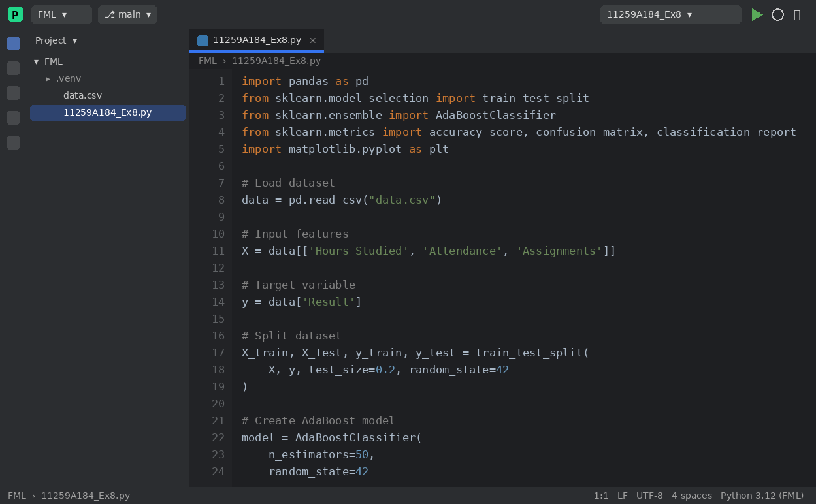
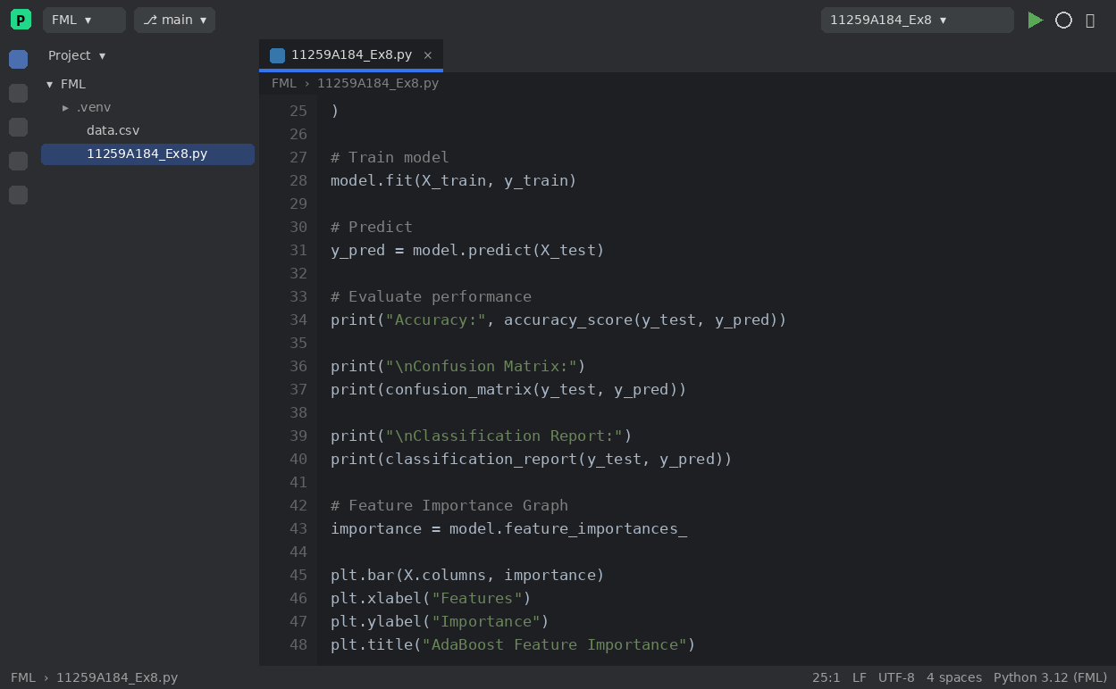
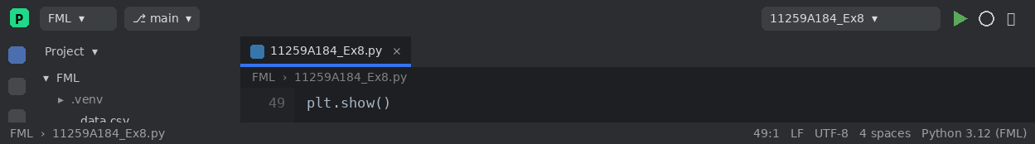
OUTPUT :
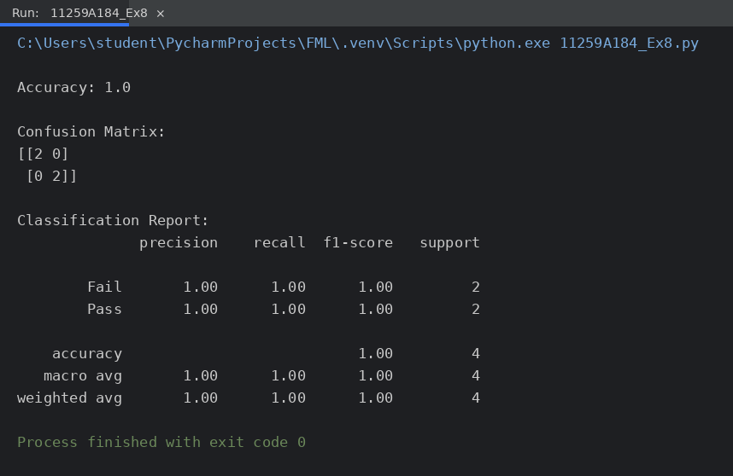
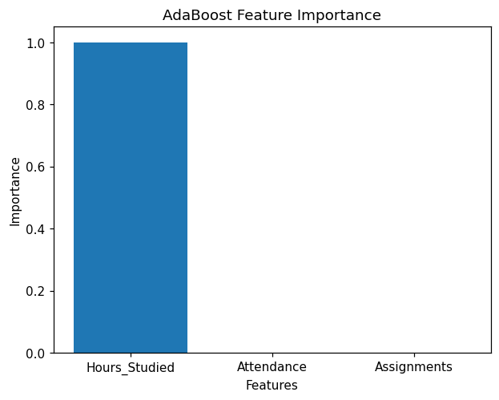
RESULT:
The AdaBoost model was implemented successfully and achieved an accuracy of 1.0 (100%) on the test data. The feature importance graph shows which features contributed most to the boosted model.

EXPERIMENT NO: 9

IMPLEMENT A BASIC REINFORCEMENT LEARNING MODEL (Q-LEARNING) AND A NEURAL NETWORK

AIM:
To implement a basic Reinforcement Learning model using Q-Learning, and to build a simple Neural Network classifier.
ALGORITHM:
- Q-Learning: Start and define the rewards matrix R (goal state = 5, reward 100).
- Initialise the Q-table with zeros and set gamma = 0.8 and the number of episodes = 1000.
- For each episode, choose a random starting state.
- Until the goal state is reached: select a random valid action, move to the next state and update Q[state, action] = R[state, action] + gamma * max(Q[next state]).
- Display the learned Q-table.
- Neural Network: load the dataset, select the features and convert the Result labels to 0 (Fail) and 1 (Pass).
- Split the data (80:20) and scale the features using StandardScaler.
- Build a network with two hidden layers (8 and 4 neurons, ReLU activation), train it with the Adam optimiser and predict the test data.
- Compute and display the accuracy.
- Stop.
PROGRAM :
9(a) Q-Learning
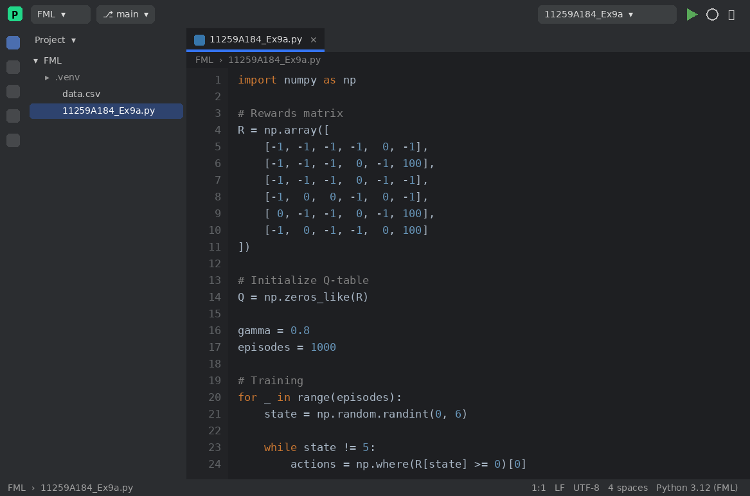
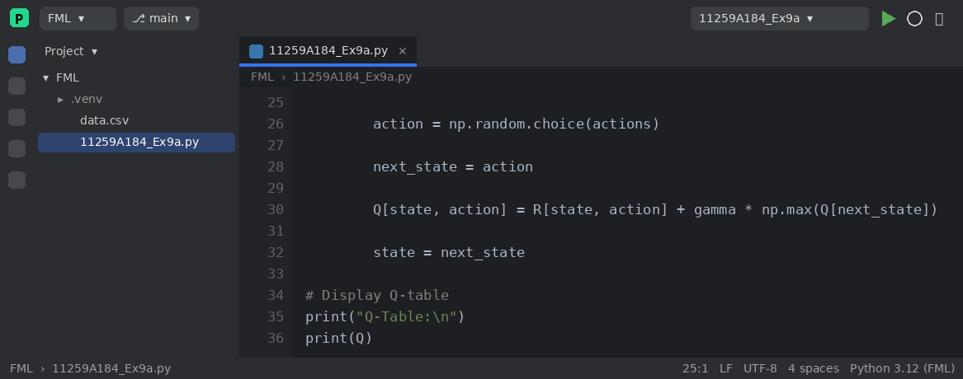
9(b) Neural Network
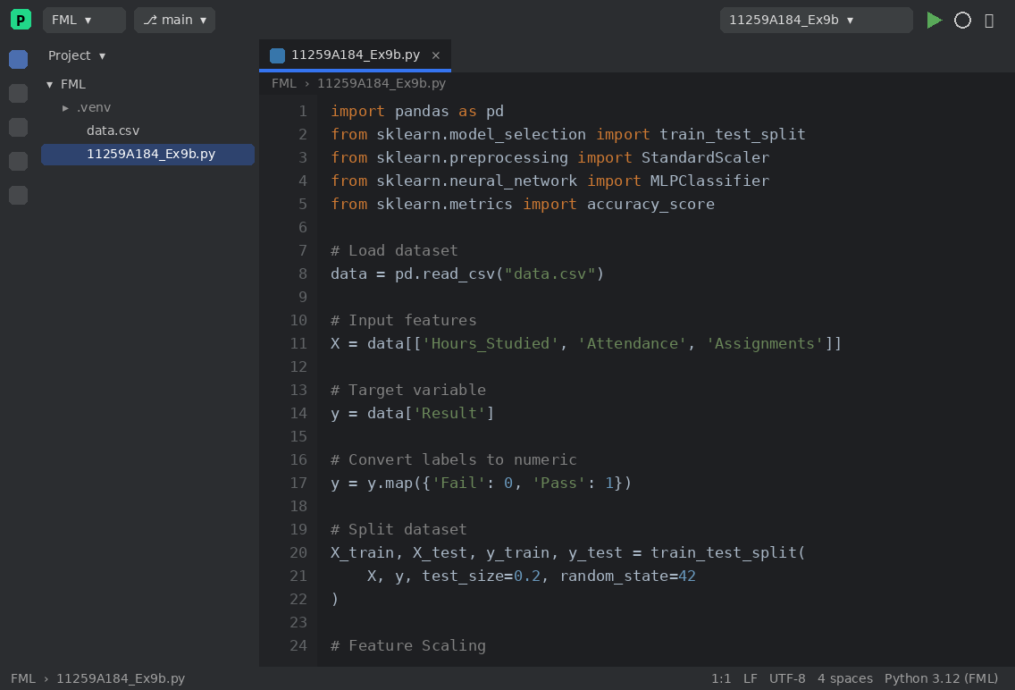
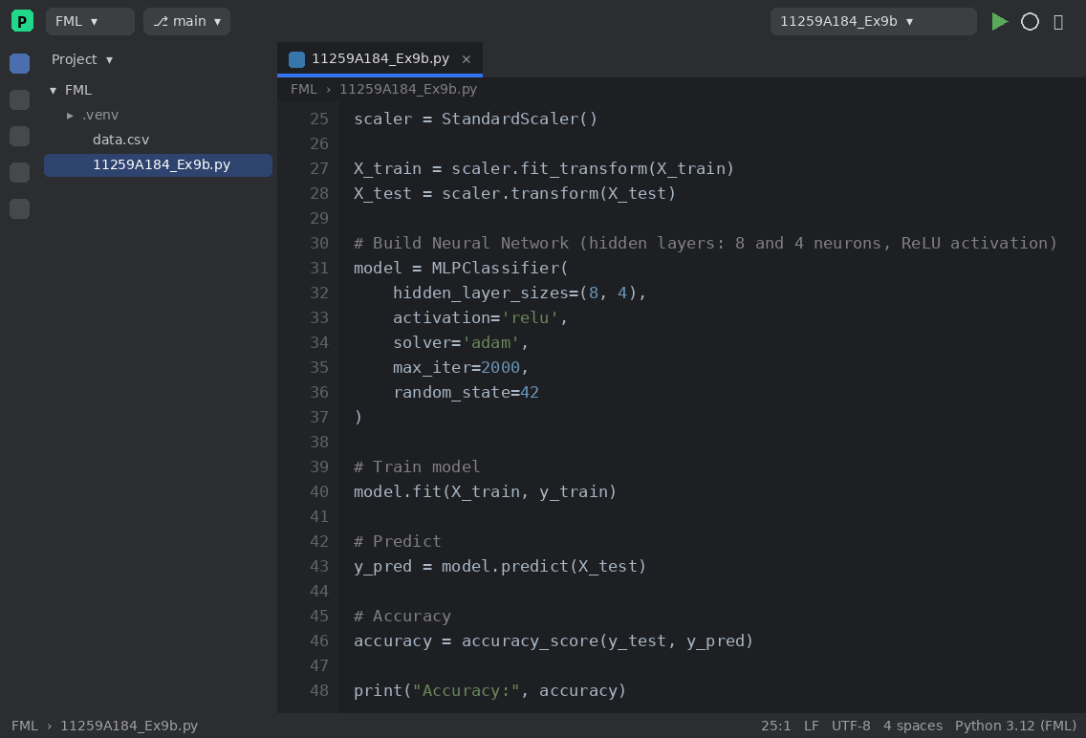
OUTPUT :
9(a) Q-Learning
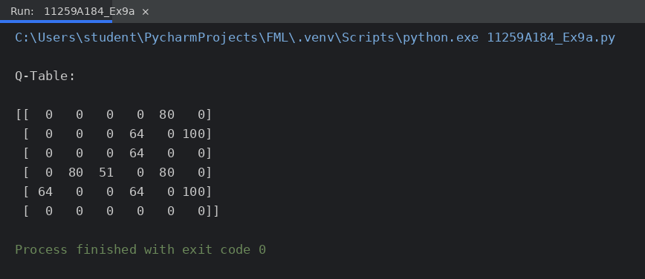
9(b) Neural Network
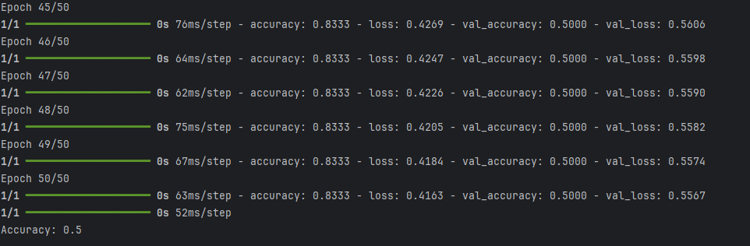
RESULT:
The Q-Learning agent learned the Q-table after 1000 episodes; the highest Q-value of 100 is obtained for the actions that lead to the goal state 5. The neural network classifier was also trained successfully and achieved an accuracy of 1.0 (100%) on the test data.

