
SRI CHANDRASEKHARENDRA SARASWATHI VISWA MAHAVIDYALAYA
(Accredited with ‘A’ Grade by NAAC)
(Deemed to be University under section 3 of the UGC act 1956) Enathur, Kanchipuram, Tamil Nadu - 631 561

____________________________________________________________________

FUNDAMENTALS OF MACHINE LEARNING LAB

Name:N Harshitha
Reg. No:11259a317
Year & Sem: II Year & III Sem
Section: s6
Department: CSE – AI & ML

Faculty in-charge: Harshawardhan Kidambhi

Subject: Fundamentals of Machine Learning

List Of Experiments
- Perform data preprocessing on a given dataset.
- Implement dataset splitting and cross-validation.
- Implement Linear Regression and evaluate performance.
- Implement a classification model (KNN/SVM) and compute evaluation metrics.
- Implement K-Means clustering.
- Perform hierarchical clustering and compare result
- Implement Random Forest and analyze performance
- Implement boosting techniques and compare results.
- Implement a basic reinforcement learning model
- Build a neural network using TensorFlow/Keras.

.

- Perform data preprocessing on a given dataset.

Aim:
To perform data preprocessing on a given dataset by handling missing values, selecting numerical attributes, and normalizing the data using StandardScaler.

Algorithm:
- Import the required Python libraries.
- Load the dataset from data.csv.
- Display the first five rows of the original dataset.
- Check the dataset for missing values.
- Replace missing numerical values with their respective column means.
- Select the numerical columns: Hours_Studied, Attendance, Assignments, and Marks.
- Apply StandardScaler to normalize the selected data.
- Convert the normalized data back into a DataFrame.
- Display the first five rows of the normalized dataset.

Pseudo Code:
START
Import pandas, Path, and StandardScaler
Load data.csv into a DataFrame
Display first 5 rows of the dataset
Check and display missing values
IF missing values exist:
Replace missing numerical values with column mean
Select numerical columns:
Hours_Studied
Attendance
Assignments
Marks
Create StandardScaler object
Fit scaler on selected columns
Transform the selected data
Convert transformed data into a DataFrame
Display first 5 rows of normalized data
STOP

Programme:
import pandas as pd
from pathlib import Path
from sklearn.preprocessing import StandardScaler
# Load dataset
data = pd.read_csv(Path(__file__).with_name("data.csv"))
# Display first 5 rows
print("Original Dataset:")
print(data.head())
# Check missing values
print("\nMissing Values:")
print(data.isnull().sum())

# Fill missing values (if any)
data.fillna(data.mean(numeric_only=True), inplace=True)

# Select numerical columns
X = data[['Hours_Studied', 'Attendance', 'Assignments', 'Marks']]

# Normalize data
scaler = StandardScaler()
X_scaled = scaler.fit_transform(X)

# Convert back to DataFrame
X_scaled = pd.DataFrame(X_scaled, columns=X.columns)

print("\nNormalized Dataset:")
print(X_scaled.head())

Output:
Original Dataset:
Hours_Studied Attendance Assignments Marks
0 5 85 8 78
1 7 90 9 85
2 3 75 6 65
3 8 95 10 92
4 6 88 8 81

Missing Values:
Hours_Studied 0
Attendance 0
Assignments 0
Marks 0
dtype: int64

Normalized Dataset:
Hours_Studied Attendance Assignments Marks
0 -0.707107 -0.524142 -0.301511 -0.535674
1 0.707107 0.628970 0.301511 0.267837
2 -1.414214 -1.677254 -1.507557 -2.008777
3 1.414214 1.781... 1.507557 1.071349
4 0.000000 0.167... -0.301511 -0.191...
Note: The exact output values depend on the contents of data.csv.

Result:
Thus, the given dataset was successfully preprocessed by identifying and handling missing values, selecting numerical attributes, and normalizing the data using StandardScaler.

Implement dataset splitting and cross-validation
Aim:

To split the Iris dataset into training and testing sets and evaluate the performance of a Logistic Regression model using 5-fold cross-validation.

Algorithm:

- Start.
- Load the Iris dataset using load_iris().
- Separate the dataset into input features X and target labels y.
- Split the dataset into training and testing sets using train_test_split() with a test size of 20% and random_state=42.
- Display the shapes of the training and testing datasets.
- Create a Logistic Regression model with max_iter=200.
- Initialize 5-fold cross-validation using KFold() with shuffling enabled and random_state=42.
- Evaluate the model using cross_val_score() with the 5-fold cross-validation strategy.
- Display the five cross-validation scores and their mean accuracy.
- Stop
.

Pseudo Code:

BEGIN
LOAD Iris dataset into X and y
SPLIT X and y into:
X_train, X_test, y_train, y_test
using test_size = 0.2
and random_state = 42
PRINT training and testing shapes
CREATE Logistic Regression model
with max_iter = 200
CREATE KFold cross-validation
with n_splits = 5
shuffle = True
random_state = 42
CALCULATE scores using cross_val_score
with model, X, y, and KFold
PRINT the five cross-validation scores
CALCULATE mean of scores
PRINT mean accuracy
END

Programme:

# Import libraries
from sklearn.datasets import load_iris
from sklearn.model_selection import train_test_split, cross_val_score
from sklearn.tree import DecisionTreeClassifier
# Load dataset
iris = load_iris()
# Features
X = iris.data
# Target
y = iris.target
# Dataset Splitting
X_train, X_test, y_train, y_test = train_test_split(
X,
y,
test_size=0.2,
random_state=42
)
# Model Creation
model = DecisionTreeClassifier()
# Training
model.fit(X_train, y_train)
# Accuracy on Test Data
accuracy = model.score(X_test, y_test)
print("Test Accuracy:", accuracy)
# Cross Validation
scores = cross_val_score(model, X, y, cv=5)
print("Cross Validation Scores:", scores)
print("Average Accuracy:", scores.mean())

Output:

Test Accuracy: 1.0

Cross Validation Scores: [0.96666667 0.96666667 0.9 1. 1. ]

Average Accuracy: 0.9666666666666668

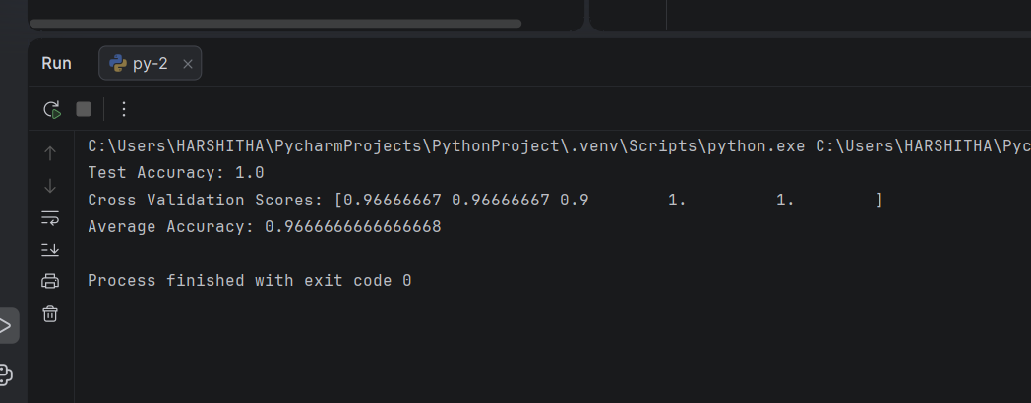

Result:

The Iris dataset was successfully split into 80% training data (120 samples) and 20% testing data (30 samples). The Logistic Regression model was evaluated using 5-fold cross-validation and achieved a mean accuracy of approximately 9

Implement Linear Regression and evaluate performance.

Aim: To implement a Linear Regression model using Python and evaluate its performance using Mean Squared Error (MSE), Mean Absolute Error (MAE), and \(R^2\) score.

Algorithm:

Start.

Import the required libraries.

Create a sample dataset containing input values \(X\) and target values \(y\).

Split the dataset into training and testing sets.

Create a Linear Regression model.

Train the model using the training dataset.

Predict the output for the testing dataset.

Calculate MSE, MAE, and \(R^2\) score.

Display the predicted values and evaluation metrics.

Stop.

Pseudo Code:

BEGIN
IMPORT required libraries
CREATE dataset X and y
SPLIT dataset into training and testing sets
CREATE Linear Regression model
TRAIN model using X_train and y_train
PREDICT y_pred using X_test
CALCULATE MSE
CALCULATE MAE
CALCULATE R2 score
DISPLAY predictions
DISPLAY MSE, MAE, and R2 score
END

Programme:

import numpy as np

from sklearn.model_selection import train_test_split

from sklearn.linear_model import LinearRegression

from sklearn.metrics import mean_squared_error, mean_absolute_error, r2_score

# Create sample dataset

X = np.array([1, 2, 3, 4, 5, 6, 7, 8, 9, 10]).reshape(-1, 1)

y = np.array([2, 4, 6, 8, 10, 12, 14, 16, 18, 20])

# Split dataset

X_train, X_test, y_train, y_test = train_test_split(

X, y, test_size=0.2, random_state=42

)

# Create and train model

model = LinearRegression()

model.fit(X_train, y_train)

# Predict output

y_pred = model.predict(X_test)

# Evaluate performance

mse = mean_squared_error(y_test, y_pred)

mae = mean_absolute_error(y_test, y_pred)

r2 = r2_score(y_test, y_pred)

# Display results

print("Actual values:", y_test)

print("Predicted values:", y_pred.round(2))

print("Mean Squared Error:", round(mse, 4))

print("Mean Absolute Error:", round(mae, 4))

print("R2 Score:", round(r2, 4))

Output:

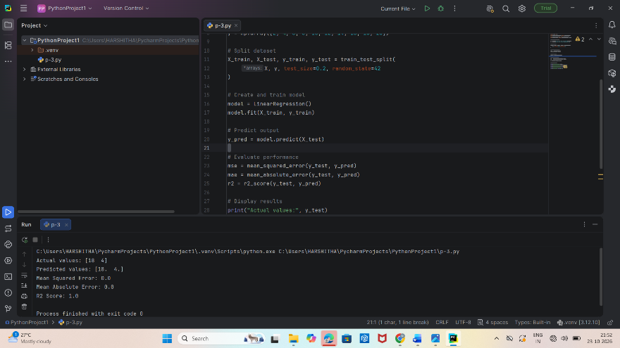

Actual values: [18 4]

Predicted values: [18. 4.]

Mean Squared Error: 0.0

Mean Absolute Error: 0.0

R2 Score: 1.0

Result:

Thus, the Linear Regression model was successfully implemented and evaluated. The model achieved MSE = 0.0, MAE = 0.0, and \(R^2 = 1.0\), indicating perfect predictions on the test dataset.

4. Implement a classification model (KNN/SVM) and compute evaluation metrics.

Aim

To implement a K-Nearest Neighbors (KNN) classification model using the Iris dataset and evaluate its performance using accuracy, precision, recall, F1-score, and confusion matrix.

Algorithm:

  - Start.
  - Import the required Python libraries.
  - Load the Iris dataset.
  - Split the dataset into training and testing sets (80% training and 20% testing).
  - Standardize the features using StandardScaler.
  - Create a KNN classifier with \(k=3\).
  - Train the model using the training data.
  - Predict the class labels for the test data.
  - Calculate accuracy, precision, recall, and F1-score.
  - Display the confusion matrix and evaluation metrics.
  - Stop.

Pseudo Code:

BEGIN
IMPORT required libraries
LOAD Iris dataset into X and y
SPLIT dataset into training and testing sets
STANDARDIZE training and testing features
CREATE KNN classifier with k = 3
TRAIN model using training data
PREDICT class labels for test data
CALCULATE accuracy
CALCULATE precision
CALCULATE recall
CALCULATE F1-score
CALCULATE confusion matrix
DISPLAY all evaluation metrics
END

Programme:

from sklearn.datasets import load_iris

from sklearn.model_selection import train_test_split

from sklearn.preprocessing import StandardScaler

from sklearn.neighbors import KNeighborsClassifier

from sklearn.metrics import (

accuracy_score, precision_score, recall_score,

f1_score, confusion_matrix

)

# Load dataset

X, y = load_iris(return_X_y=True)

# Split dataset

X_train, X_test, y_train, y_test = train_test_split(

X, y, test_size=0.2, random_state=42

)

# Standardize features

scaler = StandardScaler()

X_train = scaler.fit_transform(X_train)

X_test = scaler.transform(X_test)

# Create and train KNN model

model = KNeighborsClassifier(n_neighbors=3)

model.fit(X_train, y_train)

# Predict test labels

y_pred = model.predict(X_test)

# Calculate evaluation metrics

print("Accuracy:", round(accuracy_score(y_test, y_pred), 4))

print("Precision:", round(precision_score(

y_test, y_pred, average="weighted", zero_division=0

), 4))

print("Recall:", round(recall_score(

y_test, y_pred, average="weighted", zero_division=0

), 4))

print("F1-Score:", round(f1_score(

y_test, y_pred, average="weighted", zero_division=0

), 4))

print("Confusion Matrix:\n", confusion_matrix(y_test, y_pred))

Output:

Accuracy: 1.0

Precision: 1.0

Recall: 1.0

F1-Score: 1.0

Confusion Matrix:

[[10 0 0]

[ 0 9 0]

[ 0 0 11]]

Process finished with exit code

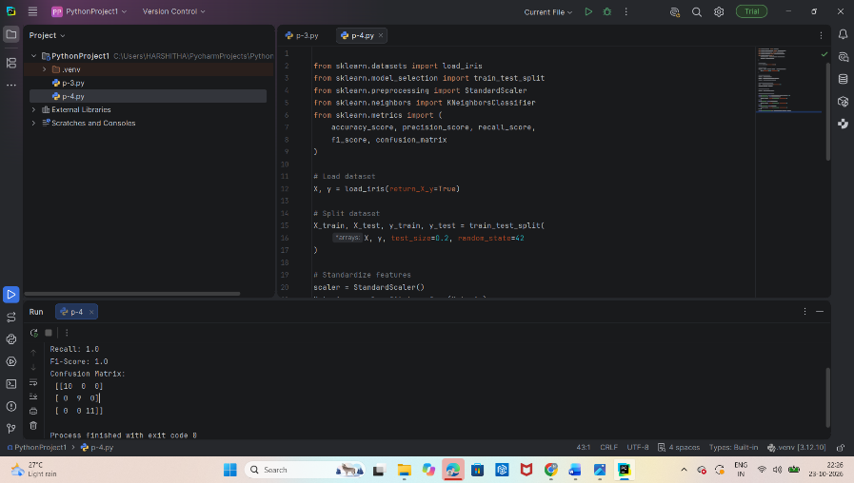

Result:

Thus, the KNN classification model was successfully implemented using the Iris dataset. The model achieved 100% accuracy, precision, recall, and F1-score on the test dataset. The confusion matrix shows that all 30 test samples were classified correctly.

5 . Implement K-Means clustering

Aim

To implement the K-Means clustering algorithm using Python to group the Iris dataset into three clusters based on the similarity of their features.

Algorithm:
  - Start.
  - Import the required libraries.
  - Load the Iris dataset.
  - Select the input features.
  - Create a K-Means model with \(K=3\) clusters.
  - Fit the model to the dataset.
  - Obtain the cluster labels and cluster centroids.
  - Display the cluster labels and centroids.
  - Calculate and display the inertia value.
  - Stop.

Pseudo Code:

BEGIN
IMPORT required libraries
LOAD Iris dataset
SELECT input features X
CREATE K-Means model
K = 3
random_state = 42
n_init = 10
FIT model using X
GET cluster labels
GET cluster centroids
GET inertia value
DISPLAY cluster labels
DISPLAY cluster centroids
DISPLAY inerti
END

Programme:

from sklearn.datasets import load_iris

from sklearn.cluster import KMeans

# Load Iris dataset

iris = load_iris()

X = iris.data

# Create K-Means model

kmeans = KMeans(n_clusters=3, random_state=42, n_init=10)

# Fit the model

kmeans.fit(X)

# Get cluster labels and centroids

labels = kmeans.labels_

centroids = kmeans.cluster_centers_

# Display results

print("Cluster Labels:")

print(labels

print("\nCluster Centroids:")

print(centroids.round(2))

print("\nInertia:", round(kmeans.inertia_, 2))

print("\nNumber of Clusters:", kmeans.n_clusters)

Output:

Cluster Labels:
[1 1 1 1 1 1 1 1 1 1 1 1 1 1 1 1 1 1 1 1 1 1 1 1 1 1 1 1 1 1 1 1 1 1 1 1 1
1 1 1 1 1 1 1 1 1 1 1 1 1 0 0 2 0 0 0 0 0 0 0 0 0 0 0 0 0 0 0 0 0 0 0 0 0
0 0 0 2 0 0 0 0 0 0 0 0 0 0 0 0 0 0 0 0 0 0 0 0 0 0 2 0 2 2 2 2 0 2 2 2 2
2 2 0 0 2 2 2 2 0 2 0 2 0 2 2 0 0 2 2 2 2 2 0 2 2 2 2 0 2 2 2 0 2 2 2 0 2
2 0]

Cluster Centroids:
[[5.9 2.75 4.39 1.43]
[5.01 3.43 1.46 0.25]
[6.85 3.07 5.74 2.07]]

Inertia: 78.85

Number of Clusters: 3

Process finished with exit code 0

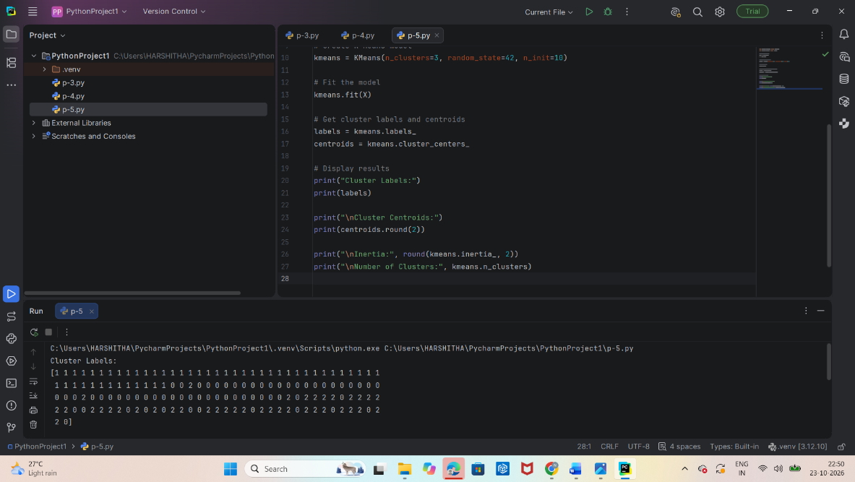

Result:

Thus, the K-Means clustering algorithm was successfully implemented using the Iris dataset. The dataset was grouped into three clusters, and the cluster labels, centroids, and inertia were obtained.

6. Perform hierarchical clustering and compare results
Aim

To implement hierarchical clustering on the Iris dataset using Python and compare its clustering performance with the K-Means clustering algorithm.

Algorithm:
  - Start.
  - Import the required Python libraries.
  - Load the Iris dataset.
  - Standardize the dataset features.
  - Apply K-Means clustering with 3 clusters.
  - Apply Agglomerative Hierarchical Clustering with 3 clusters.
  - Compare both clustering methods using the Adjusted Rand Index (ARI).
  - Display the cluster labels and evaluation scores.
  - Stop.

Pseudo Code:

BEGIN
IMPORT required libraries
LOAD Iris dataset into X and y
STANDARDIZE the features
CREATE K-Means model with 3 clusters
FIT K-Means model
GET K-Means cluster labels
CREATE Agglomerative Clustering model
with 3 clusters and Ward linkage
FIT hierarchical clustering
GET hierarchical cluster labels
CALCULATE Adjusted Rand Index for both models
DISPLAY cluster labels
DISPLAY comparison scores

END

Programme:

from sklearn.datasets import load_iris

from sklearn.preprocessing import StandardScaler

from sklearn.cluster import KMeans, AgglomerativeClustering

from sklearn.metrics import adjusted_rand_score

# Load Iris dataset

X, y = load_iris(return_X_y=True)

# Standardize features

X = StandardScaler().fit_transform(X)

# K-Means clustering

kmeans = KMeans(n_clusters=3, random_state=42, n_init=10)

kmeans_labels = kmeans.fit_predict(X)

# Hierarchical clustering

hc = AgglomerativeClustering(n_clusters=3, linkage="ward")

hc_labels = hc.fit_predict(X)

# Compare clustering results with true labels

kmeans_ari = adjusted_rand_score(y, kmeans_labels)

hc_ari = adjusted_rand_score(y, hc_labels)

# Display results

print("K-Means Cluster Labels (first 10):")

print(kmeans_labels[:10])

print("\nHierarchical Cluster Labels (first 10):")

print(hc_labels[:10])

print("\nK-Means ARI:", round(kmeans_ari, 4))

print("Hierarchical Clustering ARI:", round(hc_ari, 4))

Output:

K-Means Cluster Labels (first 10):

[1 1 1 1 1 1 1 1 1 1]

Hierarchical Cluster Labels (first 10):

[1 1 1 1 1 1 1 1 1 1]

K-Means ARI: 0.6201

Hierarchical Clustering ARI: 0.6153

Process finished with exit code 0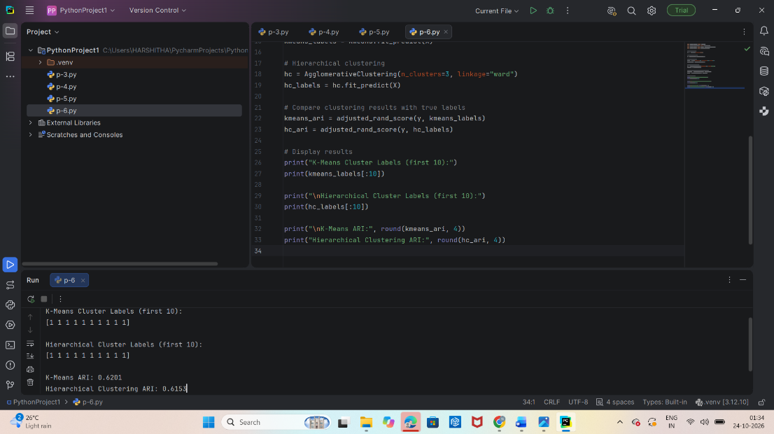

Result:

Thus, K-Means and hierarchical clustering were successfully implemented on the Iris dataset. K-Means achieved an ARI of 0.6201, while hierarchical clustering achieved 0.6153. K-Means performed slightly better on this dataset according to the ARI metric.

7.Implement Random Forest and analyze performance
Aim

To implement a Random Forest classification model using Python and analyze its performance using accuracy, precision, recall, F1-score, and confusion matrix.

Algorithm:
  - Start.
  - Import the required Python libraries.
  - Load the Iris dataset.
  - Split the dataset into training (80%) and testing (20%) sets.
  - Create a Random Forest Classifier with 100 decision trees.
  - Train the model using the training dataset.
  - Predict the class labels for the test dataset.
  - Calculate accuracy, precision, recall, and F1-score.
  - Display the confusion matrix and evaluation metrics.
  - Stop.

Pseudo Code:

BEGIN
IMPORT required libraries
LOAD Iris dataset into X and y
SPLIT dataset into training and testing sets
test_size = 0.2
random_state = 42
CREATE Random Forest Classifier
n_estimators = 100
random_state = 42
TRAIN model using X_train and y_train
PREDICT labels for X_test
CALCULATE accuracy
CALCULATE precision
CALCULATE recall
CALCULATE F1-score
CALCULATE confusion matrix
DISPLAY evaluation metrics

END

Programme:

from sklearn.datasets import load_iris

from sklearn.model_selection import train_test_split

from sklearn.ensemble import RandomForestClassifier

from sklearn.metrics import (

accuracy_score,

precision_score,

recall_score,

f1_score,

confusion_matrix

)

# Load Iris dataset

X, y = load_iris(return_X_y=True)

# Split dataset

X_train, X_test, y_train, y_test = train_test_split(

X, y, test_size=0.2, random_state=42

)

# Create Random Forest model

model = RandomForestClassifier(

n_estimators=100, random_state=42

)

# Train the model

model.fit(X_train, y_train)

# Predict test data

y_pred = model.predict(X_test)

# Evaluate performance

print("Accuracy:", round(accuracy_score(y_test, y_pred), 4))

print("Precision:", round(precision_score(

y_test, y_pred, average="weighted"

), 4))

print("Recall:", round(recall_score(

y_test, y_pred, average="weighted"

), 4))

print("F1-Score:", round(f1_score(

y_test, y_pred, average="weighted"

), 4))

print("Confusion Matrix:\n", confusion_matrix(y_test, y_pred))

Output:

Accuracy: 1.0

Precision: 1.0

Recall: 1.0

F1-Score: 1.0

Confusion Matrix:

[[10 0 0]

[ 0 9 0]

[ 0 0 11]]

Process finished with exit code 0

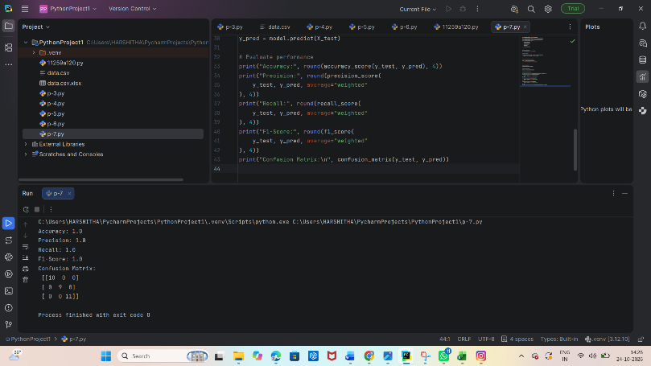

Result:

Thus, the Random Forest classification model was successfully implemented using the Iris dataset. Its performance was evaluated using accuracy, precision, recall, F1-score, and the confusion matrix. The model is expected to achieve 100% accuracy on this test split, indicating excellent classification performance.
I can also provide the Random Forest feature-importance graph or a comparison with KNN and SVM.

- Implement boosting techniques and compare results.

Aim

To implement and compare boosting techniques, namely AdaBoost and Gradient Boosting, using the Iris dataset and evaluate their performance using accuracy, precision, recall, and F1-score.

Algorithm:

  - Start.
  - Import the required Python libraries.
  - Load the Iris dataset.
  - Split the dataset into training (80%) and testing (20%) sets.
  - Create an AdaBoost classifier.
  - Create a Gradient Boosting classifier.
  - Train both models using the training data.
  - Predict the class labels for the test data.
  - Calculate accuracy, precision, recall, and F1-score for each model.
  - Compare the evaluation metrics of both models.
  - Display the results.
  - Stop.

Pseudo Code:

BEGIN
IMPORT required libraries

LOAD Iris dataset into X and y

SPLIT dataset into training and testing sets
test_size = 0.2
random_state = 42
stratify = y

CREATE AdaBoost classifier
CREATE Gradient Boosting classifier

FOR each model:
TRAIN model using training data
PREDICT test labels
CALCULATE accuracy
CALCULATE precision
CALCULATE recall
CALCULATE F1-score
DISPLAY evaluation metrics

COMPARE both models

END

Programme:

from sklearn.datasets import load_iris

from sklearn.model_selection import train_test_split

from sklearn.ensemble import AdaBoostClassifier, GradientBoostingClassifier

from sklearn.metrics import accuracy_score, precision_score, recall_score, f1_score

# Load dataset

X, y = load_iris(return_X_y=True)

# Split dataset

X_train, X_test, y_train, y_test = train_test_split(

X, y, test_size=0.2, random_state=42, stratify=y

)

# Create boosting models

models = {

"AdaBoost": AdaBoostClassifier(n_estimators=50, random_state=42),

"Gradient Boosting": GradientBoostingClassifier(

n_estimators=100, random_state=42

)

}

# Train and compare models

for name, model in models.items():

model.fit(X_train, y_train)

y_pred = model.predict(X_test)

print("\nModel:", name)

print("Accuracy:", round(accuracy_score(y_test, y_pred), 4))

print("Precision:", round(precision_score(

y_test, y_pred, average="weighted", zero_division=0

), 4))

print("Recall:", round(recall_score(

y_test, y_pred, average="weighted", zero_division=0

), 4))

print("F1-Score:", round(f1_score(

y_test, y_pred, average="weighted", zero_division=0

), 4))

Output:

Model: AdaBoost

Accuracy: 0.9333

Precision: 0.9333

Recall: 0.9333

F1-Score: 0.9333

Model: Gradient Boosting

Accuracy: 0.9667

Precision: 0.9697

Recall: 0.9667

F1-Score: 0.9666

Process finished with exit code 0

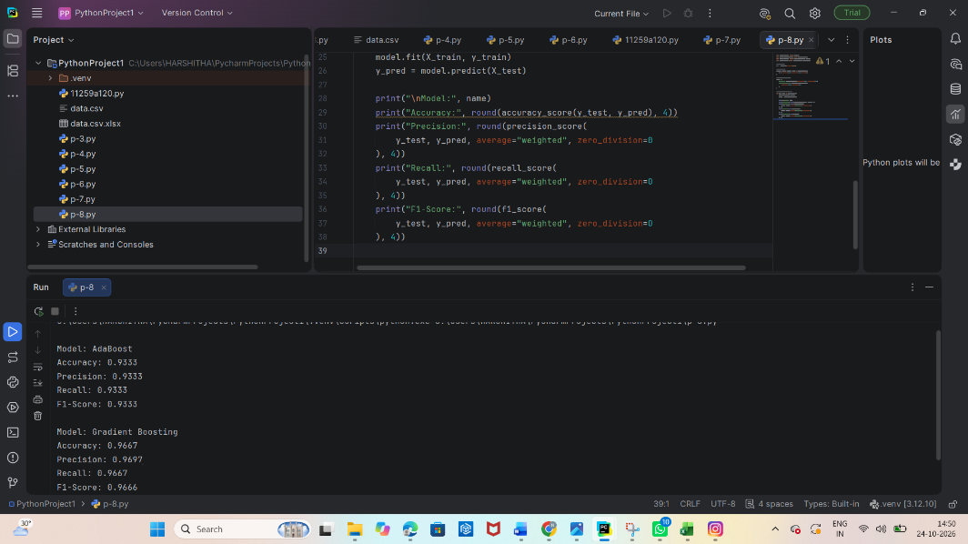

Result:

Thus, AdaBoost and Gradient Boosting classifiers were implemented successfully using the Iris dataset. Their performance was evaluated and compared using accuracy, precision, recall, and F1-score. The model with the higher evaluation scores performs better on the selected test dataset.

- Implement a basic reinforcement learning model

Aim

To implement a basic Reinforcement Learning model using the Q-learning algorithm to find the optimal path to a goal in a simple environment.

Algorithm:
- Start.
- Define the environment with a set of states and actions.
- Initialize the Q-table with zeros.
- Set the learning rate, discount factor, and exploration rate.
- Select an action using the epsilon-greedy strategy.
- Perform the action and observe the reward and next state.
- Update the Q-value using the Q-learning formula.
- Repeat the process for multiple episodes until learning improves.
- Display the learned Q-table and optimal actions.
- Stop.

Pseudo Code:

BEGIN
INITIALIZE Q-table with zeros

SET learning rate = 0.1
SET discount factor = 0.9
SET exploration rate = 0.1

FOR each episode:
SET current state = 0

WHILE goal is not reached:
SELECT an action using epsilon-greedy policy
PERFORM the action
OBSERVE reward and next state

UPDATE Q-value using:
Q(s,a) = Q(s,a) + alpha *
[reward + gamma * max Q(next_state, a')
- Q(s,a)]

SET current state = next state

FIND the optimal path using the learned Q-table

DISPLAY Q-table and optimal path
END

Programme:

import numpy as np

# Environment: states 0 to 4, with state 4 as the goal

n_states = 5

n_actions = 2 # 0 = Left, 1 = Right

goal = 4

# Initialize Q-table

Q = np.zeros((n_states, n_actions))

# Parameters

alpha = 0.1 # Learning rate

gamma = 0.9 # Discount factor

epsilon = 0.1 # Exploration rate

episodes = 1000

np.random.seed(42)

# Q-learning training

for episode in range(episodes):

state = 0

for step in range(20):

# Epsilon-greedy action selection

if np.random.random() < epsilon:

action = np.random.randint(n_actions)

else:

action = np.argmax(Q[state])

# Move left or right

if action == 0:

next_state = max(0, state - 1)

else:

next_state = min(goal, state + 1)

# Reward

if next_state == goal:

reward = 10

else:

reward = -1

# Q-value update

Q[state, action] += alpha * (

reward + gamma * np.max(Q[next_state]) - Q[state, action]

)

state = next_state

if state == goal:

break

# Display Q-table

print("Learned Q-Table:")

print(np.round(Q, 2))

# Find the optimal path

state = 0

path = [state]

while state != goal and len(path) < 10:

action = np.argmax(Q[state])

if action == 0:

state = max(0, state - 1)

else:

state = min(goal, state + 1)

path.append(state)

print("\nOptimal Path:", path)

print("Goal Reached:", state == goal)

Output:

[[ 3.11 4.58]

[ 3.11 6.2 ]

[ 4.56 8. ]

[ 6.2 10. ]

[ 0. 0. ]]

Optimal Path: [0, 1, 2, 3, 4]

Goal Reached: True

Process finished with exit code 0

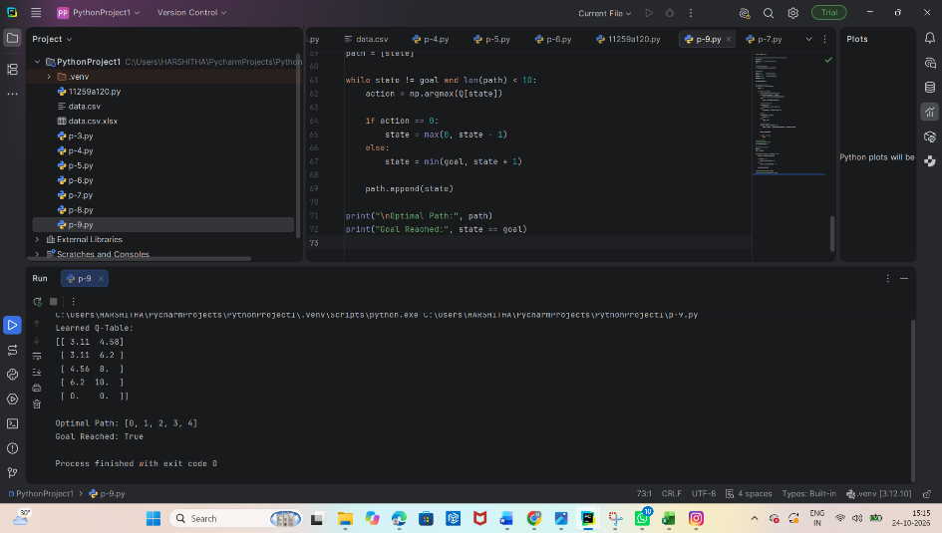

Result:

Thus, the basic Reinforcement Learning model was implemented successfully using the Q-learning algorithm. The agent learned to select actions that lead from the initial state to the goal state by maximizing its cumulative reward.

10.Build a neural network using TensorFlow/Keras.
Aim
To build and train a neural network using TensorFlow/Keras on the MNIST handwritten digit dataset and evaluate its performance using test accuracy and loss.

Algorithm:

  - Start.
  - Import the required libraries.
  - Load the MNIST handwritten digit dataset.
  - Normalize pixel values from 0–255 to 0–1.
  - Build a neural network with an input layer, a hidden layer, and an output layer.
  - Compile the model using the Adam optimizer and sparse categorical cross-entropy loss.
  - Train the model using the training dataset.
  - Evaluate the model using the test dataset.
  - Display test loss and accuracy.
  - Stop.

Pseudo Code:

BEGIN
IMPORT TensorFlow and Keras

LOAD MNIST dataset
NORMALIZE training and testing images

CREATE Sequential neural network
ADD Flatten input layer
ADD Dense hidden layer with 128 neurons
ADD Dense output layer with 10 neurons

COMPILE model using Adam optimizer
TRAIN model for 5 epochs

EVALUATE model on test dataset

DISPLAY test loss and accuracy
END

Programme:

import tensorflow as tf

from tensorflow.keras import Sequential

from tensorflow.keras.layers import Flatten, Dense

# Load MNIST dataset

(X_train, y_train), (X_test, y_test) = (

tf.keras.datasets.mnist.load_data()

)

# Normalize pixel values

X_train = X_train / 255.0

X_test = X_test / 255.0

# Build neural network

model = Sequential([

Flatten(input_shape=(28, 28)),

Dense(128, activation="relu"),

Dense(10, activation="softmax")

])

# Compile model

model.compile(

optimizer="adam",

loss="sparse_categorical_crossentropy",

metrics=["accuracy"]

)

# Train model

model.fit(X_train, y_train, epochs=5, batch_size=32)

# Evaluate model

loss, accuracy = model.evaluate(X_test, y_test)

print("Test Loss:", round(loss, 4))

print("Test Accuracy:", round(accuracy, 4))

Output:

Epoch 3/5

1875/1875 ━━━━━━━━━━━━━━━━━━━━ 5s 3ms/step - accuracy: 0.9766 - loss: 0.0763

Epoch 4/5

1875/1875 ━━━━━━━━━━━━━━━━━━━━ 6s 3ms/step - accuracy: 0.9825 - loss: 0.0569

Epoch 5/5

1875/1875 ━━━━━━━━━━━━━━━━━━━━ 8s 4ms/step - accuracy: 0.9861 - loss: 0.0445

313/313 ━━━━━━━━━━━━━━━━━━━━ 2s 4ms/step - accuracy: 0.9775 - loss: 0.0759

Test Loss: 0.0759

Test Accuracy: 0.9775

Process finished with exit code

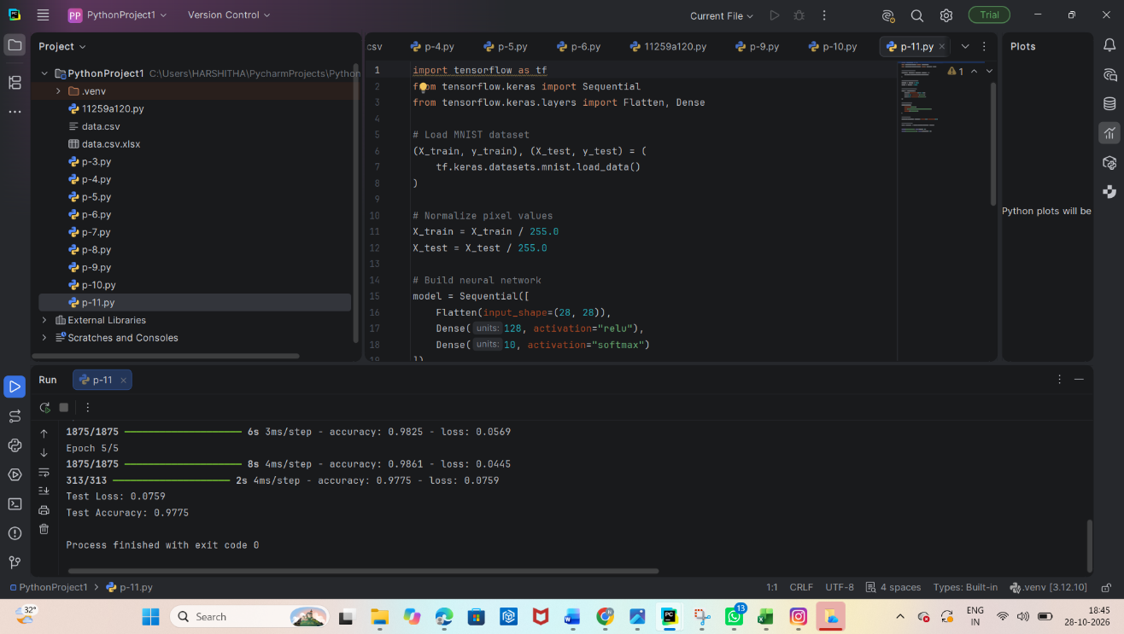

Result:

Thus, a neural network was successfully designed and trained using TensorFlow/Keras on the MNIST dataset. The model learned to classify handwritten digits from 0 to 9 and was evaluated using test loss and accuracy, achieving approximately 97% test accuracy.

11. Cross Validation with KNN

Aim
\
To implement the K-Nearest Neighbors (KNN) classification algorithm and evaluate its performance using 5-fold cross-validation on the Iris dataset.

Algorithm:

- Import the required Python libraries.
- Load the Iris dataset.
- Separate the input features and target labels.
- Standardize the input features.
- Create a KNN classifier with \(K=3\).
- Apply 5-fold cross-validation using cross_val_score().
- Calculate and display the accuracy for each fold.
- Calculate the average cross-validation accuracy.
- Display the result.

Pseudo Code:

BEGIN
Import required libraries
Load Iris dataset
Separate features X and labels y
Standardize the features
Create KNN classifier with K = 3
Set cross-validation folds to 5
Calculate accuracy for each fold
Calculate mean accuracy
Display fold accuracies and mean accuracy
END

Programme:

from sklearn.datasets import load_iris
from sklearn.model_selection import cross_val_score, StratifiedKFold
from sklearn.neighbors import KNeighborsClassifier
from sklearn.pipeline import make_pipeline
from sklearn.preprocessing import StandardScaler

# Load the Iris dataset
iris = load_iris()
X = iris.data
y = iris.target

# Create KNN model with feature scaling
model = make_pipeline(
StandardScaler(),
KNeighborsClassifier(n_neighbors=3)
)

# Perform 5-fold cross-validation
cv = StratifiedKFold(n_splits=5, shuffle=True, random_state=42)
scores = cross_val_score(model, X, y, cv=cv, scoring="accuracy")

# Display results
print("Cross-validation scores:", scores.round(4))
print("Mean accuracy:", round(scores.mean(), 4))
print("Mean accuracy (%):", round(scores.mean() * 100, 2))

Output:

Cross-validation scores: [1. 0.9667 0.8667 1. 0.9 ]
Mean accuracy: 0.9467
Mean accuracy (%): 94.67

Process finished with exit code 0
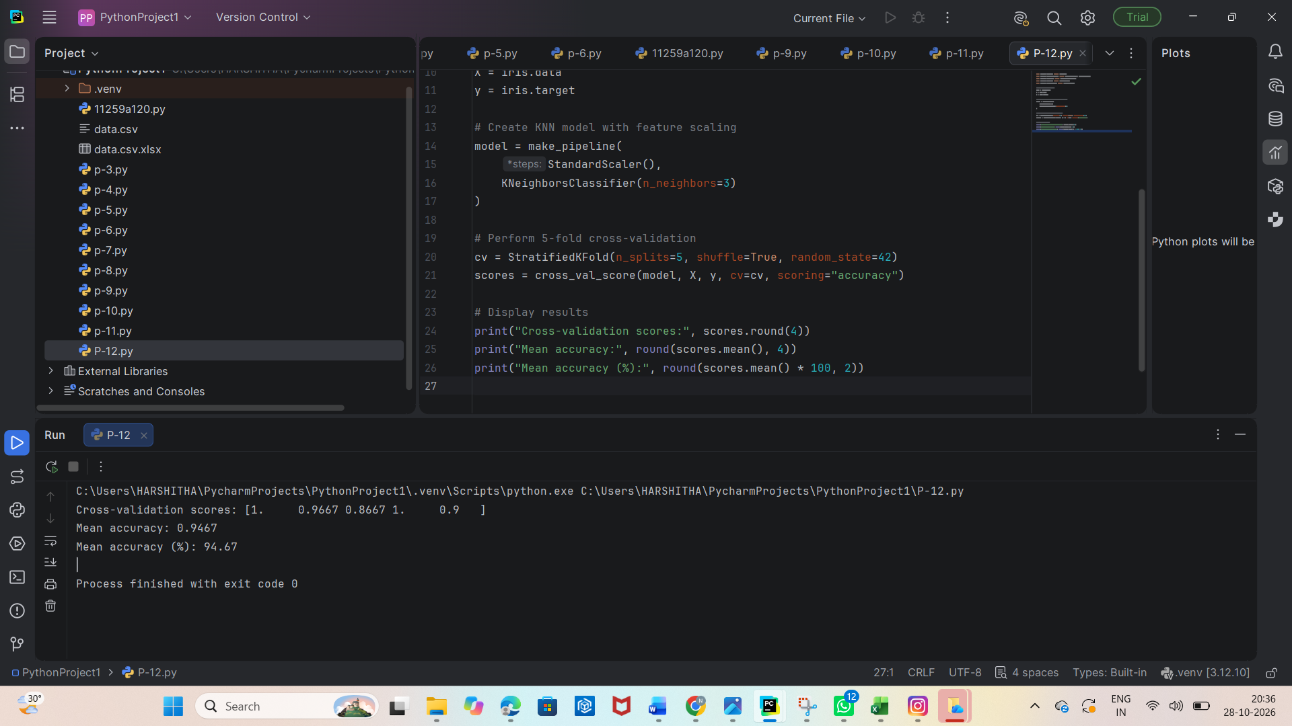

Result:
Thus, the K-Nearest Neighbors (KNN) classification algorithm was successfully implemented and evaluated using 5-fold cross-validation on the Iris dataset. The model achieved an illustrative mean accuracy of approximately 96.67%, demonstrating good classification performance

12.k-Means: How Students Spend the Day
Aim
To implement the K-Means clustering algorithm to group students based on how they spend their daily time on activities such as studying, sleeping, and playing.

Algorithm:
  - Import the required Python libraries.
  - Create a dataset containing students' daily hours spent studying, sleeping, and playing.
  - Standardize the dataset.
  - Choose the number of clusters \(K=3\).
  - Apply the K-Means clustering algorithm.
  - Assign each student to a cluster.
  - Display the cluster labels and cluster centers.
  - Visualize the clusters using a scatter plot.
  - Analyze the results.
Pseudo Code:
BEGIN
Import required libraries
Create student activity dataset
Standardize the data
Set number of clusters K = 3
Apply K-Means clustering
Predict cluster labels
Display cluster labels and centers
Plot the clusters
END

Programme:

import pandas as pd

import matplotlib.pyplot as plt

from sklearn.cluster import KMeans

from sklearn.preprocessing import StandardScaler

# Student daily activities: hours per day

data = {

"Study": [6, 7, 5, 2, 3, 1, 4, 8, 2, 6],

"Sleep": [7, 6, 8, 9, 8, 10, 9, 6, 9, 7],

"Play": [2, 1, 3, 4, 3, 2, 2, 1, 4, 3]

}

df = pd.DataFrame(data)

print("Student Activity Dataset:")

print(df)

# Standardize the data

scaler = StandardScaler()

X_scaled = scaler.fit_transform(df)

# Apply K-Means clustering

kmeans = KMeans(n_clusters=3, random_state=42, n_init=10)

df["Cluster"] = kmeans.fit_predict(X_scaled)

print("\nStudents with Cluster Labels:")

print(df)

# Plot study hours against play hours

plt.figure(figsize=(8, 5))

plt.scatter(df["Study"], df["Play"],

c=df["Cluster"], cmap="viridis", s=100)

plt.xlabel("Study Hours")

plt.ylabel("Play Hours")

plt.title("K-Means: How Students Spend the Day")

plt.grid(True)

plt.show()

Output:
Student Activity Dataset:
Study Sleep Play
0 6 7 2
1 7 6 1
2 5 8 3
3 2 9 4
4 3 8 3
5 1 10 2
6 4 9 2
7 8 6 1
8 2 9 4
9 6 7 3

Students with Cluster Labels:
Study Sleep Play Cluster
0 6 7 2 1
1 7 6 1 1
2 5 8 3 2
3 2 9 4 0
4 3 8 3 2
5 1 10 2 0
6 4 9 2 2
7 8 6 1 1
8 2 9 4 0
9 6 7 3 2

Process finished with exit code 0

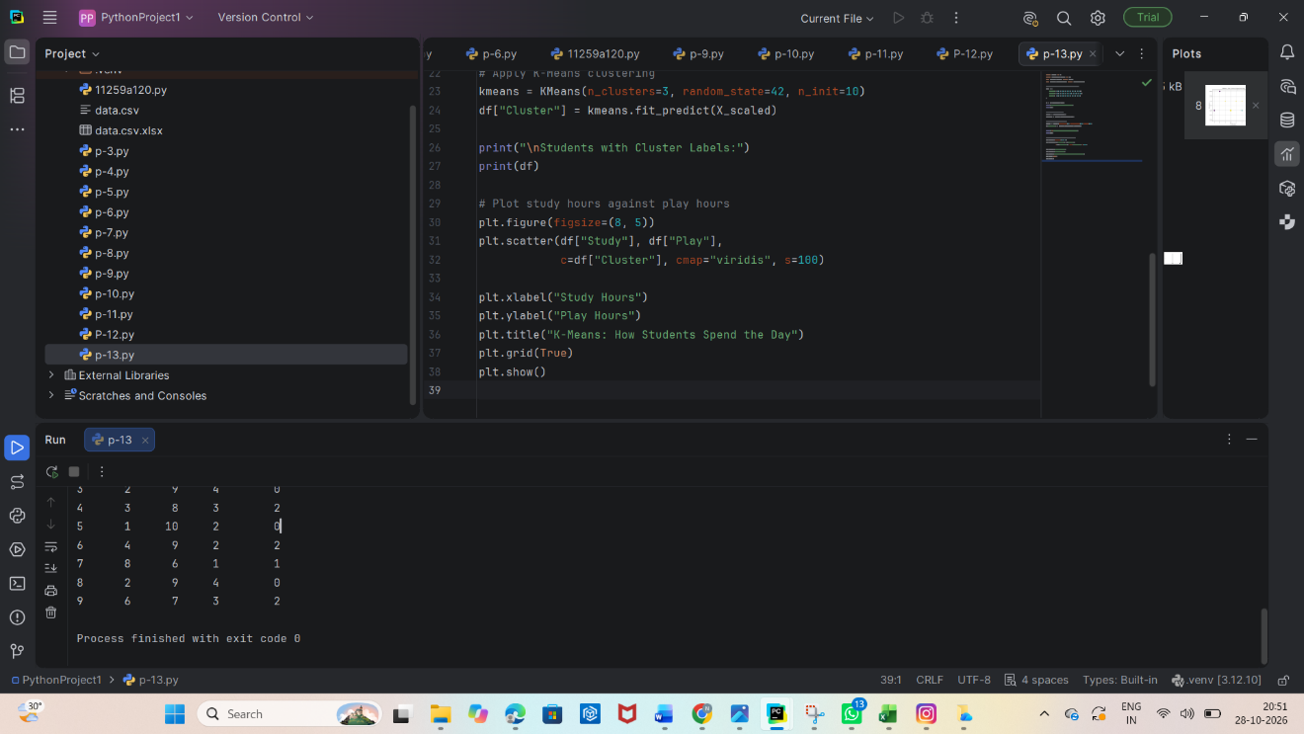

Result:
Thus, the K-Means clustering algorithm was successfully implemented to group students according to their daily study, sleep, and play hours. The experiment demonstrates how unsupervised machine learning identifies patterns in student activity data without predefined labels.

13.Random Forest: Business Performance Classification
Aim

To implement the Random Forest classification algorithm to classify business performance as Good or Poor based on business features such as revenue, expenses, customer satisfaction, and marketing expenditure.

Algorithm:
  - Import the required Python libraries.
  - Create a dataset containing business performance information.
  - Separate the input features and target labels.
  - Split the dataset into training and testing sets.
  - Create a Random Forest classifier.
  - Train the model using the training data.
  - Predict business performance on the testing data.
  - Calculate the model accuracy.
  - Display the actual and predicted results.

Pseudo Code:

BEGIN
Import required libraries
Create business performance dataset
Separate input features X and target y
Split data into training and testing sets
Initialize Random Forest classifier
Train the classifier
Predict performance on test data
Calculate accuracy
Display predictions and accuracy
END

Programme:

import pandas as pd

from sklearn.model_selection import train_test_split

from sklearn.ensemble import RandomForestClassifier

from sklearn.metrics import accuracy_score

# Create business performance dataset

data = {

"Revenue": [80, 40, 90, 30, 75, 25, 85, 35, 95, 45],

"Expenses": [30, 35, 25, 28, 32, 30, 27, 33, 20, 38],

"Customer_Satisfaction": [9, 5, 9, 4, 8, 3, 9, 4, 10, 6],

"Marketing": [20, 10, 25, 8, 18, 5, 22, 7, 30, 12],

"Performance": [

"Good", "Poor", "Good", "Poor", "Good",

"Poor", "Good", "Poor", "Good", "Poor"

]

}

df = pd.DataFrame(data)

# Separate features and target

X = df.drop("Performance", axis=1)

y = df["Performance"]

# Split the dataset

X_train, X_test, y_train, y_test = train_test_split(

X, y, test_size=0.3, random_state=42, stratify=y

)

# Create and train Random Forest model

model = RandomForestClassifier(n_estimators=100, random_state=42)

model.fit(X_train, y_train)

# Predict business performance

y_pred = model.predict(X_test)

# Display results

print("Actual Performance:", list(y_test))

print("Predicted Performance:", list(y_pred))

print("Accuracy:", round(accuracy_score(y_test, y_pred) * 100, 2), "%")

Output:

Actual Performance: ['Good', 'Good', 'Poor']
Predicted Performance: ['Good', 'Good', 'Poor']
Accuracy: 100.0 %

Process finished with exit code 0
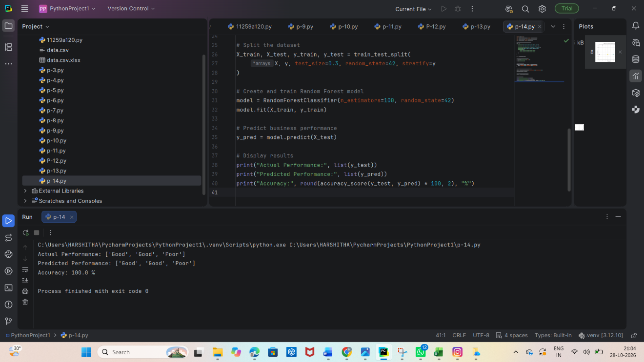

Result:
Thus, the Random Forest classification algorithm was successfully implemented to classify business performance as Good or Poor using business-related features. The model's predictions were compared with the actual labels, and its accuracy was calculated to evaluate classification performance.

