Experiment 1 - NumPy Basics
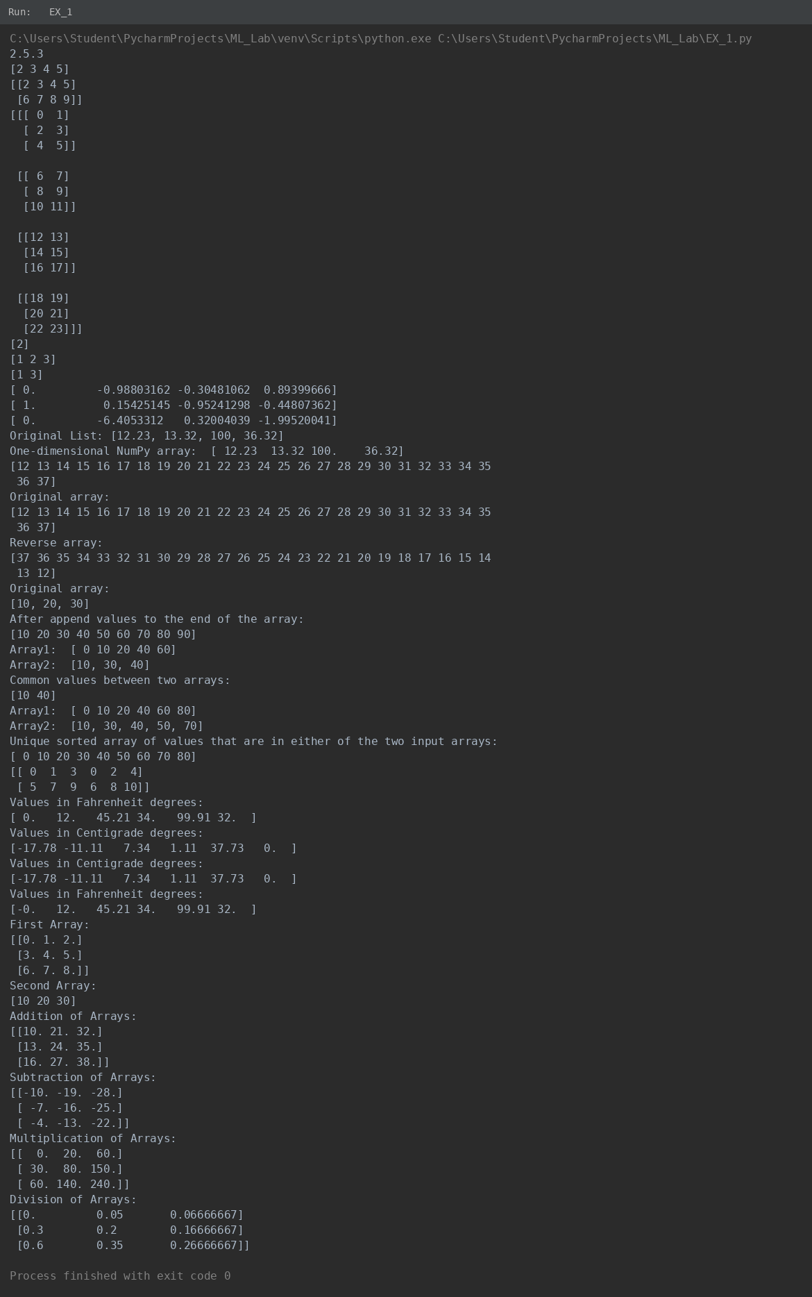

Experiment 2 - Pandas DataFrame Operations
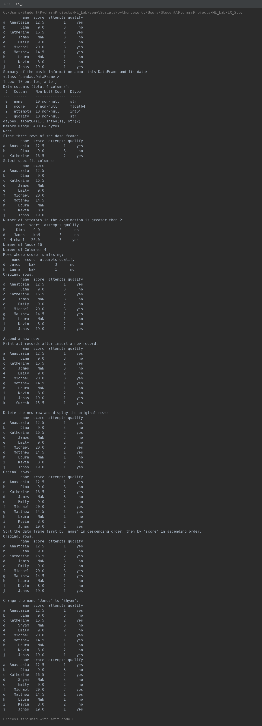

Experiment 3 - Python List Operations
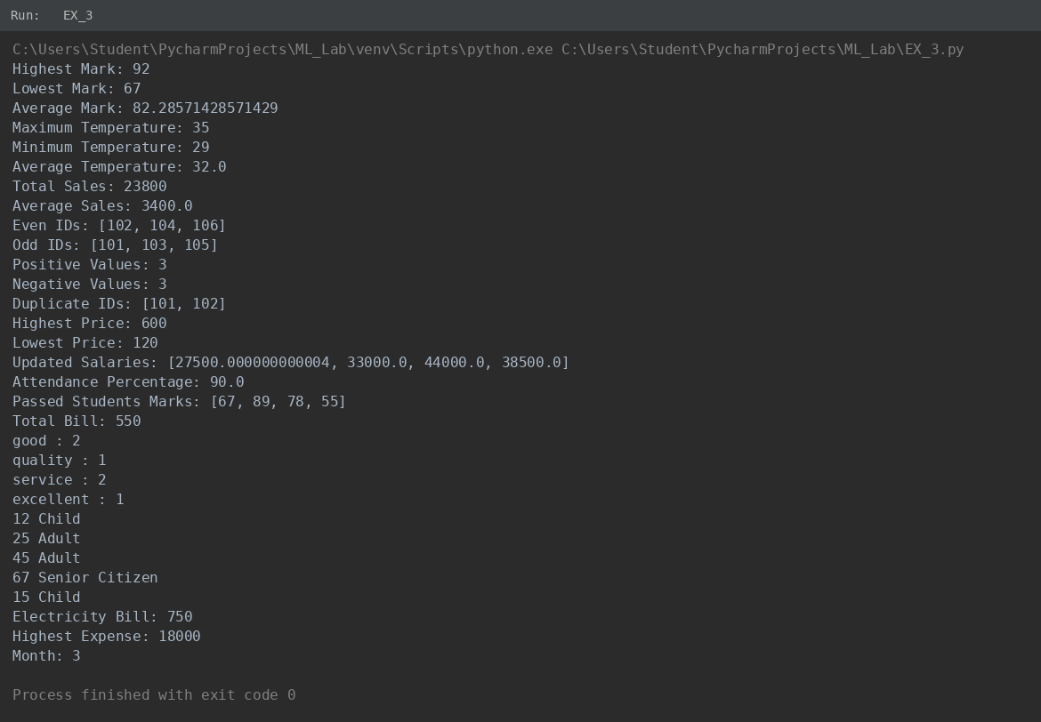

Experiment 4 - Data Preprocessing
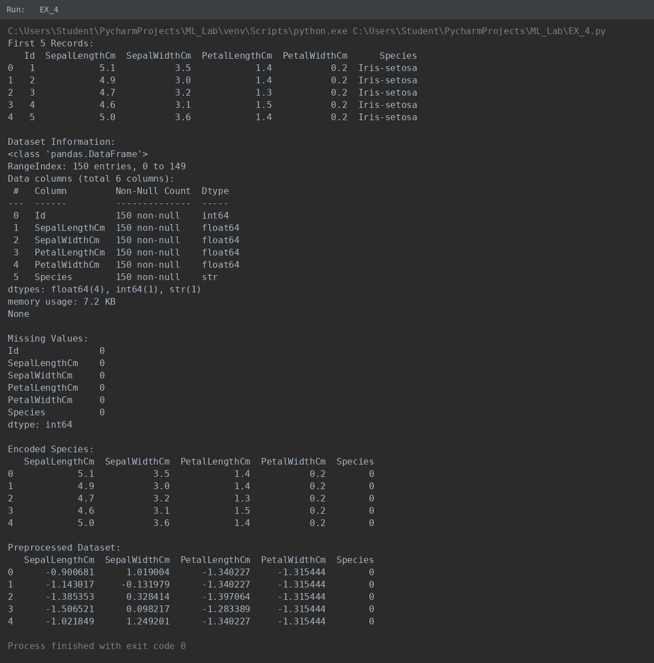

Experiment 5 - Dataset Splitting and Cross-Validation
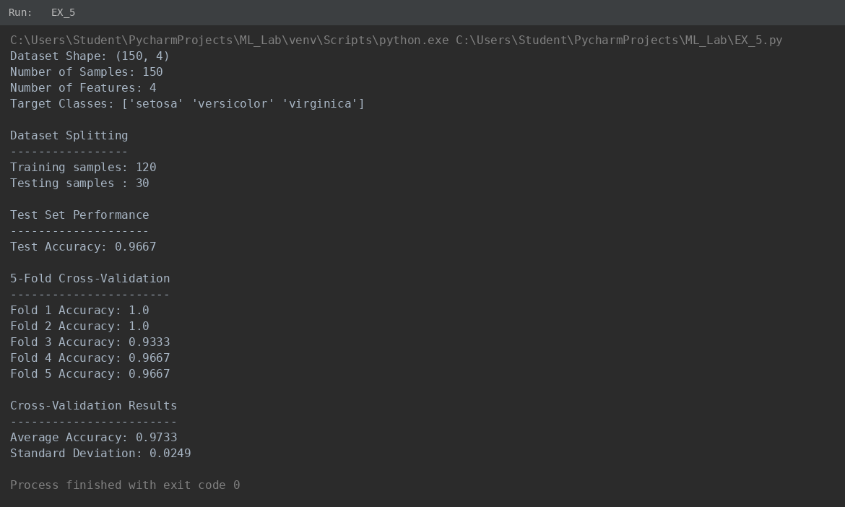

Experiment 6 - Linear Regression
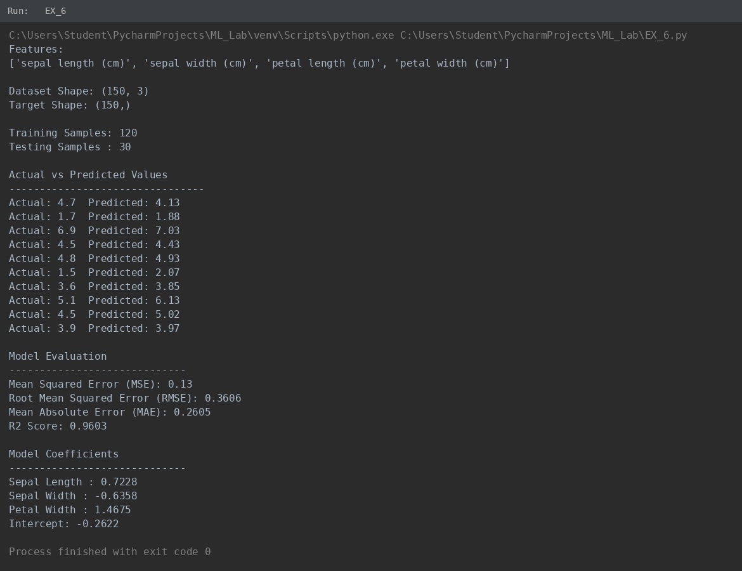

Experiment 7 - KNN Classification
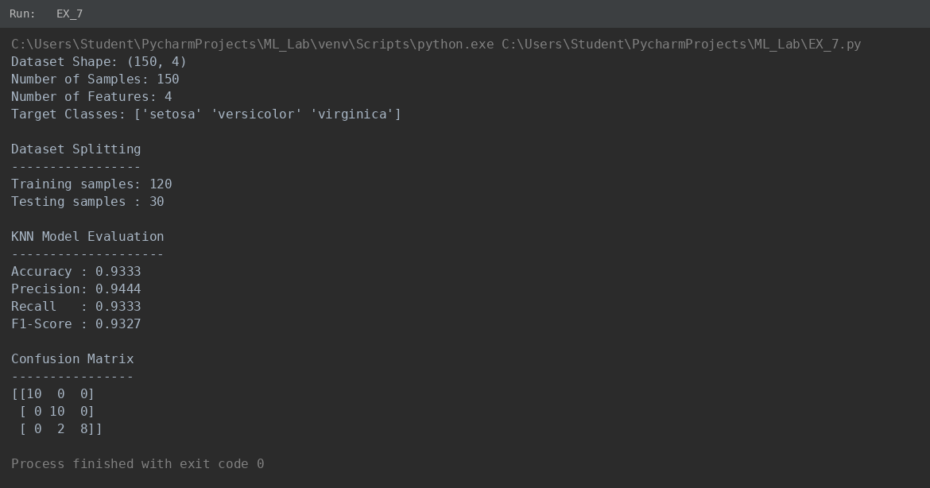

Experiment 8 - SVM Classification
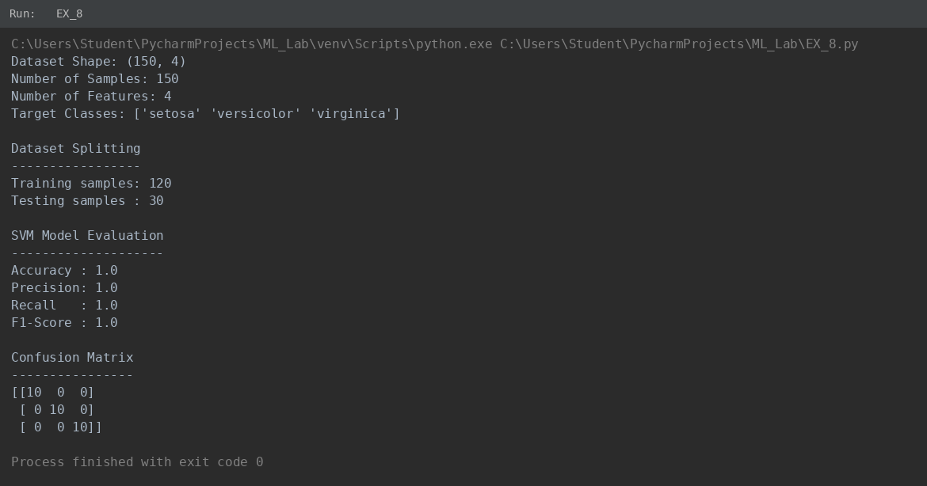

Experiment 9 - K-Means Clustering
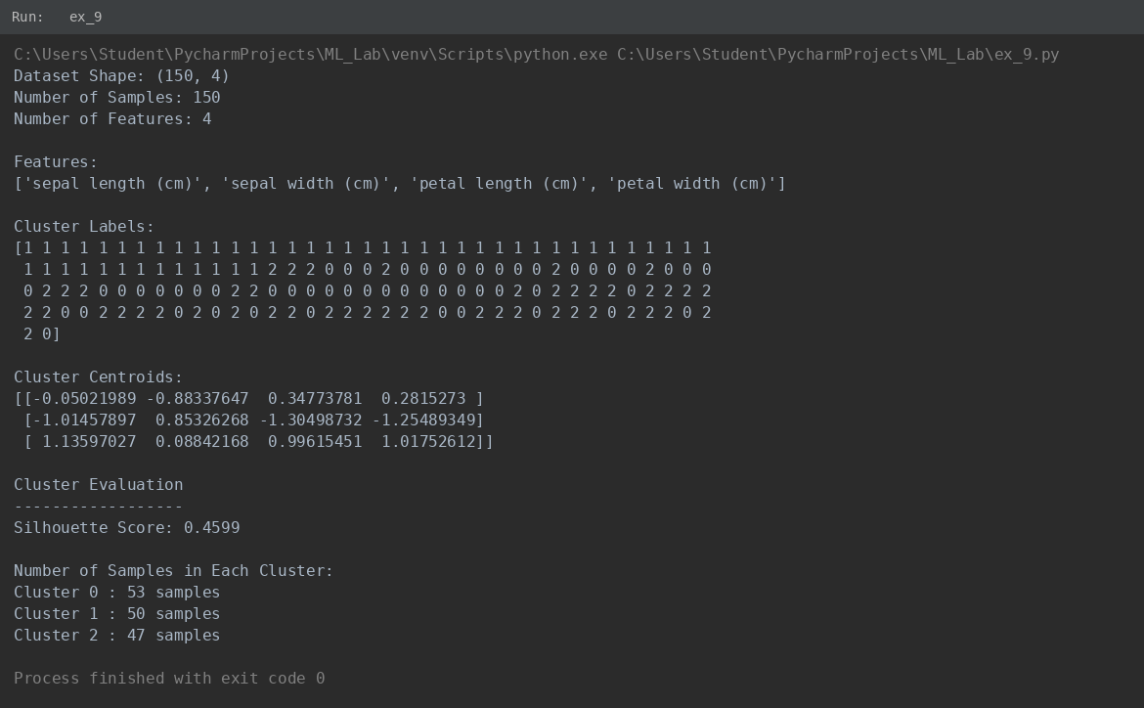
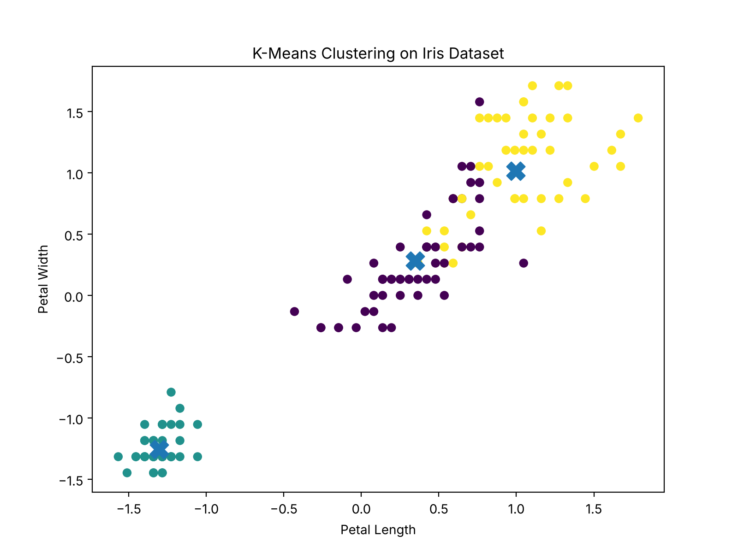

Experiment 10 - Hierarchical Clustering
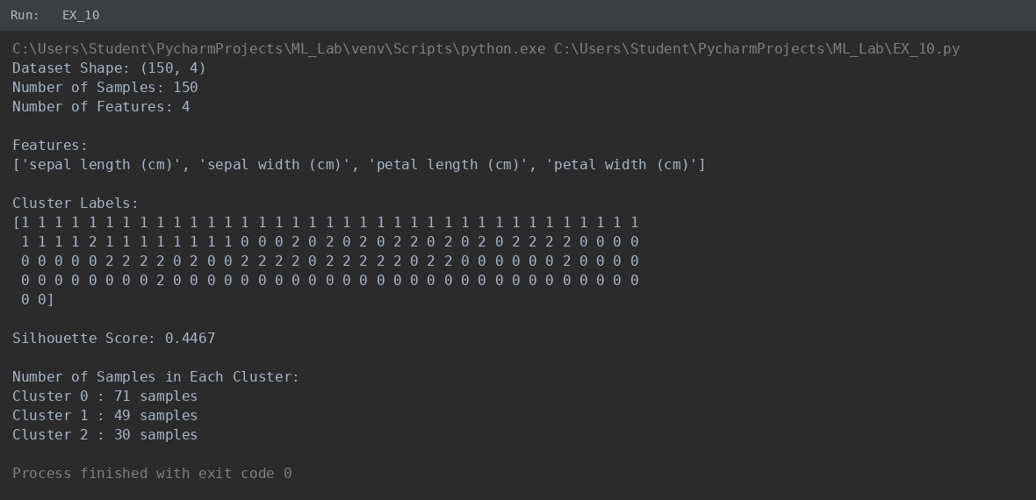
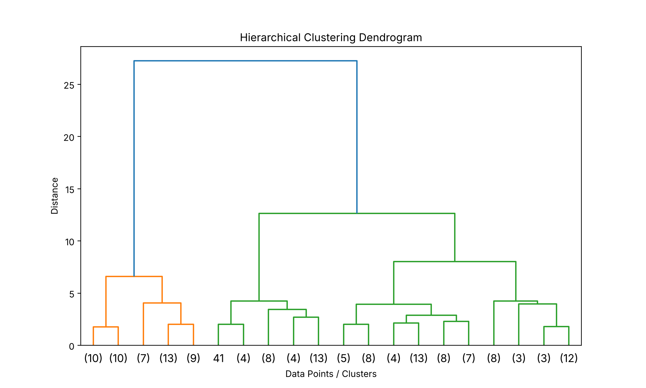
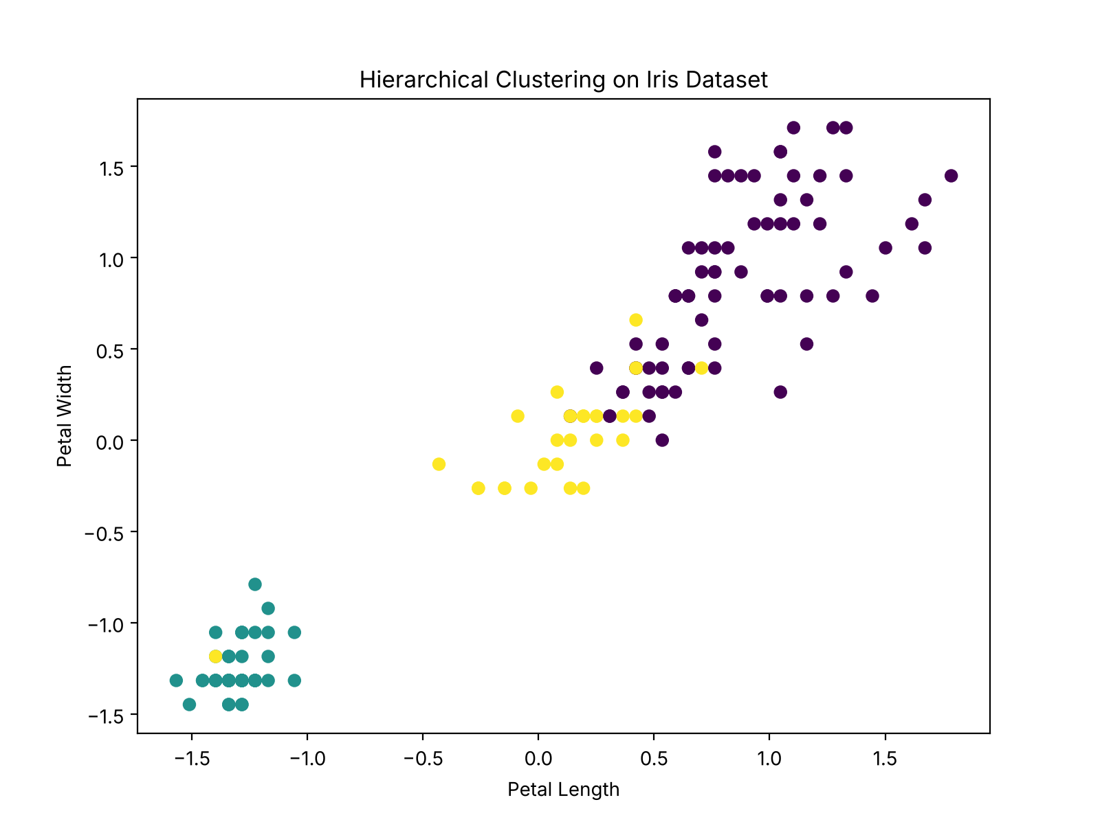

Experiment 11 - Comparison of K-Means and Hierarchical Clustering
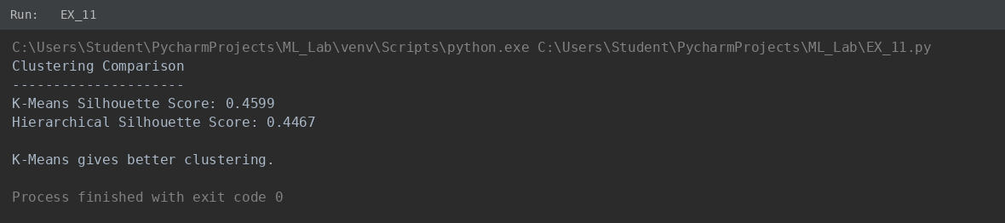

Experiment 12 - Boosting Techniques
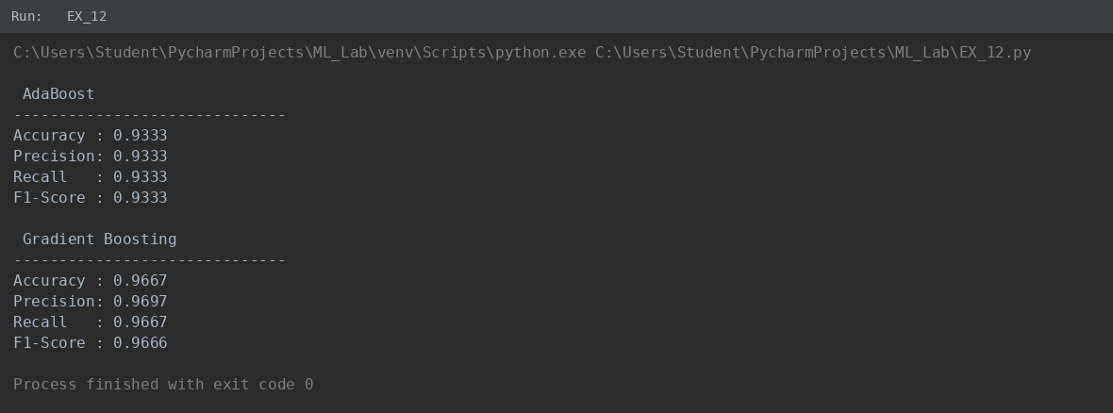
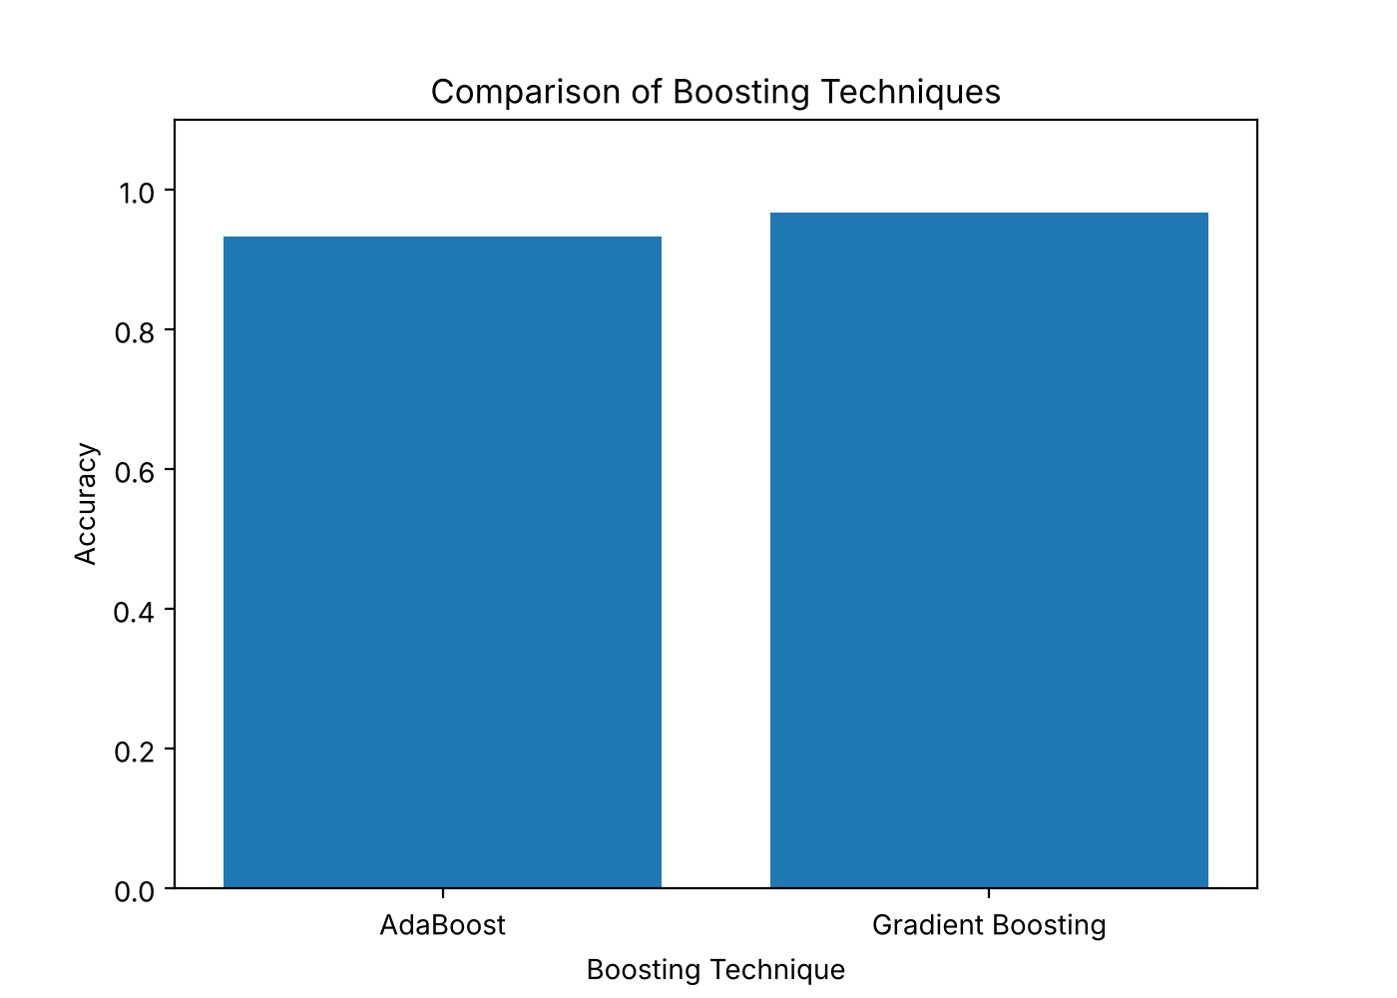

Experiment 13 - Q-Learning


