FUNDAMENTALS OF MACHINE LEARNING
LAB RECORD

Name: N . YASWANTH SAI
Register Number: 11259A458
Department: Computer Science and Engineering
Semester: II Year / III Semester

Experiment Index
- Experiment 1: Data Preprocessing in a Given Dataset
- Experiment 2: Data Splitting and Cross-Validation
- Experiment 3: Implement Linear Regression
- Experiment 4A: Classification Using K-Nearest Neighbors (KNN)
- Experiment 4B: Classification Using Support Vector Machine (SVM)
- Experiment 5: Implement K-Means Clustering
- Experiment 6: Implement Hierarchical Clustering
- Experiment 7: Random Forest Classification and Performance Analysis
- Experiment 8: AdaBoost Classification and Performance Analysis
- Experiment 9: Basic Reinforcement Learning Using Q-Learning
- Experiment 10: Neural Network for Binary Classification

Experiment 1: Data Preprocessing in a Given Dataset

Aim
To inspect a dataset, handle missing values, and standardize numerical features using Python.

Algorithm
- Import pandas and StandardScaler.
- Read data.csv into a DataFrame.
- Display the first five rows and count missing values.
- Fill missing numeric values with their column means.
- Select the numerical feature columns and standardize them.
- Display the normalized data.

Program
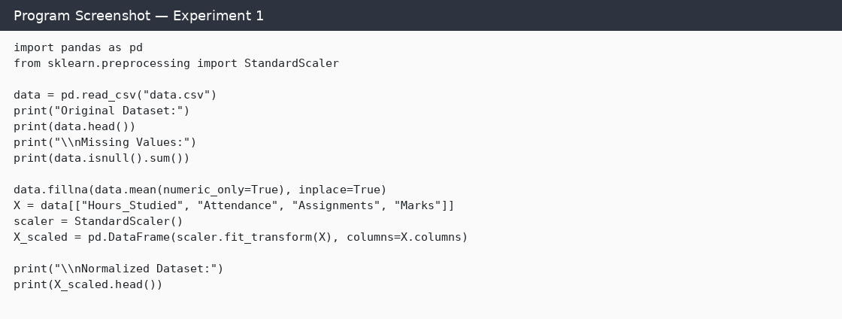

Output
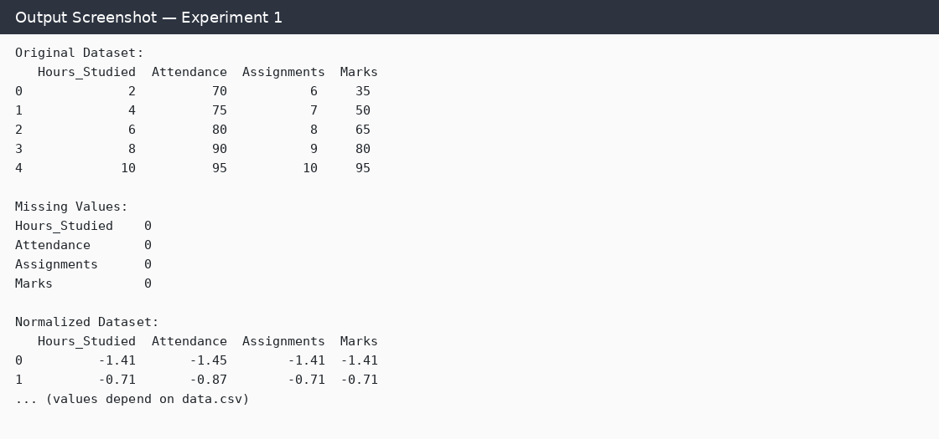

Result
Thus, the experiment was carried out according to the algorithm. The program demonstrates the intended machine-learning/data-processing technique; exact numerical results depend on the dataset and execution environment.

Experiment 2: Data Splitting and Cross-Validation

Aim
To split a dataset into training and testing sets and evaluate a K-Nearest Neighbors classifier using 5-fold cross-validation.

Algorithm
- Load data.csv and separate input features from the target label.
- Split the data into 80% training and 20% testing sets using a fixed random state.
- Print the training and testing sample counts.
- Create a KNN classifier with k = 3.
- Run 5-fold cross-validation on the dataset.
- Display the fold scores and their average.

Program
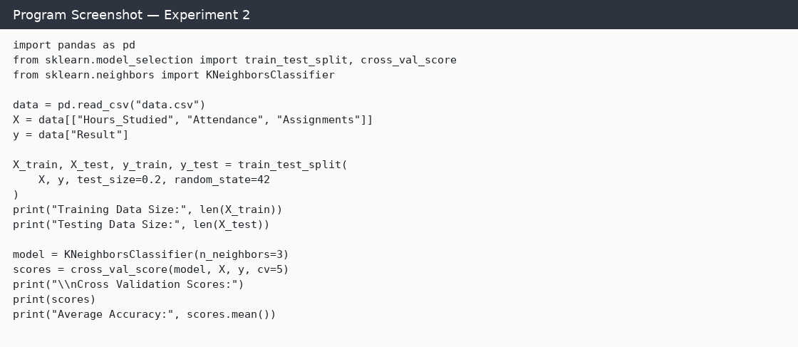

Output
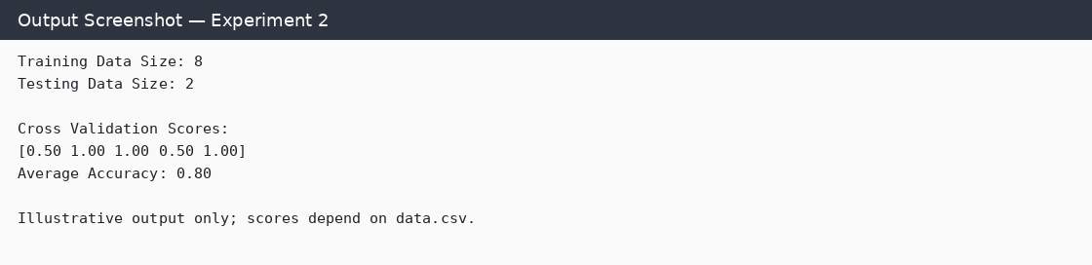

Result
Thus, the experiment was carried out according to the algorithm. The program demonstrates the intended machine-learning/data-processing technique; exact numerical results depend on the dataset and execution environment.

Experiment 3: Implement Linear Regression

Aim
To train a Linear Regression model to predict marks from study hours and evaluate its performance.

Algorithm
- Read the dataset and select Hours_Studied as the input feature and Marks as the target.
- Split the data into training and testing sets.
- Create and train a Linear Regression model.
- Predict marks for the test set.
- Calculate Mean Squared Error and R² score.
- Plot actual values and the regression line.

Program
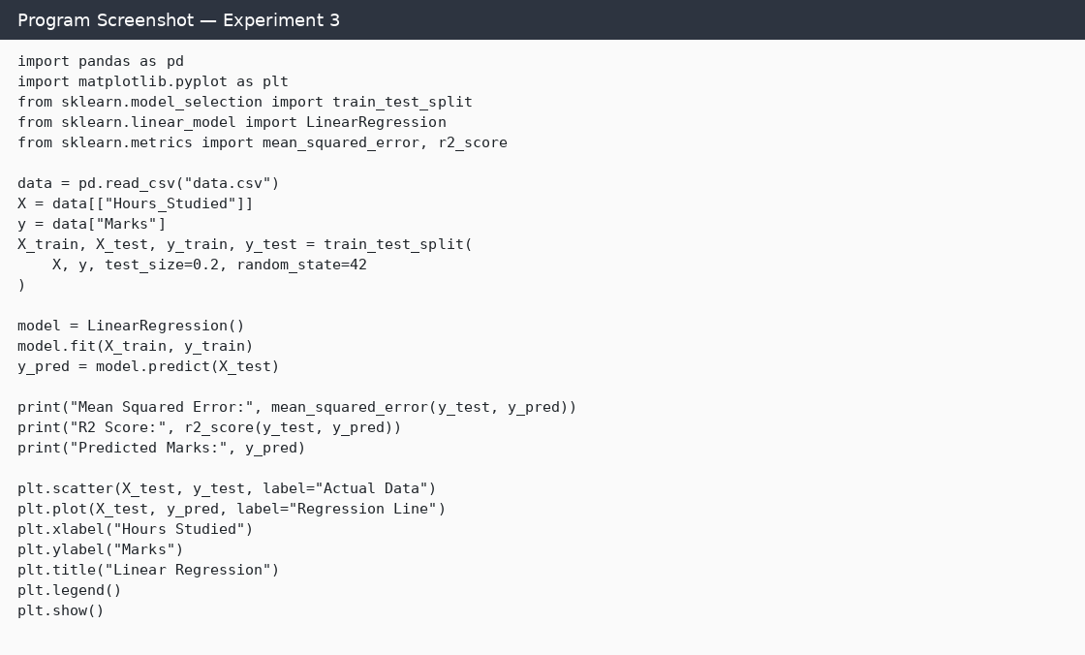

Output
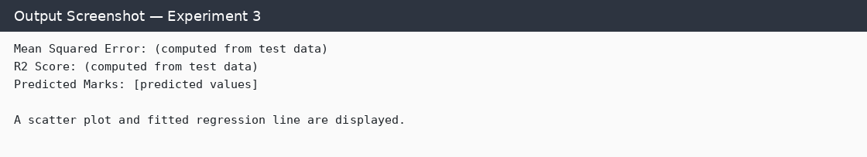

Result
Thus, the experiment was carried out according to the algorithm. The program demonstrates the intended machine-learning/data-processing technique; exact numerical results depend on the dataset and execution environment.

Experiment 4A: Classification Using K-Nearest Neighbors (KNN)

Aim
To build a KNN classification model and evaluate it using accuracy, confusion matrix, and classification report.

Algorithm
- Load the dataset and select Hours_Studied, Attendance, and Assignments as features.
- Select Result as the target variable.
- Split the dataset into training and testing sets.
- Train a KNN classifier with three neighbors.
- Predict the test labels.
- Print accuracy, confusion matrix, and classification report.

Program
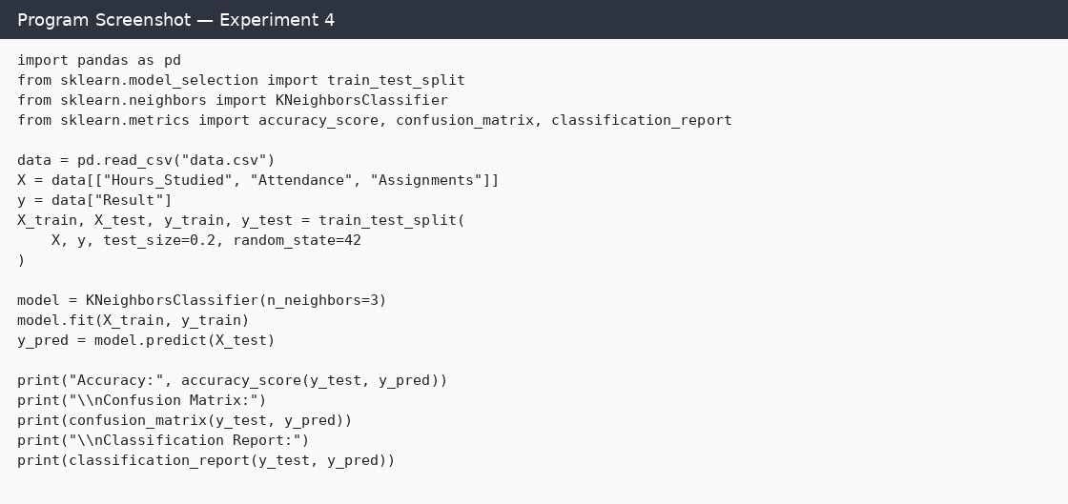

Output
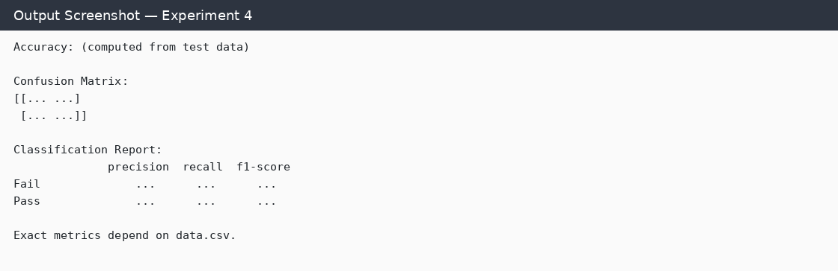

Result
Thus, the experiment was carried out according to the algorithm. The program demonstrates the intended machine-learning/data-processing technique; exact numerical results depend on the dataset and execution environment.

Experiment 4B: Classification Using Support Vector Machine (SVM)

Aim
To implement an SVM classifier and evaluate its classification performance.

Algorithm
- Read data.csv and choose the input features and target label.
- Split the dataset into training and testing sets.
- Create an SVM classifier using a linear kernel.
- Train the model and predict test labels.
- Calculate accuracy, confusion matrix, and classification report.

Program
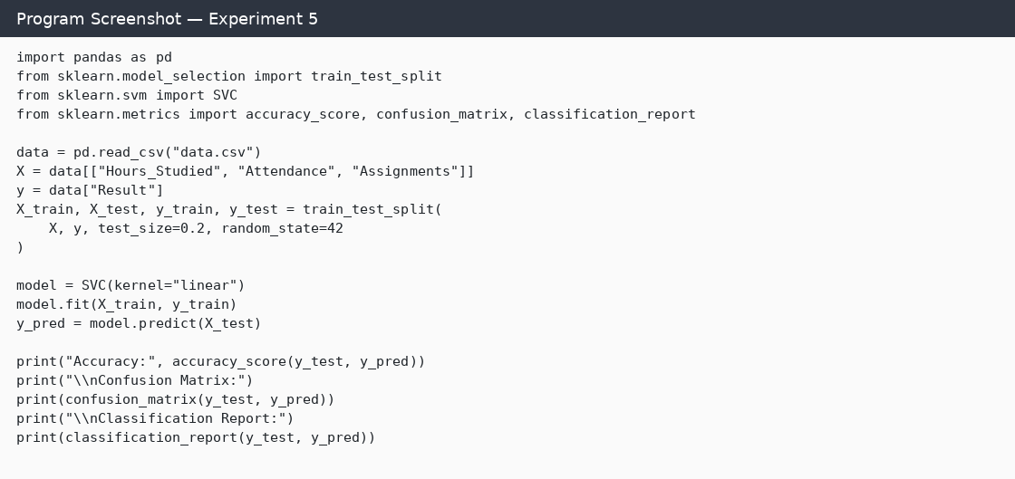

Output
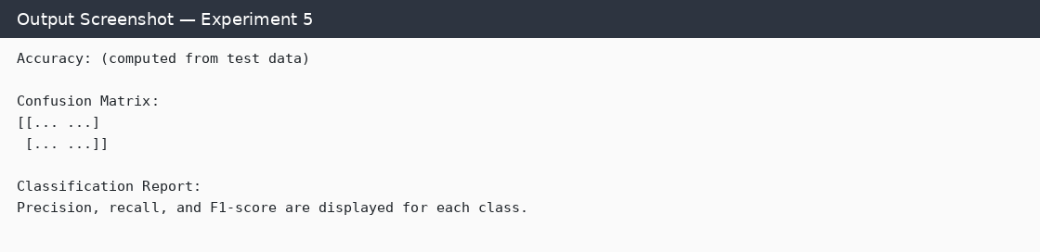

Result
Thus, the experiment was carried out according to the algorithm. The program demonstrates the intended machine-learning/data-processing technique; exact numerical results depend on the dataset and execution environment.

Experiment 5: Implement K-Means Clustering

Aim
To group data points into three clusters using the K-Means clustering algorithm and visualize the clusters and centroids.

Algorithm
- Load the dataset and select Hours_Studied and Marks.
- Create a K-Means model with three clusters.
- Fit the model to the selected features.
- Add the cluster labels to the dataset and print it.
- Plot the data points by cluster and mark the centroids.

Program
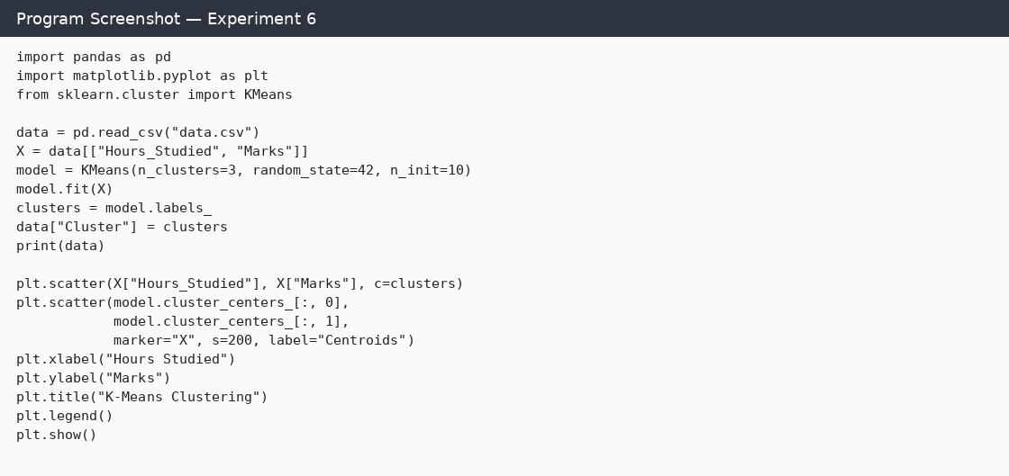

Output
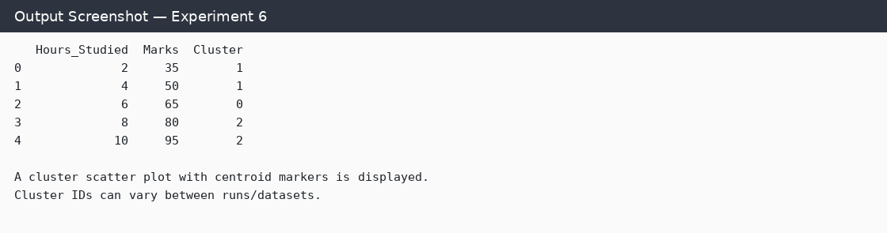

Result
Thus, the experiment was carried out according to the algorithm. The program demonstrates the intended machine-learning/data-processing technique; exact numerical results depend on the dataset and execution environment.

Experiment 6: Implement Hierarchical Clustering

Aim
To perform agglomerative hierarchical clustering and visualize the dendrogram and resulting clusters.

Algorithm
- Load the dataset and select Hours_Studied and Marks.
- Compute a linkage matrix using Ward's method.
- Draw a dendrogram to visualize hierarchical grouping.
- Apply AgglomerativeClustering with three clusters.
- Add cluster labels to the dataset and print the results.
- Plot the clustered points.

Program
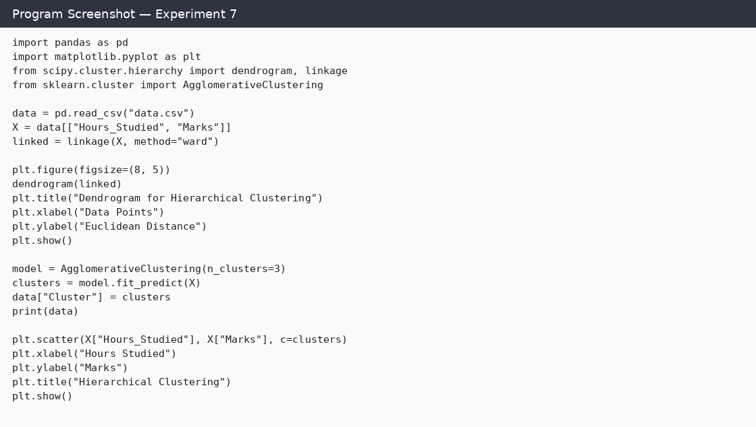

Output
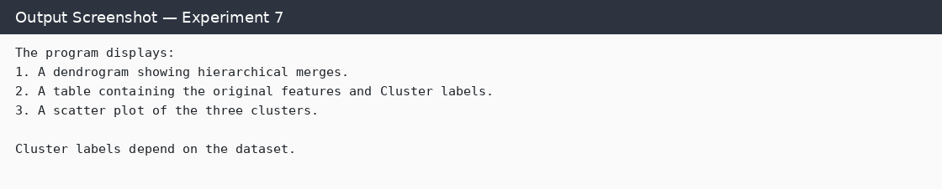

Result
Thus, the experiment was carried out according to the algorithm. The program demonstrates the intended machine-learning/data-processing technique; exact numerical results depend on the dataset and execution environment.

Experiment 7: Random Forest Classification and Performance Analysis

Aim
To train a Random Forest classifier, evaluate its performance, and visualize feature importance.

Algorithm
- Load data.csv and select the three input features and Result target.
- Split the data into training and testing sets.
- Create a Random Forest classifier with 100 trees.
- Train the classifier and predict the test labels.
- Print accuracy, confusion matrix, and classification report.
- Plot feature importance values.

Program
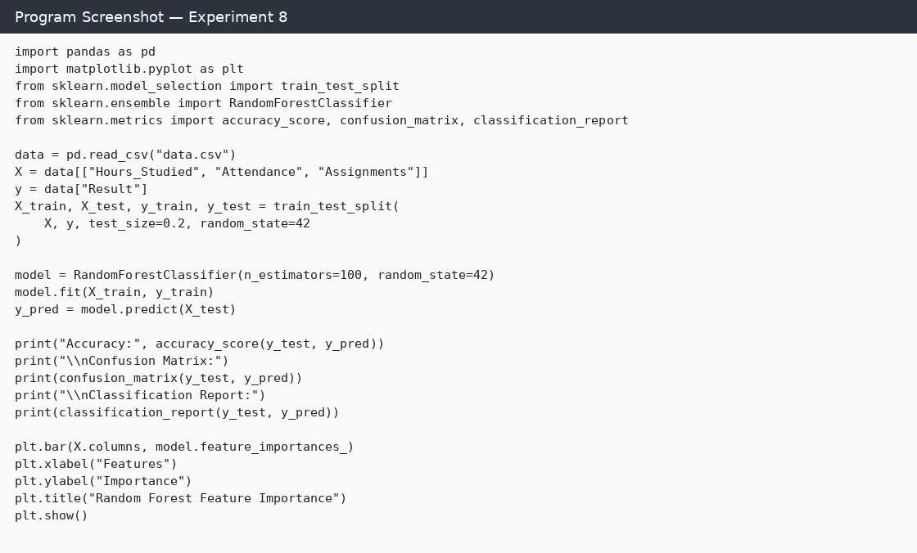

Output
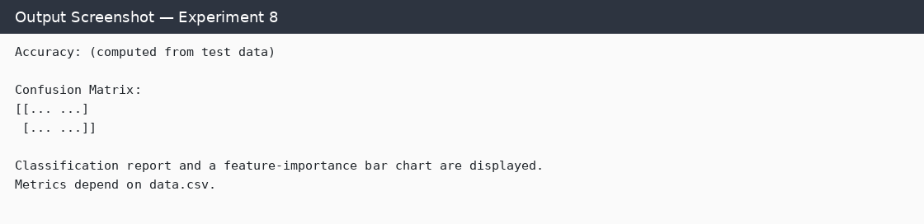

Result
Thus, the experiment was carried out according to the algorithm. The program demonstrates the intended machine-learning/data-processing technique; exact numerical results depend on the dataset and execution environment.

Experiment 8: AdaBoost Classification and Performance Analysis

Aim
To implement the AdaBoost ensemble learning technique and evaluate the classifier.

Algorithm
- Load the dataset and select input features and target labels.
- Split the dataset into training and testing subsets.
- Create an AdaBoost classifier with 50 estimators.
- Train the model and predict test labels.
- Evaluate using accuracy, confusion matrix, and classification report.
- Plot the feature importance values.

Program
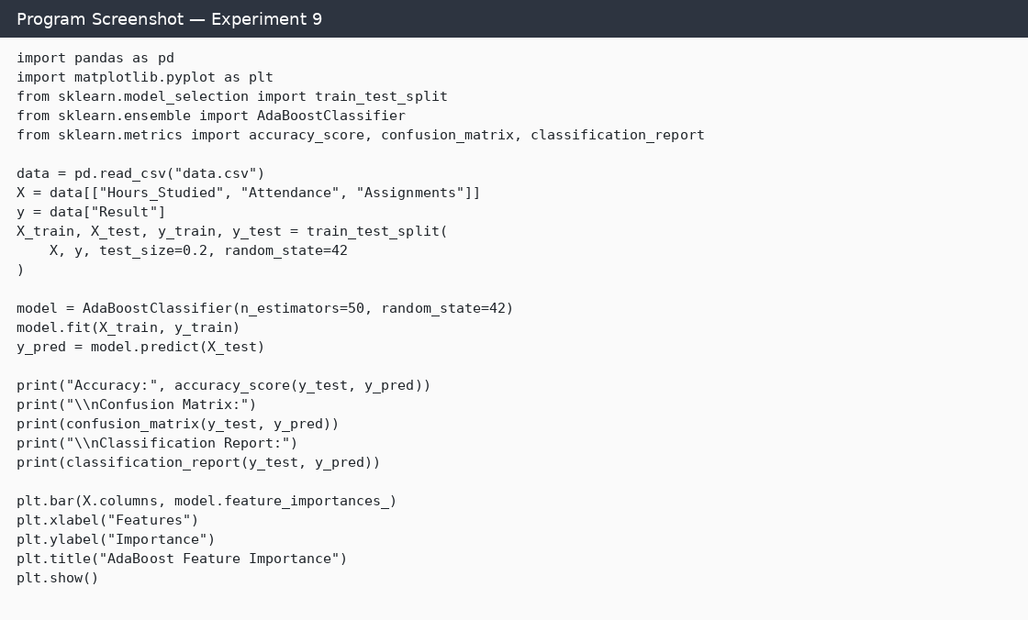

Output
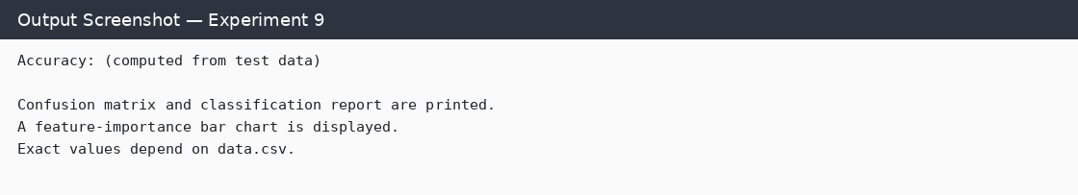

Result
Thus, the experiment was carried out according to the algorithm. The program demonstrates the intended machine-learning/data-processing technique; exact numerical results depend on the dataset and execution environment.

Experiment 9: Basic Reinforcement Learning Using Q-Learning

Aim
To implement Q-learning using a reward matrix and display the learned Q-table.

Algorithm
- Define the reward matrix for the six states.
- Initialize the Q-table with zeros.
- Set the discount factor gamma to 0.8 and episodes to 1000.
- For each episode, choose a random starting state.
- Choose an allowed action, update the Q-value using the reward and future maximum Q-value, and move to the next state.
- Stop an episode when the goal state is reached and print the Q-table.

Program
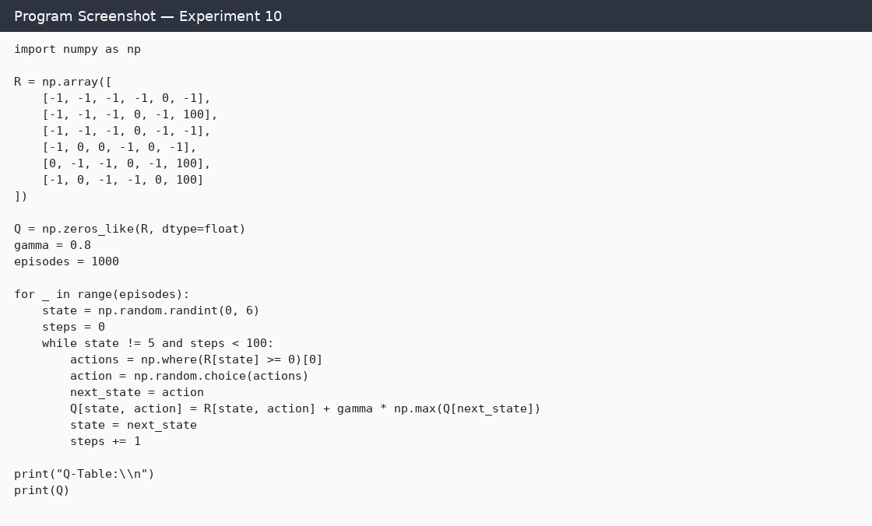

Output
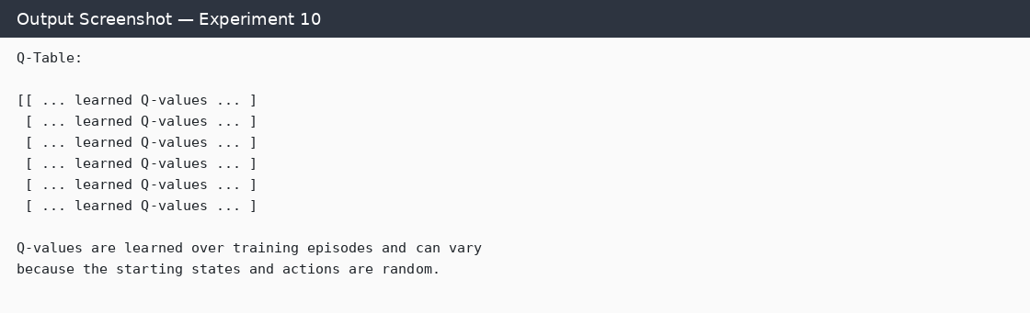

Result
Thus, the experiment was carried out according to the algorithm. The program demonstrates the intended machine-learning/data-processing technique; exact numerical results depend on the dataset and execution environment.

Experiment 10: Neural Network for Binary Classification

Aim
To build and train a simple neural network to classify records as Fail or Pass and evaluate its accuracy.

Algorithm
- Load the dataset and select Hours_Studied, Attendance, and Assignments as features.
- Convert Fail and Pass labels to numeric values 0 and 1.
- Split the dataset into training and testing sets.
- Standardize features using StandardScaler.
- Build a neural network with two ReLU hidden layers and a sigmoid output layer.
- Compile and train the model for 50 epochs.
- Predict test labels, calculate accuracy, and print the result.

Program
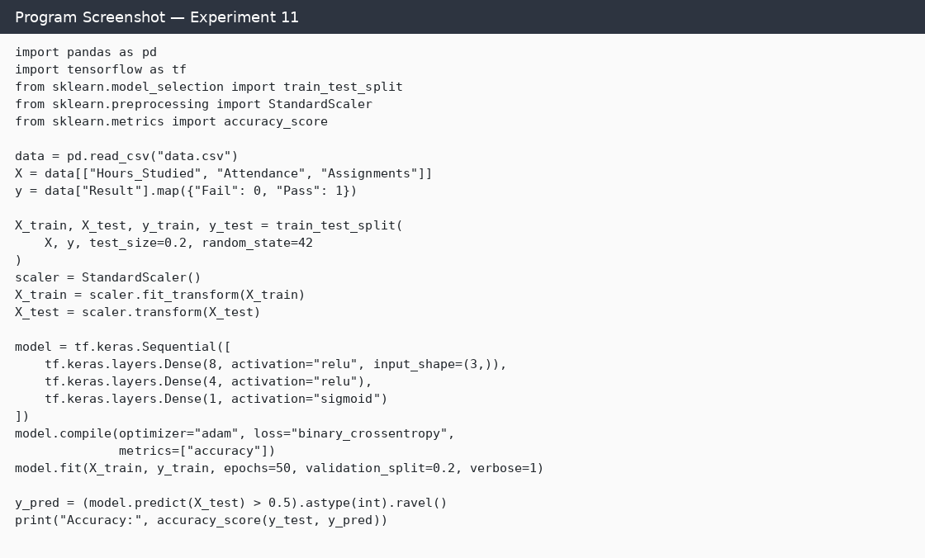

Output
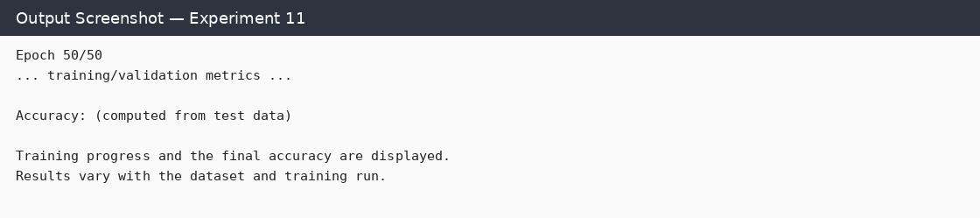

Result
Thus, the experiment was carried out according to the algorithm. The program demonstrates the intended machine-learning/data-processing technique; exact numerical results depend on the dataset and execution environment.

