**Files:**

1. austinEmployeeSalaries.json

2. walkData.html

**Solution:**

For this PS, I have selected the city data for [Austin](https://data.austintexas.gov/Business/City-of-Austin-Employee-Detail-Information/853s-zeff#column-menu). When we load the page it has a button “GET EMPLOYEE INFO” which displays the answers for the questions in the PS.

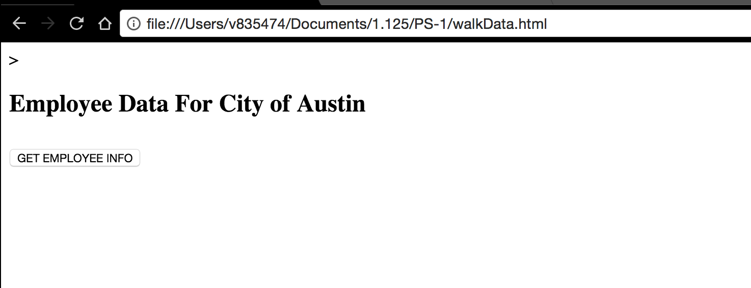

1. **How many city workers earn above $200,000 total salary ie with overtime?**

13

1. **How many police earn above $200,000 with overtime?**

1

1. **What is the total paid by the city to the police?**

177611643

**Output:**

