HW 03 - Course Catalog Analytics and Visualization

* 1. **-** Submit your curl script. Name your file curl.txt

**Submitted**

* 1. **-** Submit your raw data. Name your file raw.html

**Submitted**

**2.1. -** Submit your html-minifier script. Name your file whitespace_remove.txt

**Submitted**

**2.2. -** Submit your file without whitespace. Name your file no_whitespace.html

**Submitted**

**3.1. -** Submit the list of additional tools/packages your used.

I used VIM package for html editing

Installation command: npm install vim

**3.2. -** Submit a screen shot of every command line action you performed.

There are 4 steps I used to improve data:

**Step 1:** I opened the file using: vim catalog_clean.html

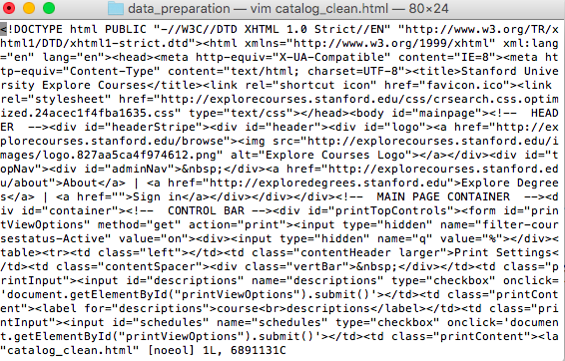

**Step 2:** I used %s command to find quotations and replace them with nothing. Command: “:%s/‘/ /g”

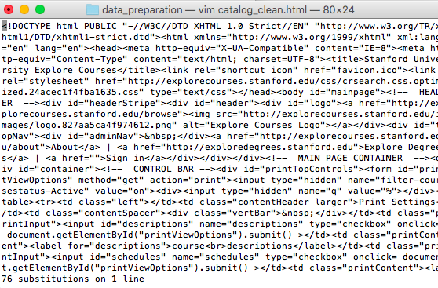

**Step 3:** I used :w command to write/save the file

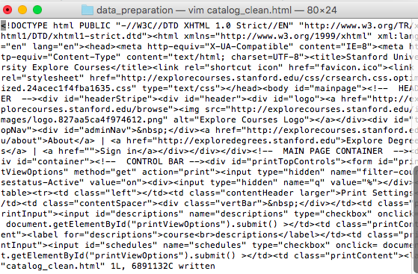

**3.2. -** Submit a file containing the additional command line scripts you performed. Name the file additional_cleaning.txt

**Submitted**

**3.3. -** Submit your final file, the ouput after all your data cleaning steps. Name your file scrubbed.html

**Submitted**

**4.1. -** Submit your file. Name your file data.js

**Submitted**

**5.1. -** Add your functions to a file called courses.html

**Submitted**

**6.1. -** Add your functions to the file you created in question 5, courses.html

**Submitted**

**7.1. -** Add your function to the file you created in question 5, courses.html

**Submitted**

**8.1. -** Submit your changes in a new file. Name your file new_graph.js

**Submitted**