Below is our Welcome Page which needs to be change a bit now:

Step 1: Enter the Search Code in the space provided

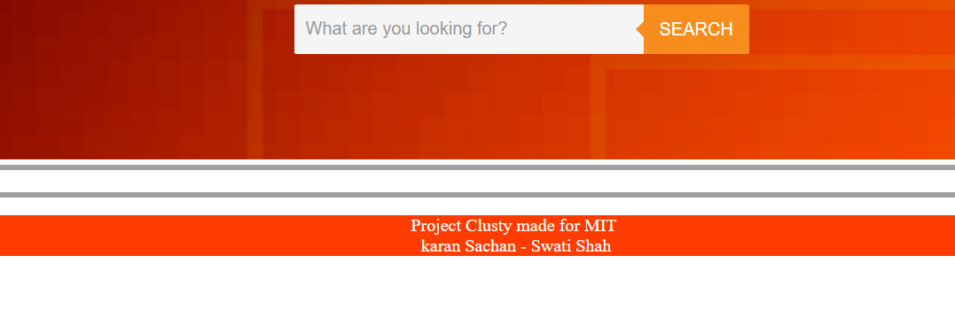

Step 2: Below results will be displayed. The format will change in future

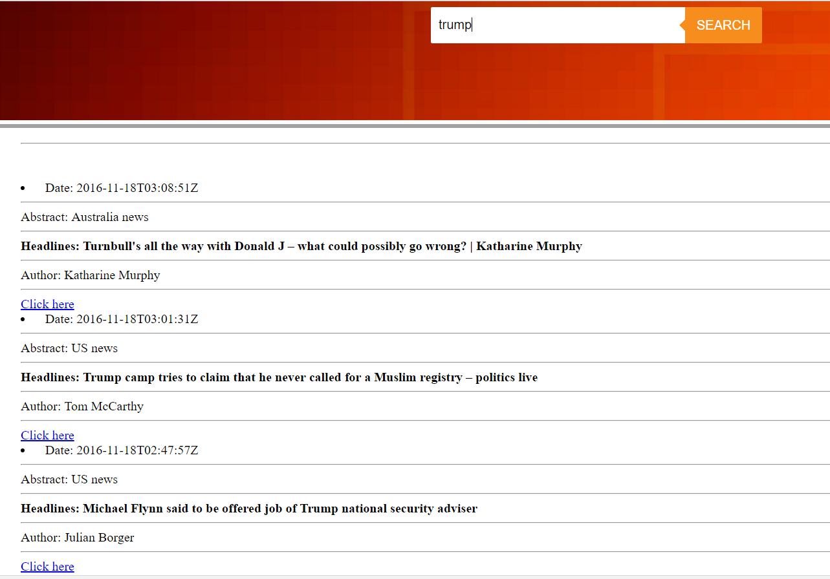

Currently, all the results are getting displayed without clustering algorithm.